TECHNICAL SPECIFICATION
NFT Mint Intelligence
and Copy-Mint Automation System
Python-based, Telegram-controlled, EVM-first implementation
Version: 1.0
Status: Developer handoff specification
Date: 5 August 2026
Audience: Backend, blockchain, DevOps and security developers
Initial scope: One EVM chain; ERC-721 and ERC-1155; analytics before execution

PRIMARY OUTCOME: Persist every wallet-to-collection mint observation, discover repeated minters dynamically, monitor their future mints, and copy only eligible public mints through guarded protocol adapters.

SECURITY POSITION: Telegram is the control plane, not the key vault. Private keys must never appear in Telegram, PostgreSQL or application logs.

Document control
Item | Value
Purpose | Implementation-ready requirements and architecture for the first production version.
Owner decisions still required | Initial EVM chain, RPC provider, hosting environment, copy-spend limits and first supported launchpads.
Change policy | Any change affecting signing, eligibility, automatic spending or identity resolution requires security review and regression tests.
Source of truth | This specification plus accepted architecture decision records (ADRs) created during implementation.

Contents
Section | Title
1 | Product definition and scope
2 | Users, roles and primary workflows
3 | Functional and non-functional requirements
4 | System architecture
5 | Core data model
6 | Collection ingestion and mint detection
7 | Wallet identity resolution
8 | Overlap analytics and wallet scoring
9 | Live monitoring and opportunity creation
10 | Mint-route adapters
11 | Copy execution engine
12 | Wallet and key management
13 | Telegram interface
14 | Security and threat model
15 | Reliability, observability and recovery
16 | API and service contracts
17 | Configuration model
18 | Edge-case catalogue
19 | Testing strategy
20 | Implementation phases
21 | Deployment and operations
22 | Definition of done
Appendix A | Enums and example payloads
Appendix B | References

1 Product definition and scope
The product is a personal or team-operated NFT intelligence system that discovers wallets minting across multiple collections, watches those wallets for future mint activity, and optionally prepares or executes a matching mint from controlled execution wallets. The initial implementation is EVM-first and uses Telegram as the operator interface.
CORE MODEL: The database stores observations, not precomputed intersections. A wallet's collection support is calculated from all stored mint events, so any future collection can reveal a new pairwise or multi-collection overlap.

1.1 Objectives
- Register a chain and NFT contract address from Telegram.
- Backfill all reliable historical mint events for the collection.
- Separate NFT recipient, transaction sender, probable initiator, operator and payer identities.
- Find exact repeated minters across any number or combination of stored collections.
- Watch high-signal wallets and detect new collections they mint.
- Classify how the target wallet minted: direct contract, OpenSea SeaDrop, known launchpad, marketplace/lazy mint or unknown route.
- Build a fresh transaction for the controlled wallet; never blindly replay another wallet's calldata.
- Apply simulation, eligibility, spend, quantity, gas and route safety rules before signing.
- Support manual approval first, then guarded automation after sufficient testing.

1.2 Initial scope
Area | Included in v1 | Deferred
Chains | One selected EVM chain; adapter-ready configuration for more EVM chains | Solana and other non-EVM chain families
NFT standards | ERC-721, ERC-1155 and ERC-2309 consecutive events | Nonstandard contracts requiring custom indexers
Execution | Direct public mints and OpenSea SeaDrop public drops | Arbitrary launchpads until adapter-tested
User interface | Private Telegram bot with inline approvals | Full web dashboard or Telegram Mini App
Automation | Analytics, alerts, paper mode and manual copy | Unattended auto mode until Phase 5

1.3 Explicitly out of scope
- Bypassing allowlists, Merkle proofs, token gates, per-wallet restrictions, CAPTCHAs or platform protections.
- Copying private signatures, vouchers or entitlements issued to another wallet.
- Guaranteeing mint profitability or treating repeated mint activity as proof of investment quality.
- Automatic secondary-market purchases unless a separate marketplace-trading module is approved.
- Storing seed phrases, raw private keys or recovery data in Telegram messages.

1.4 Terminology
Term | Meaning
Collection | An NFT contract on a specific chain. Identity is chain ID plus contract address.
Mint event | A token creation observation, normally a transfer from the zero address.
Recipient | Address receiving the newly created NFT.
Initiator | Best-estimate wallet that deliberately initiated the mint.
Support count | Number of distinct stored collections associated with a wallet.
Tracked wallet | Wallet selected for live mint monitoring.
Opportunity | A detected target mint that may be eligible for copying.
Adapter | Protocol-specific recognizer, eligibility checker, quoter and transaction builder.
Execution wallet | Controlled wallet used to submit copy-mint transactions.
Paper mode | Build and simulate without signing or broadcasting.

2 Users, roles and primary workflows

2.1 Roles
Role | Permissions
Owner | All bot, wallet, strategy, signing and emergency controls.
Analyst | Add collections, run scans, inspect overlaps and manage watchlists; cannot spend funds.
Operator | Review opportunities and approve within assigned strategy limits.
Service worker | Performs bounded jobs under service credentials; cannot change policy.
Signer | Signs only validated execution plans and exposes no private key material.

2.2 Primary workflow A - historical intelligence
- Operator submits chain and contract address.
- System validates the contract, token standard and deployment boundary.
- Indexer scans mint logs in resumable block chunks.
- Identity resolver records recipient and probable initiator separately.
- Analytics updates wallet-to-collection statistics.
- Bot reports minters, repeated wallets, classifications and scan quality warnings.
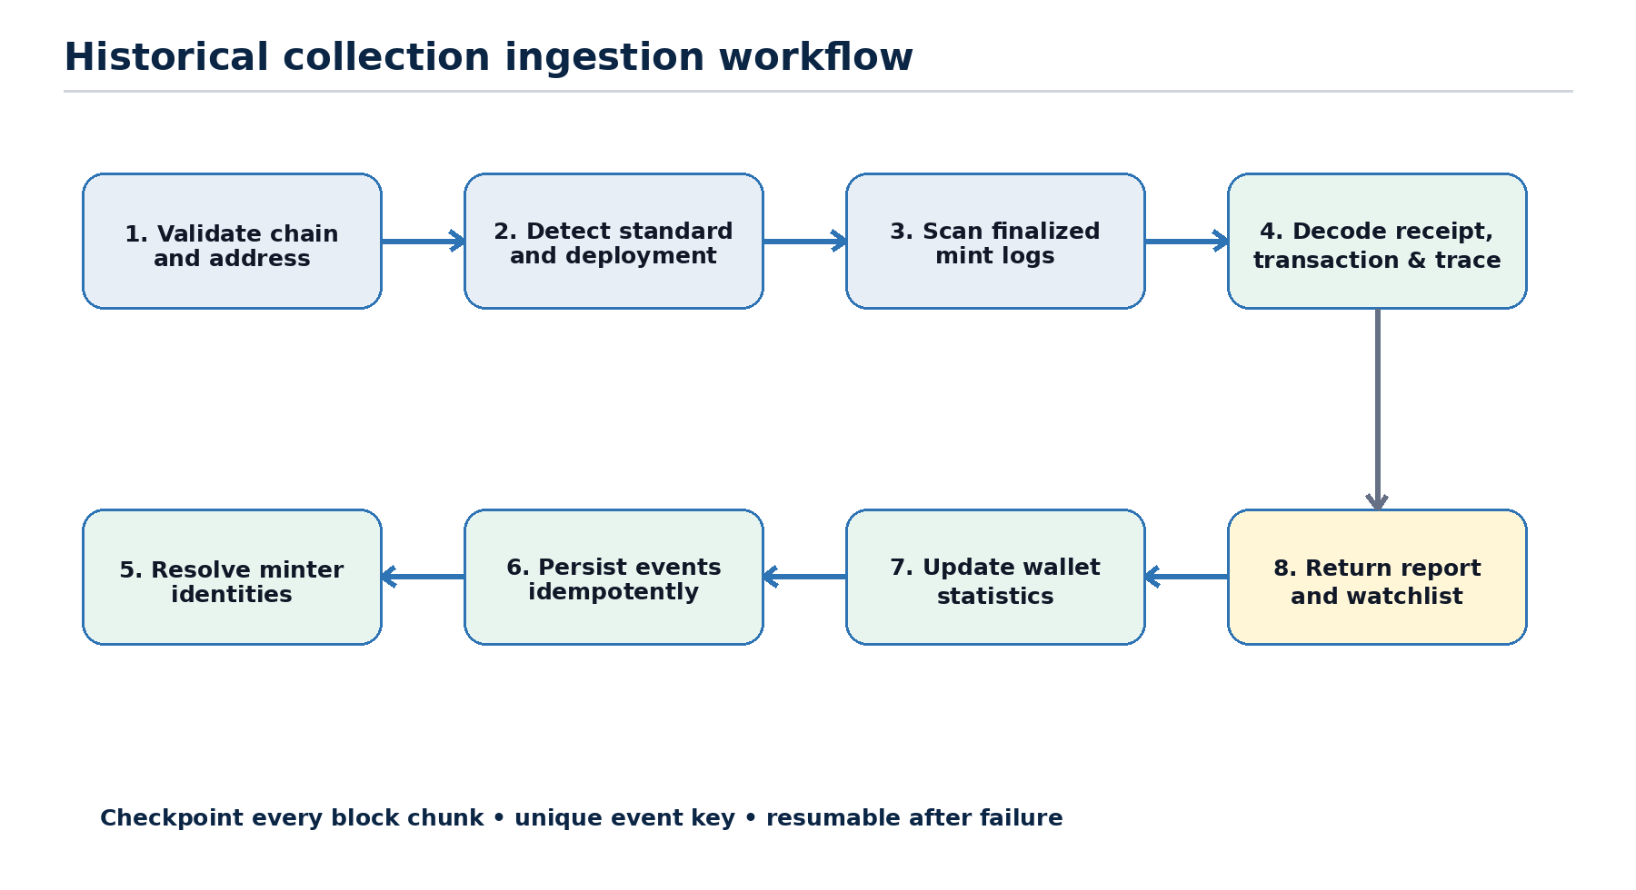
Figure 1. Historical collection ingestion is resumable, idempotent and finality-aware.

2.3 Primary workflow B - live copy opportunity
- A new finalized mint event is linked to a tracked wallet.
- The system creates a deduplicated opportunity and explains why the wallet is tracked.
- A route adapter classifies eligibility and calculates a current quote.
- The transaction is freshly built for the selected execution wallet.
- Simulation and policy checks run immediately before signing.
- Manual mode requests Telegram approval; auto mode proceeds only inside pre-authorized limits.
- The transaction manager monitors replacement, confirmation, failure, drop and reorganization states.

3 Functional and non-functional requirements
ID | Requirement | Acceptance statement
FR-01 | Chain configuration | Store immutable chain ID, namespace, currency, RPC references and finality policy.
FR-02 | Collection registration | Validate and uniquely register a contract by chain ID and normalized address.
FR-03 | Historical scanning | Backfill mint events from deployment block to the selected finality boundary.
FR-04 | Resume and deduplicate | Persist checkpoints and enforce unique event keys so jobs can safely restart.
FR-05 | Standard detection | Support ERC-721, ERC-1155 and ERC-2309; flag uncertain/nonstandard contracts.
FR-06 | Identity resolution | Store recipient, tx sender, operator, payer and probable initiator with confidence.
FR-07 | Mint classification | Classify public, free, allowlist, signed, token-gated, admin, airdrop, bridge and unknown mints.
FR-08 | Overlap analysis | Calculate support counts and arbitrary pairwise/group intersections from persisted observations.
FR-09 | Watchlist | Track wallets manually or by threshold and preserve the reason for selection.
FR-10 | Live detection | Detect new mint activity for tracked wallets and create idempotent opportunities.
FR-11 | Route recognition | Recognize direct public mints, SeaDrop and explicitly installed launchpad adapters.
FR-12 | Eligibility | Reject routes requiring unavailable proofs, signatures, gates or wallet-specific entitlement.
FR-13 | Quote and simulation | Re-read sale state, quote total cost, estimate gas and simulate before signing.
FR-14 | Execution modes | Support alert-only, paper, manual and guarded-auto modes.
FR-15 | Multiple wallets | Create/register controlled wallets through the signer and select one using an explicit policy.
FR-16 | Policy enforcement | Enforce chain, route, quantity, price, gas, daily spend and attempt limits.
FR-17 | Transaction lifecycle | Track every plan and attempt through terminal or recovery state.
FR-18 | Telegram administration | Expose commands, confirmations, audit events and emergency controls to authorized IDs.

3.2 Non-functional requirements
ID | Requirement
NFR-01 Security | No plaintext keys; signer isolation; least privilege; complete spend audit trail.
NFR-02 Correctness | Every stored event has chain, block, transaction and log provenance.
NFR-03 Idempotency | Repeated Telegram updates, jobs and provider webhooks produce no duplicate side effects.
NFR-04 Availability | Worker restart resumes from durable checkpoints without losing confirmed observations.
NFR-05 Observability | Structured logs, metrics, traces and actionable alerts cover scans and execution.
NFR-06 Performance | Historical scans use adaptive block chunks; live opportunities are created within the configured target latency.
NFR-07 Testability | Every adapter has historical fixtures and fork-based quote/build/simulate tests.
NFR-08 Maintainability | Chain, route, signer and notification modules depend on explicit interfaces.
NFR-09 Data retention | Raw mint evidence and execution audit history are never discarded by overlap recalculation.
NFR-10 Recovery | Database backup and encrypted signer recovery procedures are documented and tested.

4 System architecture
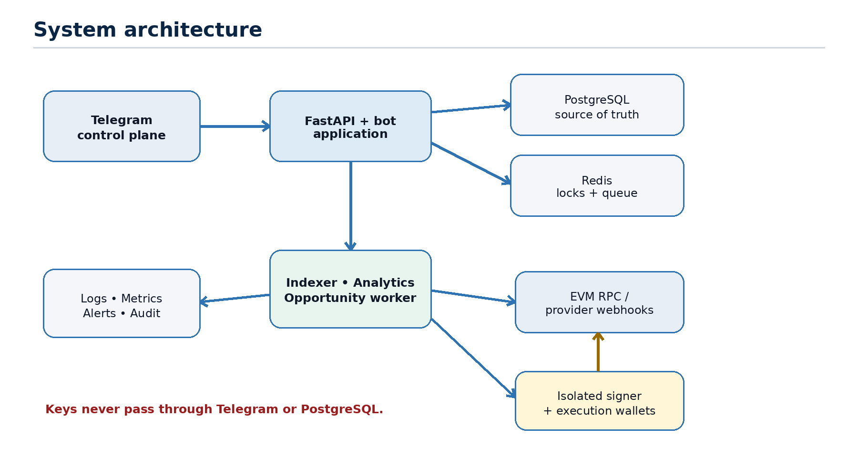
Figure 2. Logical architecture with Telegram separated from the signing boundary.
Component | Responsibility
Telegram bot | Commands, buttons, alerts and authorization. Contains no business truth or key material.
Application service | Validates requests, applies RBAC and coordinates repositories and workers.
PostgreSQL | Authoritative collections, events, identities, strategies, opportunities and audit history.
Redis | Job queue, distributed locks, nonce locks, short-lived confirmations and rate limits.
Indexer | Historical log retrieval, receipts, transactions, traces, checkpoints and reorg repair.
Analytics | Wallet stats, overlap queries, classification filters and watchlist promotions.
Opportunity worker | Correlates live mints with tracked wallets and invokes route recognition.
Execution planner | Builds deterministic plans, quotes, simulates and enforces strategy policy.
Signer | Holds encrypted key references and signs only approved chain-specific payloads.
Transaction manager | Broadcasts and monitors nonce, fee replacement, receipts and finality.
Observability | Structured logs, metrics, audit events and notifications.

4.1 Recommended deployment shape
- One Python repository, one shared domain model and separate runtime processes.
- Bot/API process is public-facing; workers and signer remain private-network services.
- PostgreSQL and Redis are not exposed to the internet.
- RPC credentials, bot token and signer secrets come from a secret manager or protected runtime environment.
- All outbound chain transactions pass through one transaction manager per chain and execution wallet.

4.2 Suggested Python modules
app/
bot/ # commands, callbacks, middleware, authorization
api/ # FastAPI endpoints and request models
chains/evm/ # RPC, logs, receipts, traces, finality
indexer/ # scan jobs, chunking, checkpoints, reorg repair
analytics/ # overlaps, scoring, classifications
opportunities/ # tracked-wallet correlation and route recognition
execution/ # adapters, planner, simulation, nonce manager
signer/ # encrypted key references and signing boundary
models/ repositories/# SQLAlchemy models and data access
workers/ # queues and scheduled jobs
security/ # RBAC, audit, secret handling
tests/fixtures/ # historical transactions and receipts

5 Core data model
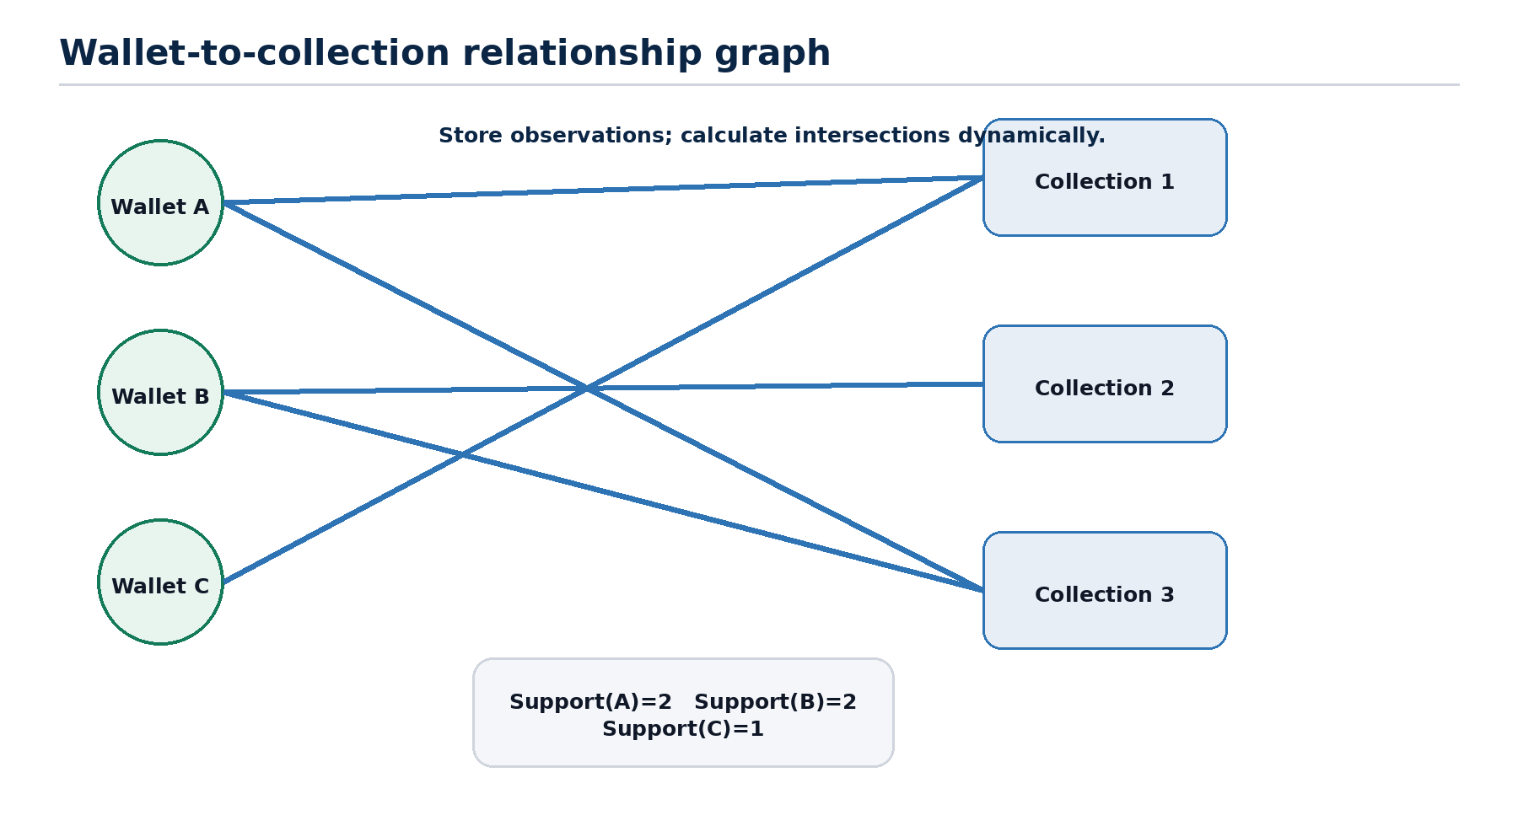
Figure 3. Wallet support remains discoverable even when earlier collection pairs have no overlap.
IDENTITY KEY: Every on-chain address is stored as (chain namespace, chain ID, normalized address). Same-format addresses across EVM chains may be grouped for analysis, but the underlying observations remain chain-specific.

Entity | Purpose | Natural/unique key
chains | Network metadata and finality policy | namespace + chain_id
collections | NFT contracts and scan state | chain_id + contract_address
scan_jobs | Backfill/rescan execution | job_id
scan_checkpoints | Last safely completed block chunk | collection_id + scan_version
mint_events | Immutable mint observations | chain_id + tx_hash + log_index + sub_index
wallet_collection_stats | Derived wallet/collection aggregate | wallet_id + collection_id + identity_mode
tracked_wallets | Watchlist and selection reason | wallet_id + chain_scope
wallet_scores | Versioned analytical scores | wallet_id + score_version
opportunities | Potential copyable mints | chain_id + source_tx_hash + target_wallet
strategies | Spend and route policy | strategy_id
execution_wallets | Public address and signer reference | chain_id + address
tx_attempts | Plan/sign/broadcast lifecycle | attempt_id
audit_logs | Actor, action, before/after and correlation | audit_id

5.1 Required mint event fields
Field | Purpose
chain_id, contract_address | Collection identity
block_number, block_hash | Canonicality and reorg repair
tx_hash, tx_index | Transaction provenance
log_index, sub_index | Unique event position, including expanded batches
token_id, quantity | Minted token or batch amount
recipient_wallet | First NFT owner
transaction_from | Transaction-level sender
operator_wallet | Protocol-reported operator when present
payer_wallet | Best-known value source
initiator_wallet | Resolved decision-making wallet
identity_confidence | 0-100 score plus reason codes
method_selector | First four calldata bytes
native_value, token_payments | Observed cost evidence
mint_route | direct/seadrop/launchpad/marketplace/unknown
classification | public, allowlist, admin, airdrop, bridge, etc.
finality_status | provisional/safe/finalized/reorged
raw_evidence_ref | Optional normalized receipt/trace reference

5.2 Example overlap query
SELECT initiator_wallet,
COUNT(DISTINCT collection_id) AS support_count,
ARRAY_AGG(DISTINCT collection_id ORDER BY collection_id) AS collections
FROM mint_events
WHERE finality_status IN ('safe', 'finalized')
AND classification IN ('public_paid_mint', 'public_free_mint')
AND initiator_wallet IS NOT NULL
GROUP BY initiator_wallet
HAVING COUNT(DISTINCT collection_id) >= :minimum_support
ORDER BY support_count DESC;

6 Collection ingestion and mint detection

6.1 Registration
- Normalize the address and bind it to the supplied chain ID.
- Call eth_getCode and reject externally owned accounts or empty addresses.
- Resolve ERC-165 support when available; fall back to observed event signatures.
- Resolve proxy and current implementation metadata without treating implementation as collection identity.
- Find deployment block from trusted explorer data or RPC binary search.
- Create scan job with a fixed end block at the selected finality boundary.

6.2 Event rules
Standard | Mint signal | Special handling
ERC-721 | Transfer(from=0x0, to, tokenId) | Constructor-time mint exception exists in the original standard.
ERC-1155 | TransferSingle/TransferBatch(from=0x0) | Expand batch arrays using sub_index; ignore zero-quantity existence signals.
ERC-2309 | ConsecutiveTransfer range from zero | Store range compactly or expand with a controlled maximum.
Custom | Nonstandard event or state change | Require explicit adapter and confidence warning.

6.3 Scanner algorithm
async def scan_collection(collection, start_block, end_block):
cursor = load_checkpoint(collection) or start_block
chunk = configured_initial_chunk
while cursor <= end_block:
upper = min(cursor + chunk - 1, end_block)
try:
logs = await rpc.get_mint_logs(collection.address, cursor, upper)
await persist_decoded_events_in_one_transaction(logs)
await save_checkpoint(collection, upper)
cursor = upper + 1
chunk = adapt_upward_if_response_small(chunk)
except ProviderRangeOrSizeError:
chunk = max(minimum_chunk, chunk // 2)
except RetryableProviderError:
retry_with_jitter_and_provider_failover()
INVARIANT: A checkpoint advances only in the same database transaction that commits all events for its block chunk.

6.4 Classification evidence
- Receipt logs and NFT transfer events are authoritative for successful token creation.
- Transaction calldata and ABI identify the external function when available.
- Traces reveal routers, forwarded calls, refunds and internal payment flows.
- Known protocol contract addresses and event signatures identify SeaDrop or a launchpad.
- Collection configuration and recognized sale events distinguish public, allowlist and signed phases.
- Classification must expose confidence and reason codes rather than silently guessing.

7 Wallet identity resolution
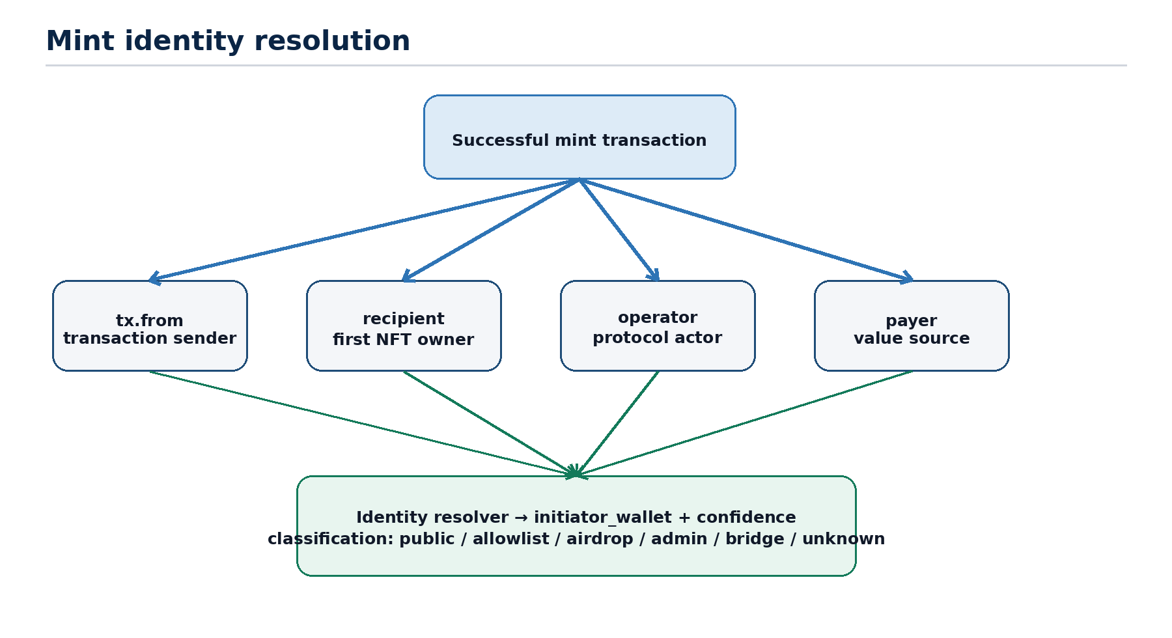
Figure 4. A mint may contain several distinct wallet roles; the resolver produces an initiator with evidence.

7.1 Resolution priority
- If a recognized protocol emits an explicit minter/payer field, use it with protocol-specific confidence.
- For a direct EOA call where tx.from receives the NFT, set initiator to tx.from with high confidence.
- If tx.from mints to another EOA, keep tx.from as probable initiator and recipient separately.
- If tx.from is a known router or relayer, inspect traces and protocol data for the user wallet.
- For ERC-4337 activity, attempt to resolve the UserOperation sender instead of treating the bundler as the minter.
- If evidence conflicts or cannot identify a user wallet, store initiator as null/unknown rather than fabricate certainty.

7.2 Identity confidence examples
Scenario | Initiator | Suggested confidence
Direct EOA call; NFT received by same address | tx.from | 95-100
Direct EOA call; recipient differs | tx.from | 85-95
Known launchpad exposes user in event | Protocol field | 90-100
Known router; user recovered from trace | Recovered caller | 75-95
Smart account through known entry point | UserOperation sender | 85-98
Shared relayer without user evidence | Unknown | 0-40; exclude by default
Admin batch airdrop | Admin is operator, not recipient | Classification high; user intent low

8 Overlap analytics and wallet scoring

8.1 Exact overlap metrics
Metric | Definition | Use
Support count | Distinct stored collections minted by wallet | Primary repeated-minter rank
Pair intersection | Wallets found in both selected collections | Direct comparison
Group intersection | Wallets found in every selected collection | Strict conviction group
At-least-k overlap | Wallets found in k of n selected collections | Resilient multi-collection discovery
Jaccard similarity | Intersection divided by union of two collection minter sets | Normalize collections of different size
Weighted support | Each collection weighted by rarity/quality policy | Reduce domination by huge free mints

8.2 Quality score
The quality score is optional and must remain separate from the factual support count. It may help prioritize alerts, but it must not erase or rewrite raw overlap results.
- Positive signals: repeated paid public mints, recent activity, early mint percentile, retention and consistent initiator confidence.
- Negative signals: airdrops, team/admin activity, bridge mints, spam collections, relayers, contracts, exchange addresses and obvious mint-farm bursts.
- Score versions are immutable. Recalculation writes a new version so historical decisions remain explainable.
- Do not include future collection price performance in the core repeated-minter score unless a separately reviewed research module is added.

8.3 Watchlist promotion
eligible = (
wallet.support_count >= strategy.minimum_support
and wallet.identity_confidence >= strategy.minimum_identity_confidence
and wallet.is_contract is False
and wallet.exclusion_reason is None
)
if eligible:
upsert_tracked_wallet(wallet, reason='support_threshold', score_version=current_version)

9 Live monitoring and opportunity creation
The live system watches mint evidence, not merely outbound wallet transactions. This catches direct calls, routed mints and recipient-only signals while still allowing the identity resolver to decide whether the tracked wallet intentionally minted.

9.1 Detection modes
Mode | Advantage | Risk/limitation
Finalized/safe logs | Highest correctness | May be too slow for fast sellouts
Confirmed block logs | Practical MVP latency | Must repair reorgs
Provider address webhook | Low operational burden | Vendor-specific semantics and possible gaps
Own block receipt scanner | Deterministic and portable | Higher RPC and infrastructure load
Pending/mempool | Earliest possible signal | False/replaced txs, private flow, fee races; deferred

9.2 Opportunity fields
- Source chain, block, transaction and tracked wallet.
- Collection address and detected token standard.
- Tracked-wallet support count, score version and watch reason.
- Route, classification, eligibility and confidence.
- Observed quantity, source cost and current quoted cost.
- Adapter name/version and risk flags.
- Deduplication key and expiry time.
- Decision: alert-only, paper, manual-ready, auto-ready or not-copyable.

10 Mint-route adapters
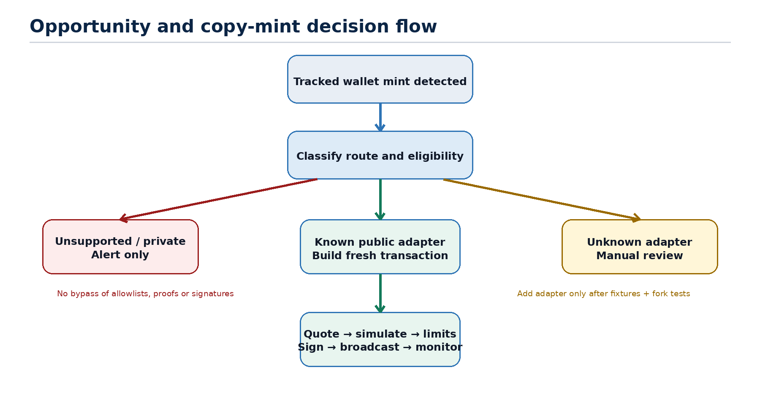
Figure 5. The system copies only recognized, currently eligible public routes.

10.1 Adapter contract
class MintAdapter(Protocol):
name: str
version: str
async def recognize(self, source_tx, receipt, collection) -> Recognition: ...
async def inspect_sale(self, collection, wallet) -> SaleState: ...
async def check_eligibility(self, collection, wallet) -> Eligibility: ...
async def quote(self, collection, wallet, quantity) -> Quote: ...
async def build(self, collection, wallet, quantity, quote) -> UnsignedTx: ...
async def simulate(self, tx) -> SimulationResult: ...

10.2 Supported route behaviour
Route | Recognition | Execution policy
Direct public contract | Target contract/function and public sale state | Fresh calldata; current price; quantity and recipient replaced correctly.
OpenSea SeaDrop public | Known SeaDrop call/events and public drop configuration | Use SeaDrop rules; quote current public price; reject gated phase.
SeaDrop allowlist/signed/gated | Merkle, server-signed or token-gated phase | Not copyable unless the execution wallet independently has valid eligibility.
Known launchpad | Versioned contract addresses, selectors and events | Only after fixture, fork and negative eligibility tests pass.
Seaport purchase | Marketplace order fulfilment | Classify as marketplace activity; not a normal copy-mint in v1.
Unknown/custom | Unrecognized router or method | Alert and preserve evidence; no automatic signing.

CRITICAL RULE: Never reuse another wallet's proof, signature, nonce, recipient-bound voucher or raw calldata. The adapter must construct a new transaction from current on-chain state.

11 Copy execution engine

11.1 Pre-signing sequence
- Load immutable opportunity and selected strategy version.
- Select one eligible execution wallet using the configured policy.
- Re-read sale state, supply, wallet limit, price and payment token.
- Build a fresh transaction with the controlled recipient and quantity.
- Calculate native value, token approvals, gas estimate and total worst-case cost.
- Simulate against the latest block and parse expected NFT mint events.
- Enforce chain, route, confidence, quantity, per-mint, daily spend, gas and approval policies.
- Acquire a database/Redis nonce lock for the selected wallet.
- Request manual approval or verify that auto authority is valid and unexpired.
- Send the exact typed plan to the signer; broadcast and monitor.

11.2 Mandatory policy fields
Field | Meaning | Safe starting position
mode | alert | paper | manual | auto | alert
allowed_chain_ids | Explicit chain list | Required
allowed_routes | Adapter allowlist | direct_public, seadrop_public
minimum_support | Tracked wallet collection count | 2
minimum_identity_confidence | 0-100 | 85
quantity_per_mint | Maximum NFT quantity | 1
max_mint_price | Native/token-denominated cap | Owner must set
max_gas_cost | Maximum gas fee | Owner must set
max_total_cost | Value + payment + gas | Owner must set
daily_spend_limit | All successful and pending attempts | Owner must set
max_attempts_per_collection | Across all wallets | 1
quote_tolerance | Allowed price drift before rebuild | 0 unless approved
approval_ttl_seconds | Manual confirmation validity | 60-120
auto_authority_ttl | How long unattended mode remains enabled | Short and explicit

11.3 Transaction state machine
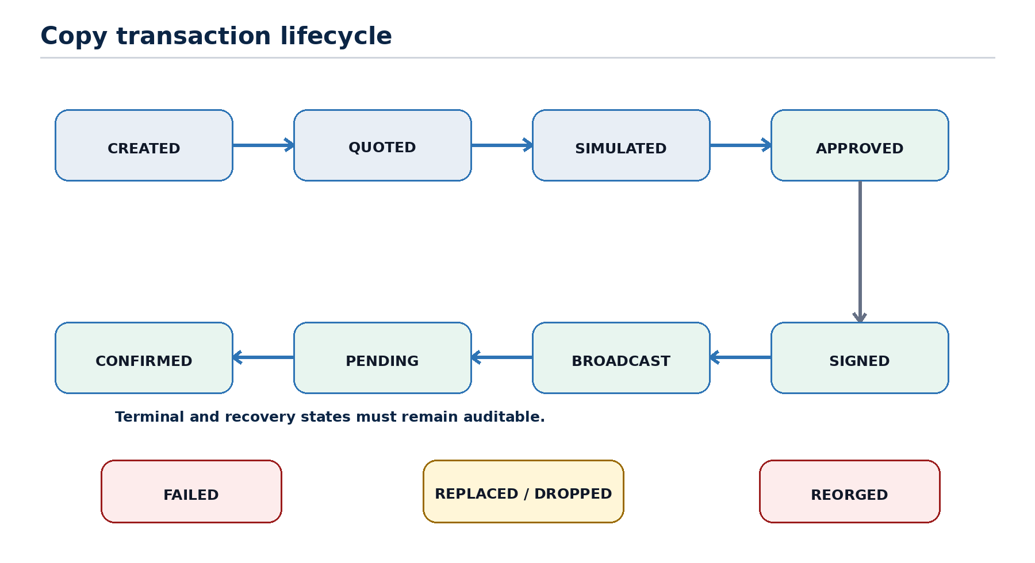
Figure 6. Each execution attempt is auditable through success, failure and recovery states.
Transitions must be append-only audit events. A worker retry may resume an existing attempt but must not create a second broadcast unless the replacement policy explicitly authorizes it.

11.4 Nonce management
- One lock namespace per chain and execution-wallet address.
- Read pending nonce while holding the lock; reserve nonce in the database before signing.
- Reconcile reserved, broadcast, pending and confirmed nonces after restart.
- A replacement transaction uses the same nonce and a recorded fee-bump policy.
- Manual transactions made outside the bot trigger reconciliation and may pause automation.

12 Wallet and key management
BOUNDARY: The bot may request wallet creation, display addresses and select wallets. Only the signer creates or accesses private key material.

12.1 Wallet creation
- Owner requests a count and chain scope from a private Telegram chat.
- Bot creates an expiring confirmation challenge containing only public configuration.
- Signer creates keys or derives approved child accounts inside its protected boundary.
- Signer stores encrypted material and returns address plus opaque signer_key_id.
- Application stores address, status, labels and signer reference; never raw key data.
- Recovery material is handled out of band and never sent through Telegram.

12.2 Wallet selection policies
Policy | Behaviour | Default
single | Always use one designated wallet | Recommended for MVP
round_robin | Rotate among funded healthy wallets | Disabled
highest_balance | Select wallet with greatest usable balance | Disabled
chain_bound | Each wallet assigned to one chain | Recommended
all_wallets | Attempt from every wallet | Prohibited unless separately approved

12.3 Funding and treasury controls
- Execution wallets should hold only bounded operating funds.
- Gas top-ups require a separate audited action and maximum top-up amount.
- Do not automatically sweep or consolidate NFTs unless a separate module is reviewed.
- Exact ERC-20 approvals are preferred; unlimited approvals to unknown contracts are rejected.
- A compromised bot token must not be sufficient to retrieve keys or bypass signer policy.

13 Telegram interface

13.1 Command catalogue
Command | Purpose | Role
/add_collection <chain> <address> | Register and optionally start historical scan | Owner/Analyst
/scan <collection> | Start/resume scan and show progress | Owner/Analyst
/collections | List stored collections and scan quality | All authorized
/overlap [filters] | Show repeated minters and support counts | All authorized
/compare <c1> <c2> ... | Exact or at-least-k intersection | All authorized
/wallet <address> | Show collection history and classifications | All authorized
/watch <address> | Track wallet with reason | Owner/Analyst
/unwatch <address> | Stop live alerts; preserve history | Owner/Analyst
/opportunities | List active and expired opportunities | Owner/Operator
/copy <opportunity_id> | Prepare manual copy confirmation | Owner/Operator
/create_wallets <chain> <count> | Request signer-managed wallets | Owner
/wallets | List addresses, balances and health | Owner
/strategy | View or change versioned limits | Owner
/mode <alert|paper|manual|auto> | Change execution mode with confirmation | Owner
/pause | Stop new transaction planning | Owner/Operator
/kill_switch | Disable signing and broadcasting immediately | Owner
/status | System, provider, queue and signer health | All authorized

13.2 Interaction rules
- Accept privileged commands only in private chats from allowlisted numeric Telegram user IDs.
- Never use username as an authorization identity.
- Every spending action displays chain, wallet, contract, route, quantity, value, gas cap and worst-case total.
- Confirmation callbacks are single-use, expire quickly and bind to the exact strategy and quote versions.
- Telegram update_id and internal idempotency keys prevent repeated webhook delivery from repeating actions.
- Webhook requests validate Telegram's secret token header before parsing commands.
- Sensitive errors are summarized to the operator; secrets and raw signed payloads remain in protected logs only when necessary and redacted.

13.3 Example opportunity card
TRACKED WALLET MINTED A NEW COLLECTION
Wallet: 0xabc...123
Support: 4 stored collections
Chain: Base (8453)
Collection: 0xdef...789
Route: SeaDrop public mint
Quantity: 1
Current quote: 0.003 ETH + estimated gas
Eligibility: Public / eligible
Confidence: 96
Mode: Manual
[PREPARE COPY] [IGNORE] [BLOCK COLLECTION]

14 Security and threat model
Threat | Impact | Required controls
Telegram bot token theft | Unauthorized commands | Numeric user allowlist, webhook secret, short confirmations, external second factor for auto mode
Signer compromise | Loss of execution-wallet funds | Isolation, encrypted keys, limited balances, egress controls, rotation and kill switch
Database compromise | Strategy manipulation or intelligence leak | No keys, least privilege, encryption, audit and immutable strategy versions
Malicious mint contract | Unexpected calls, approvals or fund loss | Known adapters, decoded plan, simulation, approval limits and cost caps
RPC tampering/outage | False state, missed logs or bad gas data | Provider failover, block-hash verification, checkpoints and reconciliation
Replay/duplicate webhook | Repeated transaction | update_id dedupe, callback nonce, request idempotency and opportunity uniqueness
Race between workers | Duplicate nonce or spend | Distributed lock, database reservation and single transaction manager
Configuration takeover | Limits raised silently | Owner-only changes, before/after audit, confirmation and optional cool-down
Sensitive logs | Secret or signed data exposure | Structured redaction, no seed/private key logging, restricted log access
Supply-chain compromise | Malicious dependency/build | Pinned lockfile, dependency scanning, signed images and minimal runtime
Insider/operator misuse | Intentional overspend | RBAC, dual approval option, hard signer caps and audit trail
Key recovery failure | Permanent loss | Encrypted offline backup and tested restore procedure

14.1 Signer authorization envelope
The signer should receive a structured plan rather than arbitrary calldata. At minimum it verifies chain ID, destination contract, value, gas cap, nonce, adapter identity, expected recipient, quantity, strategy version and plan expiry. It rejects unknown chains, expired plans and any request exceeding its independent hard caps.
DEFENCE IN DEPTH: Application policy and signer policy are separate. A compromised application must still be unable to exceed signer-enforced chain, destination, value and daily limits.

14.2 Compliance and responsible operation
- Automate only public actions for which the controlled wallet is independently eligible.
- Respect launchpad and marketplace terms, rate limits and geographic restrictions.
- Do not use multiple wallets to evade per-wallet rules or allocations.
- Record the source and basis for every automated decision.
- Present copy-minting as execution automation, not a guarantee of financial return.

15 Reliability, observability and recovery

15.1 Required metrics
Area | Metrics
Indexer | latest scanned block, finalized lag, logs processed, chunk size, retries, provider errors
Analytics | wallets scored, overlap query latency, watchlist promotions, excluded identities
Live | event-to-opportunity latency, duplicates suppressed, opportunities by route/decision
Execution | quote/simulation latency, policy rejects, approvals, broadcasts, confirmations, failures
Wallet | balance, pending nonce gap, signer health, daily committed and settled spend
Telegram | webhook failures, duplicate updates, unauthorized attempts, callback expiry

15.2 Alert conditions
- Indexer falls behind the chain-specific threshold.
- Repeated provider inconsistencies or block-hash mismatch.
- Signer unavailable, unexpected key reference or authorization rejection.
- Pending transaction exceeds timeout or nonce gap appears.
- Daily committed spend approaches or reaches its cap.
- Database, Redis or RPC failure prevents policy evaluation.
- Reorganization removes a source mint or a copied transaction receipt.
- Unauthorized Telegram user or repeated invalid callback attempts.

15.3 Recovery procedures
Failure | Recovery
Worker restart | Resume durable job/checkpoint; idempotent event insert; reconcile in-progress attempts.
RPC outage | Pause new execution, fail over provider, compare canonical block hashes, resume scans.
Database restore | Restore backup, validate migration version, reconcile chain state from checkpoint overlap window.
Redis loss | Rebuild ephemeral locks carefully; pause execution until nonce and pending-state reconciliation completes.
Signer loss | Keep automation paused; restore encrypted signer using documented process; verify addresses before funding.
Reorg | Mark removed evidence, reverse derived stats, expire dependent opportunity and reconcile execution receipt.

16 API and service contracts
Telegram handlers should call application services, not repositories or web3.py directly. The same services may be exposed through a private FastAPI interface for workers and future dashboards.
Method | Path | Purpose
POST | /v1/collections | Register collection
POST | /v1/collections/{id}/scan | Create/resume scan job
GET | /v1/scan-jobs/{id} | Progress and quality warnings
GET | /v1/analytics/overlaps | Support/intersection query
GET | /v1/wallets/{chain}/{address} | Wallet profile
POST | /v1/watchlist | Track wallet
GET | /v1/opportunities | List opportunities
POST | /v1/opportunities/{id}/prepare | Quote/build/simulate
POST | /v1/plans/{id}/approve | Approve exact plan
POST | /v1/plans/{id}/broadcast | Signer-authorized broadcast
POST | /v1/system/pause | Pause new plans
POST | /v1/system/kill | Disable signing/broadcast

16.1 Example opportunity payload
{
"id": "opp_...",
"source": {"chain_id": 8453, "tx_hash": "0x...", "tracked_wallet": "0x..."},
"collection": {"address": "0x...", "standard": "ERC721"},
"signal": {"support_count": 4, "identity_confidence": 96},
"route": {"adapter": "seadrop", "version": "1", "type": "public"},
"observed": {"quantity": 1, "native_value": "3000000000000000"},
"decision": "manual_ready",
"expires_at": "2026-08-05T10:30:00Z",
"risk_flags": []
}

16.2 Idempotency rules
- Mutating API requests require an Idempotency-Key generated by the caller.
- Opportunity creation is unique on source chain, source transaction, tracked wallet and target collection.
- A manual approval binds to one immutable execution plan and cannot be reused after plan expiry or rebuild.
- Broadcast persists the signed transaction hash before or atomically with external submission when possible.
- Unknown submission outcome triggers hash-based reconciliation, not immediate rebroadcast with a new nonce.

17 Configuration model
Setting | Meaning | Starting position
chains.<name>.chain_id | Immutable numeric chain ID | Required
chains.<name>.rpc_http/ws | Secret/provider references | Required
chains.<name>.confirmations | Provisional confirmation threshold | Chain-specific
chains.<name>.finality_tag | safe/finalized or depth policy | Preferred
indexer.initial_chunk | Initial eth_getLogs block range | Provider-tested
indexer.reorg_lookback | Blocks rescanned for canonicality | Chain-specific
analytics.minimum_support | Watchlist threshold | 2
analytics.identity_mode | initiator/recipient/either | initiator
execution.mode | alert/paper/manual/auto | alert
execution.default_quantity | NFT quantity | 1
execution.adapter_allowlist | Allowed route adapter versions | Explicit
execution.cost_limits | Mint, gas, total and daily caps | Owner-set
telegram.allowed_user_ids | Numeric authorization list | Required
telegram.webhook_secret | Secret reference | Required for webhook
signer.endpoint | Private service address | Required before Phase 4
observability.alert_targets | Telegram/admin destinations | Required

CONFIGURATION SAFETY: Never accept chain IDs, RPC URLs, signer endpoints or spend caps directly from an unverified callback payload. Callbacks carry an opaque challenge ID; the server reloads authoritative values.

18 Edge-case catalogue
The following cases are minimum required behaviour. The developer should convert each row into one or more automated tests or explicit operational checks.
Area | Edge case | Required behaviour | Severity
Input | Wrong chain selected for a valid-looking address | Reject if no code; never search other chains automatically | High
Input | Same contract added twice with different casing | Normalize and return existing collection | Medium
Input | EOA or zero address supplied | Reject before scan | High
Input | Unsupported/non-EVM chain requested | Explain unsupported adapter; make no RPC call | Low
Input | Proxy address points to changing implementation | Keep proxy as identity; version implementation metadata | High
Scan | Provider rejects large block range | Halve chunk and retry with floor | Medium
Scan | Provider truncates results without clear error | Detect provider limits using counts/cross-check; split range | High
Scan | RPC timeout after DB commit | Checkpoint transaction makes retry idempotent | High
Scan | Worker dies mid-chunk | Resume previous durable checkpoint | High
Scan | Deployment block unknown | Explorer lookup or RPC binary search; record confidence | Medium
Scan | ABI is unavailable | Decode standard events; method remains selector/unknown | Medium
Scan | ABI changes after proxy upgrade | Store implementation/version by block interval | High
Mint event | ERC-1155 TransferBatch | Expand ids/values with deterministic sub_index | High
Mint event | ERC-1155 zero-value existence event | Do not count as user mint quantity | Medium
Mint event | ERC-2309 enormous range | Store range or apply safe expansion cap | High
Mint event | ERC-721 tokens created during constructor without Transfer | Flag standard limitation; do not fabricate events | Low
Mint event | Mint then burn in same transaction | Store both; classification may exclude ephemeral token | Medium
Mint event | One tx mints several collections | Create independent events/opportunities | Medium
Mint event | One tx mints to several recipients | Store each recipient; resolve common initiator | High
Mint event | Airdrop/admin reserve | Classify and exclude from default overlap | High
Mint event | Bridge or migration creates wrapped NFT | Classify bridge/migration; not public mint | High
Mint event | Lazy mint during marketplace sale | Classify separately from public mint | Medium
Identity | tx.from is launchpad router | Use recognized protocol evidence or unknown | High
Identity | tx.from is ERC-4337 bundler | Resolve UserOperation sender where supported | High
Identity | User mints as gift | Initiator and recipient remain separate | Medium
Identity | Shared relayer hides user | Null initiator; do not rank relayer | High
Identity | Smart wallet address differs across chains | Do not assume cross-chain controller identity | Medium
Identity | Address is a contract/exchange | Tag and exclude by default; allow manual override | Medium
Identity | Conflicting protocol fields | Lower confidence and preserve reason codes | High
Analytics | Collections 1 and 2 have no overlap; 2 and 3 do | Raw observations make later overlap discoverable | High
Analytics | Same wallet mints many tokens in one collection | Support counts collection once; preserve quantity | High
Analytics | Huge free mint dominates overlaps | Expose exact result; optional weighting/filter | Medium
Analytics | Classification changes after improved adapter | Version derivation and recompute; preserve source event | Medium
Analytics | Wallet score formula changes | Write new score version; keep previous decisions | Medium
Analytics | Wallet removed from watchlist | Stop live alerts; retain history | Low
Live | Provider sends duplicate webhook | Deduplicate by event and opportunity keys | High
Live | Log arrives before receipt is available | Retry enrichment; do not lose provisional event | Medium
Live | Chain reorganization removes source mint | Mark reorged, reverse stats and expire opportunity | High
Live | Watcher falls behind | Alert lag; catch up from durable block cursor | High
Live | Pending target transaction is replaced | MVP ignores pending; future mode tracks replacement | Medium
Live | Tracked wallet receives unsolicited spam mint | Recipient-only, low intent; exclude by default | High
Opportunity | Same source mint matches multiple tracked identities | One opportunity per controlled target and collection; aggregate reasons | Medium
Opportunity | Opportunity expires before approval | Reject and rebuild/requote if still eligible | High
Route | Public sale becomes allowlist phase | Eligibility recheck rejects copy | High
Route | Target used Merkle proof | Do not reuse; require our wallet's own proof | Critical
Route | Server signature bound to target wallet | Not copyable without independently issued signature | Critical
Route | Token-gated mint | Verify our holdings; reject if not eligible | High
Route | Unknown launchpad | Alert/manual analysis only | High
Route | OpenSea Seaport purchase appears with mint | Classify lazy/marketplace, not public drop | Medium
Execution | Mint sold out after detection | Sale-state check/simulation fails; no broadcast | High
Execution | Price changes after quote | Requote; require tolerance or new approval | High
Execution | Gas spikes after approval | Enforce max fee and total cap; expire plan | High
Execution | Contract returns refund | Use worst-case debit for policy; record actual receipt | Medium
Execution | Payment uses ERC-20 | Check balance/decimals; exact allowance; simulate payment | High
Execution | Unexpected approval request | Reject unless adapter and policy explicitly allow | Critical
Execution | Simulation succeeds but state changes before mining | Monitor receipt; no assumption of success | High
Execution | Simulation emits no expected mint event | Reject plan | Critical
Execution | Insufficient native balance | No sign; alert required funding | High
Execution | Nonce already used outside bot | Reconcile and rebuild while locked | High
Execution | Broadcast times out with unknown result | Derive/check tx hash; reconcile before retry | Critical
Execution | Transaction dropped | Mark dropped after policy timeout; optional same-nonce replacement | High
Execution | Transaction replaced | Link replacement; keep one logical attempt | High
Execution | Copied transaction reorged | Return to reconciliation; verify canonical receipt | High
Execution | Two workers select same wallet | Distributed nonce lock and DB reservation | Critical
Execution | Daily cap counted only after confirmation | Include approved/pending commitments | Critical
Wallet | Wallet creation request repeated | Idempotent challenge; no duplicate keys | High
Wallet | Private key appears in bot response | Prohibited; security incident and key rotation | Critical
Wallet | Signer unavailable | Pause execution; analytics remains available | High
Wallet | Wrong signer address returned | Verify derived address and registered key reference | Critical
Wallet | All wallets selected accidentally | Default single-wallet policy; explicit elevated confirmation | Critical
Wallet | Balance top-up exceeds need | Apply top-up cap and audit | High
Telegram | Username changes | Authorization remains numeric ID based | High
Telegram | Callback replay | Single-use challenge and update dedupe | Critical
Telegram | Approval message forwarded | Callback still binds to authorized user and private chat | High
Telegram | Bot added to a group | Privileged commands refused | High
Telegram | Webhook secret invalid | Reject before application handling | Critical
Operations | Migration partially applied | Transactional migrations; service compatibility check | High
Operations | Redis data lost | Pause execution and reconcile nonce/commitments | Critical
Operations | Clock skew affects expiry | Use UTC and monitored time sync | Medium
Operations | Log storage leaks secrets | Redaction tests and restricted access | Critical
Operations | Backup exists but cannot restore | Scheduled restore drill | High

19 Testing strategy

19.1 Test layers
Layer | Minimum coverage
Unit | Decoders, classifiers, overlap queries, policy rules, amount arithmetic and state transitions
Fixture | Historical raw transactions, receipts, logs and traces for every supported route and edge case
Database | Unique constraints, checkpoint atomicity, concurrent jobs, migrations and derived-stat rebuilds
Fork integration | Quote/build/simulate against a pinned historical block or controlled fork
Provider contract | Log pagination, rate limits, error mapping, failover and block-hash consistency
Signer | Authorization envelope, cap rejection, expiry, wrong chain, wrong destination and key isolation
Telegram | RBAC, duplicate updates, callback replay, expiry, private-chat enforcement and redaction
End-to-end | Collection input through overlap report; source mint through paper/manual transaction outcome
Failure/chaos | Worker kill, RPC timeout, Redis restart, database reconnect and reorg simulation
Security | Dependency scan, secret scan, permission review and threat-model regression

19.2 Required golden fixtures
- Direct ERC-721 paid public mint.
- ERC-721 gift mint where initiator and recipient differ.
- ERC-1155 single and batch mint.
- ERC-2309 consecutive event.
- SeaDrop public mint.
- SeaDrop allowlist and signed mint rejection for an ineligible wallet.
- Known launchpad routed mint.
- Admin airdrop, bridge mint and lazy marketplace mint.
- Smart-account/bundler transaction.
- Reorganized log and transaction replacement.

19.3 Acceptance test examples
GIVEN Collection 1 has minters A and C
AND Collection 2 has minter B
WHEN Collection 3 is scanned with minters A and B
THEN support(A) = 2 with {Collection 1, Collection 3}
AND support(B) = 2 with {Collection 2, Collection 3}
AND no previous event is deleted or overwritten.
GIVEN a tracked wallet uses a wallet-bound Merkle proof
WHEN the execution wallet has no independent proof
THEN the opportunity is marked NOT_COPYABLE
AND no unsigned transaction reaches the signer.

20 Implementation phases
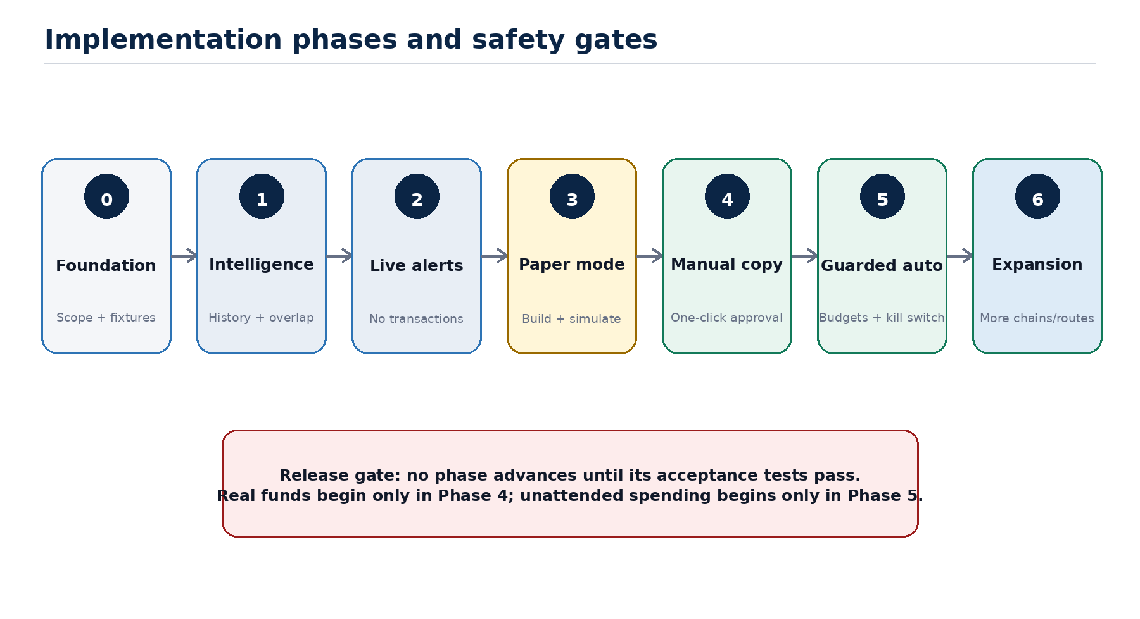
Figure 7. Each phase has an explicit safety and acceptance gate.
Phase | Deliverables | Exit criteria
0 - Foundation | Confirm chain/RPC; repository; CI; migrations; domain enums; fixture set | Architecture review passed; secrets and environments separated
1 - Intelligence | Collection registration, historical scanner, identity fields, overlap queries, reports | Known fixture counts match; resume creates no duplicates; 1/2/3 overlap scenario passes
2 - Live alerts | Block/webhook watcher, watchlist, opportunity creation, Telegram alerts | Catch-up and reorg tests pass; no signing code enabled
3 - Paper mode | Direct + SeaDrop adapters, eligibility, quote, build, simulation and policy | No keys required; negative eligibility tests pass; expected mint event verified
4 - Manual copy | Signer, one execution wallet, nonce manager, one-click approval, receipt monitor | Testnet/fork drills pass; strict caps; kill switch tested; owner approves limited production trial
5 - Guarded auto | Short-lived auto authority, multi-wallet selection, replacement policy, hard signer caps | Sustained manual history; incident drill; independent security review
6 - Expansion | More EVM chains/launchpads, pending mode research, non-EVM adapters, dashboard | Each adapter/chain has its own fixtures, finality policy and release gate

20.1 Suggested implementation order within Phase 1
- Database migrations and repository interfaces.
- Chain configuration, RPC client and deployment-block resolver.
- ERC-721 and ERC-1155 log decoder with fixture tests.
- Chunked scanner, checkpoint atomicity and job progress.
- Transaction/receipt enrichment and initial identity resolver.
- Mint classification and exclusion reason codes.
- Wallet collection aggregates and overlap endpoints.
- Telegram collection, scan, overlap and wallet commands.
- Operational metrics, backup and recovery runbook.

21 Deployment and operations

21.1 Environments
Environment | Purpose | Funds/keys
Local | Unit tests and fixture replay | No production keys; mocked signer
Development | Shared API/DB and test chain | Testnet keys only
Staging | Production-like workers, monitoring and fork drills | Dedicated minimal-value keys
Production | Approved chain and real alerts/execution | Bounded execution funds; isolated signer

21.2 Services
- bot-api: FastAPI plus aiogram webhook handlers.
- indexer-worker: historical jobs and canonicality repair.
- live-worker: new-block/provider-webhook ingestion.
- analytics-worker: aggregates, scores and watchlist updates.
- execution-worker: quote/build/simulate/policy and transaction monitoring.
- signer: private-network service with independent hard limits.
- postgres, redis and monitoring stack.

21.3 Release checklist
- Database migrations reviewed, reversible where practical and tested from empty plus prior release.
- Dependency lockfile, secret scan and vulnerability scan pass.
- All supported adapter fixtures and fork tests pass.
- Telegram authorization, replay and expiry tests pass.
- Signer caps match strategy caps and cannot be raised through bot callbacks.
- Backup is current and restore drill is within recovery objective.
- Kill switch, pause, provider failover and nonce reconciliation are exercised.
- Dashboards and alerts are active before worker rollout.

22 Definition of done
PHASE 1 DONE: A developer can add a collection on the selected EVM chain, obtain a reproducible minter dataset, see exact repeated wallets across any stored collections, and rerun or resume scans without duplicates.

PRODUCTION EXECUTION DONE: The system can recognize a supported public mint, prove current eligibility, build and simulate a fresh transaction, enforce independent application and signer limits, obtain valid approval, broadcast exactly once, and reconcile the final canonical outcome.

- All requirements have traceable tests or documented manual controls.
- All edge cases marked Critical and High have automated regression coverage where technically reproducible.
- No private key or seed phrase is present in Telegram, database exports, logs or application configuration.
- Every executed transaction has source signal, strategy version, quote, simulation, approval and receipt provenance.
- Runbooks cover provider outage, reorg, pending nonce, signer failure, database restore and security incident.
- Operator-facing messages explain why a mint is eligible, rejected or uncopyable.

Appendix A Enums and example statuses
Enum | Values
identity_mode | initiator, recipient, either
token_standard | erc721, erc1155, erc2309, custom, unknown
mint_route | direct, seadrop, launchpad, marketplace, relayer, unknown
classification | public_paid_mint, public_free_mint, allowlist_mint, token_gated_mint, server_signed_mint, admin_mint, airdrop, bridge_mint, migration_mint, lazy_marketplace_mint, unknown_mint
finality_status | provisional, safe, finalized, reorged
opportunity_decision | alert_only, paper_ready, manual_ready, auto_ready, not_copyable, expired, blocked
execution_mode | alert, paper, manual, auto
attempt_status | created, quoted, simulated, approved, signed, broadcast, pending, confirmed, failed, replaced, dropped, reorged, cancelled
severity | info, low, medium, high, critical

Appendix A.1 Suggested audit event shape
{
"audit_id": "aud_...",
"timestamp": "2026-08-05T09:00:00Z",
"actor": {"type": "telegram_user", "id": "123456789"},
"action": "execution_plan_approved",
"resource": {"type": "execution_plan", "id": "plan_..."},
"correlation_id": "corr_...",
"before": {"status": "simulated"},
"after": {"status": "approved", "expires_at": "..."},
"client": {"chat_type": "private", "update_id": 12345}
}

Appendix B References
[R1] ERC-721 Non-Fungible Token Standard: https://eips.ethereum.org/EIPS/eip-721
[R2] ERC-1155 Multi Token Standard: https://eips.ethereum.org/EIPS/eip-1155
[R3] ERC-2309 Consecutive Transfer Extension: https://eips.ethereum.org/EIPS/eip-2309
[R4] Ethereum JSON-RPC API: https://ethereum.org/developers/docs/apis/json-rpc/
[R5] web3.py Events and Logs: https://web3py.readthedocs.io/en/stable/filters.html
[R6] OpenSea SeaDrop: https://docs.opensea.io/docs/seadrop
[R7] OpenSea Seaport: https://docs.opensea.io/docs/seaport
[R8] Telegram Bot API: https://core.telegram.org/bots/api
[R9] Etherscan V2 Event Logs API: https://docs.etherscan.io/api-reference/endpoint/getlogs
DEVELOPER HANDOFF: Before coding begins, record the initial chain, RPC provider, first adapter list, hosting target and owner-defined spend limits as Architecture Decision Records.

