Faculty of

كلية هندسة الحاسوب والمعلوماتية.

قسم هندسة البرمجيات ونظم المعلومات.

Computer& Informatics & Eng.

Department of Software &

Information Systems Eng.

**Project Name:**

**Student Project Management System.**

**Prepared By:**

**Jimmy Yazji**

**Mohammed Omran Alkhaldy**

**Supervised By:**

**Dr. Mohammed Ali Mohammed**

**Academic Year:**

**2020/2021**

**SUPERVISOR CERTIFICATION**

I certify that the preparation of this project entitled “Students Project Management System”, prepared by the Students Jimmy Yazji and Omran Alkhaldy, was made under my supervision at the faculty of Computer, Information & Communication Engineering, department of Software & Information System Engineering in partial fulfillment of the Requirements for the Degree of Bachelors of Software and Information System Engineering.

Date: ………………………………………………………………………………

Name: ………………………………….. Signature: …………………..................

**Abstract**

The system aims to serve the students, staff and supervisors of the Syrian Private University with the creation and development of their senior and graduation project, assisting them with the learning process.

It provides project supervisors the ability of following up with the student’s work to facilitate the management of projects remotely

which in turn saves time and effort from students and those involved with the projects from supervisors and coordinators, in result helping the student make better projects and guiding them how to make them more efficiently by using the tools provided by the system.

**الملخص**

ويهدف النظام إلى خدمة طلاب الجامعة السورية الخاصة وموظفيها والمشرفين عليها من خلال إنشاء وتطوير مشروعهم الخاص بالرفع والتخرج، ومساعدتهم في عملية التعلم.

وهو يوفر للمشرفين على المشاريع القدرة على متابعة عمل الطالب لتيسير إدارة المشاريع عن بُعد

وهذا بدوره يوفر الوقت والجهد من جانب الطلاب ومن يشاركون في المشاريع من المشرفين والمنسقين، مما يساعد الطالب على تنفيذ مشاريع أفضل ويوجههم إلى كيفية جعلها أكثر كفاءة باستخدام الأدوات التي يوفرها النظام.

**TABLE OF CONTENTS:**

**SUPERVISOR CERTIFICATION…………………………………………….…………..…….…….…….…….…….….. 2**

**ABSTRACT……………………………………………………….…….…….…….…………....……………………………... 3**

**TABLE OF CONTENTS…………………………………………………………………….…….…….…….…….…….…… 5**

**LIST OF TABLES ………………………………...……………………………………...……….…….…….…….…….…….9**

**LIST OF FIGURES……………………………………………………………………………….…….…….…….…….…….10**

**LIST OF ABBREVIATIONS……………………………………………...………………..…….…….…….…….…….…11**

**CHAPTER 1. INTRODUCTION……………………………………………………...…...…….…….…….…….……. 12**

* 1. **About Project……………………………………………………………………….…………….…….…..12**
  2. **Problem Statement………………………………………………………………….…...…….…….... 13**
  3. **Research Aims……………………………………………………………………….…….…….…….….. 14**
  4. **Research Objectives………………………………………………….….…….…….…….…….…….. 14**
  5. **Importance of the study……………………………………………….……...…….…….…….…... 15**
  6. **Outline Methodology………………………………………………………….…….…….…….…….. 17**

**CHAPTER 2. FEASIBILITY ………………………………………………………………….…….…….…….…….……. 18**

**2.1. Who will benefit from this service? ……………………………………...…….…….……..18**

**CHAPTER 3. WORK PLAN………………………………………………….….……….…….…….…….…….………..19**

**3.1. Time Policy……………………………………………………………………….…….…….…….…………19**

**3.1.1. Default Policy…………………………….…….…….………………….…….…………….19**

**3.1.2. Actual Policy……….…….…….….………………………………….…….….….……....22**

**3.2. Operating Environment……………………………….……………..……….…….…….…….…25**

**3.3. Resources Required to Develop the Application………………………….……..….....25**

**CHAPTER 4. SOFTWARE DEVELOPMENT PHASES………...……………………...…….…….…….…….….26**

**4.1. Planning…………………………………………………………….……......…….…….…….…….…27**

**4.1.1. Requirements Collecting…………………….……………………...…….…….……..27**

**4.2. Requirements Analysis….…………………………….……….……………….………….………27**

**4.2.1. Functional Requirement……………………….…………………..…….…….……...28**

**4.2.2. Non-Functional Requirements……………………………………………….……...31**

**4.2.3. Diagrams………………………………………………………….....…….…….…….……..33**

**4.2.3.1. USE-CASE Diagram…………….…………………….…..…….…….……....33**

**4.2.3.1.1. Users and Roles Use-Case Diagram…………….…….….33**

**4.2.3.1.2. Groups Use-Case Diagram………………………….……..…35**

**4.2.3.1.3. Projects Use-Case Diagram………………………….……...37**

**4.2.3.2. Data Flow Diagram ……………………………………….…...…….……...39**

**4.2.3.2.1. Login Register User and Roles Dataflow Diagram…….…39**

**4.2.3.2.2. Groups and Projects Data Flow Diagram…………..…….….40**

**4.2.3.3. Sequence Diagram…………………………………........…….…….….....41**

**4.2.3.3.1. User Registration Sequence Diagram…….….………..……..41**

**4.2.3.3.2. User Login Sequence Diagram…………………….…….………..42**

**4.2.3.3.3. Group Creation Sequence Diagram….……………………...…..43**

**4.3. Designing……………………………………………….…………………..…….…….…….…….…...44**

**4.3.1. Database Design…………………………………………………….…….…….…….……44**

**4.3.4. User Interface Design (UI Design) …………….………………….…….………….46**

**CHAPTER 5. MARKET AND COST ANALYSIS………………………….………….…….…….…….…….……...52**

**5.1. Market Analysis…………………………………………………………….…….…….………..……52**

**5.2. Cost Analysis………………………………………….…………………..…….…….…….………....52**

**CHAPTER 6. CONCLUSION AND FUTURE WORKS.……………….…….…….…...………….………….…..53**

**6.1. Introduction………………………………………………………………………….…….…….……..53**

**6.1. Future Work……………………………………………………………..…….…….…….…….……..53**

**6.3. Conclusion…………………………………………….…………………….…….…….…….…………53**

**6.4. Recommendations…………………………………….……………….………….……...…………54**

**REFERENCES…………………………………………………….……………………………….…….…….…….…….…….57**

**LIST OF TABLES**

|  |  |  |
| --- | --- | --- |
| **Table No.** | **Description** | **Page** |
| **Table 1.3** | **Default policy** | **19** |
| **Table 2.3** | **Actual policy** | **22** |
| **Table 1.4** | **User and Role Use-Case Glossary** | **34** |
| **Table 2.4** | **Groups Use-Case Diagram** | **36** |
| **Table 3.4** | **Projects Use-Case Diagram** | **38** |
| **Table 1.5** | **Cost Analysis** | **40** |

**LIST OF FIGURES**

|  |  |  |
| --- | --- | --- |
| **Fig. No.** | **Description** | **Page** |
| **Figure 1.4** | **Users and Roles Use-Case Diagram** | **33** |
| **Figure 2.4** | **Groups Use-Case Diagram** | **35** |
| **Figure 3.4** | **Projects Use-Case Diagram** | **37** |
| **Figure** | **Login Register User and Roles Dataflow Diagram** | **39** |
| **Figure** | **Groups and Projects Data Flow Diagram** | **40** |
| **Figure** | **User Registration Sequence Diagram** | **41** |
| **Figure** | **User Login Sequence Diagram** | **42** |
| **Figure** | **Group Creation Sequence Diagram** | **42** |
| **Figure** | **Database Diagram** | **45** |

**LIST OF ABBREVIATION**

**LIST OF ABBREVIATIONS**

DFD Data Flow Diagram

ERD Entity Relationship Diagram

UI design User Interface design

SWOT Strength- Weakness- Opportunities- Threat

**CHAPTER 1: INTRODUCTION**

* 1. **About The Project:**

Our current era is known as the era of the technological revolution and the explosion of knowledge. The last decade of the twentieth century and the beginning of the twenty-first century witnessed tremendous progress in the field of information technology, and modern technological means have transformed the world into a small global village. This development was reflected in many fields, but the field that benefited greatly from it was education; Technology has helped to find many means and tools that facilitated the educational process and made it more in line with the developments of the times, the issue of the presence of technology in the field of education is inevitable, as the field of education witnessed a great boom in the late twentieth century. Public and private educational institutions competed to find and provide effective means that help the student to learn easily and provide him with the ability to be creative effectively in study and in his future work. The employment of technology in the educational process facilitates the process of communication and communication between the student and the teacher, as well as facilitating many administrative processes, such as converting some paper processes into electronic ones. This will lead to the development of administrative work, reducing paperwork, and improving services by reducing mobility. Between departments for the circulation of business between employees, and to facilitate access to information at any time and place, and this in turn will lead to an increase in the speed in the completion of work and reduce the costs of administrative work while raising the level of performance in addition to the possibility of overcoming the problem of the geographical and temporal dimensions, developing the work mechanism and keeping pace with developments. Based on this point, the project team worked on building an electronic system for managing graduation projects at the Syrian Private University, through which administrative processes such as coordination and supervision of graduation projects were automated and creating a more interactive and developed environment in line with the university’s goals and orientations towards keeping pace with development and using technology in the service of education and make it more efficient and effective.

* 1. **Problem Statement:**

In view of the technological development and the spread of the Internet and its use to significantly develop the educational and administrative method, and in line with the orientation of the Syrian Private University in integrating technology to serve teaching and learning, and what this requires of focusing on the processes of cooperation and communication between the different parties in the college, the project team thought to work on building an electronic system for managing The senior and graduation projects of the College of Administrative Sciences and Information Systems keep pace with this technological development and work to solve many problems, and to complement what the college has done in terms of pelleting and transforming many operations. The project team conducted interviews with a group of teachers, administrators and students to identify some of the problems that can be solved through this electronic system. We reached some problems facing supervisors and students in how to manage graduation projects and follow up on student projects.

**Among these problems:**

1. The project supervisor was pressured at work when there are numbers of students who need to follow up on the graduation project.

2. The difficulty of coordinating between the supervisor and the students and scheduling meetings and meetings that both parties need to complete the graduation project.

3. Difficulty in finding the idea of the project.

4. The defect in determining the dates of discussions for graduation projects, the supervisor may sometimes be surprised by the difference between the scheduled discussion date and the agreed upon date.

5. Difficulty in finding scientific and court sources and references that the student needs in completing and documenting the project.

6. Difficulty in finding certified translation sites to translate scientific papers.

* 1. **Research Aims:**

The project aims to create a system that simplify the development process of the senior and graduation projects of the Syrian Private University and make it more efficient by make it accessible remotely.

* 1. **Research Objectives:**

The project team seeks to build an electronic system that achieves the following objectives:

1. Facilitating project management electronically, which will save time and effort for students and those involved in graduation projects from supervisors and coordinators.

2. Assisting the student in finding the appropriate idea according to his specialization and inclinations, and providing the necessary consultations to start the project.

3. Enable the supervisor to present instructions and topics to help students in completing and completing the project.

4. Giving students the opportunity to evaluate each other and the opportunity for supervisors to evaluate the project team.

5. Effectiveness in communicating between students and project supervisors and following up on projects through the use of

6. Notifications that help alert students to the remaining time.

* 1. **Importance of The Project:**

The importance of a project varies according to the category you will be dealing with, so we will explain its importance to four categories of users:

**First: The importance of the project for the institution:**

Serves the university’s strategic goals in that it keeps pace with technological progress and employs it in improving educational and administrative services within the university, so that it works to raise the capabilities and efficiency of the university in providing educational and administrative services, enhancing its educational position among students and society, and increasing its competitiveness in the field of service knowledge and the educated.

**Second: The importance of the project for supervisors:**

Reducing the job burden on supervisors, facilitating the process of managing graduation projects, following up on students, providing them with the necessary directions, resources and tasks, and communicating with them in an effective and more reliable way in delivering news and updates to them.

**Third: The importance of the project for the coordinators:**

Facilitating the process of forming work teams, coordinating with their supervisor, communicating with them and reviewing the progress of work.

**Fourth: The importance of the project for students:**

To facilitate work on the graduation project efficiently and successfully. The system will provide the student with everything he needs to finish his graduation project, starting from the idea to the series of steps and rules followed in starting documentation to the sources, resources and references he needs to the date and place of discussion and even the method of presentation and submission.

**Fifth: The importance of the project for the project team:**

Completion of obtaining a bachelor’s degree in the field of information systems at the Syrian University, and the practical application of what was learned during the academic stage at the university and increasing the capacity and experience in the field of work, in addition to having a footprint in our university and being an effective and important part in this great scientific edifice.

* 1. **Outline Methodology:**

In analyzing and developing this system, the project team will follow the System Development Life Cycle (SDLC) methodology. This methodology consists of several basic stages, starting with the planning stage, then system analysis, then design, and then preparing the system. At this stage, examination, testing, maintenance and post-examination are carried out. Preparation, as this methodology contains a test for each stage before moving to the next stage, and data related to the analysis of this system will be collected through previous studies and open interviews with a number of teachers, supervisors and students within the college.

**CHAPTER 2**

**FEASIBILITY STUDY**

* 1. **Who will benefit from This Service?**

The students will be able to join groups, find project ideas and manage them in an easier way saving time and effort, Supervisors will be able to supervise projects remotely and have more regulation over the projects they supervise and the administrators will be able to do their job better and easier than before since the project will replace the regular paper forms they usually have to provide to the students and supervisors.

**CHAPTER 3**

**WORK PLAN**

* 1. **Time Policy:**
     1. **Default Policy:**

**Table 1.3 Default policy**

|  |  |  |  |  |  |
| --- | --- | --- | --- | --- | --- |
| **Phases** | **Days** | **Start day** | **End day** | **Description** | **Supervised by** |
| **1. Planning** | 5 | 14/3/2021 | 19/3/2021 | The selection and determination of the title of the project developed, determine the objectives, scope, expected results and statement of the problem. | Jimmy Yazji  Mohammed Omran Al-Khaldy |
| **2.  Requirements Analysis** | 10 | 19/3/2021 | 29/3/2021 | The literature is also analyzed to compare the existing system with similar systems. In addition, an analysis of the hardware and software requirements as well as the programming language used is also performed. | Jimmy Yazji  Mohammed Omran Al-Khaldy |

|  |  |  |  |  |  |
| --- | --- | --- | --- | --- | --- |
| **Phases** | **Days** | **Start day** | **End day** | **Description** | **Supervised by** |
| **3. Design** | 20 | 29/3/2021 | 18/4/2021 | The activity involved is a process in which the design of the system is made. The purpose of this phase is to translate the functions in the requirement specification to software components, which then produces a system that meets the quality requirements in the most effective approach. Interface and database design are available to describe entities, attributes and relationships between entities of the system. | Jimmy Yazji    Mohammed Omran Al-Khaldy |

|  |  |  |  |  |  |
| --- | --- | --- | --- | --- | --- |
| **Phases** | **Days** | **Start day** | **End day** | **Description** | **Supervised by** |
| **4. Implementation** | 30 | 18/4/2021 | 18/5/2021 | All software, hardware and application program are utilized to convert or translate the design sketched in the form of program code by using the hardware and software requirements that have been clarified. | Jimmy Yazji  Mohammed Omran Al-Khaldy |
| **5. Testing** | 20 | 18/5/2021 | 8/6/2021 | The proposed system where a user must test to ensure the system is free of error and can function according to user requirements. This phase involves testing the primary functions of the customer and administrator side. | Jimmy Yazji  Mohammed Omran Al-Khaldy |

* + 1. **Actual Policy:**

**Table 2.3 Actual policy**

|  |  |  |  |  |  |
| --- | --- | --- | --- | --- | --- |
| **Phases** | **Days** | **Start day** | **End day** | **Description** | **Supervised by** |
| **1.  Planning** | 5 | 14/3/2021 | 19/3/2021 | The selection and determination of the title of the project developed, determine the objectives, scope, expected results and statement of the problem. | Jimmy Yazji  Mohammed Omran Al-Khaldy |
| **2.  Requirements’**  **Analysis** | 15 | 19/3/2021 | 3/4/2021 | The literature is also analyzed to compare the existing system with similar systems. Also, an analysis of the hardware and software requirements as well as the programming language used is also performed. | Jimmy Yazji  Mohammed Omran Al-Khaldy |

|  |  |  |  |  |  |
| --- | --- | --- | --- | --- | --- |
| **Phases** | **Days** | **Start day** | **End day** | **Description** | **Supervised by** |
| **3.  Design** | 25 | 3/4/2021 | 28/4/2021 | The activity involved is a process in which the design of the system is made. The purpose of this phase is to translate the functions in the requirement specification to software components, which then produces a system that meets the quality requirements in the most effective approach. Interface and database design are available to describe entities. | Jimmy Yazji  Mohammed Omran Al-Khaldy |

|  |  |  |  |  |  |
| --- | --- | --- | --- | --- | --- |
| **Phases** | **Days** | **Start day** | **End day** | **Description** | **Supervised by** |
| **4. Implementation** | 60 | 28/4/2021 | 27/6/2021 | All software, hardware and application program are utilized to convert or translate the design sketched in the form of program code by using the hardware and software requirements that have been clarified. | Jimmy Yazji  Mohammed Omran Al-Khaldy |

|  |  |  |  |  |  |
| --- | --- | --- | --- | --- | --- |
| **Phases** | **Days** | **Start day** | **End day** | **Description** | **Supervised by** |
| **5. Testing** | 15 | 27/6/2021 | 12/7/2021 | The proposed system where a user must test to ensure the system is free of error and can function according to user requirements. This phase involves testing the primary functions of the customer and administrator side. | Jimmy Yazji  Mohammed Omran Al-Khaldy |

* 1. **Operating Environment:**

**Server Side:**

* **Processor:** Intel® Xeon® processor 3500 series
* **HDD:** Minimum 500GB Disk Space
* **RAM:** Minimum 16GB
* **OS:** Windows 8.1, Linux
* **Database:** MySQL
* **Application:** PHP, MySQL Server

**Client Side (Minimum Requirement):**

* **Processor:** Intel Core 2 Duo or later
* **HDD:** Minimum 2GB Disk Space
* **RAM:** Minimum 1GB
* **Application:** Any Browser
  1. **Resources required to develop the application [4] [5] [26]**

**Hardware Resources:**

* **OS**: Window 7 or later
* **Memory**: 4 GB or more
* **Storage**: 20 GB or more
* **Processor**: 2.0 GHZ: Intel core i3 or later

**Software Resources:**

* **Programming Language**: PHP, HTML5, CSS, JavaScript
* **Framework:** Laravel, TailwindCSS
* **Database:** MySQL
* **Application:** Any Text Editor, MySQL Workbench, Node JS

**CHAPTER 4**

**SOFTWARE DEVELOPMENT PHASES**

* 1. **Planning**

Among the activities involved in this phase is the selection and determination of the title of the project developed, determine the objectives, scope, expected results and statement of the problem. Opinion questionnaire is also conducted with some of the customers about SPMS’s application. From Opinion questionnaire and the requirements interview from the project supervisor the objectives and scope of the project are identified. All the activities involved in the project development process is structured and designed in accordance with the scheduling and planning phase.

* + 1. **Requirement’s Collection**

This study was aimed to evaluate student’s satisfaction using web-app based project management service in the Syrian Private University. Both data primary and secondary were gathered through opinion questionnaire and supervisor interview whom is the owner in this case.

Data was analyzed through correlation and regression models to derive valid information about the project management service.

* 1. **Requirement’s Analysis**

In this phase, there are several factors that need to be analyzed such as all information or data gathered. The literature is also analyzed to compare the existing system with similar systems. In addition, an analysis of the hardware and software requirements as well as the programming language used is also performed.

Requirement analysis is a software engineering technique that is composed of the various tasks that determine the needs or conditions that are to be met for a new or altered product, taking into consideration the possible conflicting requirements of the various users.

* + 1. **Functional Requirements:**

Functional requirements are those requirements that are used to illustrate the internal

working nature of the system, the description of the system, and explanation of each

subsystem. It consists of what task the system should perform, the processes involved,

which data should the system hold and the interfaces with the user? The functional

requirements identified are:

1. **Registration:**

* The system should provide a way for users to create their own account.
* The system should notify the administrators of a creation of a new account.
* New registered account shouldn’t have full access to the functionality of the system we handle that by giving roles (more on that later).

1. **Login:**

* The system should allow the users to login by their email and passwords (possibly college’s serial number).
* The system shall allow customer to change account password.
* The system should allow customer to logout.
* The system should help in-case the user forgot their password by allowing them to change it after verifying their ownership of the account by accessing their email.

1. **Profile:**

* The system shall allow users to view their profile to see how it looks from other perspective.
* The system should allow users to edit their information (name, email, password, avatar).

1. **Users:**

* The system shall allow specific users to access the list of users to view, edit or delete their accounts based on their role for the purpose of administration.
* The users should be able to search through the list of users using their name, serial number or email.
* The system should allow the creation of a new account through administrators.

1. **Roles:**

* The system should allow administrators to access the list of role that can be given to users.
* The system shall allow searching for the roles based on their name.
* The system should allow editing the roles for a massive change in permissions.
* The system must have an admin role by default.

1. **Groups:**

* The system should allow users to view the list of all groups.
* The system should allow users to search groups by its id or members.
* The system should allow users to send group join requests.
* The system shall send notifications when a user sends a group join request to all group members.
* The system should allow group members to browse through group requests and accept or reject them.
* The system should allow the cancelation of a group join request.
* The system should notify the group request sender of the acceptance of their group request.
* The system should allow users to leave groups and delete empty groups.
* The system should allow the group members to manage their group info and status.

1. **Projects:**

* The system should allow users to create a new project idea based on their role.
* The system should allow only the supervisors to supervise projects.
* The system should allow users to browse through the list of projects.
* The system should allow users to search the projects by its name.
* The system should allow specific users to edit or delete projects based on their role.
* The system should provide a file system for the storage of the project files.
* The system should provide a way of commenting on specific files or on the project.
* The system should notify supervisors of the assignation of a group of their supervised project and notify group members when there is a new file in their project storage or a new comment on the files or project.
  + 1. **Non-Functional Requirements:**

It describes aspects of the system that are concerned with how the system provides the

functional requirements. They are:

1. **Security:**

The system should provide a high level of security and integrity of the data held by the system, only authorized personnel of the company can gain access to the company’s secured page on the system; and only users with valid password and username can login to view pages.

1. **Performance and Response time:**

The system should have high performance rate when executing user’s input and should be able to provide feedback or response within a short time span usually 15 seconds for highly complicated task and 2 to 10 seconds for less complicated task.

1. **Error handling:**

Error should be considerably minimized and an appropriate error message that guides the user to recover from an error should be provided. Validation of user’s input is highly essential. Also, the standard time taken to recover from an error should be 2 to 5 seconds.

1. **Availability:**

This system should always be available for access at 24 hours, 7 days a week.

1. **Ease of use:**

Considered that this project should make the creation process of projects easier, a simple but quality user interface should be developed to make it easy to understand and require none to very few training.

1. **Usability:**

The system should be responsive (should provide deferent pages for deferent platform used to access it).

1. **Quality:**

* Maintain a user-friendly environment that is visually appealing.
* Easy on the eyes (text size and fonts).
* Maintain readable content.
  + 1. **Diagrams:**
       1. **Use-Case Diagrams:**
          1. **Users and Roles Use-Case Diagram:**

**Figure 1.4 User and Roles Use-Case Diagram**

**Table 1.4 User and Role Use-Case Glossary**

|  |  |  |
| --- | --- | --- |
| Use-Case Name | Use-Case Description | Participating Actors and Roles |
| Register | This use-case classifies the event of a potential user (a student or a supervisor) submitting a registration form this includes logging-in of the registered user. | * Potential User (primary business) * Administrator (primary business) |
| Login | This use-case classifies the event of a user logging in starting a new session | * System User (primary business) |
| Logout | This use-case classifies the event of a user logging out closing the current session | * System User (primary business) |
| Reset Password | This use-case classifies the even of a user requesting a password reset incase the forgot their current one | * System User (primary business) |
| Create User | This use-case classifies the event of an administrator creating a new user instead of the user registering themselves. | * Administrator (primary business) * Potential User (primary business) |
| Notify Administrator | This use-case classifies the event of sending a notification to the administrator. | * Administrator (primary business) |
| View Dashboard | This use-case describes the only permission that is given to a newly registered user after registration. | * User (primary business) |
| Edit Profile | This use-case classifies the event of a user changing their account data. | * System User (primary business) |
| Edit User | This use-case classifies the event of an administrator editing some user’s data includes assigning roles. | * Administrator (primary business) |
| Delete User | This use-case classifies the event of an administrator deleting some user’s account. | * Administrator (primary business) |
| Assign Roles | This use-case classifies the event of an administrator giving a role to a user giving them more permissions to the features of the system | * Administrator (primary business) |
| Submit User Inquiry | This use-case classifies the event of an administrator (anyone with the permission) to browse through the list of users. | * Administrator (primary business) |
| Create Role | This use-case classifies the event of an administrator adding a new role specifying its name and permissions | * Administrator (primary business) |
| Edit Role | This use-case classifies the event of an administrator editing a role’s name or permissions | * Administrator (primary business) |

* + - * 1. **Groups Use-Case Diagram:**

**Figure 2.4 Groups Use-Case Diagram**

**Table 2.4 Groups Use-Case Glossary**

|  |  |  |
| --- | --- | --- |
| Use-Case Name | Use-Case Description | Participating Actors and Roles |
| Create Group | This use-case classifies the event of a registered student establishing a new group in the system | * Student (primary business) |
| Submit Group Join Request | This use-case classifies the event of a registered student requesting to join an already existent group created by another student | * Student (primary business) |
| Cancel Group Join Request | This use-case classifies the event of a registered student canceling their request join a group created by another student | * Student (primary business) |
| Edit Group | This use-case classifies the event of a group member or an admin submitting changes to their group. | * Group Member (primary business) * Administrator (primary business) |
| Manage Group Requests | This use-case classifies the event of a group member accepting a join request or rejecting it. | * Administrator (primary business) * Group Member (primary business) |
| Submit Group inquiry | This use-case classifies the event of student or an administrator viewing groups. | * Administrator (primary business) * Group Member (primary business) |
| Leave Group | This use-case classifies the event of a group member leaving a group they’ve joined previously (includes deleting the group if its empty after leaving). | * Group member (primary business) |
| Delete Group | This use-case classifies the even of a n administrator deleting a group. | * Administrator (primary business) |

* + - * 1. **Projects Use-Case Diagram:**

**Figure 3.4 Projects Use-Case Diagram**

**Table 3.4 Projects Use-Case Diagram**

|  |  |  |
| --- | --- | --- |
| Use-Case Name | Use-Case Description | Participating Actors and Roles |
| Create New Project | This use-case classifies the event of a group member supervisor or an administrator adding a new project to the system | * Group Member (primary business) * Supervisor (primary business) * Administrator (primary business) |
| Submit Project Inquiry | This use-case classifies the event of a group member supervisor or an administrator viewing projects. | * Group Member (primary business) * Supervisor (primary business) * Administrator (primary business) |
| Assign Group to project | This use-case classifies the event of a group member or an administrator assigning a group to a project. | * Group Member (primary business) * Administrator (primary business) |
| Unassign Group to project | This use-case classifies the event of group member or an administrator unassigninga group assigned to a project. | * Group Member (primary business) * Administrator (primary business) |
| Delete Project | This use-case classifies the event of a supervisor or an administrator deleting a project (has to be theirs for a supervisor to be able to delete it). | * Supervisor (primary business) * Administrator (primary business) |
| Upload file | This use-case classifies the event of a group member supervisor or an administrator adding a file to a project storage | * Group Member (primary business) * Supervisor (primary business) * Administrator (primary business) |
| Notify of New File | This use-case classifies the event of the system sending a notification to the group members and the supervisor of a project notifying them of a new file. | * Group Member (primary business) * Supervisor (primary business) |
| Add New Comment | This use-case classifies the event of a group member supervisor or an administrator adding a comment on a project or a file uploaded to a storage of a project. | * Group Member (primary business) * Supervisor (primary business) * Administrator (primary business) |
| Notify New Comment | This use-case classifies the event of the system sending a notification to the group members and a supervisor of a project notifying them of a new comment. | * Group Member (primary business) * Supervisor (primary business) |

* + - 1. **Data Flow Diagram:**
         1. **Login Register User and Roles Dataflow Diagram:**

**Figure 1.3 Login Register User and Roles Dataflow Diagram**

* + - * 1. **Groups and Projects Data Flow Diagram:**

**Figure 1.4 Groups Data Flow Diagram**

* + - 1. **Sequence Diagrams:**
         1. **User Registration Sequence Diagram:**

**Figure 1.5 User Registration Sequence Diagram** 

* + - * 1. **User Login Sequence Diagram:**

**Figure 1.6 User Login Sequence Diagram** 

* + - * 1. **Group Creation Sequence Diagram**

**Figure 1.6 Group Creation Sequence Diagram** 

* 1. **Designing:**

During the design phase, the activity involved is a process in which the design of the system is made. Design phase produces an outline of the real system. This phase involves defining the system architecture to show how the system works.

 The purpose of this phase is to translate the functions in the requirement specification to software components, which then produces a system that meets the quality requirements in the most effective approach. Interface and database design are available to describe entities, attributes and relationships between entities of the system.

 Two types of designs are database design and interface design will be made in this this phase. Database design shows the type of data stored in the system database. While the interface design also serves to indicate the inclusion of data input and display output to the user. This phase also involves Entity Relationship Diagram (ERD) is used to describe the flow and storage of data for the proposed system and class diagram.

* + 1. **Database Design:**

Using Laravel the database creation is an easy task since the tables are variables stored in Laravel and migrated to most types of databases.

In the development phase the database used is MySQL as it is the best choice for testing.

**Figure 1.7 Database Diagram** 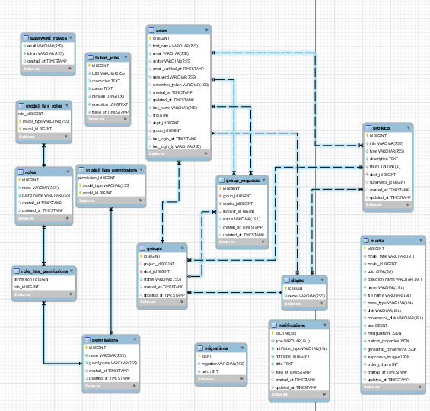

* + 1. **User Interface Design UI Design:**

The main feature of any software application infrastructure relies on the ‘ease’ of use of the system providing a simple yet effective UI for the user.

The design of the system is a user interface design that lets users interact with the system.

 The importance of system interfaces is to enable users to easily and quickly interact with the system and its features. Interfaces for Student Project Management System was designed based on the needs and requirements of users of the system who will use the system. Users have to log in prior to the next page.

**GETTING STARTED:**

1. Head to the website’s link using any browser.
2. You’ll find yourself in the landing page, select “Register”

You’ll them be asked to provide an email, your college serial number, first name, last name department and a password.

1. Fill in the information required (everything is mandatory except for the serial number if you’re not a student) and click on “Register” to complete your registration.
2. Once registration is complete you’ll be logged in to the system and you’ll receive a flash message notifying you of the successful registration.

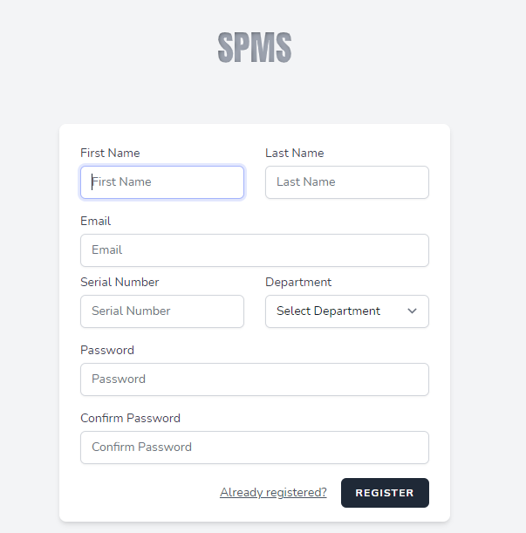

Alternatively,

You might have you account already created and provided by an administrator in this case all you have do is to click on the “Login” button from the landing page this will take you to the login page where you have to enter your email address and password select remember me if you wish to stay logged in on the device used to log in.

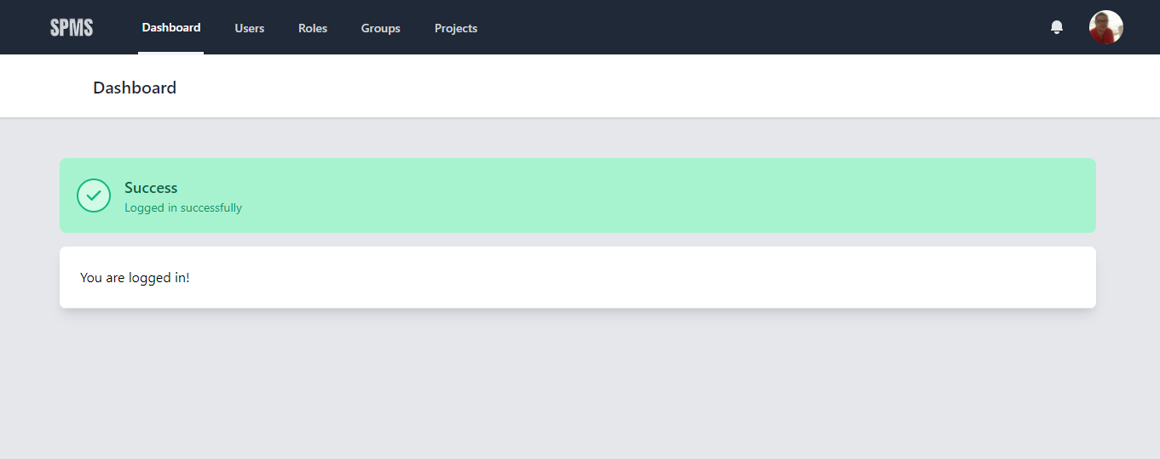

Now it’s time for you to wait for an administrator to login and add the required role to provide you with the services you need.

But in the meanwhile, you can edit your info or add a profile picture by clicking on your avatar picture from the navigation bar then click on your name and select edit profile.

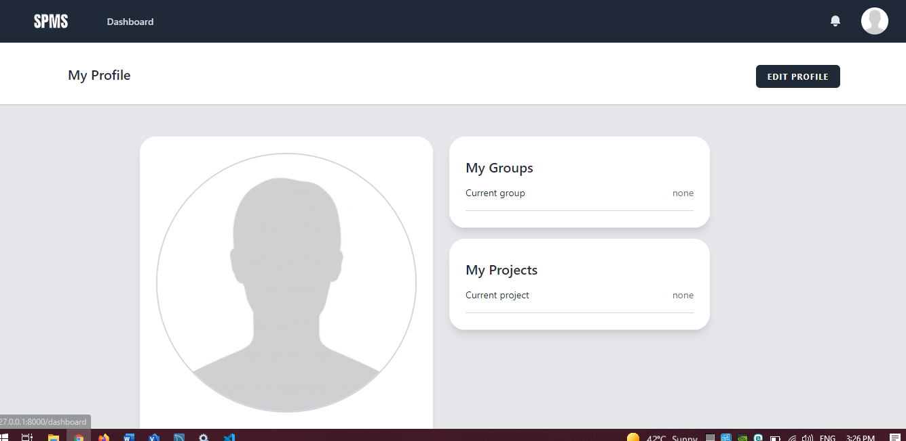

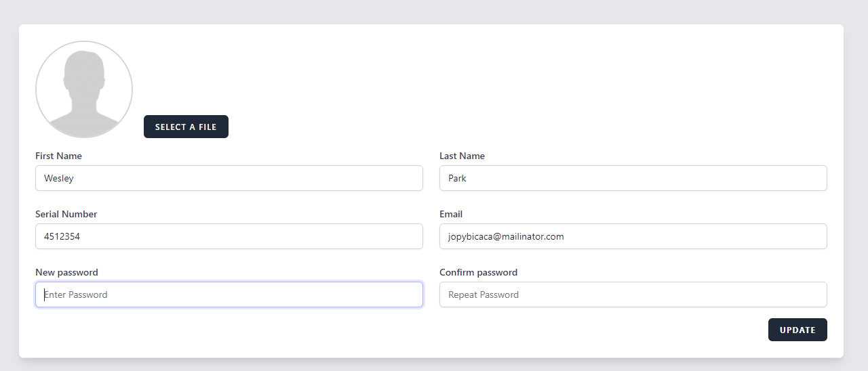

**GROUP CREATION:**

Now that you have the student role you want to create a group for you and your colleagues to join. You can do that by clicking on the groups panel from the navigation bar and selecting create project.

This will redirect you to the group creation form page which you will have to fill the info required, select members you wish to join you (this will send a group invitation) and select a project if you’re already decided on one.

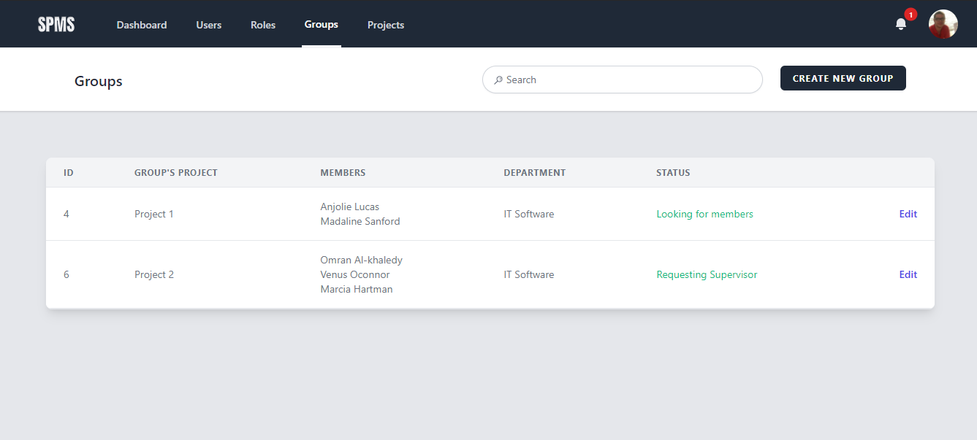

Alternatively,

Your colleagues might have already created a group and you wish to join them. You can do that by searching their group number or your colleague’s name from the header search bar then click on their group number you’ll be redirected to a new page showing the group details, all you have to do here is click on the send request and wait for a response from any group member.

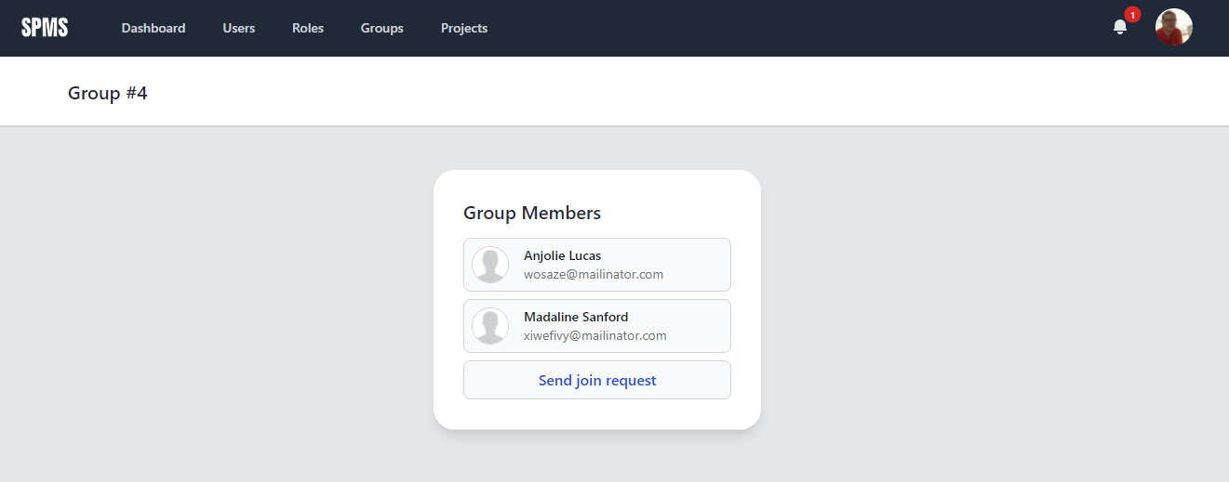

**PROJECT CREATION:**

After you successfully form your group now you want to create a project idea or assign your group to one. You can do that obviously by clicking on the projects tab from the nav bar, then either selecting create a new project, or by finding a project you like from the list shown in the page.

Fill out the form and click create or click assign and you’re all done you’ve successfully created your project.

You can also use the search bar to search for the project by its name or it’s supervisor name.

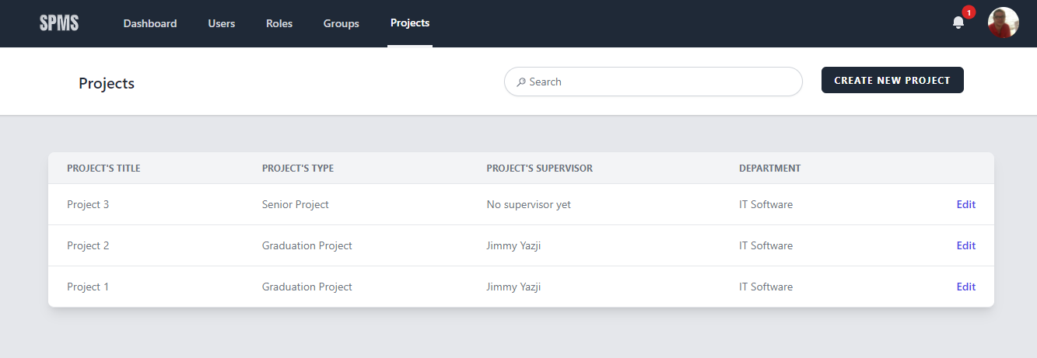

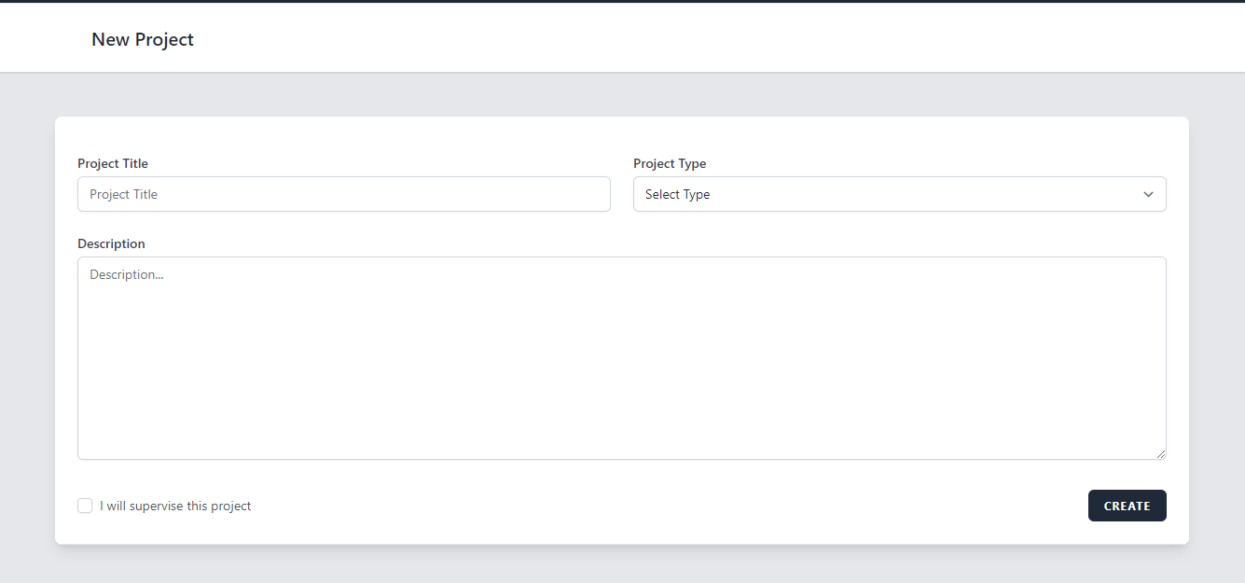

If you’re a supervisor creating a project you’ll find a checkbox with the name of “I will supervise this project” which allows you to decide whether you want to supervise the project you just added.

**CHAPTER 5**

**MARKET AND COST ANALYSIS**

* 1. **Market Analysis:**

There was no market analysis required since the project is academic and made to be used in the Syrian Private University.

* 1. **Cost Analysis**

The cost analysis is not required since the project was made completely free for academic purposes but was a cost analysis table was created anyway to show how much the project would’ve cost if it was made for commercial purposes.

**Table 1.5 Cost Analysis**

|  |  |  |  |  |  |
| --- | --- | --- | --- | --- | --- |
| **Phase** | **Team** | **Hours of work** | **Cost of Hour** | **Additional Cost** | **Total** |
| **Planning** | 2 | 15 | 1400 | Transportation fees: 5000 | 26000 |
| **Requirements**  **Analysis** | 2 | 45 | 15000 | - | 675000 |
| **Designing** | 2 | 75 | 30000 | - | 2250000 |
| **Implementation** | 2 | 180 | 15000 | - | 2700000 |
| **Testing** | 2 | 45 | 4000 | - | 180000 |
| **Total Cost: 5831000 SP** | | | | | |

**CHAPTER 6**

**CONCLUSION AND FUTURE WORKS**

* 1. **Introduction:**

After completing the design and analysis of the system (Students Project Management System for the Syrian Private University), the work team reached several conclusions, and developed a set of future development ideas for the system, which are as follows:

* 1. **Future Work:**

1. Adding the feature to archive graduate students so that their records are archived to another database.
2. Building a mobile application and link it to the system.
3. Adding the ability to confirm login through mobile messages (2-step verification).
4. Add an internal social network system for university students and employees.
5. Automate the office interviews by adding a video call conferences feature with the ability to make conferences appointments.

* 1. **Conclusion:**

In light of the results that were reached after the development process of the Students Project Management System for the Syrian Private University, the following was concluded:

The system was able to achieve the goals for which it was built, as the system works on managing projects for students electronically, automating previous projects, and facilitating communication between the supervisor and the student Thus, the system saves a lot of time and effort for users and contributes to the development of administrative processes in the college.

The system provides electronic resources for senior and graduation projects and makes it easier for students to follow up on the tasks assigned by the project supervisor through notifications within the system. The system also helps supervisors in the process of managing graduation projects, facilitating communication with the student, providing access to projects at any time, remote follow-up, and the ability to communicate via e-mails. Thus, the system helps eases the process of communication and interaction between students and the supervisor by providing many services on the site. And one educational environment, keeping pace with development and technological progress and employing it in the university and educational services.

* 1. **Recommendations:**

Based on the findings, the project team developed a set of recommendations, as follows:

1. Forming a specialized committee to fully examine and test the system, and then implement the system within the Syrian Private University
2. Dissemination of the graduation project management system to all faculties at the Syrian Private University.
3. Encouraging the use of the system and introducing users to the method of use and introducing them to the benefits and features of the system because the system is similar to systems that will be required in their career.

**References**

* Whitten, Jeffrey L., and Lonnie D. Bentley. *Systems Analysis and Design Methods*. 2007.
* Matt S. Laravel: Up & Running, 2nd Edition. 2019.
* Arda K., H. Ibrahim Y. Laravel Design Patterns and Best Practices. 2014.