**Build options:**

Enable compiler cache

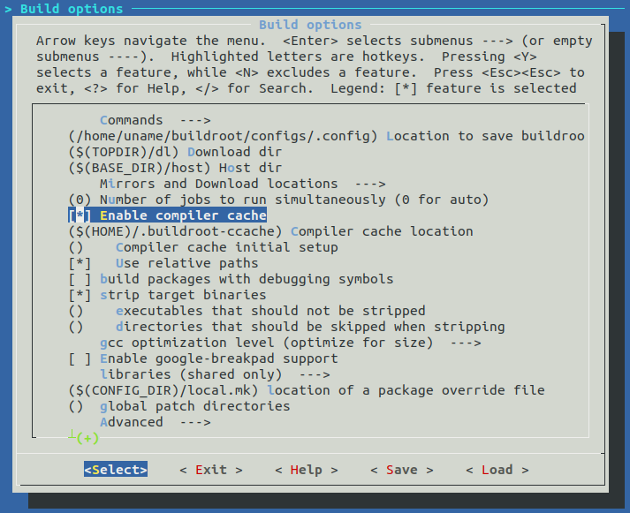

**Toolchain**:

C library --> glibc

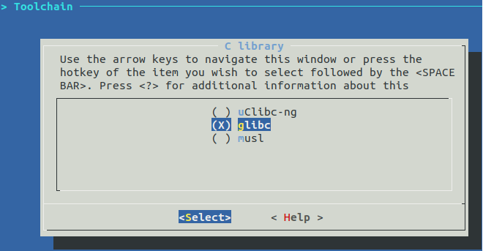

**System configuration:**

Enable root login with password -->12345

Custom scripts to run before creating filesystem images --> ~/buildroot/postBuild/post-build.sh

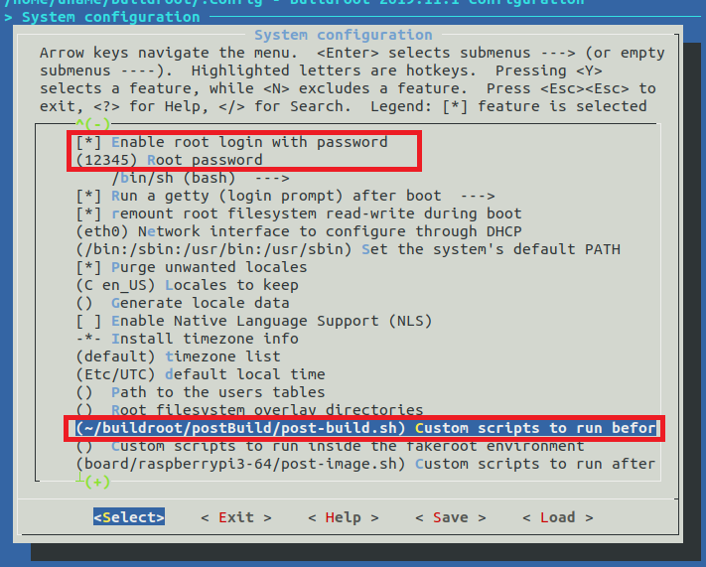

**Target** **Packages**:

Audio and Video applications --> alsa-utils, aumix, bluez-alsa {select all}, espeak

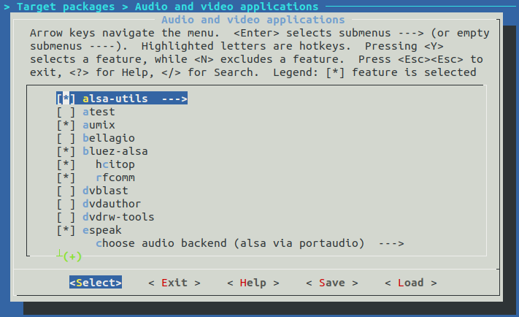

Audio and Video applications --> alsa-utils --> {alsaconf , alsactl, alsamixer, amixer, aplay/arecord}

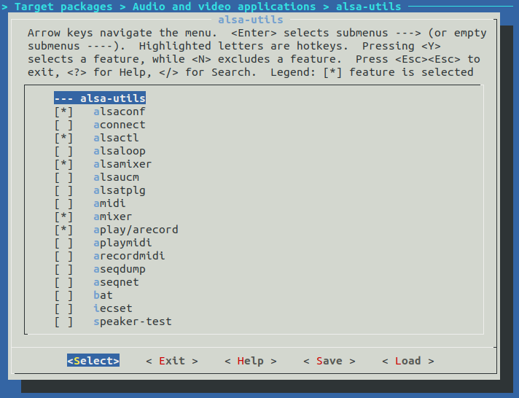

Audio and Video applications --> espeak --> choose audio backend --> alsa via portaudio

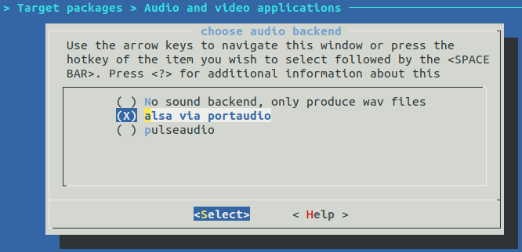

Audio and Video applications --> mpg123, pulseaudio {start as a system daemon}

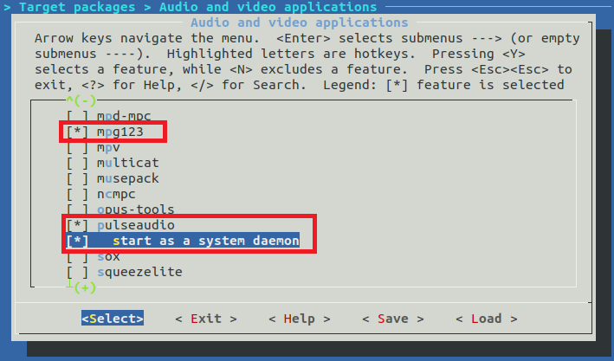

Hardware handling --> Firmware --> rpi-bt-firmware, rpi-wifi-firmware

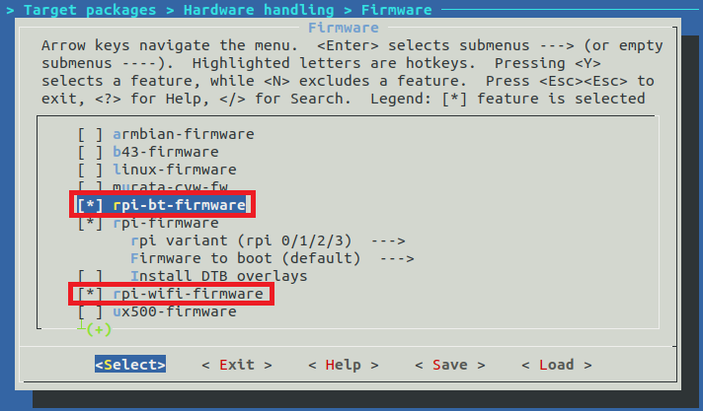

Libraries --> Audio/Sound --> alsa-lib --> select all

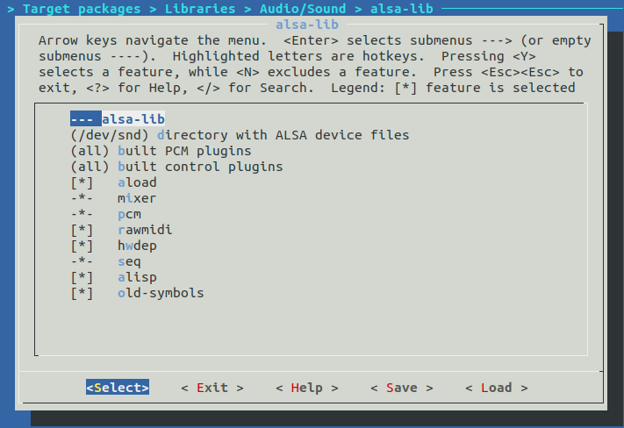

Libraries --> Audio/Sound --> bcg729, libid3tag, libmad {Architecture-specific optimizations}, libsndfile,  
 portaudio {alsa support, C++ bindings}, speex

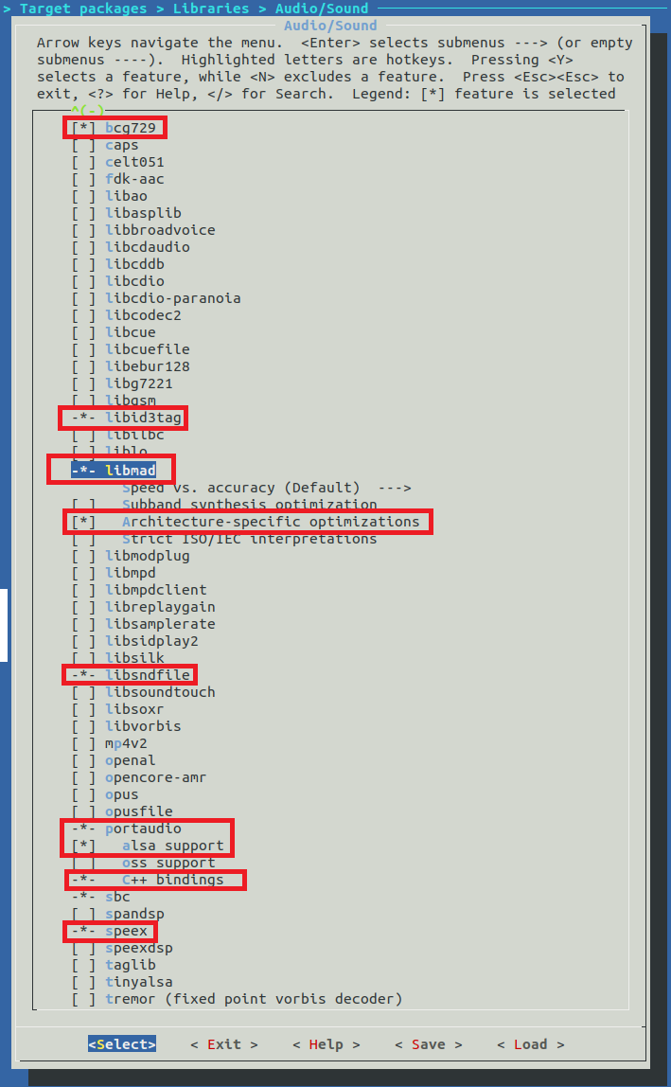

Networking applications --> bluez-tools, bluez-utils 5.x {select all}, ifupdown scripts, openssh,   
 wpa_supplicant {Enable nl80211 support, Enable autoscan}

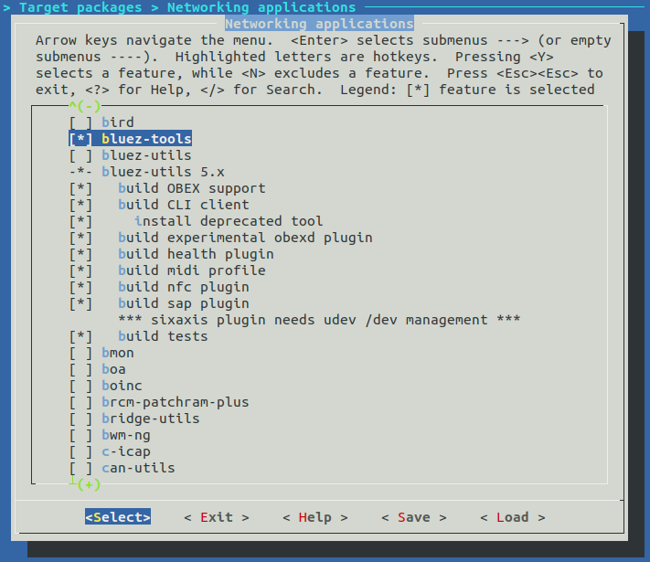

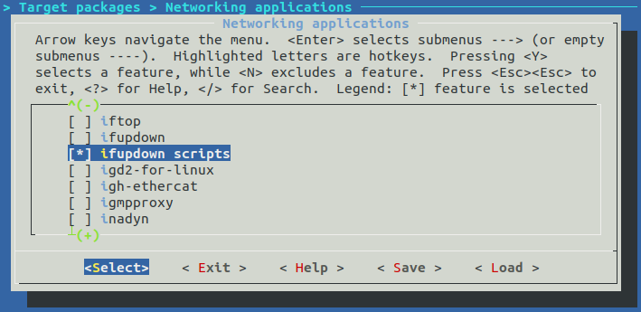

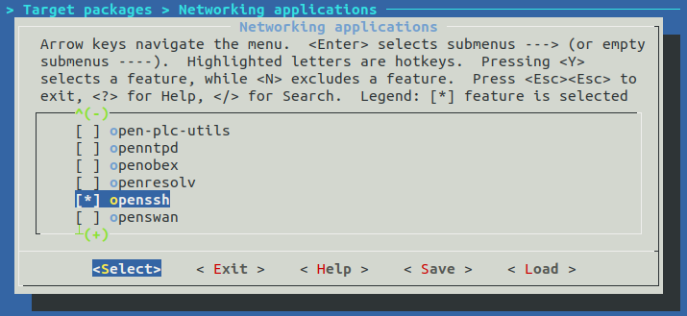

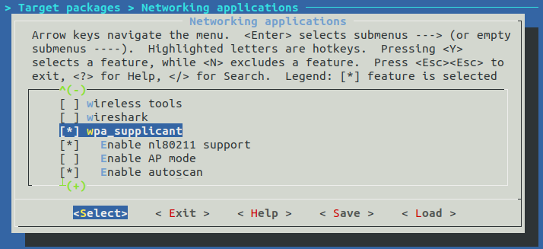

Shell and utilities --> sudo

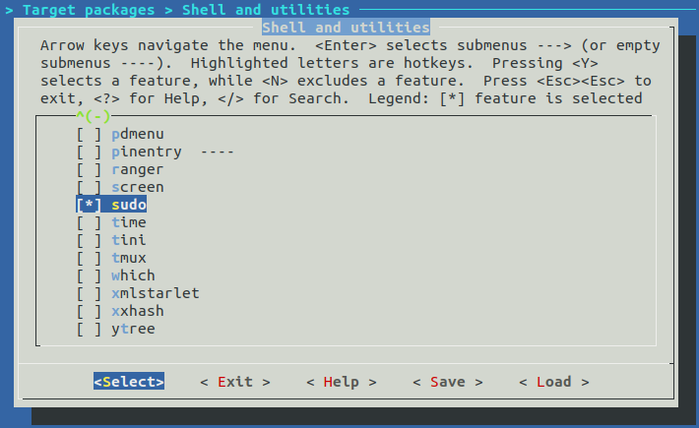

System tools --> util-linux -> wall, write

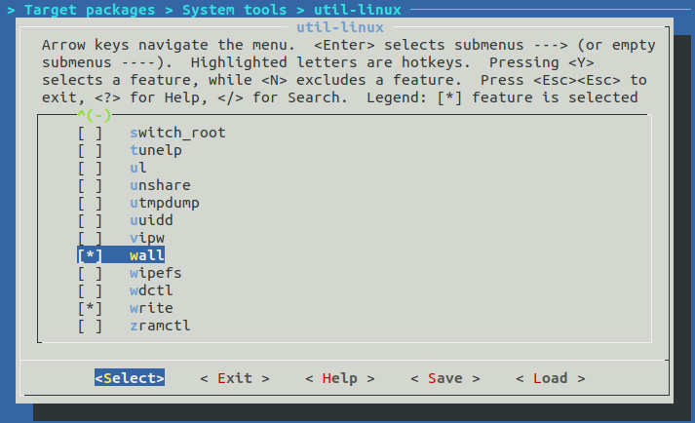

**Filesystem images**

exact size --> 300M

