Automated Detection of White Blood Cells (Leukocytes) in Digital Microscopic Image

Dr. Omar Ahmad, Muhammad Haris Irfan, Syed Hassnain Kazmi, Abdul Ahad

***Abstract*-- White blood cells that are also known as Leukocytes are very significant in defending the human body against several bacterial and viral infections. Identification of different kinds of white blood cells can assist in gathering valuable information for the diagnosis and treatment of different kinds of infections. So, an automated system can be designed to identify different kinds of white blood cells based on the features of their appearance e.g., color, geometric shape etc. Such a system can not only make the whole process fast and cost efficient but will also minimize the chances of human error. This study will be entirely focused on identifying different kinds of white blood cells and estimate their count in a sample microscopic blood smear image. Different image processing techniques will be used on publicly available datasets with expert marked ground-truths.**

**The desired outcome will be the comparison of efficacy and shortcomings of each of these methods for the leukocyte identification and enumeration. Also, the to make appropriate changes in different subsections and tuning parameters of the proposed method and analyze the effect of change and ultimately to improve the performance measures of overall method**.

* 1. INTRODUCTION

Blood is the most essential fluid of human body as it constitutes almost 8% of the total human body’s weight. Blood has many components from which Red Blood Cells, White Blood Cells and Platelets are major components. White Blood cells contain nucleus and cytoplasm which can be distributed into four major categories basophils, monocytes, lymphocytes and neutrophils. Since White blood cells are major part of Immune system so, collecting quantitative and qualitive information about White Blood Cells can help pathologists in detecting and diagnosing several diseases.

It’s a difficult and time and effort consuming process to manually identify and count the white blood cells in microscope. So, there is a vital space for an automated system that identify different kinds of white blood cells based on their features of their appearance e.g., color, geometric shape, etc. This project will be entirely focused on identifying different kinds of white blood cells and estimate their count in a sample microscopic blood smear image. Segmentation has always been remained the major step in microscopic image analysis.

This project focusses more on the pre-processing techniques used to improve the overall contrast of image before segmentation. Objective for this project would be to change the methods and parameters of existing methods to analyze the effect of change and then setting those parameters to achieve maximum possible results. Then different image processing techniques are used on publicly available datasets with expert marked ground-truths. The desired outcome will be the comparison of the efficacy and shortcomings of each of these methods for leukocyte identification and enumeration.

A white blood cell count has a great significance in medical field as it can provide important information regarding the hidden infections within the human body that can be used to alert doctors to undiagnosed medical conditions, such as autoimmune diseases, immune deficiencies, and blood disorders. It can also help doctors in monitoring the effectiveness of chemotherapy or radiation treatment in cancer patients.

.

* 1. LITRERATURE REVIEW:

Hedge [6] suggested that blend of arithmetical and morphological tasks with dynamic form can section cores even if there should arise an occurrence of brightening varieties and revealed normal dice score of 0.965. For mechanization of WBCs cores discovery, a ton of endeavors have been made, yet at the same time there is a need of hearty and more exact technique which can likewise deal with power varieties.

Wang [7] proposed leukocyte cores division in view of part contrast in GGB variety space by switching pictures from RGB over completely to GGB. B-G values sectioned the cores and platelets and platelets are prohibited by applying limit.

Ongun [8] set forward division calculation in view of dynamic form models (snakes and inflatables) and utilized shape and morphological administrators. for the arrangement of WBCs. The calculation was made utilizing the investigations of twelve classes of WBCs. Prinyakupt [9] divided WBC by contrasting straight promotion innocent Bayes classifier and got dice likeness of around 0.98 and 0.91 and rectification pace of around 98% and 94% in division, individually.

pick up an object and if there is any external communication is required to direct the robots. Furthermore, they illustrated the importance of explicit communication, planning, and global control for making the coordinating robots more useful and efficient in moving objects.

Li [10] suggested double edge strategy for WBC division which is blend of math activities alongside middle channels and the precision of proposed calculation was 97.85%. HSV variety portrayal close by and XOR consistent activities to section leukocyte and detailed precision was 97.7% for 10 pictures. Chu [11] proposed a technique for the divisions of WBCs with Dice Score of 0.95, Sensitivity of 0.93 and FPR of 0.0009.

In 2009, Sadeghian et al. [12] set forward a division calculation to portion WBCs as well as their cores and a division method to isolate the cytoplasm of the WBCs cell. His structure to section WBC is isolated into two sections. Right off the bat, Nucleus Segmentation-Based on morphological examination gives 92% precision while Cytoplasm Segmentation-Based on pixel-force thresholding giving 70% exactness.

His strategy incorporates a red, green, and blue (RGB) picture changed over completely to dark picture then vigilant edge discovery is applied trailed by inclination vector stream to associate the limit of the core then an opening filling procedure is applied to continually get the core. Additionally, Zack calculation is likewise applied into the dim picture to get the twofold picture to remove the cytoplasm of the cell by taking away the double picture from the dark picture.

Kose [13] Blood issue is thought of as generally perilous among sicknesses which can prompt passing. A large number of these blood illnesses are related with white platelets. White platelets give insusceptibility against infections by gulping the unfamiliar bodies and creating antibodies. Andrade [14] thought about various leukocyte division techniques and showed two strategies which gave most noteworthy division exactness of 97% however sectioned just 58.44% pictures.

In 2015 Madhloom et al. [15] proposed a division procedure to fragment WBCs and their core. The propose of the calculation was to mechanize the course of discovery and characterization of leukocytes. In particular, the white platelets are perceived and characterized into different unmistakable subtypes. The alteration was done to diminish reliance on the picture starting differentiation. This difference reliance prompts the distinguish every one of the components that have a similar dim level as of the WBCs

Deshmukh [18] fragmented cores by utilizing the blend of math activities, SVM (Support Vector Machine) classifier and K-implies bunching. Ramoser et al. [19] proposed a completely computerized approach for division of leukocyte that is vigorous concerning cell appearance and picture resolution. Nucleus and Cytoplasm characteristics are addressed by a bunch of highlights and pairwise SVM grouping separates between various cell types. Assessment on 1166 pictures (13 classes) brought about 95% right divisions and 75% to almost 100% right characterization.

* 1. METHODOLOGY

## 3.1- Flow Chart

## 3.2 Proposed algorithm steps

## The blood image is processed as follows:

## Convert the color domain of input image A from RGB to CMYK (Cyan Magenta Yellow Black).

## Extract the C component from CMYK image into image B

## 3) Adjust the gray scale image, B, intensity values with a

## linear contrast stretching to get image L.

## 3) Enhance the contrast of the gray scale image, B, using

## histogram equalization to get image H.

## 4) Obtain the image R3= 2*L+H.

## 5) Implement, seven times, 2-by-2 minimums filter on the

## image R3.

## 6) Calculate a global threshold value using Otsu’s

## method.

## 7) Convert R3 to binary image using the threshold from step 8.

## 8) Use morphological opening to remove small pixel groups. Use a disk structuring element with a radius of 9 pixels

## pixels.

## 11) Use morphological closing to smooth the edges of detected cell. Use a disk structuring element with a radius of 12 pixels

## 12) Apply the size test to remove all objects that are less

than 50% of average RBC area.

Figure 5: High Level Block Diagram of Single Robot

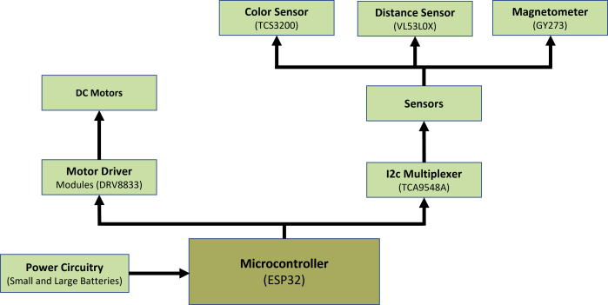

Figure 6: Detailed Block Diagram of Single Robot after Component Selection

Ccertain factors were taken into consideration:

* Cost of the product.
* Size of the product.
* Availability of the components.
* Efficiency and effectiveness of the product.

These factors were considered in order to obtain the end- product utilizing minimum resources along with minimal cost.

## 3.1.1-Hardware Designing:

The following flow chart shows the step-by-step procedure for the development of the robot:

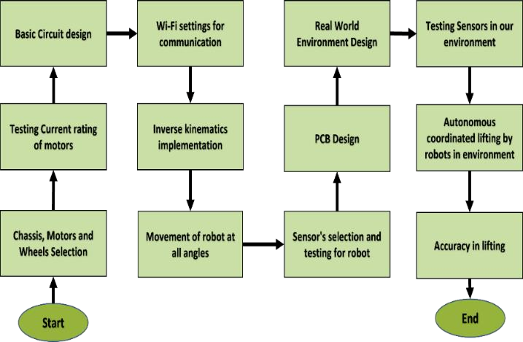

*Figure 1: Flow chart for the Development of Autonomous Weightlifting Robots*

## 3.1.2.- Wi-Fi and Bluetooth setting for communication

Wi-Fi is used for communication between the robots and for sending them the coordinates of the destination they have to reach.

For this program the main ESP32 (the headquarter) will send the coordinates as the access point also known as ESP32 server, and rest of the ESP32 as ESP32 Client also known as Station. The station ESP’s will be connected to the ESP32 (the headquarter) access point, this will allow station (client) ESP’s to make HTTP GET requests to the server to get any data or information, this is how the communication works.

## 3.1.3.- Inverse Kinematics Implementation

Inverse kinematics is the use of mathematical equations to determine the motion of robot to reach a desired location. Inverse kinematics for the wheeled robot can be defined as “What will be the speed of individual wheel of the robot given the overall speed of the robot”? The wheels used in the development of the educational robot are Mecanum wheels. The inverse kinematics is used to find the direction of single wheel given the overall speed and the angle of the robot. The figure given below represents different parameters used in the derivation of the inverse kinematics.

*Figure 2: Robot with Labelled Dimensions*

The research was done on the implementation of the inverse kinematics.

## 3.2.1-Movement of robot at all angles:

After implementation of inverse kinematics equations, the task was to make sure robot’s movement to all the angles was accurate with minimum diversion for which a lot of testing and removed small errors in angles by tweaking both our code and the hardware.

## 3.2.2-Circuit and PCB Design:

A PCB was designed and in here we list key features of this PCB along with details about using each feature.

**Figure 2.3 and Figure 2.4** show the component placement on the top and bottom side of the PCB

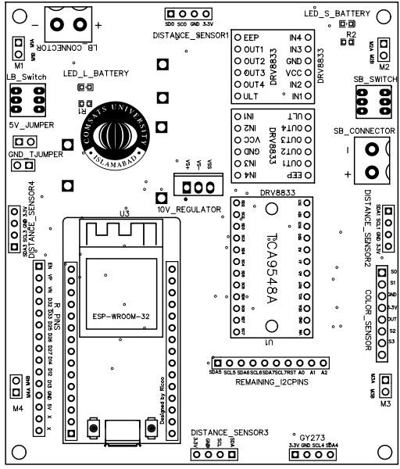

*Figure 14: Top and Bottom Silk Layer of Project PCB*

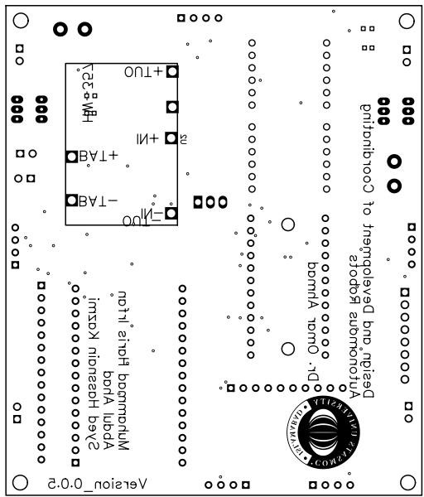𝜔 = 1 [𝑣 + 𝑣 − (𝐿 + 𝐻)𝜔 ]

1 𝑅 𝑦 𝑥

𝜔 = 1 [𝑣 − 𝑣 + (𝐿 + 𝐻)𝜔 ]

2 𝑅 𝑦 𝑥

𝜔 = 1 [𝑣 − 𝑣 − (𝐿 + 𝐻)𝜔 ]

3 𝑅 𝑦 𝑥

𝜔 = 1 [𝑣 + 𝑣 + (𝐿 + 𝐻)𝜔 ]

4 𝑅 𝑦 𝑥

Schematics of Main Board Version 0.5

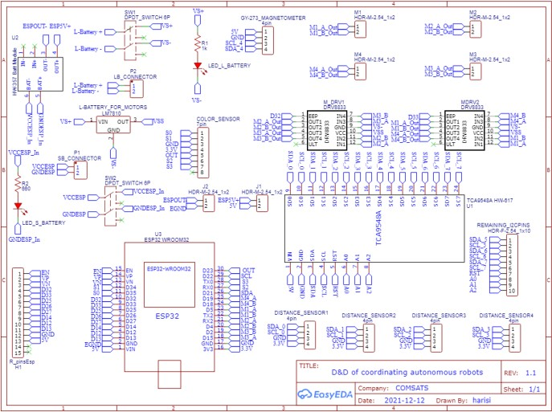

***Figure 1: Schematic of Project Circuitry***

* On/Off buttons for both Large Battery and Small Battery
* Two separate power sources for Digital and Power circuits
* Voltage *Figure 3: Bottom Silk Layer of Project PCB*

regulation (5V) and (10V) for the two batteries.

* 4x 90*╚ Female Header for Distance Sensors
* Header for GY273 (Magnetometer)
* Header for HW357 (Boost Convertor for small battery)
* Jumper header for ESP32 (to supply 5V from board)

## 3.2.3- Autonomous coordinated lifting by robots in environment

To ensure the objective is accomplished, enabling a certain degree of independence among robots was required and for that, the following tasks are mentioned below:

* Work while coordinating with one another.
* Work in such a way that each independent module communicates with the main controller making the system increasingly efficient with time.
* Work only under the supervision of main controller which controls and manages all individual modules separately. Work with a feedback system with all its functionality being autonomous
  1. RESULTS AND DISCUSSIONS

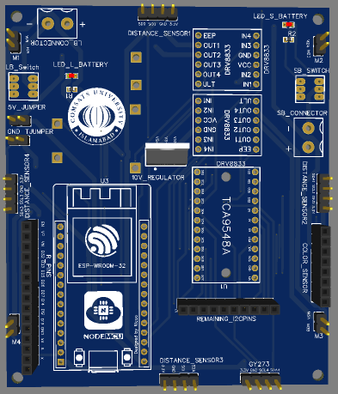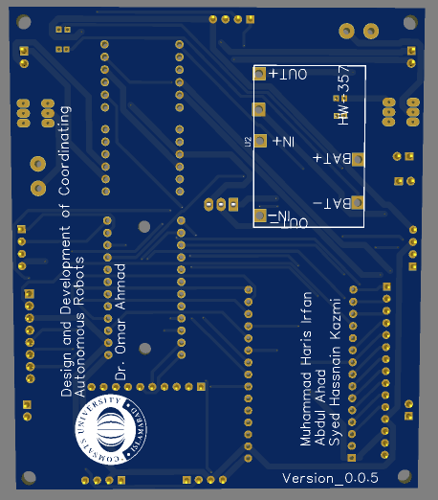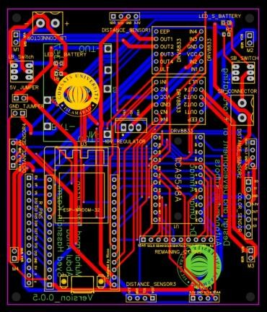

***y s***

***er and Bottom Layer of Project PCB***

***Figure 2: Top La***

***Connection***

## 4.1- Results:

The goal was to design and develop three robots capable of doing coordinated tasks, i.e. lifting of weight.

During the course of this objective, various learning related to both hardware and both software was accumulated as there was very little research in this area to start with.

***Figure 4: 3D Top View of the PCB***

Key Features:

* Supports ESP32 WROOM-32

***Figure 3 3D bottom view of the PCB***

**4.2- Learning:**

Firstly, a hand-made prototype was developed and then shifted to already readymade toy. The hardware was entirely made on breadboard and then later on PCB was designed on a software called EasyEDA where every component of the hardware was incorporated into one board for better wiring and connections. Secondly, variety of sensors were used and learned how to interface each sensor and understand their values and then converted those values accordingly into meaningful data.

Thirdly, equations of kinematics were learned for movement of omni direction wheels where equations are of two types:

* Forward Kinematics
* Inverse Kinematics

Forward kinematics uses the joint parameters to compute the configuration of the chain, and inverse kinematics reverses this calculation to determine the joint parameters that achieve a

* Headers strip for interfacing to IOs on ESP32
* Interface header for TCS3200 Color Sensor
* Header for TCA9548A I2c Multiplexer
* Connectors for 4 DC motors
* 2x Header for DRC8833 Motor drivers

desired configuration.

Fourthly, a design was developed that changed along the way be it selection of components, approach towards tasks, or circuitry.

* 1. CONCLUSION

This section signifies the provisional completion of our project, which was the design and development of coordinating autonomous robots.

For autonomous movement various sensors were used such as time of flight sensor, magnetometer, color sensor, the analog values coming from these sensors were converted to information useful to us, which in turn helped us autonomously move as per the given angle.

A controlled environment was made, and experimented for robots movement in that environment, after several changes they were able to implement and reach desired goal that was to coordinate a task between three robots.

* 1. REFERENCES

# Alami, R., Ingrand, F.F. and Qutub, S., 1998, August. A Scheme for Coordinating Multi-robots Planning Activities and Plans Execution. In *ECAI* (pp. 617-621).

1. Gul, F., Rahiman, W. and Nazli Alhady, S.S., 2019. A comprehensive study for robot navigation techniques. *Cogent Engineering*, *6*(1), p.1632046.
2. Panigrahi, P.K. and Bisoy, S.K., 2021. Localization strategies for autonomous mobile robots: A review. *Journal of King Saud University-Computer and Information Sciences*.
3. Rus, D., Donald, B. and Jennings, J., 1995, August. Moving furniture with teams of autonomous robots. In *Proceedings 1995 IEEE/RSJ International Conference on Intelligent Robots and Systems. Human Robot Interaction and Cooperative Robots* (Vol. 1, pp. 235-242). IEEE.

# Thrun, S., 1997. A probabilistic approach to concurrent mapping and localization for mobile robots. In *TO APPEAR IN MACHINE*

*LEARNING AND AUTONOMOUS ROBOTS (JOINT ISSUE)*.

1. Verner, I.M., Cuperman, D. and Reitman, M., 2017. Robot Online Learning to Lift Weights: A Way to Expose Students to Robotics and Intelligent Technologies. *International Journal of Online Engineering*, *13*(8).

# Wurman, P.R., D'Andrea, R. and Mountz, M., 2008. Coordinating hundreds of cooperative, autonomous vehicles in warehouses. *AI magazine*, *29*(1), pp.9-9.