
Department of Engineering Technology
Foundation University Islamabad
School of Science and Technology
Visual Programming Lab
Name: Muhammad Waleed
Roll no.: 086
Lab 3: Windows Form App
OBJECTIVES:
- To design a Windows Forms GUI application using common input controls.
- To collect and process user input in C# using event-driven programming.

Performance |  |  | Lab Report
Description | Total  Marks | Marks  Obtaine d | Description | Total  Marks | Marks Obtained
Operate  Software | 5 |  | Communication | 5
Code writing | 5
Total Marks obtained
Remarks (if any): ………………………………….
Name & Signature of faculty: …………………………………

LAB 03
Question:
Create a registration form for a job seeker in Windows Forms App.
It should include common form elements. At least 15-20 input elements Controls to be Used:
Textboxes, Labels, RadioButtons, CumboBox, CheckBoxes, DateTimePicker, NumericUpDown, File Dialog.
Form:
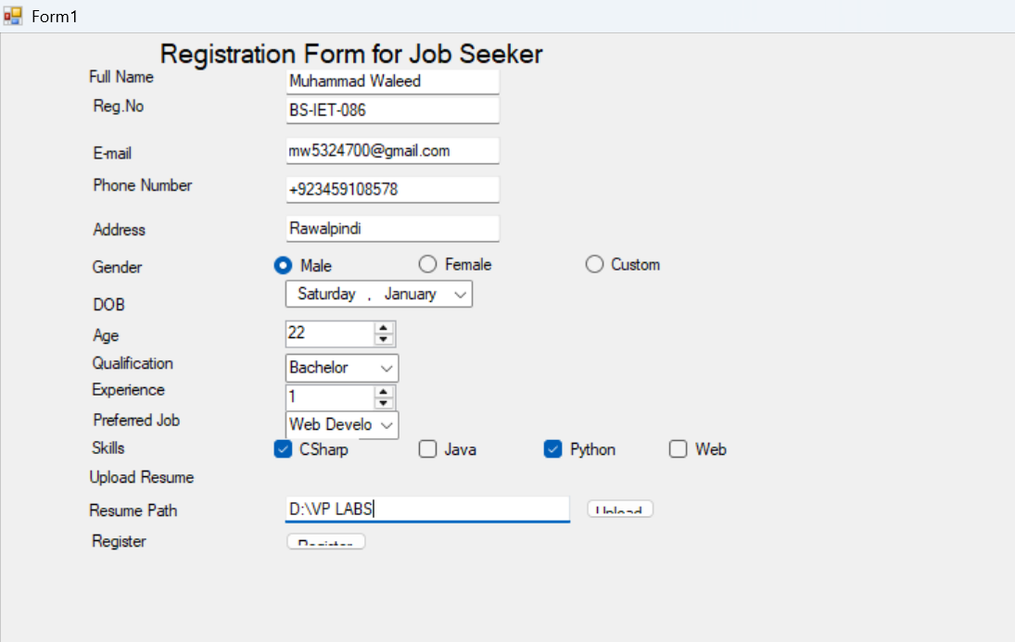
THE END

