
Visual programming
Midterm Exam

April 7, 2026
Muhammad Waleed
FA23-BS-IET-086(B)

VP LAB MID EXAM
- Console App to Input Product Name & Price. Apply 10% discount if price >5000. (Discount = price*0.10). At the show product name and price.
Code:
using System;

class Program
{
static void Main()
{
string productName;
double price;
double discount;

Console.Write("Enter Product Name: ");
productName = Console.ReadLine();

Console.Write("Enter Product Price: ");
price = Convert.ToDouble(Console.ReadLine());

double finalPrice = price;

if (price > 5000)
{
discount = price * 0.10;
finalPrice = price - discount;
Console.WriteLine("10% discount applied!");
}

Console.WriteLine("\nProduct Name: " + productName);
Console.WriteLine("Original Price: " + price);
Console.WriteLine("Final Price: " + finalPrice);
}
}
Output:
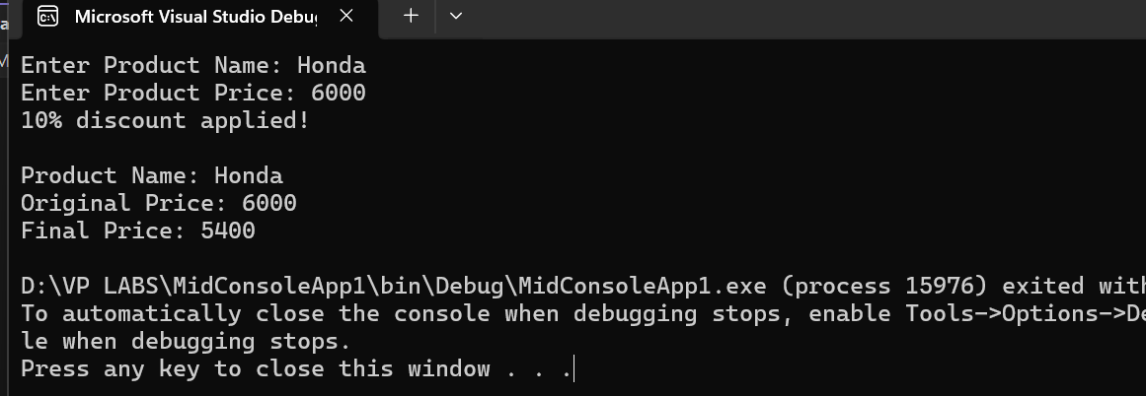
- Windows Form App for login. Show “Success” Message if username = “admin” & password = “1234”
Code:
using System;
using System.Collections.Generic;
using System.ComponentModel;
using System.Data;
using System.Drawing;
using System.Linq;
using System.Text;
using System.Threading.Tasks;
using System.Windows.Forms;

namespace MidWindowsFormsApp1
{
public partial class Form1 : Form
{
public Form1()
{
InitializeComponent();
}

private void buttonLogin_Click(object sender, EventArgs e)
{
var user = this.textBoxUsername.Text ?? string.Empty;
var pass = this.textBoxPassword.Text ?? string.Empty;

if (user == "admin" && pass == "1234")
{
MessageBox.Show("Success", "Login", MessageBoxButtons.OK, MessageBoxIcon.Information);
}
else
{
MessageBox.Show("Invalid username or password.", "Login Failed", MessageBoxButtons.OK, MessageBoxIcon.Error);
}
}
}
}
Output:
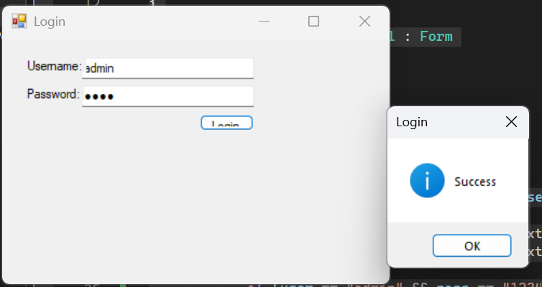
THE END

