
Department of Engineering Technology
Foundation University Islamabad
School of Science and Technology
Visual Programming Lab
Name: Muhammad Waleed
Roll no.: 086
Lab 4: Event Handling in Windows Forms Application
OBJECTIVES:
i. Create a Windows Forms Application for checkout with at least five product
selections for the user, along with the quantity of each product.
ii. On clicking the “Checkout” button, the quantity and product price calculation should
take place and display the complete order to the user along with a grand total.
iii. The “Cancel” button should reset all the products.

Performance |  |  | Lab Report
Description | Total  Marks | Marks  Obtaine d | Description | Total  Marks | Marks Obtained
Operate  Software | 5 |  | Communication | 5
Code writing | 5
Total Marks obtained
Remarks (if any): ………………………………….
Name & Signature of faculty: …………………………………

LAB 04
Question:
i. Create a Windows Forms Application for checkout with at least five product
selections for the user, along with the quantity of each product.
ii. On clicking the “Checkout” button, the quantity and product price calculation should
take place and display the complete order to the user along with a grand total.
iii. The “Cancel” button should reset all the products.
Program:
namespace CheckoutApp;
public partial class Form1 : Form
{
// Product prices
private decimal[] prices = { 1.99m, 0.59m, 2.49m, 3.29m, 2.99m };
private string[] productNames = { "Apple", "Banana", "Bread", "Milk", "Eggs" };

public Form1()
{
InitializeComponent();
}

private void checkoutBtn_Click(object sender, EventArgs e)
{
orderList.Items.Clear();
decimal grandTotal = 0m;

NumericUpDown[] qtys = { product1Qty, product2Qty, product3Qty, product4Qty, product5Qty };

for (int i = 0; i < 5; i++)
{
int qty = (int)qtys[i].Value;
if (qty > 0)
{
decimal lineTotal = qty * prices[i];
grandTotal += lineTotal;
string item = $"{productNames[i]}: {qty} @ ${prices[i]:F2} = ${lineTotal:F2}";
orderList.Items.Add(item);
}
}

totalLabel.Text = $"Grand Total: ${grandTotal:F2}";
}

private void cancelBtn_Click(object sender, EventArgs e)
{
product1Qty.Value = 0;
product2Qty.Value = 0;
product3Qty.Value = 0;
product4Qty.Value = 0;
product5Qty.Value = 0;
orderList.Items.Clear();
totalLabel.Text = "Grand Total: $0.00";
}
}

Output:
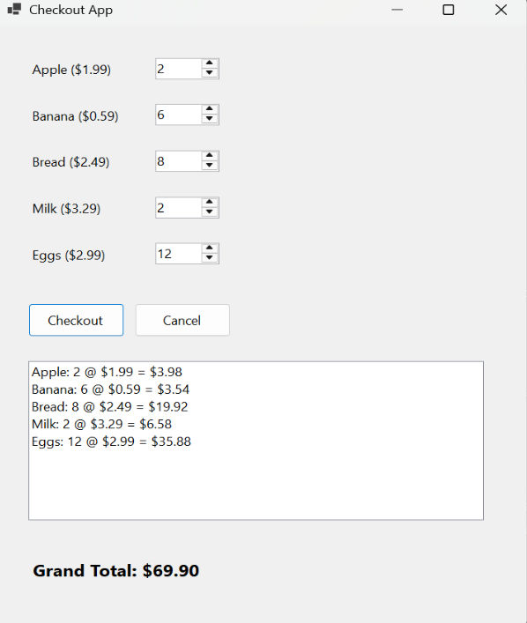
THE END

