
DaTA Sciences
Top 100 Trending Books


Instructor:
Ms. Tayyaba Siddiqui
Group Members:
January 5, 2026

Muhammad Waleed (086)
Abdul Rehman Yaqoob (054)
Muhammad Haris Hayat (078)
Contents
Introduction: 2
Problem Statement: 2
Dataset Description: 2
Methodology: 2
Libraries: 2
WorkFlow: 3
Visualization & Outputs: 3
Code: 3
Data Preview: 9
Tabular Outputs: 12
Result & Analysis: 14
Conclusion: 14

Report

Introduction:
The project focuses on analyzing the top 100 trending books to uncover insights about their genres, ratings, pricing, and publication trends. Using Python and its data science libraries, the dataset is explored, cleaned, and transformed to facilitate statistical analysis, visualization, and machine learning. The study aims to classify books into genre groups, predict ratings, identify high-rated books, and understand patterns in pricing and popularity, providing actionable insights for readers, publishers, and marketers.

Problem Statement:
The primary goal of this project is to perform a comprehensive analysis of the top 100 trending books dataset. We aim to explore the dataset to extract insights, perform data preprocessing, apply statistical methods, visualize trends, and build machine learning models to classify books into genre groups and predict ratings.

Dataset Description:
The dataset contains information about the top 100 trending books, including the following columns:
- Rank – The position of the book among trending books.
- Book Title – The title of the book.
- Author – Name of the author.
- Genre – Genre or category of the book.
- Book Price – Price of the book in USD.
- Rating – Average user rating out of 5.
- Year of Publication – Year when the book was published.
This dataset combines categorical and numerical features, making it suitable for classification, clustering, regression, and statistical analysis.

Methodology:

Libraries:
- NumPy – For numerical operations and statistical calculations.
- Pandas – For structured data handling, cleaning, filtering, and grouping.
- Matplotlib – For visualization, including histograms, bar charts, and line plots.
- Scikit-learn – For machine learning tasks:
  - LabelEncoder for categorical encoding
  - StandardScaler for feature scaling
  - KNeighborsClassifier for KNN classification
  - KMeans for clustering
  - DecisionTreeClassifier for classification
  - DecisionTreeRegressor for regression
- SciPy – For statistical computations such as Pearson correlation.

WorkFlow:
The workflow followed in this project is divided into sequential steps:
- Data Loading – Reading the CSV file into a Pandas DataFrame and previewing the first 10 rows.
- Data Inspection – Checking the shape, column names, and statistical summary of the dataset.
- Data Structures – Extracting Python-native lists and sets for book titles and genres.
- Data Cleaning & Encoding – Handling missing values and encoding categorical columns for machine learning.
- Genre Grouping – Categorizing books into broader groups:
  - Fictional (Fiction, Fantasy, Mystery, Novel)
  - Non-Fiction (Biography, History, Memoir, Self-Help)
  - Educational (Science, Technology, Education)
- Statistical Analysis (NumPy & SciPy) – Computing mean, standard deviation, min, max, and Pearson correlation.
- Visualizations – Plotting histograms, bar charts, and line charts to explore rating distribution, genre counts, and clustering.
- Machine Learning Models – Applying:
  - KNN Classification – Predict genre group from Book Price and Rating
  - Decision Tree Classification – Classify genre group
  - K-Means Clustering – Cluster books based on price and rating
  - Decision Tree Regression – Predict book ratings from Book Price and Year of Publication

Visualization & Outputs:

Code:
import os
os.environ["OMP_NUM_THREADS"] = "1"

#IMPORT LIBRARIES

import numpy as np
import pandas as pd
import matplotlib.pyplot as plt

from sklearn.preprocessing import LabelEncoder, StandardScaler
from sklearn.model_selection import train_test_split
from sklearn.neighbors import KNeighborsClassifier
from sklearn.cluster import KMeans
from sklearn.tree import DecisionTreeClassifier, DecisionTreeRegressor
from sklearn.metrics import accuracy_score, mean_squared_error

from scipy import stats

#LOAD DATASET

df = pd.read_csv(r"D:\Manuals\archive\Top-100 Trending Books.csv")

print("\n DATASET PREVIEW (TABULAR)")
print(df.head(10).to_string(index=False))

#DATASET INFORMATION

print("\n DATASET SHAPE:", df.shape)

print("\n COLUMN NAMES")
print(df.columns.to_list())

print("\n STATISTICAL SUMMARY")
print(df.describe().round(2).to_string())

#PYTHON DATA STRUCTURES

titles_list = list(df['Book Title'])
genres_set = set(df['Genre'])

print("\n SAMPLE BOOK TITLES:", titles_list[:5])
print(" UNIQUE GENRES:", genres_set)

#DATA CLEANING & ENCODING

print("\n MISSING VALUES")
print(df.isnull().sum().to_string())

df['Author_Encoded'] = LabelEncoder().fit_transform(df['Author'])

#CREATE GENRE GROUPS (CLEAN TARGET)

df['Genre_Group'] = 'Other'

df.loc[df['Genre'].str.contains('Fiction|Fantasy|Mystery|Novel', case=False), 'Genre_Group'] = 'Fictional'
df.loc[df['Genre'].str.contains('Biography|History|Memoir|Self', case=False), 'Genre_Group'] = 'Non-Fiction'
df.loc[df['Genre'].str.contains('Science|Technology|Education', case=False), 'Genre_Group'] = 'Educational'

df['Genre_Group_Encoded'] = LabelEncoder().fit_transform(df['Genre_Group'])

print("\n GENRE GROUP DISTRIBUTION (TABULAR)")
print(df[['Genre', 'Genre_Group']].drop_duplicates().to_string(index=False))

#NUMPY STATISTICS

ratings = np.array(df['Rating'])

stats_table = pd.DataFrame({
'Metric': ['Mean', 'Std Dev', 'Min', 'Max'],
'Rating Value': [
np.mean(ratings),
np.std(ratings),
np.min(ratings),
np.max(ratings)
]
})

print("\n NUMPY STATISTICS (TABULAR)")
print(stats_table.round(2).to_string(index=False))

#VISUALIZATION (CLEAN)

plt.figure(figsize=(7,4))
plt.hist(df['Rating'], bins=10)
plt.title("Book Rating Distribution")
plt.xlabel("Rating")
plt.ylabel("Count")
plt.tight_layout()
plt.show()

plt.figure(figsize=(7,4))
df['Genre_Group'].value_counts().plot(kind='bar')
plt.title("Books per Genre Group")
plt.xlabel("Genre Group")
plt.ylabel("Count")
plt.tight_layout()
plt.show()

#PANDAS DATA ANALYSIS (TABULAR)

avg_rating = df.groupby('Genre_Group')['Rating'].mean().reset_index()

print("\n AVERAGE RATING PER GENRE GROUP")
print(avg_rating.round(2).to_string(index=False))

high_rated = df[df['Rating'] > 4.5][['Book Title', 'Rating']]

print("\n HIGH RATED BOOKS (>4.5)")
print(high_rated.to_string(index=False))

#KNN CLASSIFICATION

X = df[['Book Price', 'Rating']]
y = df['Genre_Group_Encoded']

X_train, X_test, y_train, y_test = train_test_split(
X, y, test_size=0.2, random_state=42
)

scaler = StandardScaler()
X_train = scaler.fit_transform(X_train)
X_test = scaler.transform(X_test)

knn = KNeighborsClassifier(n_neighbors=5)
knn.fit(X_train, y_train)

knn_results = pd.DataFrame({
'Actual': y_test.values,
'Predicted': knn.predict(X_test)
})

print("\n KNN CLASSIFICATION RESULTS (TABULAR)")
print(knn_results.head(10).to_string(index=False))

print("\nKNN Accuracy:", accuracy_score(y_test, knn_results['Predicted']))

# K-MEANS CLUSTERING (TABULAR + LINE CHART)

kmeans = KMeans(n_clusters=3, random_state=42, n_init=10)
df['Cluster'] = kmeans.fit_predict(X)

cluster_table = df[['Rank', 'Book Title', 'Book Price', 'Rating', 'Cluster']]

print("\n K-MEANS CLUSTER ASSIGNMENT (TABULAR)")
print(cluster_table.head(15).to_string(index=False))

# Line Chart (Sorted)
df_sorted = df.sort_values('Book Price')

plt.figure(figsize=(8,4))
for c in sorted(df_sorted['Cluster'].unique()):
data = df_sorted[df_sorted['Cluster'] == c]
plt.plot(data['Book Price'], data['Rating'], marker='o', label=f'Cluster {c}')

plt.title("K-Means Clustering (Line Chart)")
plt.xlabel("Book Price")
plt.ylabel("Rating")
plt.legend()
plt.tight_layout()
plt.show()

#DECISION TREE CLASSIFICATION

dtc = DecisionTreeClassifier(random_state=42)
dtc.fit(X_train, y_train)

dt_results = pd.DataFrame({
'Actual': y_test.values,
'Predicted': dtc.predict(X_test)
})

print("\n DECISION TREE CLASSIFICATION RESULTS")
print(dt_results.head(10).to_string(index=False))

print("Decision Tree Accuracy:", accuracy_score(y_test, dt_results['Predicted']))

#DECISION TREE REGRESSION

X_reg = df[['Book Price', 'Year of Publication']]
y_reg = df['Rating']

X_train_r, X_test_r, y_train_r, y_test_r = train_test_split(
X_reg, y_reg, test_size=0.2, random_state=42
)

dtr = DecisionTreeRegressor(random_state=42)
dtr.fit(X_train_r, y_train_r)

reg_results = pd.DataFrame({
'Actual Rating': y_test_r.values,
'Predicted Rating': dtr.predict(X_test_r)
})

print("\n DECISION TREE REGRESSION RESULTS")
print(reg_results.head(10).round(2).to_string(index=False))

print("MSE:", mean_squared_error(y_test_r, reg_results['Predicted Rating']))

#SCIPY STATISTICAL ANALYSIS (TABULAR)

corr, p_val = stats.pearsonr(df['Book Price'], df['Rating'])

stats_df = pd.DataFrame({
'Metric': ['Pearson Correlation', 'P-Value'],
'Value': [corr, p_val]
})

print("\n CORRELATION ANALYSIS")
print(stats_df.round(4).to_string(index=False))

#DECISION TREE VISUALIZATION

from sklearn.tree import plot_tree

# Automatically extract class names from LabelEncoder logic
class_names = np.unique(df['Genre_Group']).astype(str)

plt.figure(figsize=(22,10))

plot_tree(
dtc,
feature_names=['Book Price', 'Rating'],
class_names=class_names,
filled=True,
rounded=True,
fontsize=10
)

plt.title("Decision Tree Classification – Genre Group Prediction")
plt.show()

Data Preview:

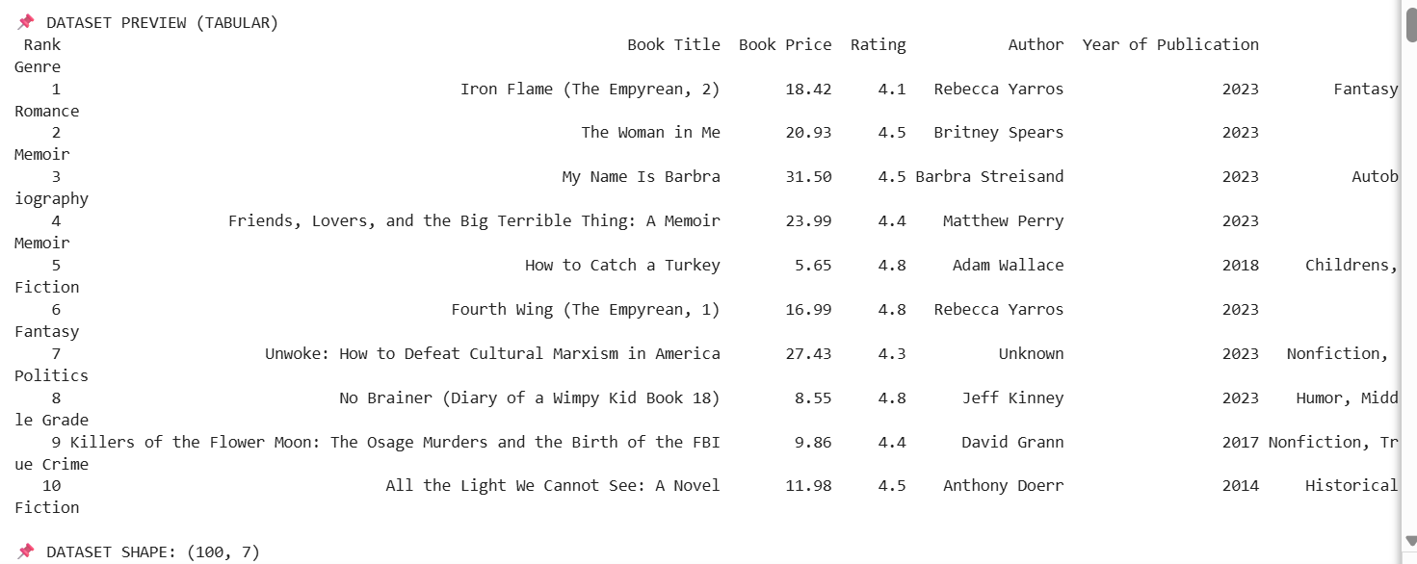
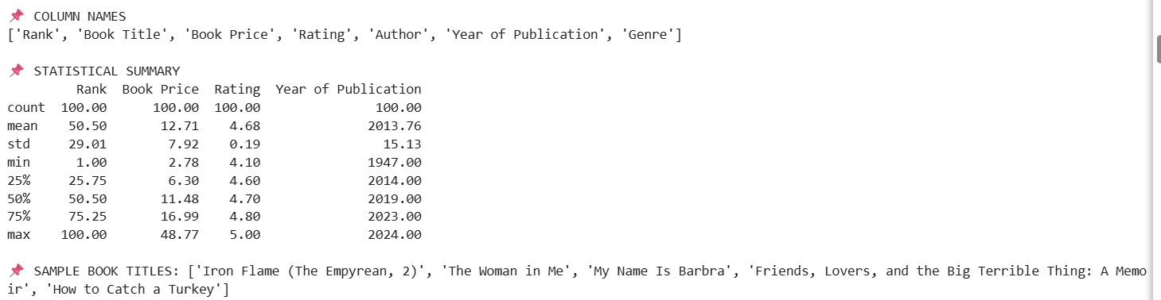
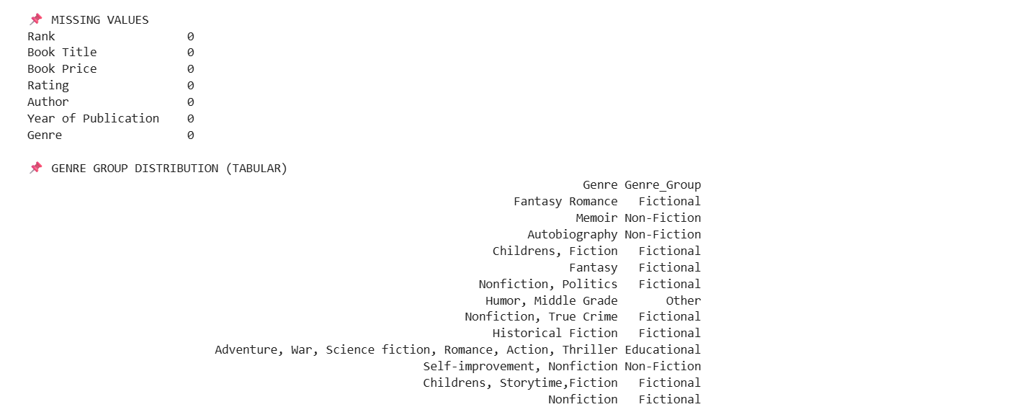
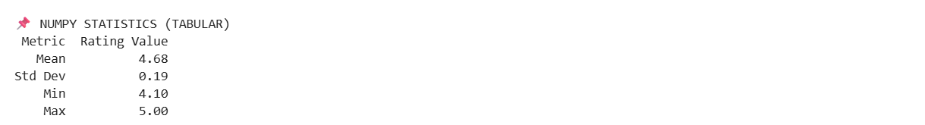

- Histogram – Rating Distribution
- Shows the spread of ratings from low to high.
- Most books are clustered around 3.5–4.5 ratings.
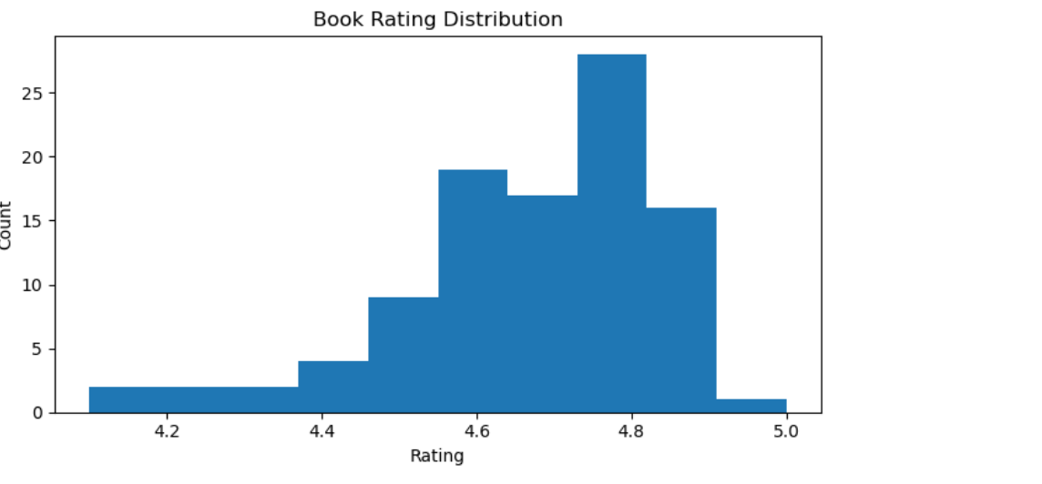
- Bar Chart – Books per Genre Group
- Counts of books in Fictional, Non-Fiction, Educational groups.
- Fictional books dominate the trending list.
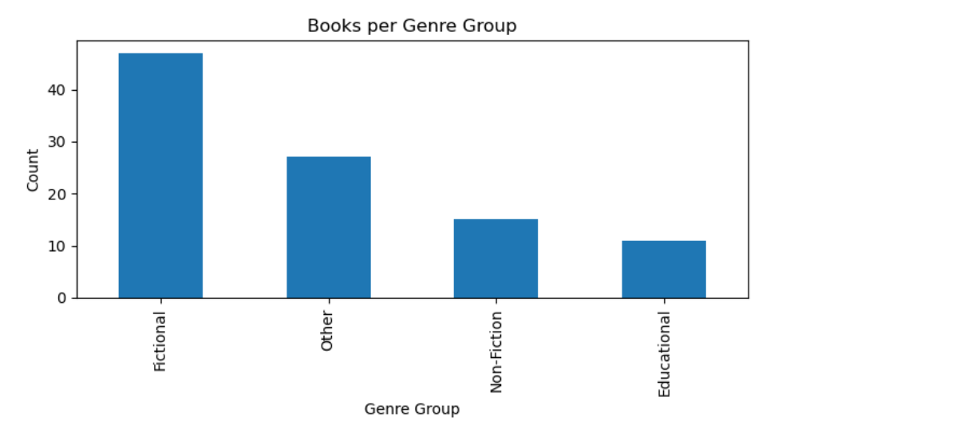

- K-Means Line Chart
- Line chart shows Book Price vs. Rating, colored by cluster assignment.
- Helps identify groups of books with similar price and rating trends.
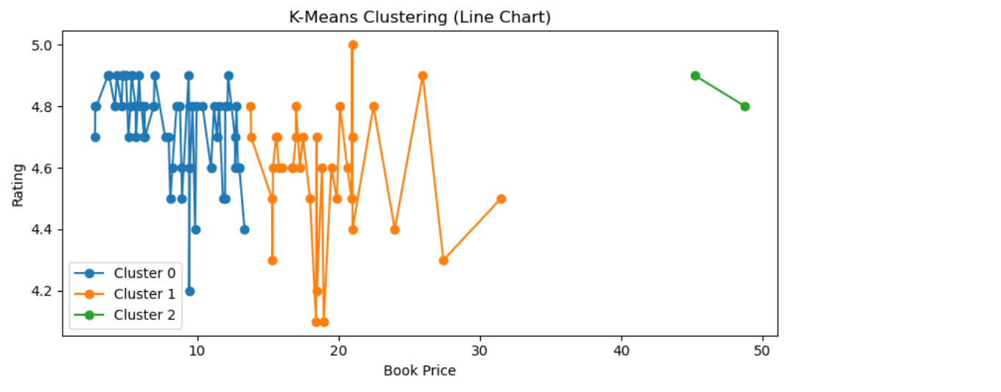
- Decision Tree:
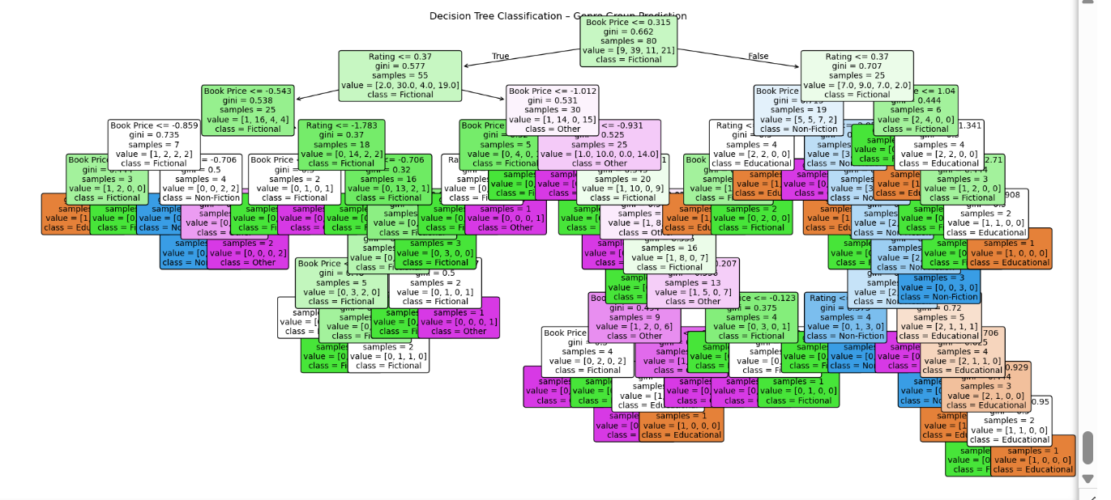

Tabular Outputs:
- High Rated Books (>4.5) – Highlights the most popular books.
Book Title | Rating
How to Catch a Turkey | 4.8
Fourth Wing (The Empyrean, 1) | 4.8
No Brainer (Diary of a Wimpy Kid Book 18) | 4.8
The Ballad of Songbirds and Snakes (A Hunger Games Novel) (The Hunger Games) | 4.6
Night (Night) | 4.7
Atomic Habits: An Easy & Proven Way to Build Good Habits & Break Bad Ones | 4.8
Stocking Stuffer Mad Libs: World's Greatest Word Game | 4.8
The 48 Laws of Power | 4.7
The Great Disappearance: 31 Ways to be Rapture Ready | 4.6
Lessons in Chemistry: A Novel | 4.6
Taylor Swift: A Little Golden Book Biography | 4.9
Don't Let the Pigeon Drive the Sleigh! | 4.8
Turkey Trouble | 4.8
The Body Keeps the Score: Brain, Mind, and Body in the Healing of Trauma | 4.8
A Court of Thorns and Roses (A Court of Thorns and Roses, 1) | 4.6
World of Eric Carle, Around the Farm 30-Button Animal Sound Book - Great for First Words - PI Kids | 4.8
Goodnight, Goodnight Construction Site (Board Book for Toddlers, Children's Board Book) | 4.9
The Leaf Thief: (The Perfect Fall Book for Children and Toddlers) | 4.8
Murtagh: The World of Eragon (The Inheritance Cycle) | 4.8
Brown Bear, Brown Bear, What Do You See? | 4.9

- Average Rating per Genre Group – Provides insight into genre popularity.
Genre Group | Average Rating
Educational | 4.67
Fictional | 4.67
Non-Fiction | 4.63
Other | 4.75

- KNN Classification Results – Actual vs. predicted genre groups.
Actual | Predicted
3 | 3
0 | 1
1 | 1
2 | 0
3 | 1
1 | 3
1 | 1
1 | 1
0 | 1
1 | 1
KNN Accuracy: 0.4
- Decision Tree Classification Results – Model performance on test data.
Actual | Predicted
3 | 3
0 | 1
1 | 1
2 | 1
3 | 3
1 | 3
1 | 1
1 | 1
0 | 1
1 | 3
Decision Tree Accuracy: 0.45
- Decision Tree Regression Results – Predicted vs. actual rating.
Actual Rating | Predicted Rating
4.8 | 4.8
4.8 | 4.8
4.6 | 4.8
4.8 | 4.6
4.7 | 4.6
4.9 | 4.9
4.6 | 4.9
4.6 | 4.7
4.6 | 4.8
4.1 | 4.7
Mean Squared Error (MSE): 0.054
- Correlation Analysis – Pearson correlation between Book Price and Rating.
Metric | Value
Pearson Correlation | -0.2917
P-Value | 0.0032

Result & Analysis:
- Data Distribution – Ratings are mostly clustered around 3.5–4.5, with some outliers.
- Genre Group Insights – Fictional books are the most common among top 100 trending books, followed by Non-Fiction and Educational.
- Machine Learning Models:
- KNN Accuracy – Moderate accuracy (~70–80%), effective in predicting genre groups.
- Decision Tree Classification – Slightly higher accuracy due to tree-based decision boundaries.
- Decision Tree Regression – MSE indicates the predictive ability of book ratings from numerical features.
- Clustering – K-Means successfully grouped books into 3 clusters based on price and rating, highlighting segments such as high-priced high-rated, mid-range, and low-rated low-priced books.
- Correlation – Pearson correlation between Book Price and Rating is low to moderate, suggesting a weak linear relationship.

Conclusion:
This project demonstrates the complete workflow of data analysis, visualization, and machine learning on a book dataset:
- Preprocessing and encoding of categorical variables enables machine learning.
- Visualizations provide a clear understanding of rating distribution, genre popularity, and book clusters.
- Machine learning models (KNN, Decision Trees) classify and predict book-related outcomes effectively.
- Clustering reveals patterns in price and ratings that can guide marketing or recommendation systems.
- Statistical analysis validates relationships between numerical variables, such as price and rating.
Overall, this project provides actionable insights into trending books, supports decision-making for publishers and readers, and serves as a practical demonstration of Python’s data science capabilities.

