## When is my next event

This feature helps the end-user to get information about the next booked event. If the end-user has booked **“Does culture matter on international business ?”** event on 4th April, The end-user would say phrases like “Hey Seea, when is my next event ?” and the voice assistant should respond “your next event **“Does culture matter on international business ?”** is tomorrow at 5 PM”.

This requires that the voice assistant in use is aware of the end-user booked events.

Figure Original Photo credits to google

## Suggest events based on users of the same taste

When a user books an event, the app would start creating a matching process in the background to suggest new apps to attend, based on what did the co-attendees who visited the same event booked later.

The matching process would have to completely anonymous so that the privacy of the end-user doesn’t get violated.

The developer team really liked this idea because it helps to create a social relationships between the end-users who have the same taste and interests. This idea’s human value is really high to be just dropped, because it would help to create a real social community around the Swiss Engineering platform.

## Let Seea get to know you

Seea is the name of the voice assistant inside the app, the name is the initials of the project “**S**wiss **E**ngineering **E**vent **A**pp ”.

Seea would start asking the end-user several questions to get to know him/her better, and start filling out the gaps to construct a model and start looking what events should it suggest to the end-user.

Those suggestion can be shown whether in the same page after answering all the question, or later in the suggestions screen.

This idea requires that Seea is aware of the events Database and can convert the textual recognized speech into a query to retrieve the results.

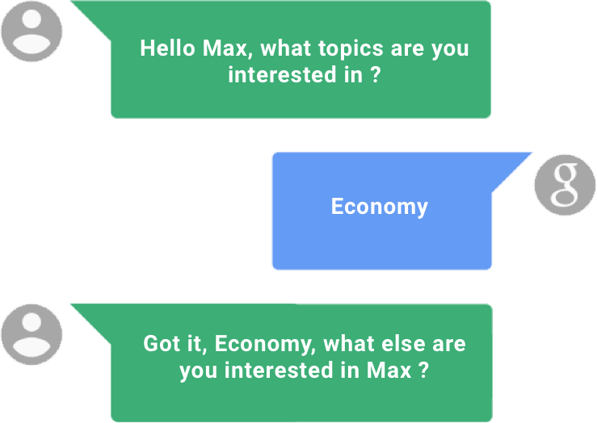

## Use Voice Assistant for follow-up questions

We as a developing team understands the different between the human and machine, for instance the human would remember the name of the streets that was raised in, visited as a teenager or had business in as an adult.

One of the first questions that the end-user would after showing an interest in an event, is where is it? even if the end-user saw the name of the street, the user would most probably search for that location to know how far away is it, especially if that event is taking place in another canton.

So this feature would save the time opening the maps and entering the name of the street and choosing the end-user location, as the end-user would ask simple direct questions, such as “How far away is it?” and Seea would reply “10 km” for instance so that the end-user can decide whether or not to book this event.

This feature requires that Seea is aware of the users current location – or the address listed as the address in the user’s profile – and the location of the event.

## Event search

The obvious go to feature when voice assistant is to implement in an event app. The end-user would trigger the voice assistant “Seea” and ask her to search for events that match the entered vis speech criteria given.

Seea would then respond with showing the events that match those criteria as a list in the events search results screen.

Entering the criteria could be done in the following two different ways:

* **Input as one sentence**

The end-user would have to say full sentences, for instance “Show me the events about **economy** on **4th April** in **Zurich**”, then Seea will retrieve the result of searching for those three inputs: Topic, date and location.

* **Input as a conversation**

Seea would first ask the user about which type of search criteria input to enter via voice, for instance Seea would say “What topics are you interested in?” the end-user would say “Economy”, then Seea would ask about the date by saying “which date should I search for” then end-user would then say “4th April” and Seea would finally ask about the location by saying “in which canton should I search” and the end-user would say “Zurich”.

Of course the feasibility of implementing such a feature is still discussable, because of how intuitive is it to replace the normal text input which most of the potential end-users prefer with a speech input.

Seea has to be connected to the Database of the available events and their corresponding attributes needed to complete this search query.

## Add events to calendar

This is one of the most intuitive to use features on this list. Normally when the end-user books an event, the next step is to copy this event information manually in the calendar, or wait for an event invitation via mail to import the event object to the calendar or if the user was lucky enough, the app would offer the end-user a button called “import to calendar” to import the event into the user’s private calendar service.

Seea has a potential usage at this point to import the booked event to the end-user’s calendar by just saying “import this event to my calendar” and that is it, the event is now saved into the user’s default calendar in use.

In this case, Seea has to be aware which calendar is the end-user using and also to know how to construct an event calendar object to import it into the calendar.

## TagSquare

This is a gamic feature that might make the process of entering the end-user’s preferences more fun than usual. In the screen a square will be shown with a label in the middle containing a name of one of the tags entered as an event was created, the users task is to swipe the tag label into one of the four corners of the square, namely “**book me**, **interesting**, **meh** and **hell no**” each time the user swipes one tag into one of those four corners and release a new tag appear in the middle to repeat the operation again. The end goal is to teach the AI what topics are the end-user interested in to send the end-user better suggestions in the future.

All what is needed is an access to the list of tags used for events, and then a way to save the end-user’s choices and use them in the future to help provide even better suggestions.

## Even**Tinder**

Dating is back on the table for all involved in a relationship ☺

This idea is basically about using the event’s tags to create a list of cards stacked on each other, all what the end-user needs to do is to swipe the card right or left, smash or pass.

The “smashed” cards tags will be used in the future to provide better recommendations in the future for the end-user.

The AI needs to be aware of the tags entered in the database to provide them as cards.

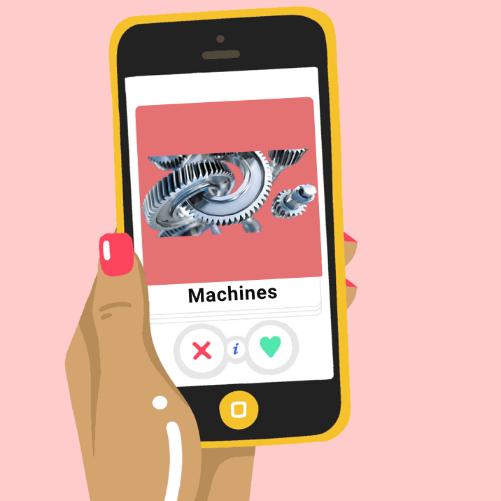

Figure Original Photo https://www.bustle.com

## Seea Mascot

This is another attempt of gamification. The Idea would be to create a visual personal assistant (e.g. Microsoft clippy) that is always present on the screen and would double as an integrated help function. For example, the mascot would notify the user if there is no internet connection present or would be clickable on pages that might require help. The mascot should be located on one of the edges or corners of the screen to be easily accessible without obscuring the view on the actual application and its functions.

The Mascot would need to be aware about the content of each screen so that it give helpful instructions, the team needs to design the Mascot as well.