Assignment-1 Report

Translating and Evaluating Transformer Models for English to Hindi Translation



Name | ID
Jyotirmoy Singh | 2021B3A72513H
Pradyut Ganesh | 2021AATS2434H
Waleed Iqbal Shaikh | 2021B3A70559H

Instructor In-Charge: Prof. N L Bhanu Murthy

April 2025

Contents
Contents 2
Introduction 3
Methodology 4
1. Fine-Tuning a Transformer Model 5
2. Evaluation of a Pre-Trained Transformer Model 7
3. Comparative Framework 7
Results & Comparison 8
Task 1: Fine-Tuning Results 8
Task 2: Evaluation of Pre-Trained Models 9
Task 3: Comparative Analysis and Discussion 11
Conclusion 13
References 15

Introduction
In today's globalized world, it is important that people can effectively communicate their thoughts without having to worry about language barriers. Machine translation has, therefore, become a pivotal technology in achieving this goal. Our assignment involves using state-of-the-art transformer models for this exact purpose. We use the dataset IITB English-Hindi Parallel corpus, which has over 1.66 million high-quality parallel sentence pairs, offering a substantial resource for model training. This dataset is, therefore, a critical asset in helping advance natural language processing(NLP) research in multilingual contexts.
We have used a dual approach in this assignment. We fine-tuned an existing transformer model in the first phase to optimize it for the machine-translation task using the IITB English-Hindi Parallel Corpus. This essentially allowed us to customize and tailor the architecture of the transformer model by leveraging the intricate linguistic patterns and nuances inherent in the dataset. In the second phase, we evaluated the performance of existing pre-trained transformer models as detailed in the assignment guidelines, sourced from Hugging Face, to benchmark their translation performance with our fine-tuned model that we obtained in the first part. Models from both phases have been scrutinized using metrics like BLEU, ROUGE, and METEOR to analyze the translation quality comprehensively.
For the fine-tuning task, we carefully selected among the various available architectural choices — including BERT, T5, mBART, GPT, and MarianMT. We decided to choose MarianMT for its inherent design, which is tailored to machine translation. MarianMT is an encoder-decoder model pre-trained on extensive multilingual translation corpora. It is ideal since it is already equipped with a solid baseline for handling diverse language pairs. On the other hand, BERT is an encoder-only model, so it is primarily designed for understanding and contextualizing text, which makes it ideal for classification and question-answering tasks, while T5 and mBART are encoder-decoder models like MarianMT too, but have been trained for more general tasks of text-to-text problems, instead of being trained explicitly for just machine translation like MarianMT, making MarianMT the better choice for our assignment. Lastly, GPT is a decoder-only model, so it is not exactly optimized for translation tasks because translation tasks require that the semantic nuances of the source language are properly captured and the context of the source language understood, which would require an encoder architecture.
By using these approaches, the assignment helped us uncover insights into each method's effectiveness, highlighting their respective strengths and limitations in addressing the complexities of neural machine translation (NMT). Our exploration revealed that while fine-tuning offers the opportunity for domain-specific optimization and nuanced translation improvements, pre-trained models provide robust, out-of-the-box performance with significantly reduced computational overhead. This exploration is particularly relevant in the context of low-resource languages, where high-quality datasets and effective model architectures are key to bridging linguistic gaps. The findings from this project not only contribute to academic understanding but also offer practical implications for deploying translation systems in real-world applications, such as AI-powered chatbots and multilingual communication tools.
Ultimately, this report sets the stage for a detailed comparative analysis that emphasizes both theoretical understanding and hands-on implementation, providing a roadmap for future advancements in the field of machine translation.

Methodology
Optimizations done for low resource / faster training :
FP 16
Reduced Memory Usage: FP16 uses 16 bits per value instead of 32, halving memory consumption.
Hardware Acceleration: Modern GPUs (e.g., NVIDIA Turing/Ampere) optimize FP16 operations with specialized cores like Tensor Cores.
Improved Throughput: Lower memory bandwidth per operation enables more parallel operations, speeding up inference.
Mixed Precision Balance: Combining FP16 with FP32 in sensitive parts ensures high performance without sacrificing accuracy.
Batching:
- Aggregated Processing: Multiple inputs are processed in a single forward pass, reducing per-sample overhead and leveraging parallelism.
- Enhanced Throughput: By grouping data into batches, the system maximizes hardware utilization, which is especially beneficial on GPUs.
Gradient Accumulation (During Training):
- Simulating Large Batches: Accumulates gradients over several mini-batches to mimic the effect of a larger batch size without exceeding memory limits.
- Memory Efficiency: This method allows for training with an effective large batch size even when individual batches are kept small due to limited resources.
Steps Involved -
- Obtaining a small percentage of the dataset, 10% for our training purposes
- Initializing the Model
- Initializing the Tokenizer
- Tokenization of the Full Training and Validation Datasets
- Setting up Data Collator and DataLoader
- Computing Testing Accuracy on the Base Model and Calculating Evaluation Metrics
- Initializing Trainer with full training and validation datasets
- Fine-tuning the model
- Obtaining Evaluation Metrics

Results & Comparison

Task 1: Fine-Tuning Results

Hyperparameter Variation -
Hyperparameter | Mod Batch | Large Batch | Default
Train Batch Size | 8 | 16 | 8
Eval Batch Size | 8 | 16 | 8
Gradient Acc. Step | 2 | 1 | -
Learning Rate | 2.5e-5 | 2e-5 | 3e-5
Weight Decay | 0.1 | 0.05 | 0.1
Warmup Ratio | 0.05 | 0.06 | -
Warmup Steps | - | - | 1000
Smoothing Factor | 0.07 | 0.08 | 0.1

Testing Data Results on each Hyperparameter Set -
BLEU | 0.017672960319474882 | 0.016691677272882153 | 0.015863846867241016
ROUGE-1 | 0.06799797704727062 | 0.07341671314547261 | 0.05446781592993254
ROUGE-2 | 0.010392989508805378 | 0.01229201741325689 | 0.008397830612101243
ROUGE-L | 0.06773651592810578 | 0.07326554910320368 | 0.053592722332356645
METEOR | 0.10929249096983246 | 0.10801830553140529 | 0.10164826742393684
(Sets are Vertical in nature)

Hyperparameter Set 1 -

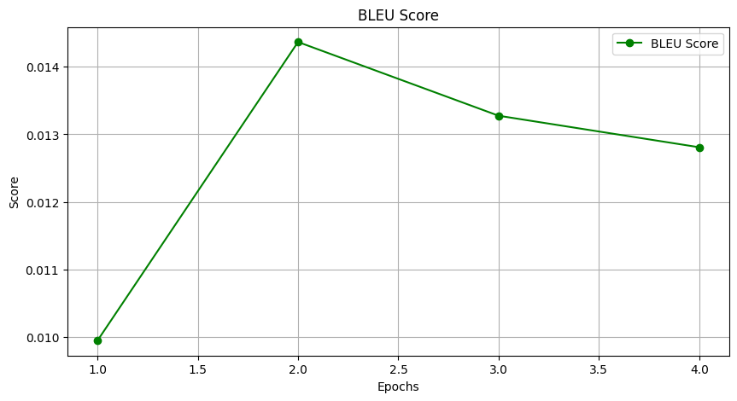
BLEU Score increases initially, suggesting an increase in performance, but it decreases from epoch 3 onwards, suggesting overfitting, hence the performance decreases.
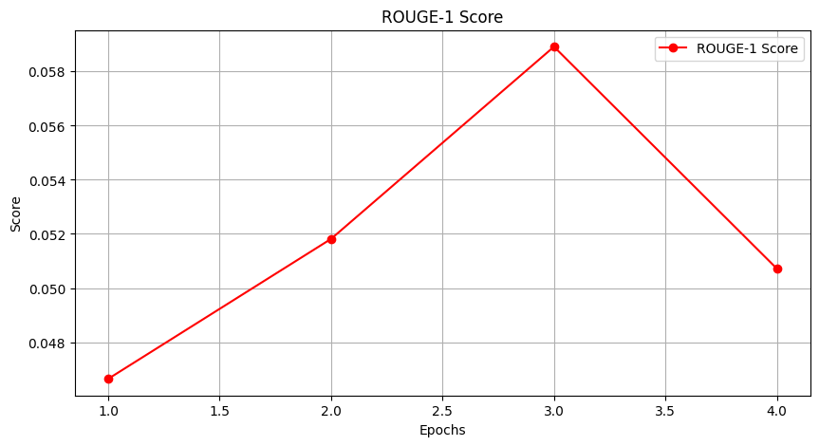
Rouge-1 follows a similar trend, peaking at epoch three and then declining, which indicates that the model benefits from training until the 3rd epoch, but training further decreases generalization.
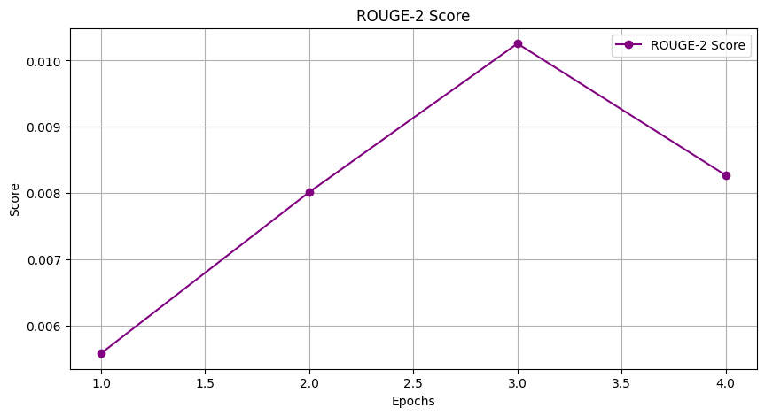
Rouge-2 follows same hypothesis as Rouge-1, suggesting that overfitting is happening beyond 3rd epoch.
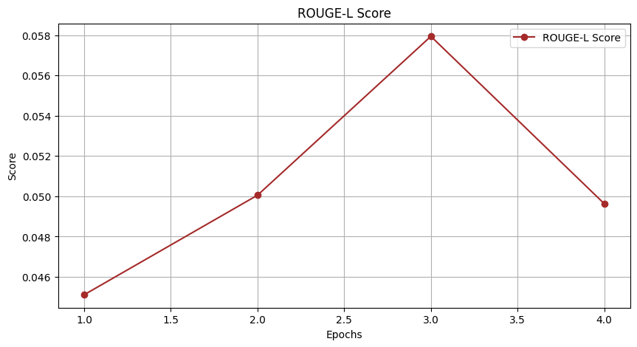
Rouge-L similarly suggests that epoch 3 is the ideal limit for training the model.

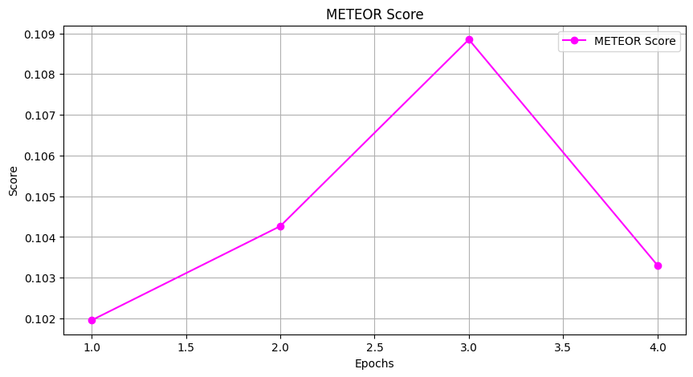
METEOR score shows a steady increase up to epoch 3, then a decline. This implies that meaningful n-gram and synonym matches are best optimized at epoch 3.

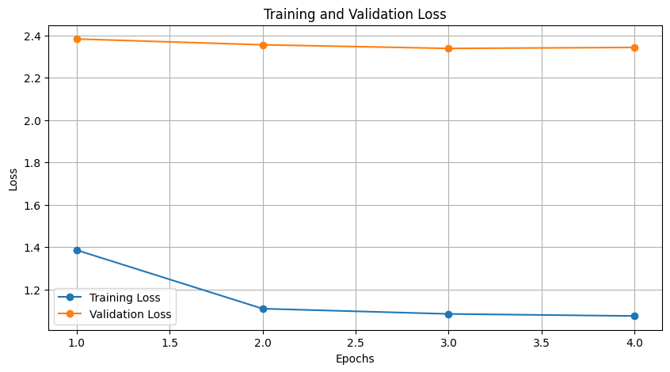
Training loss decreases, indicating that the model is learning. However, validation loss remains almost constant, suggesting overfitting or an issue with generalization.

Hyperparameter Set 2 -

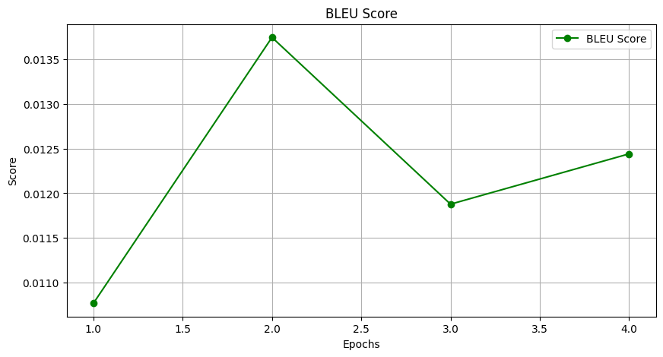
BLEU improves initially, peaks at epoch 2, then drops and slightly recovers at epoch 4. Indicating that the model initially improves is not consistent.
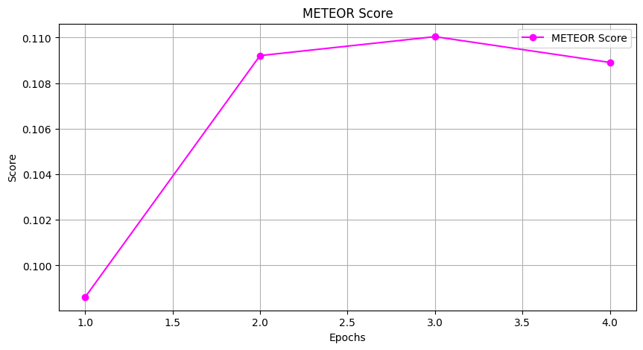METERO Improves up to epoch 3, then slightly decreases. This suggests steady improvements in sentence-level alignment but slight overfitting.

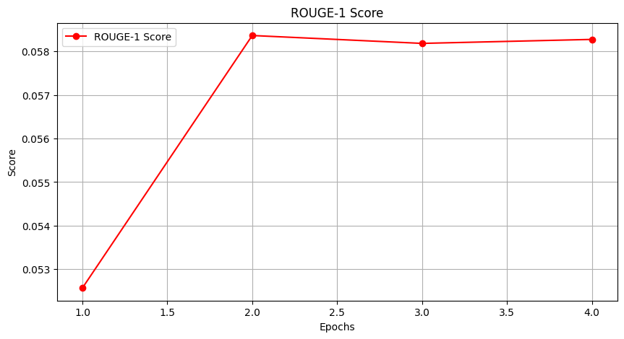
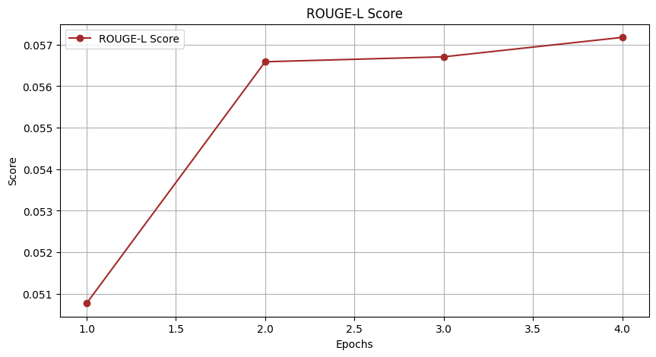
ROUGE-1 and ROUGE-L scores increase rapidly until epoch 2 and plateau.
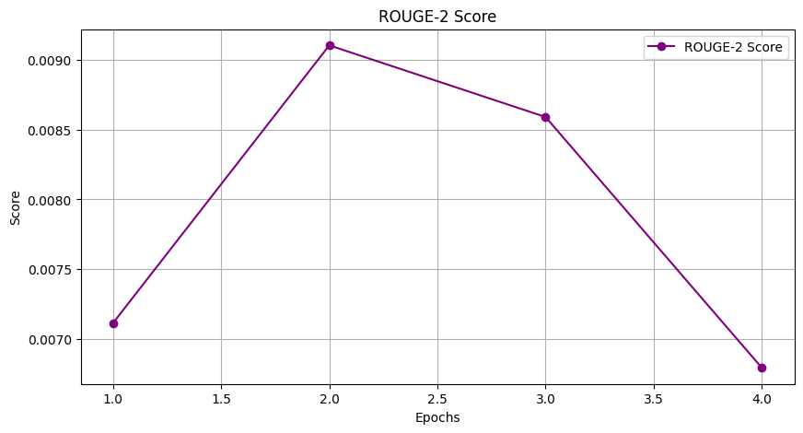
ROUGE-2 follows a similar pattern but declines after epoch 2.
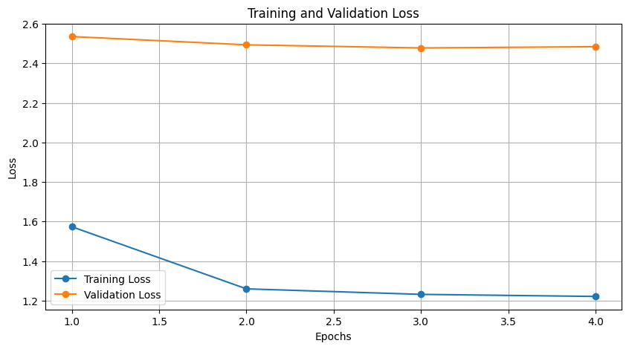
Training loss decreases consistently, while validation loss remains high. This indicates the model is overfitting, as generalization to unseen data is poor.

ROUGE-1, ROUGE-2, and ROUGE-L behave differently as they capture different aspects of text similarity. ROUGE-1 measures word-level overlap and remains stable, while ROUGE-2 evaluates phrase-level coherence and often declines due to poor bigram structuring. ROUGE-L tracks fluency using sequence matching and stays closer to ROUGE-1. The decline in ROUGE-2 suggests issues with phrase continuity, which can be reduced using beam search, coverage mechanisms, or sequence-level training.

Hyperparameter Set 3 -
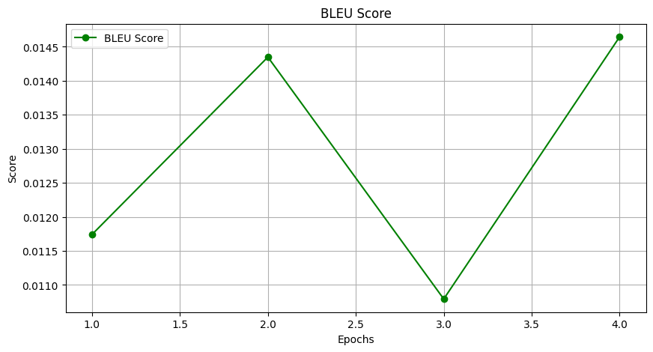
BLUE Score fluctuates across epochs, indicating instability; it peaks at epoch 2, drops significantly at epoch 3, and rises again at epoch 4. This suggests that the model's translation quality is inconsistent.
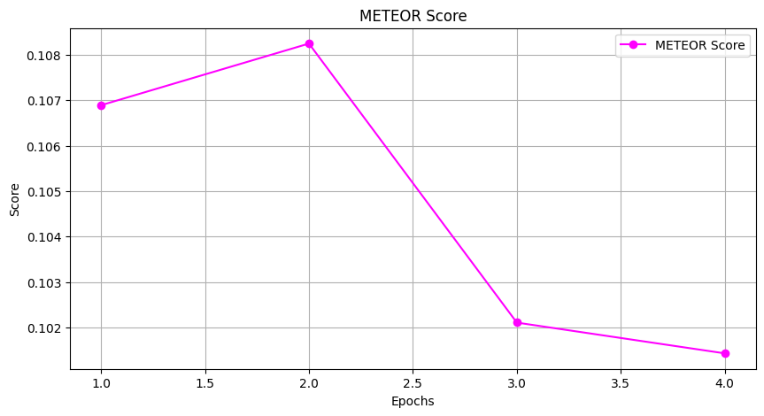
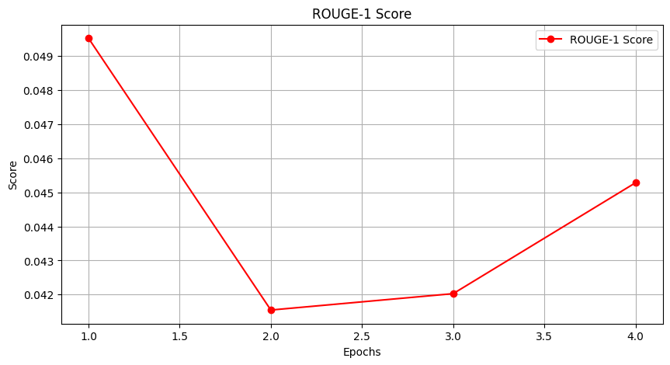
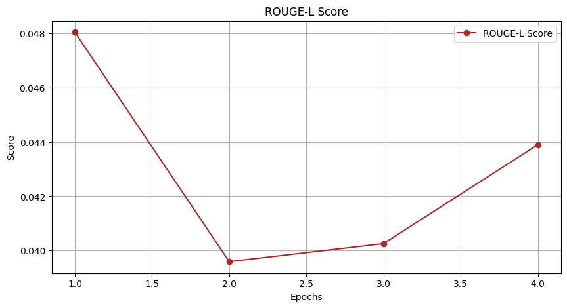
Rouge-1 decreases significantly after the first epoch, then slightly improves toward epoch 4. Rouge-L follows a similar pattern to ROUGE-1, dropping initially but recovering slightly. The initial drop in these scores might indicate that early training disrupts meaningful word overlap, but later epochs show some recovery.
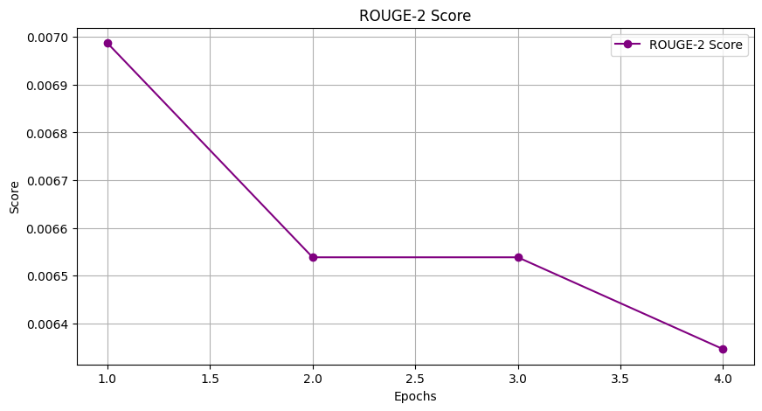
Rouge-2 shows a steady decline over epochs. This indicates that bigram-based recall is worsening, suggesting that the model might be failing to capture contextual phrase patterns effectively.
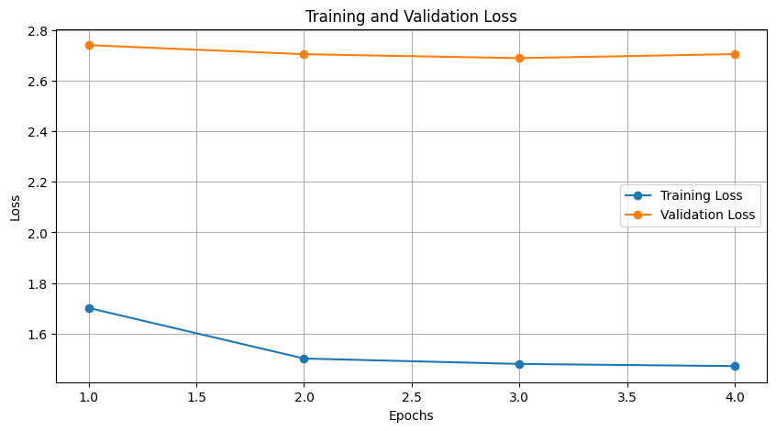
Training Loss decreases over time, indicating that the model is learning and optimizing parameters well on the training data, while the Validation Loss stays almost constant, which suggests that the model is struggling to generalize to unseen data and could be underfitting.

Various Results Obtained by Testing Out on Other Hyperparameters -
BLEU | 0.010017640007 | 0.015698138767 | 0.018084135196 | 0.017672960319
ROUGE-1 | 0.046 | 0.071727667126 | 0.069948038558 | 0.067997977047
ROUGE-2 | 0.024 | 0.011053377197 | 0.012361231688 | 0.010392989508
ROUGE-L | 0.045111111111 | 0.071840955728 | 0.069673802242 | 0.067736515928
METEOR | 0.081865232057 | 0.105745101766 | 0.109300457785 | 0.109292490969

Various Sample Outputs -
Input - Interface Viewer
Output - अंतराफलक दर्शक
Input - It was not something people wanted.
Output - यह ऐसी चीज नहीं है, जिसे लोग चाहते थे।
Input - Cars get many more miles to the gallon.
Output - अब एक गैलन गैस में कार पहले से अधिक मील चलती है।
Input - Clear event log
Output - घटना रोजनामचा मिटाओ
Input - This really is a must for our nation.
Output - यह हमारे देश के लिए वास्तव में अनिवार्य वस्तु है।

Task 2: Evaluation of Pre-Trained Models
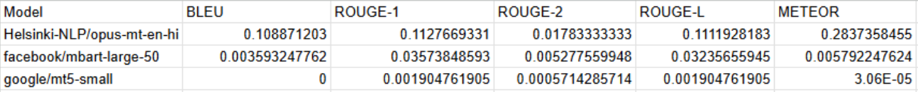
Task 2 Overview:
- Selection of Pre-Trained Models: Three pre-trained models—Helsinki-NLP/opus-mt-en-hi, facebook/mbart-large-50, and google/mt5-small—were chosen from Hugging Face.
- Evaluation Procedure: Each model was directly evaluated on the IITB English-Hindi Parallel Corpus test set without any additional fine-tuning.
- Metrics Used: Standard machine translation metrics—BLEU, ROUGE-1, ROUGE-2, ROUGE-L, and METEOR—were computed for each model’s outputs.
- Results:
  - Helsinki-NLP/opus-mt-en-hi achieved the highest overall scores (BLEU ~0.1089, ROUGE-L ~0.1112, METEOR ~0.2837), clearly outperforming the other two models.
  - facebook/mbart-large-50 had significantly lower scores (BLEU ~0.0036, METEOR ~0.0058).
  - google/mt5-small performed the worst (BLEU near 0, METEOR near 0).
Key Takeaway:
Helsinki-NLP/opus-mt-en-hi demonstrated the strongest translation performance among the pre-trained models, making it the leading candidate for English-to-Hindi translation in this direct evaluation.

Task 3: Comparative Analysis and Discussion

1. Selection of the Best Fine-Tuned Model
After experimenting with three fine-tuned models, we evaluated their performance using key metrics such as BLEU, ROUGE, and METEOR. The models were configured as follows:
- Model 1 (mod_batch):
  - BLEU: 0.01767
  - ROUGE-1: 0.06800
  - ROUGE-2: 0.01039
  - ROUGE-L: 0.06774
  - METEOR: 0.10929
- Model 2 (large_batch):
  - BLEU: 0.01669
  - ROUGE-1: 0.07342
  - ROUGE-2: 0.01229
  - ROUGE-L: 0.07327
  - METEOR: 0.10802
- Model 3 (results):
  - BLEU: 0.01586
  - ROUGE-1: 0.05447
  - ROUGE-2: 0.00840
  - ROUGE-L: 0.05359
  - METEOR: 0.10165
Based on these results, we determined that Model 1 (mod_batch) is our best performing fine-tuned model, as it achieved the highest BLEU (0.01767) and METEOR (0.10929) scores among our experiments. Although Model 2 demonstrated slightly higher ROUGE scores, we prioritized BLEU and METEOR for translation quality assessment.

2. Comparison with Pre-Trained Models
We compared our best fine-tuned model against several pre-trained models evaluated on the test set:
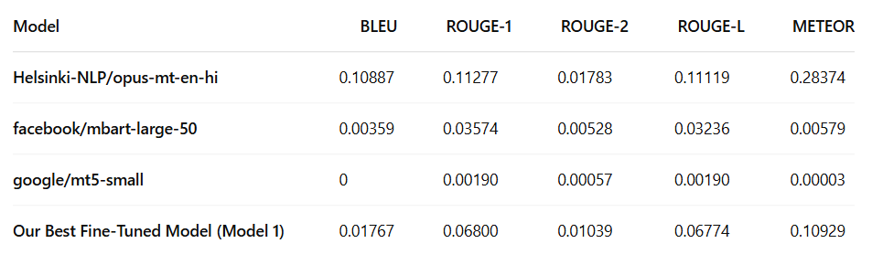
From the comparison, it is evident that the Helsinki-NLP/opus-mt-en-hi model significantly outperforms our fine-tuned model, with substantially higher scores across all metrics. On the other hand, the other pre-trained models (facebook/mbart-large-50 and google/mt5-small) perform much worse than our fine-tuned approaches.

3. Analysis of the Fine-Tuned Model’s Performance
We observed that our best fine-tuned model still underperforms compared to the Helsinki model. Some potential reasons for this include:
Limited Training Data and Epochs: Although the IITB English-Hindi Parallel Corpus is substantial, our fine-tuning was conducted for less epochs and only 10% of the training data ( due to compute limitations). This limited exposure may not have been sufficient for the model to learn generalized translation patterns, and instead, the model might have learned patterns specific to the training set.
Overfitting to the Training Data: By fine-tuning the Helsinki-NLP/opus-mt-en-hi model on our dataset, we could have overfitted the model, where the model memorized our training data rather than capturing broader language translation patterns. This overfitting resulted in the degradation of performance metrics on the test set compared to the original pre-trained model. Essentially, while the pre-trained model benefits from exposure to diverse and extensive multilingual data, the fine-tuned model becomes overly specialized to the specific training set, thereby losing some of the generalization power.
Model Initialization and Capacity: The pre-trained Helsinki-NLP/opus-mt-en-hi model is the result of training on a massive, diverse dataset. Its parameters are well-tuned for general language understanding and translation. Fine-tuning on a smaller, more specific dataset can inadvertently shift these well-balanced parameters, causing the model to perform well on familiar training data but poorly on unseen data.

4. Discussion: Training from Scratch vs. Fine-Tuning
In our study, we evaluated the pre-trained Helsinki-NLP/opus-mt-en-hi model against a fine-tuned version of the same model using the IITB English-Hindi Parallel Corpus. Our results indicated that the fine-tuned version actually underperformed relative to the original pre-trained model, largely due to overfitting. We discuss the pros and cons of training from scratch versus fine-tuning while incorporating these observations.

Training from Scratch
Pros:
- Complete Customization: Developing a model from scratch allows us to design the architecture specifically for our domain. In theory, this could capture domain-specific nuances if managed well.
- Avoiding Pre-Trained Biases: Starting from zero avoids inheriting any limitations or biases present in pre-trained models, potentially allowing for more tailored behavior on domain-specific tasks.
Cons:
- High Resource Demand: Training from scratch requires significant amounts of data, computational power, and training time—resources that are often not readily available.
- Risk of Underperformance Without Large Datasets: Without the benefit of extensive pre-training on diverse data, models trained from scratch may struggle to achieve competitive performance, especially when the available domain-specific data is limited.
- Complexity in Hyperparameter Tuning: Building a model from scratch involves managing numerous hyperparameters from the ground up, which can lead to suboptimal performance if not finely tuned.

Fine-Tuning Pre-Trained Models
Pros:
- Resource Efficiency: Fine-tuning a pre-trained model leverages the extensive language understanding acquired during large-scale pre-training. This makes it much more resource-efficient and faster than training from scratch.
- Rapid Adaptation: With fine-tuning, we can quickly adapt a model to a specific domain or dataset using a relatively small number of additional training epochs.
- Strong Initial Performance: The pre-trained Helsinki-NLP/opus-mt-en-hi model already has robust generalization capabilities, which provide a strong performance baseline.
Cons:
- Risk of Overfitting: As demonstrated in our experiments, fine-tuning the Helsinki model on the IITB dataset led to overfitting. The model became too specialized to the training data, which degraded its performance on unseen test data compared to the pre-trained version.
- Loss of Generalization: Over-aggressive fine-tuning can shift the model’s parameters away from the broadly applicable representations learned during pre-training. In our case, this resulted in a fine-tuned model that was less effective overall than its pre-trained counterpart.
- Limited Domain Flexibility: While fine-tuning can help a model adapt to specific domains, if the target dataset is not sufficiently large or diverse, the fine-tuning process may not yield the desired improvements and can even harm performance due to overfitting.

Conclusion
The fine-tuned Helsinki-NLP/opus-mt-en-hi model exhibited overfitting, leading to degraded performance compared to the original pre-trained model. This suggests that in real-world applications, fine-tuning must be approached cautiously, especially when domain-specific data is limited. While training from scratch offers full customization, it is often impractical due to high resource demands. Leveraging pre-trained models directly or fine-tuning with strong regularization remains the most efficient strategy for balancing generalization and specialization.

References
- Hugging Face. “Transformers.” GitHub, 2020. Accessed April 2025. https://github.com/huggingface/transformers.
- CFILT. “IITB English-Hindi Parallel Corpus.” Hugging Face Datasets. Accessed April 2025. https://huggingface.co/datasets/cfilt/iitb-english-hindi.

- Vaswani, Ashish, Noam Shazeer, Niki Parmar, Jakob Uszkoreit, Llion Jones, Aidan N. Gomez, Łukasz Kaiser, and Illia Polosukhin. “Attention Is All You Need.” In Advances in Neural Information Processing Systems 30, 5998–6008. 2017.

