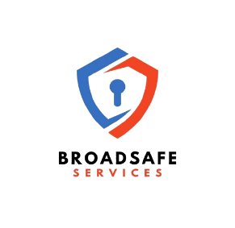

Modern Slavery Statement

Version # 1
Doc # QMS059

Broadsafe Services acknowledges that all organisations play an important role in respecting and promoting human rights and eradicating modern slavery. We recognise that modern slavery is a growing and complex problem, best tackled by collective commitment and responsibility to bring it to an end and we are committed to working with all our stakeholders to fulfil this common goal.
If we uncover the use of Modern Slavery, we will act as quickly as practicable to remedy its adverse impacts on workers, individuals or communities and we will engage directly with affected stakeholders. We understand that the Australian Modern Slavery Act 2018 took effect on 1 January 2019 and requires Broadsafe Services to not make annual public reports (Modern Slavery Statements) at this stage on the actions to address modern slavery risks in their operations and supply chains.
However, as an organisation we do take this seriously, hence we ensure that we:
- conduct regular due diligence to ensure that Broadsafe Services is compliant with local, national, and other applicable laws and regulations in the areas in which the businesses operate.

- source products and services in accordance with legal obligations and community expectations while seeking reassurance from suppliers that their social and environmental practices are best practice, that they act to prevent, mitigate and where appropriate, remedy modern slavery in their operations and supply chains.

- implement procedures to ensure that we are addressing modern slavery and ethical sourcing risks in our operations and supply chains

- include in our operational and supplier contract terms, requirements that suppliers comply with all local, national, and other applicable laws and regulations in the areas in which they operate.

- ensure that we maintain the rights of termination if the supplier is unable or unwilling to work towards full compliance with the Minimum Standards with regard to the modern slavery act.

- have a modern slavery risk management process implemented that includes regular reviews of our approach to eradicating the use of Modern Slavery in the supply chain.

Mario Shar – Managing Director
