Carbon capture and storage using two stage aqueous mineral carbonation
Introduction
CO2 is the most important greenhouse gas. Green house gasses are the one which absorbs and emit radiant energy within the thermal infrared range. So, their excessive amount in atmosphere is dangerous.
Carbon sequestration is the long-term removal, capture or sequestration of carbon dioxide from the atmosphere to slow or reverse atmospheric CO2 pollution and to mitigate or reverse global warming.
Why CO2 capture and Storage is important?
According to the recent Panel on Climate Change, global greenhouse gas (GHG) emissions must be reduced by 50 to 80 percent to avoid dramatic consequences of global warming. By 2050, global population will rise from 7-9 billion people & the World enter demand is expected to increase by 50% over the next 20 years.
Due to global warming our climate is changing and increased in temperature has been observed. Results are in the form of Air pollution(smog), melting of glaciers, leading to reduced water and food resources. To avoid global warming, we choose this project as a solution.

International Energy Agency, 2009
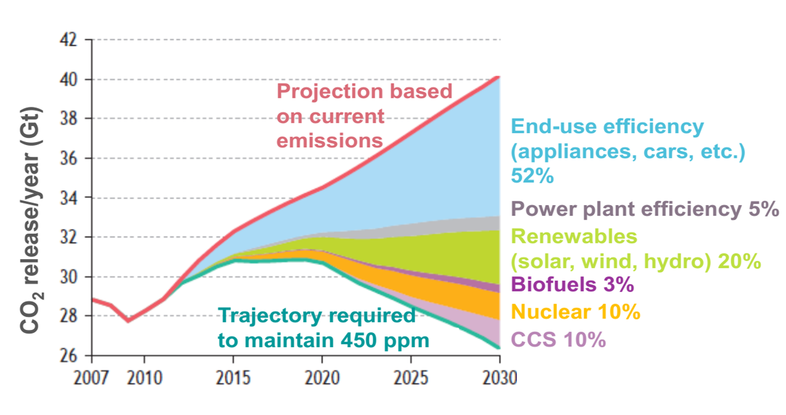

Main Sources of CO2 Emission
There are two main sources of CO2 emission
- Industries
- Power station (coal based)
So, it can be captured from the air in the form of CO2 or directly from the site (power station) to use in the mines to recover oil and gas.
CO2 Capture and storage by mineral carbonation
Mineral carbonation method is one such technique to capture atmospheric CO₂ and store it in a carbon sink. CO2 can be mineralized in an engineered environment via the extraction of magnesium (Mg) or Calcium (Ca) from a suitable precursor material in an aqueous medium, followed by the reaction of these metals with dissolved CO2 to form carbonate.
Carbonate can be used as raw material in the construction industry (e.g. aggregates, dykes, land expansion etc.) From storage point of view, less preferably, in chemical industry (e.g. fillers, fire retardants, etc.). Mineral carbonation, aims at chemically converting CO2 into an environmentally stable product.
Mg, Fe and Ca are the most commonly used elements in mineral carbonation processes on account of the fact that not only they are abundantly found on the earth's crust, but are also able to be extracted from industrial waste. The products generated by mineral carbonation can be commercialized, thus reducing process costs.
Single stage carbonation
It is performed in stirred reactors at partial pressure of CO2 up to 1bar, temperatures between 30C and 190C. The degree of carbonation of products is quantified using thermogravimetric analysis. Carbonation is confirmed by the formation of two Mg carbonates nesquehonite and hydromagnesite
Single stage carbonation limitations
Low process efficiencies were observed for single-step batch experiments with partially dehydroxylated lizardite reacting in an aqueous medium under a gas flow of pure CO2 and up to temperatures of 90C. The reaction progress was hindered by a passivating layer of re-precipitated silica or quartz. The extent of carbonation did not exceed more than 20% due to equilibrium limitations.

Two stage carbonation
Double-step carbonation experiments were carried out at an atmospheric pressure. Using one of the interconnected Teflon reactors as the precipitator. And the other one as the dissolution reactor. The CO2 content of the feed gas (100%), and the slurry density (1wt%) in the dissolution reactor. The temperature in the precipitator (90C) were kept unchanged.
Double step carbonation is better than single stage carbonation
A double-step strategy proved successful in addressing the single stage problem by controlling the pH of the solution. This is achieved by continuously removing the Mg from the dissolution reactor and letting it precipitate at a higher T and a lower pCO2 in a separate reactor. The extent of double stage carbonation is 50% much better than single stage carbonation. Thus, we choose double stage carbonation.

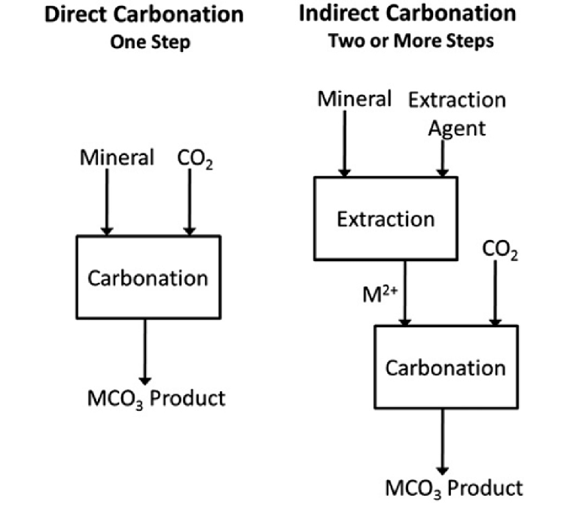

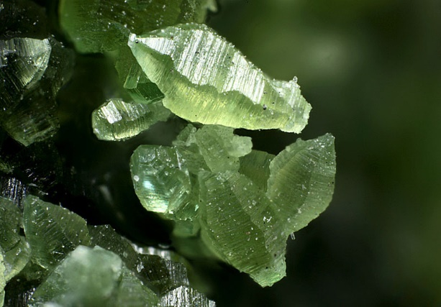
Raw material selection
We select Lizardite as raw material
- Formula : Mg3(Si2O5)(OH)4
- Color : green, brown, light yellow to white
- Lustre : Resinous, Waxy, Greasy
- Hardness:2½
- Specific Gravity:2.55
- Crystal System : Trigonal
- Member of : Serpentine Subgroup

Process description
- Flue gases (CO2+N2) are coming from the plant that has temp. of 120C. These gases send to cooler where temp. reduces to 50C at atmospheric pressure.
- Then these flue gases send to adsorber where the N2 is extracted and it converts rich amines into lean amines. The rich amines are made in the stripper where lean amines stream is attached and stripper makes amines rich that transfer to adsorber where N2 is extracted. This process is continuous for extraction of N2 and streams b/w adsorber and stripper are transferred with the help of pumps.
- After stripper stream(99%pure,CO2) is send to compressor. From where it is send to the carbonation reactor and precipitator. CO2 analyzer is installed that analyze CO2.
- We prepare slurry in mixer by adding activated feed material (Lizardite) and distilled water. It is send to the heater with the help of pump where its temp. rises. So that it can send to the carbonation reaction.
- In carbonation reactor, slurry is added at 45C with 5 bar pressure and CO2 from compressor is added. From reactor CO2 is send to treated gas holder by analyzing with the help of CO2 analyzer.
- From Carbonation reactor , product is send to the filter where undesired solids are removed from the product. From filter product is send to precipitator with the help of pump. After reaction in reactor product temp. is 90C and pressure is 2 bar.
- In precipitator , product is added and CO2 that is 99% pure from compressor is added. Temp. reduced to 40C and stream is send to filter. From filter circulated water and product is separated. Our product is Nesquehonite.

Process flow diagram
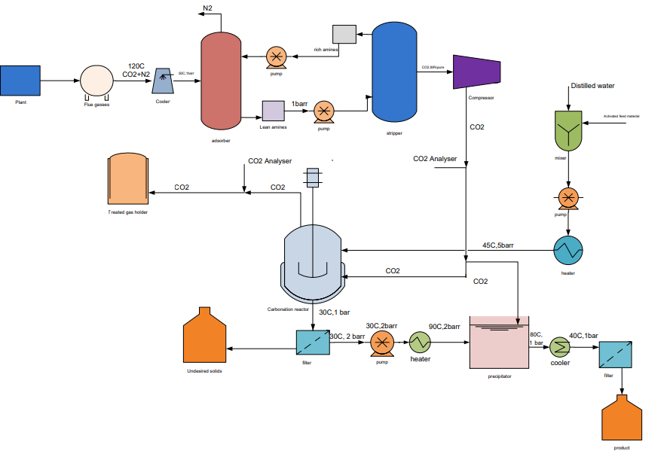

Capacity selection
- 1kg of CO2 required 2 kg of lizardite
- 1 ton = 1000kg
- 1 ton CO2 captured per day = 1000kg / day
- CO2 capture per hour = 1000/24 = 41.67kg/h
- So, plant is designed to capture and store 41.67kg of CO2
- 1kg CO2 require = 2kg of lizardite
- 41.67kg/h CO2 require = 83.34kg/h lizardite
Material Balance
Raw materials required
- We need 2% conc. Slurry for the reaction
- 2% lizardite (solids)
- 98% sol (water)

ENERGY AND MATERIAL BALANCE

OVERALL MATERIAL BALANCE:

ST-2
ST-1

ST-3

PROCESS

ST-4

ST-5

IN
COMP | ST-1  FLUE GAS |  | ST-3
 | Mol% | Kg/h | Mol% | Kg/h
N₂ | 68.08 |  | - | -
  218.20
O₂ | 5 | 16.0255 | - | -
H₂O | 12 | 38.46 | 98 | 4083.33
CO₂ | 13.5 | 43.36 | - | -
Ar | 2 |  | -
  6.4102
LIZARDITE | - | - | 2 | 83.33
 | ST-2 |  | ST-4 |  | ST-5
 | Mol% | Kg/h | Mol% | Kg/h | Mol% | Kg/h
N₂ | 93.16 | 217.69 | - | - | - | -
O₂ | 3.3 | 7.71 | - | - | - | -
H₂O | 0.5 | 1.168 | 100 | 4120.71 | 1 | 1.33
CO₂ | 1.84 | 4.299 | - | - | - | -
Ar | 1.2 | 2.8 | - | - | - | -
Nesqhionite | - | - | - | - | 99 | 131.43
OUT

CAPACITY
1 kg of CO2 requires 2 kg of Lizardite. So, 1 ton/day= 1000/24 kg/hr = 41.667kg/hr.
So, from the above statement it is clear that 41.667kg/hr of CO2 will require 83.33kg/hr of Lizardite.
So, total inlet flowrate of ST-3 = 83.33/0.02= 4166.7 kg/ hr of feed. From the above statement we know that
0.13*ST-1 = 41.667 kg/hr of CO2
ST-1 = 320.51 kg/hr.

N₂ Balance
0.68*320.51 = 0.9316* ST-2
ST-2 = 233.68 kg/hr
H₂O Balance
0.12*320.51 + 0.98*4166.5 = 0.005*233.68 + ST-3
ST-4 = 4120.41 kg/hr
ST-1 + ST-3 = ST-4 + ST-2 + ST-5
ST-5 = 132.76 kg/hr

EQUIPMENT MATERIAL BALANCE:
COMP | ST- 1 |  | ST-6
 | Mol% | Kg/h | Mol% | Kg/h
N₂ | 68.08 |  | - | -
  218.20
O₂ | 5 | 16.0255 | - | -
H₂O | 12 | 38.46 | 64.64 | 67.206
CO₂ | 13.5 | 43.36 | 8.77 | 9.11
Ar | 2 |  | - | -
  6.4102
MEA | - | - | 26.6 | 27.65

MATERIAL ON ABSORBER

Temp=8°C
Pressure=1.01325 bar
Material in:

Material out:
COMP | ST-2 |  | ST-7
 | Mol% | Kg/hr | Mol% | Kg/hr
N₂ | 79.39 | 185.86 | - | -
O₂ | 6.63 | 6.63 | - | -
H₂O | 1 | 1 | 54.58 | 103.94
CO₂ | 15.74 | 36.86 | 22.57 | 42.98
Ar | 0.956 | 2.2386 | - | -
MEA | - | - | 22.58 | 43.001

ST-1 + ST-6 = ST-2 + ST-7
320.51 - 233.68 = ST-7 - ST-6

H₂O Balance
0.12*320.15 + 0.6464* ST-6 = 0.005*233.68 + 0.5485*(86.47+ ST-6)
ST-6 = 103.97 kg/hr
ST-7 = 190.44 kg/hr

MATERIAL BALANCE ACROSS STRIPPER:

Material in:
COMP | ST-7
 | Mol% | Kg/hr
H₂O | 54.58 | 103.94
CO₂ | 22.57 | 42.98
MEA | 22.58 | 43.001

Material out:
COMP | ST-6 |  | ST-8
 | Mol% | Kg/hr | Mol% | Kg/hr
H₂O | 64.64 | 67.206 | 1 | 0.8657
CO₂ | 8.77 | 9.11 | 99 | 85.7043
MEA | 26.6 | 27.65 | - | -

ST-7 = ST-6 + ST-8
ST-8 = 86.57 kg/hr

MATERIAL BALANCE ACROSS REACTOR:
Material in:
COMP | ST-3 |  | ST-8
 | Mol% | Kg/hr | Mol% | Kg/hr
H₂O | 98 | 4083.366 | 1 | 0.8657
CO₂ | - | - | 99 | 85.7043
LIZARDITE | 2 | 83.334 | - | -

Material out:
COMP | ST-9
 | Mol% | Kg/hr
LIZARDITE | 1 | 42.5327
CO₃ ⁻² | 0.057 | 2.24
Mg⁺² | 0.26 | 11.058
SiO₂ | 0.43 | 18.28
H₂O | 98.253 | 4178.98

ST-3 + ST-8 = ST-9
ST-9 = 4253.27 kg/hr
Molar mass of Lizardite = 277.11 g/mole
No. of moles = 83334/277.11 = 300.72 mole/hr
Fa = Fa0(1-Xa)
Where Xa at 45 C, 5 bar, 600 Pa in one hour is 0.5
Fa = 300.725(1-0.5) = 150.36 moles/hr
HCO₃⁻² Balance
Fb = Fb0 – Fa0*Xa*b/a
Mg₃Si₂O₅(OH)₄ + 6H⁺ 3Mg⁺² + 2SiO₂ 5H₂O
Fb0 = CO₂ in feed/MW of CO₂ = 4144/44 = 941.818 mol/hr
Fb = 941.818 – (300.725) *(0.5) *6
Fb = 39.643
Mg⁺² Balance
Fc = Fc0 -Fa0*Xb*c/a
Fc = (300.725) *(0.5) *(3) = 451.0875 moles/hr
O₂ Balance
Fd = Fd0 -Fa0*Xa*d/a
Fd = (300.725) * (0.5) * (2)
Fd = 300.725 moles/hr
Product stream
- Lizardite = 150.36 * 277.11 = 42.52 kg/hr
- CO₃⁻² = 39.643 * 60.009 = 2.42 kg/hr
- Mg⁺² = 451.087 * 24.305 = 11.15 kg/hr
- SiO₂ = 300.725 * 60 = 18.283 kg/hr
- H₂O (out) = 4178.96 kg/hr
Total = 4253.23 kg/hr
Composition of the product stream
- Lizardite = 42.52/4253.23 = 0.01
- CO₃⁻² = 2.42/4253.23 = 0.00051
- Mg⁺² = 11.15/4253.23 = 0.0026
- SiO₂ = 18.283/4253.23 = 0.0043
- H₂O = 4178.96/4253.23 = 0.9825

MATERIAL BALANCE ACROSS FILTER 1:
COMP | ST-9
 | Mol% | Kg/hr
LIZARDITE | 1 | 42.5327
CO₃ ⁻² | 0.057 | 2.24
Mg⁺² | 0.26 | 11.058
SiO₂ | 0.43 | 18.28
H₂O | 98.253 | 4178.98
Material in:

Material out:
COMP | ST-10 |  | ST-11
 | Mol% | Kg/hr | Mol% | Kg/hr
SiO₂ | 0.5 | 10.6352 | - | -
LIZARDITE | 2 | 42.54 | - | -
H₂O | 97.5 | 2073.864 | 99.51 | 2116.23
Mg⁺² | - | - | 0.09 | 1.91
CO₃⁻² | - | - | 0.4 | 8.5

ST-9 = ST-10 + ST-11
0.97* ST-10 + 0.99* ST-11 = 4178.83
0.975*(4253.27 - ST-11) + 0.99* ST-11 = 4178.83
ST-11 = 2126.66 kg/hr
ST-10 = 2127.04 kg/hr

MATERIAL BALANCE ACROSS PRECIPITAOR
Mg⁺² + CO₃⁻² MgCO₃ (MAGNESITE)
MgCO₃ MgCO₃.3H₂O

Material in:
COMP | ST-11 |  | ST-8
 | Mol% | Kg/hr | Mol% | Kg/hr
CO₂ | - | - | 99 | 85.7043
H₂O | 99.51 | 2116.23 | 1 | 0.8657
Mg⁺² | 0.09 | 1.91 | - | -
CO₃⁻² | 0.4 | 8.5 | - | -

Material out:
COMP | ST-12
 | Mol% | Kg/hr
MgCO₃.3H₂O | 0.43 | 9.51
H₂O | 99.56 | 2203.47

ST-11 + ST-8 = ST-12
ST-12 = 2213.21 kg/hr
Molecular mass of Mg⁺² = 24.305 g/mol
No. of moles = 11058/24.305 = 454.96
Mg⁺² Balance
Fa0 = 454.96
Fa = Fa0(1-Xa) = 454.96(1-0.5) = 227.48 moles/hr

CO₃⁻² Balance
Fb = Fb0(1-Xa)*b/a
Fb = 40.39 + (227.48) (0.5)
Fb = 154.13 moles/hr
MgCO₃ Balance
Fc = Fc0-Fa0(Xa)
Fc = (227.48) (0.5)
Fc = 113.74 moles/hr
Product stream
MgCO₃ = 84.313 * 113.74 = 9589.76/1000 = 9.58 kg/hr
9.58/2213.21 = 0.0043
1- 0.0043 = 0.9956

MATERIAL BALANCE ACROSS FILTER 2:

ST-12 = ST-15 + ST-13
ST-13 = 2080.09 kg/hr
ST-15 = 133.12 kg/hr
Material in:
COMP | ST-12
 | Mol% | Kg/hr
MgCO₃.3H₂O | 0.43 | 9.51
H₂O | 99.56 | 2203.47

Material out:
COMP | ST-13 |  | ST-15
 | Mol% | Kg/hr | Mol% | Kg/hr
MgCO₃.3H₂O | 0.2 | 4.16 | 99 | 131.788
H₂O | 99.56 | 2070.93 | 1 | 1.33

OVERALL ENERGY BALANCE:
Overall Energy Balance:
Energy balance accounts for energy being transferred to or from the each equipment and is done here by taking into account the law of conservation of energy that is defined as bellow.
Law of conservation of energy:
It states that:
[Rate of energy going into the system] - [Rate of energy going out of the system] + [Rate of energy generation within the system] - [Rate of energy consumption within the system] = [Rate of energy accumulation in the system]
Now the energy balance of each equipment is given bellow

ST-4
WASH WATER
ST-3
TREATED FLUE GAS

ST-2
COMPRES CO₂

PROCESS
ST-1
FLUE GAS

ST-6
CONDENS WATER
ST-5
MAKEUP AMMONIA SOLUTION

STREAM NO | ∆T | MASS FLOW | AVERAGE C_{P} | AVERAGE DENSITY | m*c_{p}*∆T | m*∆P/ϸ | Q
 | (k) | Kg/h | Kj/kg.k | Kg/m³ | KW | KW | KW
1 | 393 | 320.51 | 1.39 | 0 | 48.63 | - | 48.63
2 | 323 | 233.94 | 1.0347 | 0 | 21.71 | 0.13 | 21.71
3 | 298 | 4166.7 | 4.068 | 0 | 1403.09 | - | 1403.09
4 | 313 | 4120.71 | 4.0737 | 0 | 1459.49 | - | 1459.49
5 | 313 | 132.56 | 1.5 | 0 | 17.28 | - | 17.28

Stream in: 81.28-0.77-.013 = 80.49 KW
Stream out -8.79-27.36-13.85 = -50.03 KW

EQUIPMENT ENERGY BALANCE

ENERGY BALANCE ACROSS DIRECT CONTACT COOLER:

STREAM | TEMPERATURE | AVERAGE CP | FLOW RATE | Q
 | °C | Kj/kg.k | Kg/h | KW
FLUE GAS INTO DCC-1 | 50 | 1.49 | 7872.94 | 81.46
FLUE GAS FROM DCC-1 | 30 | 1.49 | 7872.94 | 16.29

ENERGY BALANCE ACROSS HEAT EXCHANGER (BEFORE ABSORBER)

STREAM | TEMPERATURE | AVERAGE CP | FLOW RATE | Q
 | °C | Kj/kg.k | Kg/h | KW
FLUE GAS INTO CHILLER-1 | 30 | 1.49 | 7872.94 | 16.29
FLUE GAS FROM CHILLER-1 | 8 | 1.49 | 7872.94 | -55.39

ABSORBER ENERGY BALANCE:
HEAT OF REACTION:

∆H_{rxn}= ∑(ν_{i}*∆H_{f,i})_{products}-∑(ν_{i}*∆H_{f,i})_{reactants}

For 1st:
1(-940.772) - (-285.8-393.5-2*46.2) = -169.1 kj/mole
For 2nd:
1(-853.385) - (-285.8-393.5-46.2) = -127.885 kj/mole
For 3rd:
2(-853.385) - (-940.772-393.5-285.8) = -86.69 kj/mole
For 4th:
1(151.8) - (-393.5-2*46.2) = 637.7 kj/mole
COMPONENTS | HEAT OF FORMATION
CO₂ | -393.5
H₂O | -285.8
NH₃ | -46.2
NH₄HCO₃ | -853.385
(NH₄)₂CO₃ | -940.772
NH₄CO₂NH₂ | 151.8

STREAM | TEMPERATURE | AVERAGE CP | FLOW RATE | Q
 | °C | Kj/kg.k | Kg/h | KW
FLUE GAS INTO ABSORBER | 8 | 1.49 | 7872.94 | 81.46
FLUE GAS FROM TOP OF THE ABSORBER | 9 | 1.55 | 6416.37 | -16.29
LEAN SOLUTION INTO ABSORBER | 8 | 3.09 | 3732.334 | -54.46
RICH SOLUTION DISCHARGE FROM THE ABSORBER | 50 | 3.28 | 5191.16 | 118.24

ENERGY BALANCE ACROSS STRIPPER:
STREAM | TEMPERATURE | AVERAGE CP | FLOW RATE | Q
 | °C | Kj/kg.k | Kg/h | KW
RICH SOLUTION FROM STRIPPER | 120 | 3.025 | 136.098 | 44.94
LEAN SOLUTION FROM ABSORBER | 70 | 2.694 | 222.668 | 57.15
COMPRESSOD CO₂ | 120 | 0.939 | 86.57 | 8.87

INTERMEDIATE HEAT EXCHANGER ENERGY BALANCE:

STREAM | TEMPERATURE | AVERAGE CP | FLOW RATE | Q
 | °C | Kj/kg.k | Kg/h | KW
LEAN SOLUTION FORM STRIPPER BEFORE HE-1 | 110 | 3.09 | 3732.334 | 272.30
LEAN SOLUTION INTO ABSORBER AFTER HE-1 | 70 | 3.09 | 3732.334 | 144.161
RICH SOLUTION FROM ABSORBER BEFORE HE-1 | 50 | 3.28 | 5191.16 | 118.24
RICH SOLUTION INTO STRIPPER AFTER HE-1 | 90 | 3.28 | 5191.16 | 307.43

