**2019**

**Bin Asad, Waleed**

**REGITSERATION NUMBER: 1805967**

**Assignment -1**

CE206 – Human computer interaction design and information visualisation

**TASK 1**

**A bad HCI poster**

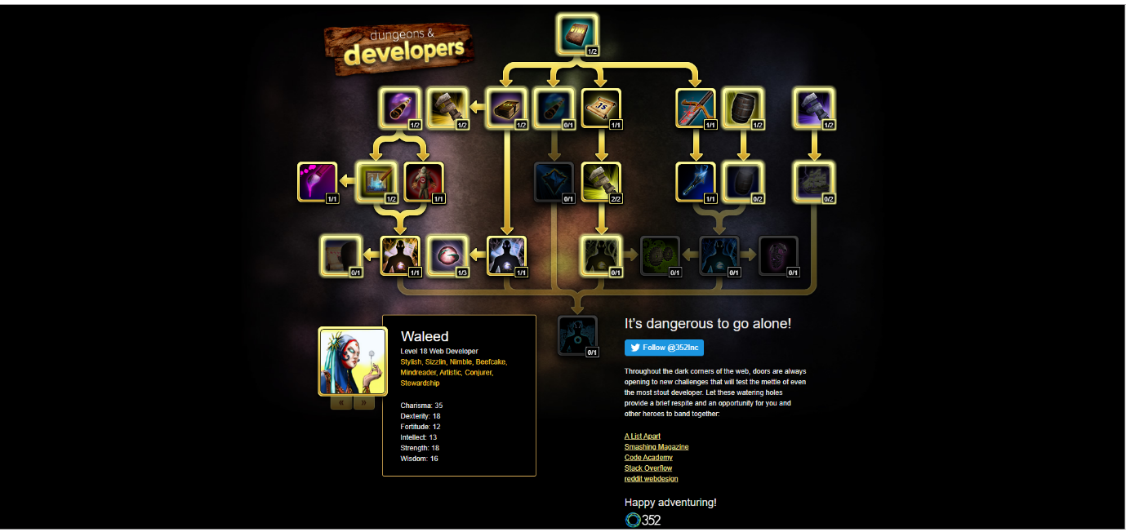**My web development skill stack**

**TASK 2**

**Inspiration for Website Design**

1. <https://www.birmingham.ac.uk/index.aspx>

University of Birmingham

The website created for Birmingham University gives the user a satisfying experience. As you can see from the website, it has classic and inspiring example for website design. It fits the page well and it shows you all the necessary requirements needed to be present on the index page, which can motivate students in joining it. The colour themes and the fonts used are well suitable for the webpage and it makes a clear understanding to the students. There is a search button at the top with the proper icon and colour background, which lets students an option to choose which degree they want to apply in. It’s header with navigation option presented matches with the image background of the container. It also has many other features.

1. <https://www.essex.ac.uk/>

University of Essex

The website for Essex University has the best animations as we scroll down through the main index page. It’s highly visible page titles provides location feedback and help user remains oriented. Its mixture of colour red, purple on the background image is fabulous. Its three different font’s variation is consistent. It’s important navigation option does not let user scroll down. This inspires me to add animations, bold text etc. on my website.

1. <https://acecomics.co.uk/>

Ace Comics

The comics website has everything organised in their department section. This gives the user a satisfying experience. It shows it newly released books on the front header page. It gives updates of all the variety of comic books. It has different sections which gives you an option of either buying them, signing up for a newsletter etc. The size of the image and text are large and very clear in quality. When clicking to any item it redirects to its specific page. The buttons of the page are spaced out and the user is not limited to find its way around the website. It motivates me to give appropriate font size, pic size, spacing etc. on my website.

**Profile webpage for a computer scientist**

**How is it going to be structured?**

Based on my research and the inspiration I got from viewing different websites gives me a clear idea that is going to be needed on Irena’s’ webpage.

Therefore, here are a few of them:

* Firstly, in the header page, there should be highly visible text, which gives clear user satisfaction.
* There should be a small biography section.
* Fonts must be of appropriate size, colour.
* There should be a background image, which indicates what the website about.
* Appropriate images must be used to give quality content.
* It needs to have five navigation options with proper anchor tags.
* Users must be able to jump to specific content.
* The website must have at least three external links.
* Users must be able to find information about Irena’s yoga classes.
* The website must be able
* It should have a good webpage speed.
* It needs to have Social Media icons linking to Irena’s accounts at the footer.
* The webpage should be flexible.
* The website must allow commenting on Irena’s post linking that to her main page.
* The website must show different projects companies in that project section.

**Irene Au webpage design**

* Irena Au name will be printed on the header part, with bold font size and appropriate colour background.
* There will be five navigation options which are (about, projects, social, Blogs, Services). For all of the navigation buttons there will be five sections. These will be underneath her name and will not clash with any sub headers.
* About section will give a brief bio of her and will not over collide with any other section.
* In her services, there will be two another navigation options, which would allow clients to book in for yoga sessions. The other one will be on upcoming events.
* Her blog section will give all the recent posts she has done in the UX field. (Book recommendations, which jobs to take etc...). linked to her main posts page.
* Irene social section will give all of her details where clients can contact them like on Facebook, Instagram etc...
* In her project, section there is going to be different companies she has worked in and performed her talent in UX.

**Clients**

**User Personas**

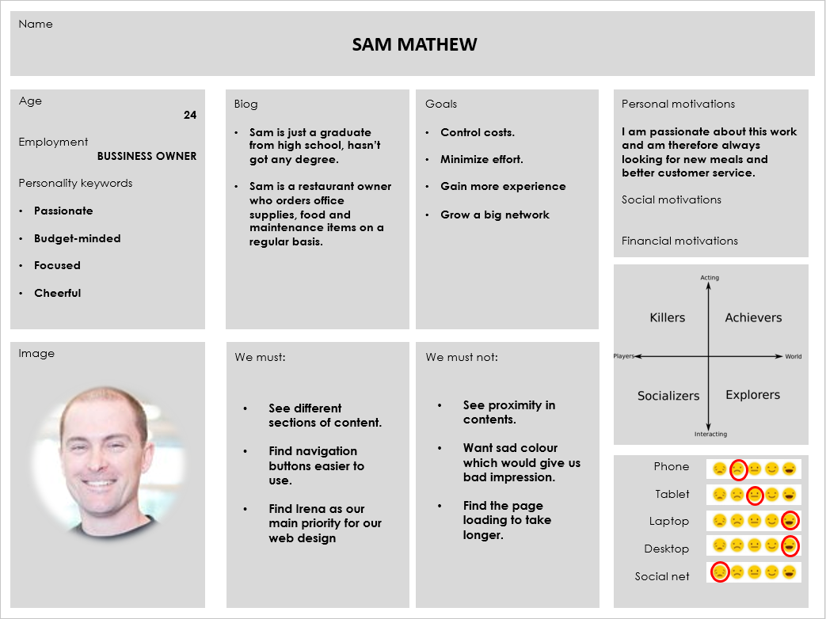

1. 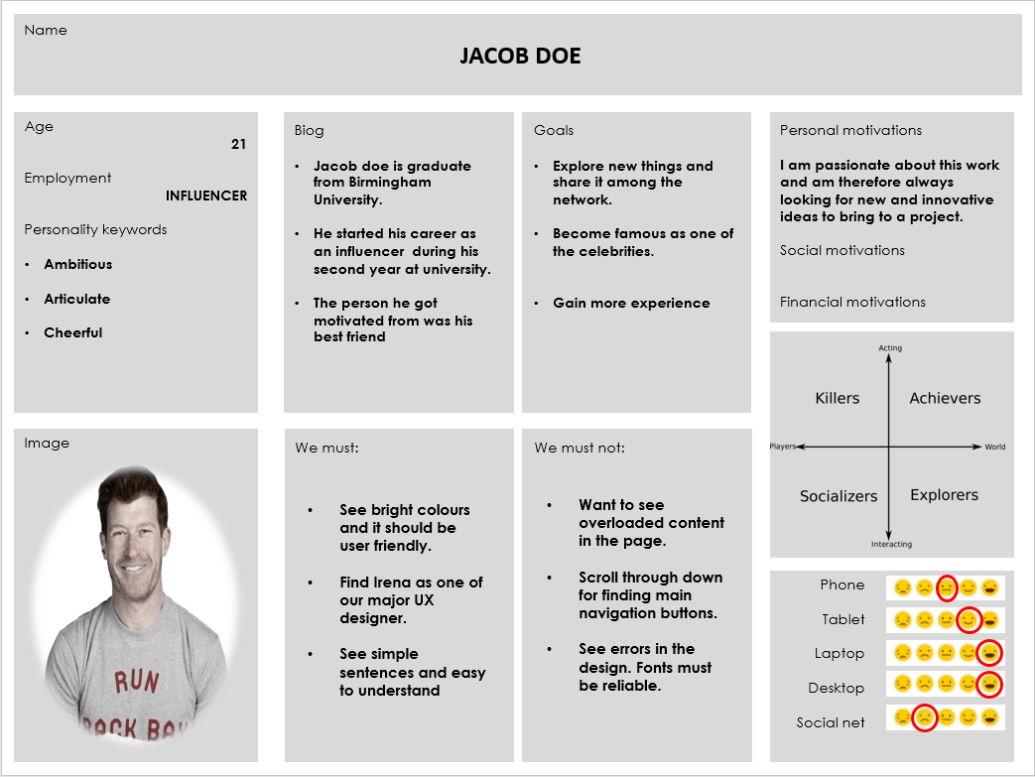

**User Stories**

**(SAM MATHEW)**

1. As a ***<role>*** business owner ***</role>***, I need to ***<goal>*** be able to contact Irene, to receive advice on how to improve as a designer and as a company***</goal>.*** So I can ***<benefit>*** make greater designs for our clients in the future. ***</benefit>***

**(JACOB DOE)**

1. As a ***<role>*** Influencer ***</role>***, I need to ***<goal>*** be able to view Irene’s previous projects in google, yahoo etc. ***</goal>.*** So I can ***<benefit>*** make sure that she is the right person to higher for my website design. ***</benefit>***

**User Journeys**

This is the wireframe prototype of my webpage design for Irene Au

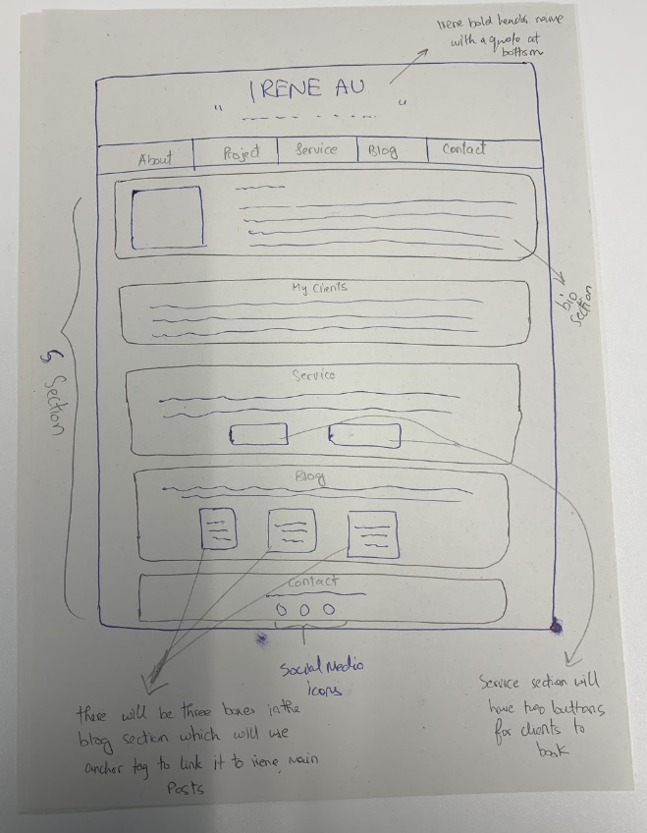

The clients (user personas) need to go through sever steps for booking in a yoga session.

START

Sam and Jacob first need to open the webpage.

Then go on the navigation bar and select the services option.

Checks for the yoga button and clicks it.

Now they are redirected to Irena’s yoga session page.

Clicks the day they found and are redirected to another page.

Now they enter their details and click submit

Finally, they get an email back confirming their session booking. With a message “**Thank you for being for part of the yoga team, I hope to see you soon**”.

END

**TASK 3**

**Inspiration for Website Design**

1. <https://www.wired.com/>

Wired website

The wired website has a nice layout, for the main page. Its navigation bars are just below the main bold text of the company. If we use fitt’s law on it, then accessing the navigation bar is fast. Webpage loading speed is also good. It has different section in the form of boxes, which have good animation when we bring our cursor on it. It also has a subscribe button at the top which allows you subscribing the company for their blogs, news etc. It sends a pop up box when we access the webpage at first.

1. <https://abcnews.go.com/>

abc news

The website for abc news has the best layout for CSS as we scroll down through the main index page. It has different section of boxes relating to the live news, awards etc. when we click on the box, it takes us to its specific webpage where in depth the details are given about them. It has proper padding all the of them fit on the centre of the page. Also uses the three different font types, etc. It’s logo is also unique and matches the colour of the page

1. <https://www.ovh.co.uk/>

OVHcloud

The OVHcloud website is based on buying domains and hosting them. It follows a good posture of the UX design. The whole website suits the theme. Every navigation option at the top has its own ordered lists. For e.g.; when we click on servers, it shows different type of servers and clicking further it takes us on its specific page. Showing the contract plans etc. The icons are also very relatable to its specific content. It also has many other features, which I really like. It’s CSS used is amazing.

**My Design**

As inspired from different website’s I came up with this design in this way its easier to use the navigation buttons. Page is simple and it shows what key elements are in it. There will be a unique logo added on the header part. The content is distributed in appropriate format and it can facilitate interaction. It also achieves a pleasant effect. In addition, the proximity is less so the elements of the page will not look like they are together. Even the white space used is not useless. It helps to guide the eye and helps understand the grouping information. My webpage follows the UX design method with all the specific requirements needed. It has several boxes, which have data related to the specific navigation option. The colour theme also matches the website. There is a bold text at the top, which indicates whom the website is about. There will be a small quote underneath the name of Irena. My padding is also well set. The project section will have three boxes with an external link. This gives user a better satisfaction. Three different font types will be used.

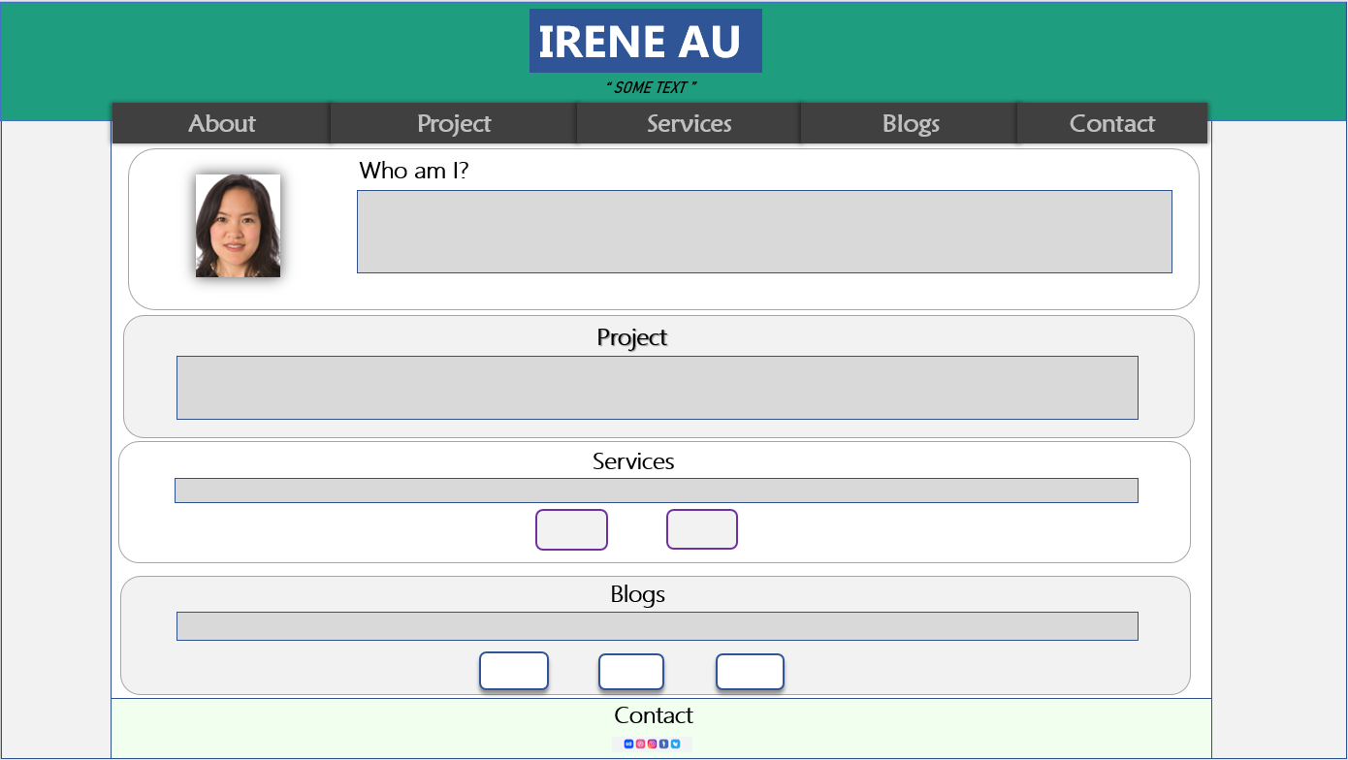My final design is going to look like the one below.

This is my header part where it has the name and a quote. Name and quote will be of font-size 40px, bold, Microsoft PhagsPa font style. There will be a green background.

These silver boxes are the content section. Which give user an idea, what is the page about.

This five-navigation bar will have bold text, font-size 34px; there will have an underline hover effect when the cursor is brought on it.



The blog section will show three different boxes of Irena’s recent posts etc. they will have a shadow effect and a hover effect as well. If the client wants to read more about the blog then they will be redirected a separate page, where it describes the blog more in depth.

This section of project will have content relating to her projects she had done with google, yahoo, Netscape etc.

The Services section is going to show two buttons which are related to yoga and her upcoming events. Which makes it easier for user to analyse. It going have small font size, and Arial font type.

**TASK 4**

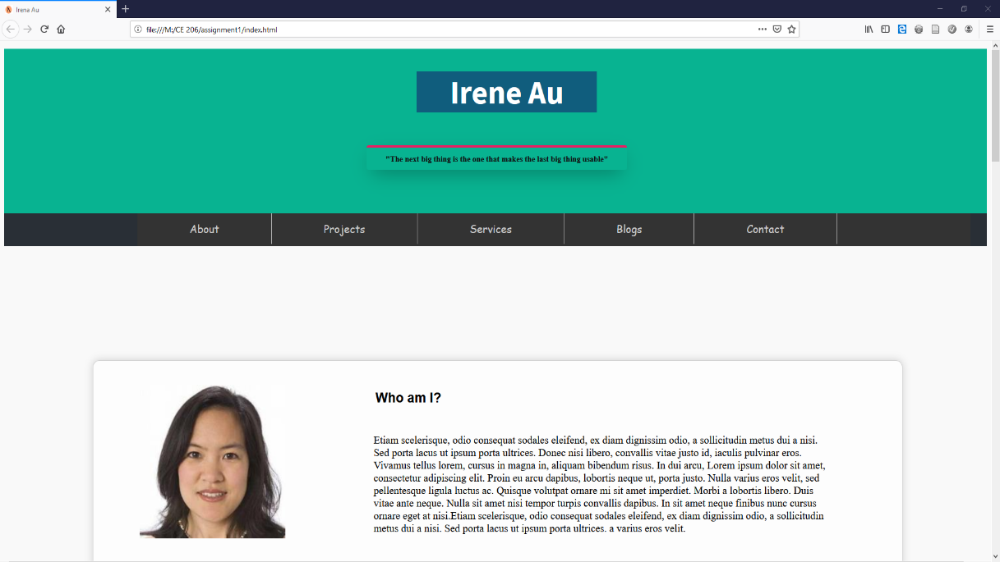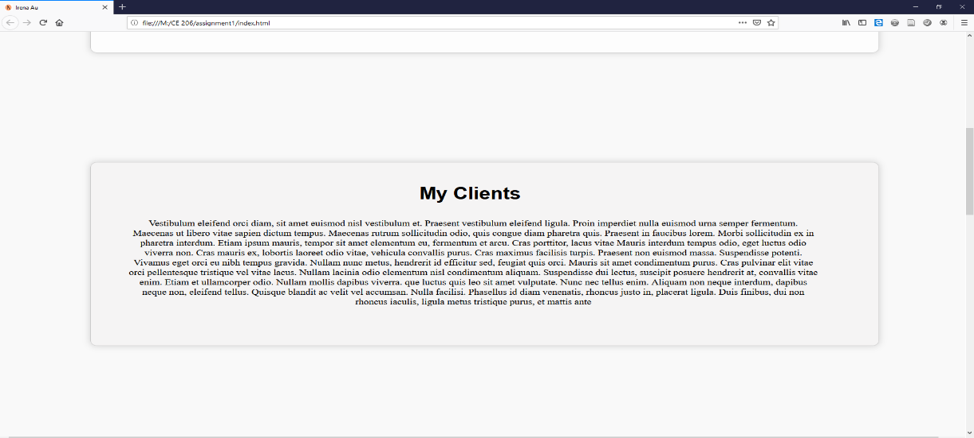

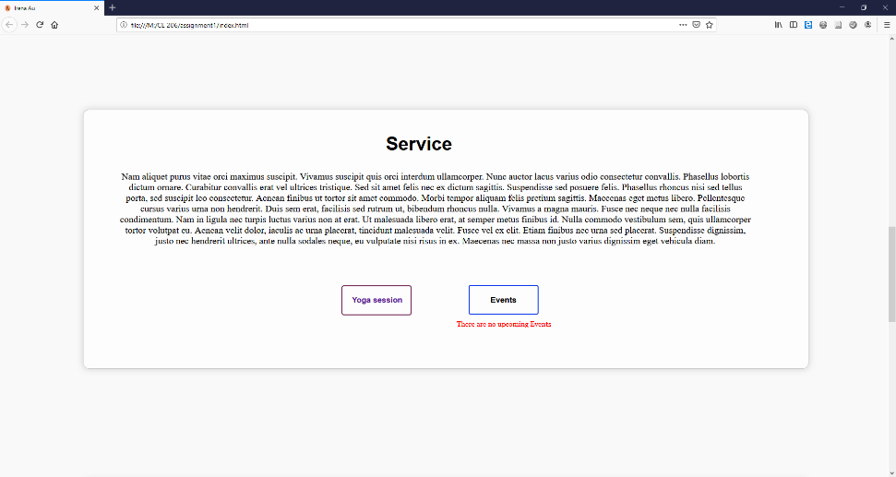

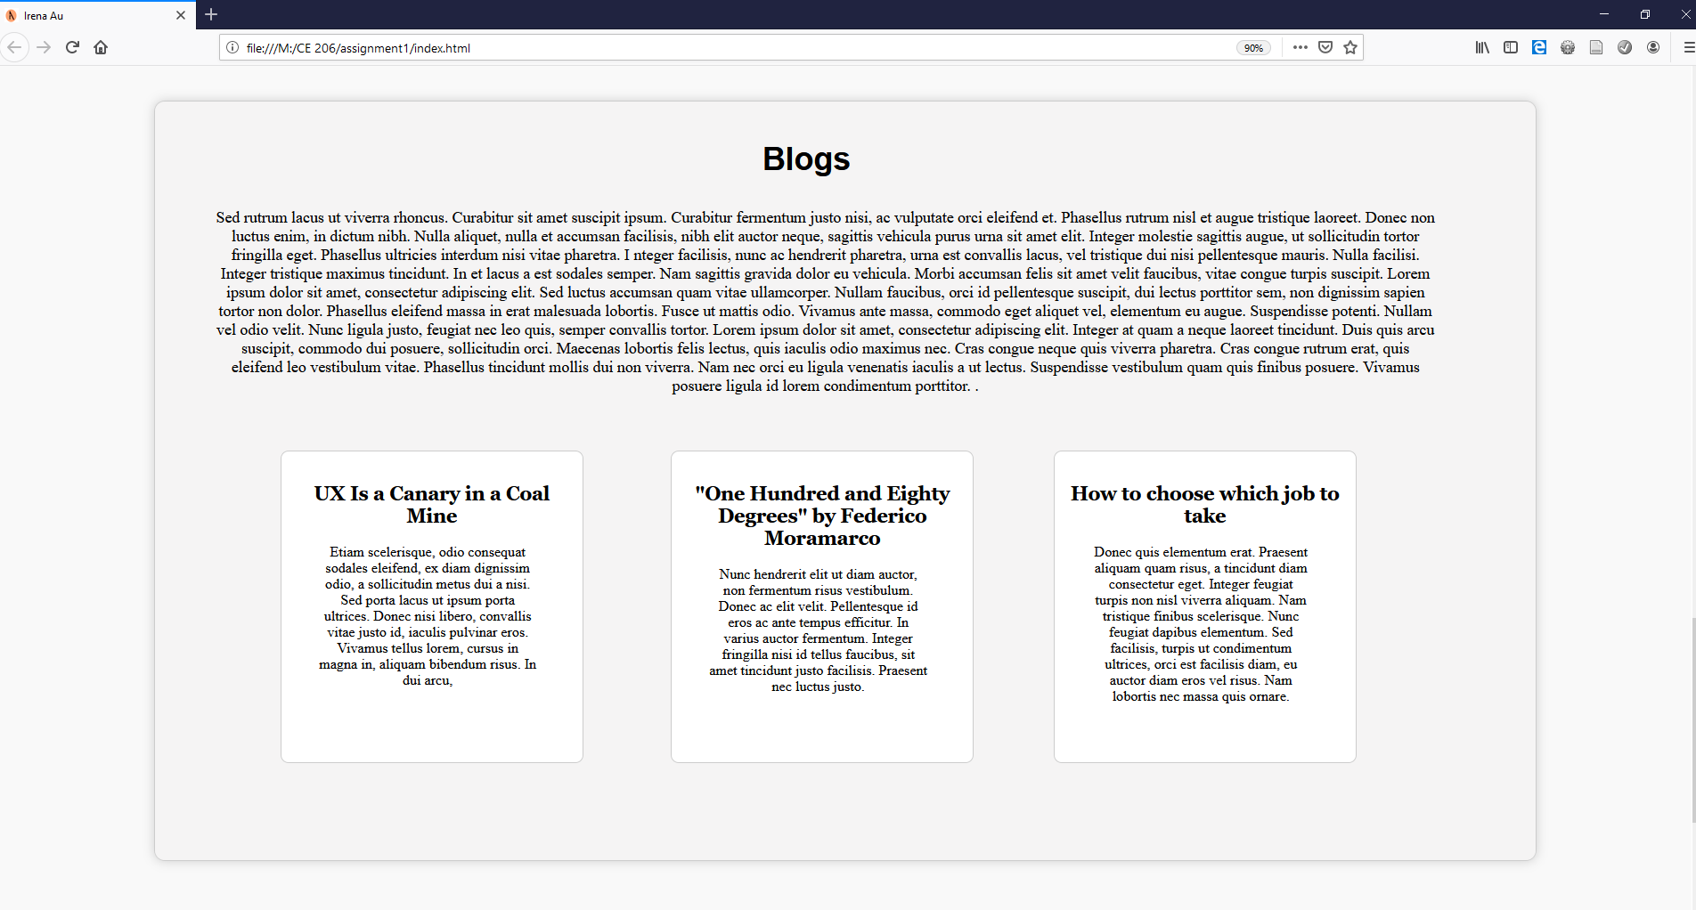

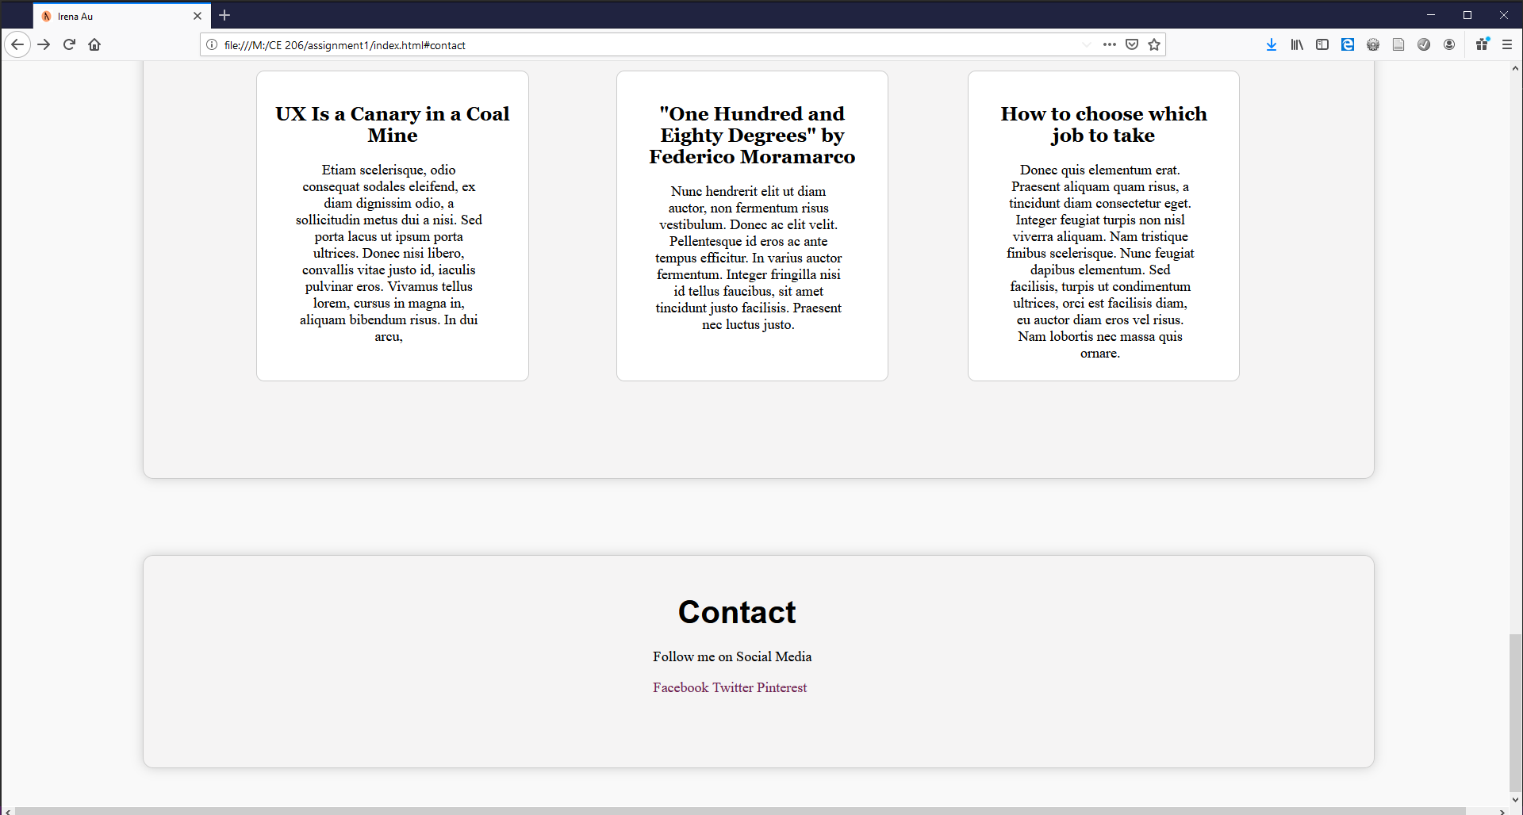

**TASK 5**

Calculating Fitt’s Law for my current index.html

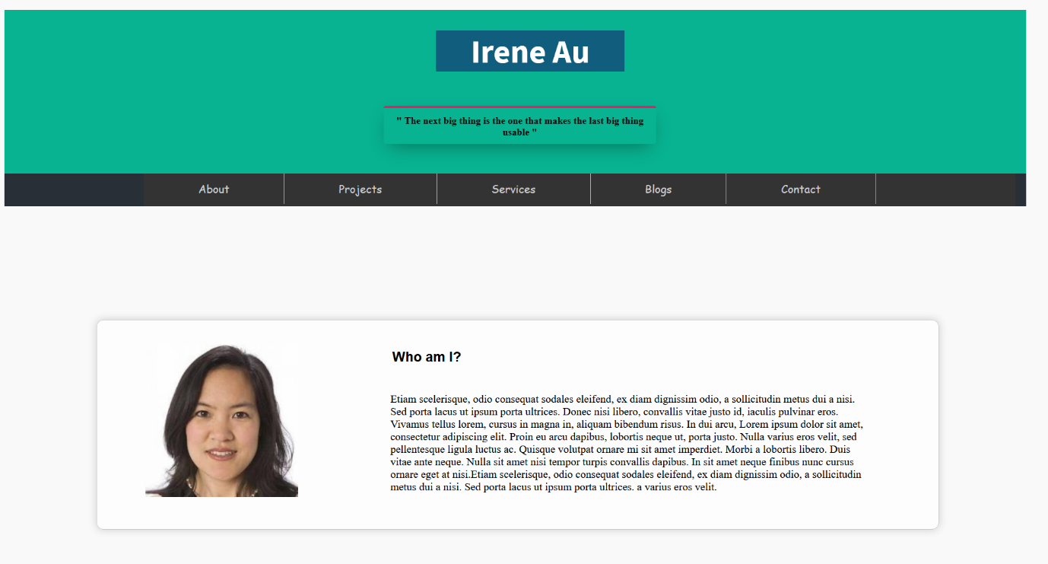**5.1**

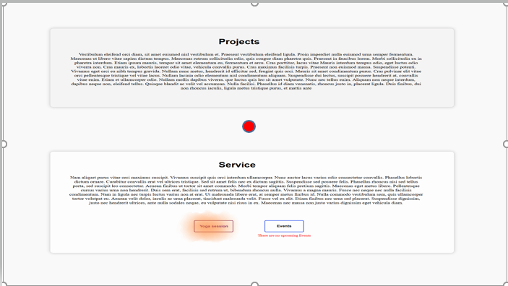

**5.2**

t = **a** + **b**·log2(d/w)

**a = 0.25 s**

**b = 0.125 s**

**The calculation are all from centre of the page represented by red dot to the navigation options.**

|  |  |  |  |  |
| --- | --- | --- | --- | --- |
| **Name** | **d** | **w** | **t or Mt** |  |
| About | 12 cm | 2 cm | 0.57 |  |
| Project | 7 cm | 2 cm | 0.48 |  |
| Service | 4 cm | 2 cm | 0.38 |  |
| Blogs | 7 cm | 2 cm | 0.48 |  |
| Contact | 12 cm | 2 cm | 0.57 |  |
| Yoga Session | 5 cm | 1 cm | 0.54 |  |
| Blog 1 | 9 cm | 2 cm | 0.52 |  |
| Blog 2 | 8 cm | 2 cm | 0.50 |  |
| Blog 3 | 9 cm | 2 cm | 0.52 |  |

**5.3**

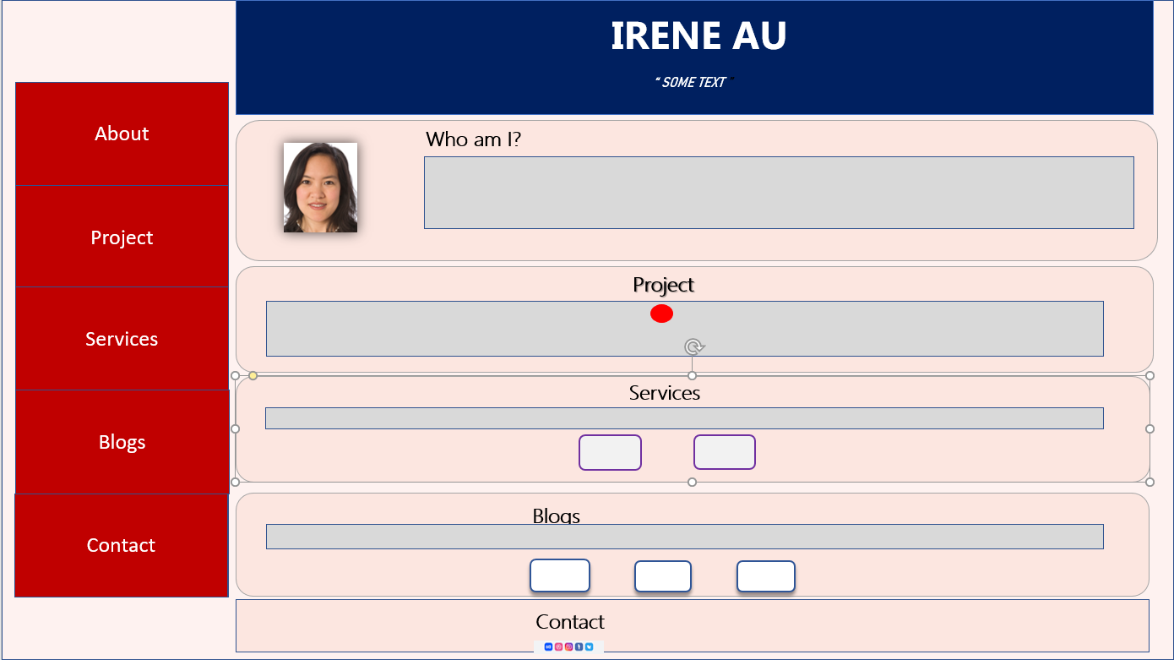New layout design for Irena au webpage that would reduce the average Mt without damaging the page’s functionality and quality of appearanc



I would make the navigation bar vertical and make the buttons larger.

This will also be fixed in its position so user won’t have to scroll up searching for the buttons. If they want to go in any specific section.

This is going to give a better mt value in fits law.

I would align the boxes for each section to left, so the page becomes user friendly.

The rest of my format remains the same as previous design. It give shadow boxes, with content in it. And three external links used inside blog. One external link used for yoga session button.

**5.4**

Calculating new mt

t = **a** + **b**·log2(d/w)

**a = 0.25 s**

**b = 0.125 s**

**The calculation are all from centre of the page represented by red dot to the navigation options.**

|  |  |  |  |  |
| --- | --- | --- | --- | --- |
| **Nav name** | **d** | **W** | **t or Mt** |  |
| About | 19 cm | 4 cm | 0.53 |  |
| Project | 18 cm | 4 cm | 0.52 |  |
| Service | 17 cm | 4 cm | 0.51 |  |
| Blogs | 18 cm | 4 cm | 0.52 |  |
| Contact | 19 cm | 4 cm | 0.53 |  |
| Yoga Session | 5 cm | 1 cm | 0.54 |  |
| Blog 1 | 8 cm | 2 cm | 0.50 |  |
| Blog 2 | 8 cm | 2 cm | 0.50 |  |
| Blog 3 | 8 cm | 2 cm | 0.50 |  |

**Statistical analysis**

I have measured five objects and calculated the MT using Fitt’s law equation. Below are my results for the analysis between the interfaces.

My Analysis for the both the MT after calculation is:

|  |  |  |  |  |  |  |  |  |  |  |  |  |  |  |  |
| --- | --- | --- | --- | --- | --- | --- | --- | --- | --- | --- | --- | --- | --- | --- | --- |
| |  |  |  | | --- | --- | --- | | **Group** | **Group one** | **Group two** | | *Mean* | 0.5067 | 0.5167 | | *SD* | 0.0581 | 0.0150 | | *SEM* | 0.0194 | 0.0050 | | *N* | 9 | 9 |   T = **0.5000**  df = **16**  Standard error of difference = **0.020**  The two-tailed P value = **0.6239** |

|  |  |
| --- | --- |
| **Mt-1** | **Mt -2** |
| 0.57 | 0.53 |
| 0.48 | 0.52 |
| 0.38 | 0.51 |
| 0.48 | 0.52 |
| 0.57 | 0.53 |
| 0.54 | 0.54 |
| 0.52 | 0.50 |
| 0.50 | 0.50 |
| 0.52 | 0.50 |

1. Since my P, value is not less than 0.05. I have measured fewer objects, which resulted in it being less significant.
2. I should design my webpage in a better layout. Therefore, it is easier for user to navigate around it.
3. From my prospective view webpages should be significant, because that the main priority to users. It makes them look through the page after just having a glance at the main page.

**Questionnaire**

**What do you like about the site?**

Age **19**, **computer science**: **I like the navigation bar.**

Age **19**, **LAW**: **Easy to reach information that you might want to look at.**

Age **21**, **psychology**: **the footer contact section is convenient.**

Age **19**, **Business Management**: **the fonts are impressive**

Age **22**, **Accounting: simple but nice colours**

**What would make you want to go back to it?**

Age **19**, **computer science**: **If it looked more colourful, that it makes me want look at it again.**

Age **19**, **LAW**: **if there was information that I needed to look at quickly**

Age **21**, **psychology**: **If there is more information on**

Age **19**, **Business Management**: **if the font was different in more places of the webpage, so it looked more interesting**

Age **22**, **Accounting and Finance**: **if it is easy to use**.

**What went wrong?**

Age **19**, **computer science**: **the contact form is not working properly.**

Age **19**, **LAW**: **The logo/image at the title section looks compressed.**

Age **21**, **psychology**: **The colour of the page.**

Age **19**, **Business Management**: **Design is basic**

Age **22**, **Accounting and Finance**: **The layout is lazy**

**How would I change my design?**

* I need to learn more about web-kit css for animations etc**.** Also designing more hover effects.
* There is more layout design I have to focus on. Like for instance organising every section in appropriate boxes, adding live wallpaper, videos.
* Absolute positioning of objects and staying flexible is what I need to focus more on.
* Setting up proper heights for each objects
* Making appropriate divisions in html.
* Adding different font styles and colors.

**TASK 6**

Based on my analysis using Fitt’s law and the assessments reviews I got have made me do some of the following modifications.

* I should design my navigation bar in vertical way on the right hand side and make is position fixed.
* Boost images of Irena in appropriate sections.
* I should specify better CSS background colour for each section.
* Utilize the white space properly.
* Add more 3d effects on it.
* I shall gain typography and readability.
* Develop colour palette and imagery.
* Add banners in header and other part of sections.
* Use of different font styles
* Make it more user friendly

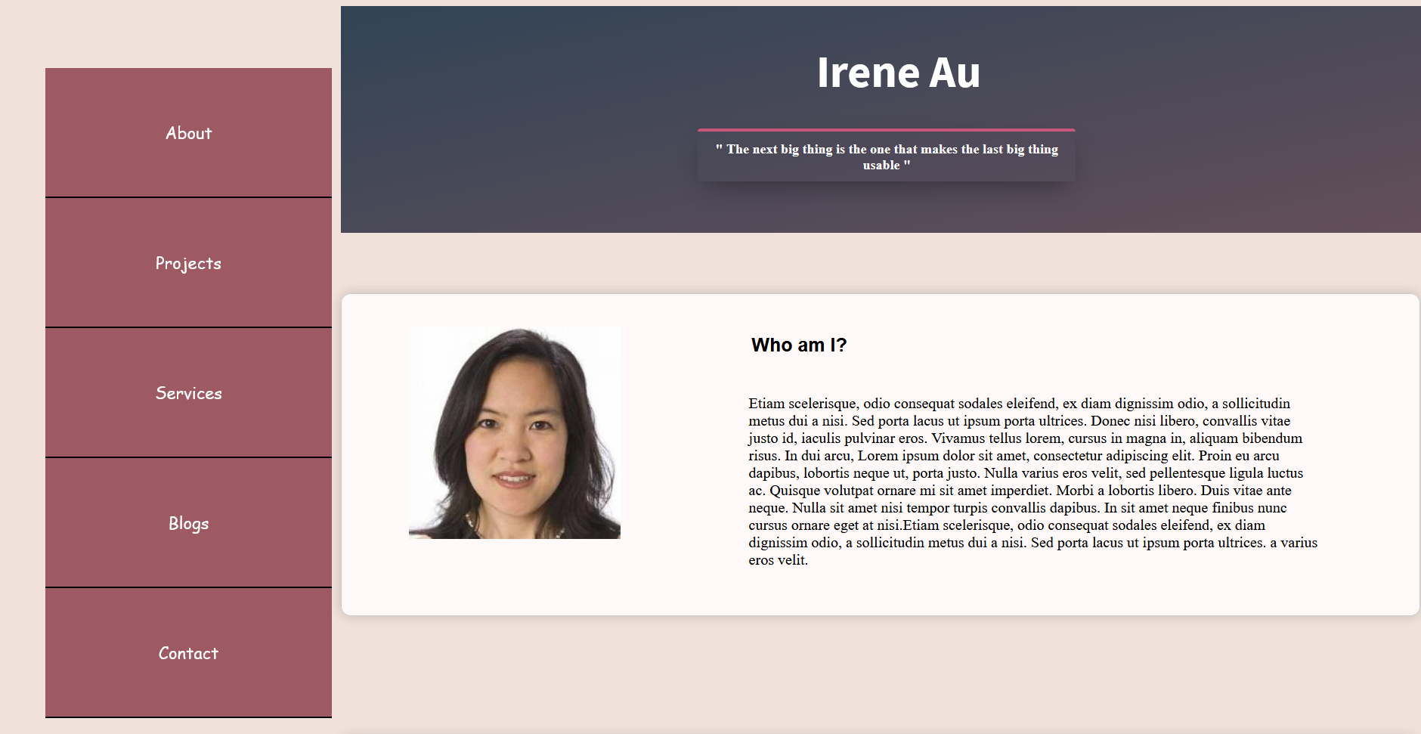**My final redesigned CSS**

