CE155 Assignment 1 – Cisco CCNA1 Skills Test

John Woods and Mays AL-Naday – October 2018

**Note:** The assignment brief consists of two parts:

1. This document – a generic document describing the assignment.

2. An individual set of parameters for each student, (available from where you obtained this document) with each student page indexed via registration number. This is your “unique parameter web page”.

**Where you will submit the assignment:** Electronic submission server.

**When you will submit it:** Please check entry on Faser for the deadline date and time

**What you will submit:** A single word document (.doc or docx), named as following the format: **<YOUR_REGISTERATION_NUMBER>.docx**. For example, if your registration number is **1234567**, then the submission document you will upload to FASER should be named **1234567.docx**.

The content are summarised below, but see the individual parts for full details:

Part 1: Tables 1 and 2 completed according to the specification.

Part 2: A description of the efficiency of the address assignment and how to improve it.

Part 3: A description of the two application layers protocols that you have been allocated.

**Marking schedule:**

Part 1: 38% spread equally across the table elements.

Part 2: 22% broken down as:

15% for the technical content.

7% for presentation and English usage.

Part 3: 40% broken down as:

20% for the technical description of the protocols.

10% for presentation and English usage.

10% for including a reference for each protocol and citing it with correct context.

**1. Address assignment**

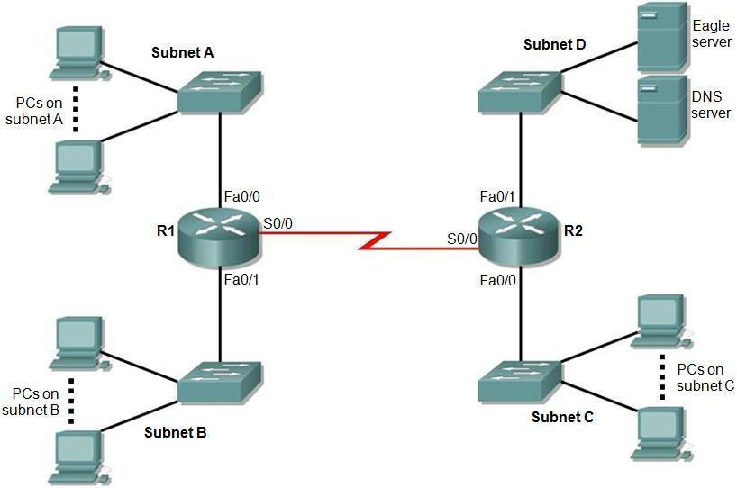

Figure 1. Topology diagram.

Figure 1 shows a network topology with five IP subnets. Notice that **Subnet E** covers the **WAN** between R1 and R2. By referring to your unique parameter web page you will find you have been allocated:

* The number of PCs on subnets A, B and C.
* An address range for you to use.
* A subnet mask length to use for ALL the five subnets.

Your task is to assign IP addresses to the devices in the network. You will fill in Table 1 and Table 2 with appropriate information bearing in mind the values on your unique parameter web page and the following facts:

* In addition to the PCs, each router interface needs a “host” IP address and it is part of the subnet.
* Only the DNS server and Eagle server are on Subnet D.
* Switches are not allocated IP addresses in this network.
* PCs and servers are to be allocated the lowest IP addresses in each subnet.
* Router interfaces are to be allocated the highest IP addresses in each subnet.
* The subnets are to be allocated in the order A, B, C, D and E, (i.e. A is the lowest address and E is the highest).

In Table 2, it is only necessary to indicate the first and last address of the PCs in each subnet using the lowest block of addresses.

|  |  |  |  |  |
| --- | --- | --- | --- | --- |
| Subnet | Network address | Mask in dotted decimal form  (e.g. 255.255.0.0) | Number of hosts, including PCs and router interfaces | Number of unused addresses |
| A |  |  |  |  |
| B |  |  |  |  |
| C |  |  |  |  |
| D |  |  |  |  |
| E |  |  |  |  |

Table 1. Subnet details.

|  |  |  |  |  |
| --- | --- | --- | --- | --- |
| Device | Interface | IP address | Mask in dotted decimal form  (e.g. 255.255.0.0 for /16) | Default Gateway |
| R1 | Fa0/0 |  |  | N/A |
| Fa0/1 |  |  | N/A |
| S0/0 |  |  | N/A |
| R2 | Fa0/0 |  |  | N/A |
| Fa0/1 |  |  | N/A |
| S0/0 |  |  | N/A |
| 1st PC subnet A | NIC |  |  |  |
| Last PC subnet A | NIC |  |  |  |
| 1st PC subnet B | NIC |  |  |  |
| Last PC subnet B | NIC |  |  |  |
| 1st PC subnet C | NIC |  |  |  |
| Last PC subnet C | NIC |  |  |  |
| 1st PC subnet D | NIC |  |  |  |
| Last PC subnet D | NIC |  |  |  |
| DNS server | NIC |  |  |  |
| Eagle server | NIC |  |  |  |

Table 2. Addressing table.

**2. Analysis of address space usage**

You will submit an explanation encompassing:

* A statement on how many further subnets are available using the address range and mask that you have been allocated.
* A comment on how efficiently the address space you have been allocated has been used.
* A brief description of how the address space you have been allocated could be utilised more efficiently to leave a maximum number of addresses free for future expansion. You should not state any actual addresses but rather provide a general description of the process used.

**3. Application layer services**

In your unique parameter web page you have been allocated two application layer services. In most cases the name is given as an abbreviation.

For each one, provide:

* The full title of the protocol if it is given in abbreviated form (e.g. HTTP is hypertext transfer protocol)
* A brief description of the purpose of the application
* The transport layer protocol (or protocols) usually used to transport the application protocol
* The normal (well known) transport layer port(s) that the protocol uses (some may use more than one)
* A very brief description of how the protocol works, for example the key messages sent by the protocol
* A full reference to either: a book, published article, or standards document that describes the protocol. The reference should be included at a suitable point in your description of the protocol. A web reference (except to a standards document) is unacceptable. For example HTTP is defined in RFC 2626 [1], described in a journal paper by Janssen [2] and also described by Tanenbaum [3]. Note how a recognised reference standard is used here as an example to a standards document, a scholarly article and finally a well-known text book.

**4. References**

[1] R. Fielding et al., Hypertext Transfer Protocol -- HTTP/1.1, IETF RFC 2626, June 1999. Available from: http://www.ietf.org/rfc/rfc2616.txt

[2] W. C. Janssen, “A next generation architecture for HTTP,” IEEE Internet Computing, Volume 3, Issue 1, Jan.-Feb. 1999, pp 69-73.

[3] A. S. Tanenbaum, *Computer Networks*, Pearson Education, 4th ed., 2007.