[KAN-1] No data to select in required field https://tutorialsninja.com/demo/ Created: 22/Jan/26
Status: | In Progress
Project: | Bug Reporting Board
Components: | None
Affects versions: | None
Fix versions: | None

Type: | Bug | Priority: | Medium
Reporter: | Muhammad Waleed Hassaan | Assignee: | Muhammad Waleed  Hassaan
Resolution: | Unresolved | Votes: | 0
Labels: | None
Remaining Estimate: | Not Specified
Time Spent: | Not Specified
Original estimate: | Not Specified

Attachments: | bug1.png
Rank:

Description

When ordering for a camera, user has to select a type , after clicking on the drop down there is no option to select from. This field is a required field
Steps to Reproduce:
- Navigate to the home page at https://tutorialsninja.com/demo/
- Locate the camera “Canon EOS 5D”.
- Observe that there are no options available to select from.
Expected Behavior: There should be options available to select from.
Actual Behavior: There are no options available, hence not adding the product to the cart

[KAN-2] The Name of the product is not mentioned https://tutorialsninja.com/demo/ Created: 22/Jan/26
Status: | Done
Project: | Bug Reporting Board
Components: | None
Affects versions: | None
Fix versions: | None

Type: | Bug | Priority: | Medium
Reporter: | Muhammad Waleed Hassaan | Assignee: | Muhammad Waleed  Hassaan
Resolution: | Done | Votes: | 0
Labels: | None
Remaining Estimate: | Not Specified
Time Spent: | Not Specified
Original estimate: | Not Specified

Attachments: | bug2.png
Rank:

Description

When we hover over MP3 players, there are multiple options available named test12, test11 etc.
Steps to Reproduce:
- Navigate to the https://tutorialsninja.com/demo/index.php?route=product/category&path=57
- Hover over the MP3 player options
Expected Behavior: Clear names of mp3 players should be displayed
Actual Behavior: Test data and incorrect names are being displayed.

Test Worthy Credentials: Username: fa25msseooo9@maju.edu.pk Password: 13April2000@04

[KAN-3] The navigation bar links are not working properly https://tutorialsninja.com/demo/ Created: 22/Jan/26
Status: | In Progress
Project: | Bug Reporting Board
Components: | None
Affects versions: | None
Fix versions: | None

Type: | Bug | Priority: | Medium
Reporter: | Muhammad Waleed Hassaan | Assignee: | Muhammad Waleed  Hassaan
Resolution: | Unresolved | Votes: | 0
Labels: | None
Remaining Estimate: | Not Specified
Time Spent: | Not Specified
Original estimate: | Not Specified

Attachments: | bug3.png
Rank:

Description

The links on the navigation bar , on directly clicking them are not redirecting to the category.
Steps to Reproduce:
- Navigate to the https://tutorialsninja.com/demo/
- Locate the navigation bar
- Click on any link
Expected Behavior: It should redirect to the respective page.
Actual Behavior: It is not redirecting

[KAN-4] Pagination Links Missing Next and Previous Options https://tutorialsninja.com/demo/index.php?route=product/category&path=24 Created: 22/Jan/26
Status: | In Progress
Project: | Bug Reporting Board
Components: | None
Affects versions: | None
Fix versions: | None

Type: | Bug | Priority: | Medium
Reporter: | Muhammad Waleed Hassaan | Assignee: | Muhammad Waleed  Hassaan
Resolution: | Unresolved | Votes: | 0
Labels: | None
Remaining Estimate: | Not Specified
Time Spent: | Not Specified
Original estimate: | Not Specified

Attachments: | bug4.png
Rank:

Description

When navigating through paginated content,the pagination controls do not include options for "Next" and "Previous" links.
Steps to Reproduce:
- Navigate to https://tutorialsninja.com/demo/index.php?route=product/category&path=24
- Locate the pagination link.
Expected Behavior: The pagination controls should include options for "Next" and "Previous" links.
Actual Behavior: The pagination controls donot have "Next" and "Previous" links.

[KAN-5] Characters in Phone number field https://tutorialsninja.com/demo/ Created: 22/Jan/26
Status: | Done
Project: | Bug Reporting Board
Components: | None
Affects versions: | None
Fix versions: | None

Type: | Bug | Priority: | Medium
Reporter: | Muhammad Waleed Hassaan | Assignee: | Muhammad Waleed  Hassaan
Resolution: | Done | Votes: | 0
Labels: | None
Remaining Estimate: | Not Specified
Time Spent: | Not Specified
Original estimate: | Not Specified

Attachments: | bug5.png
Rank:

Description

The website lets user to add non numeric characters in the telephone field
ChatGPT
Bug Title: Pagination Links Missing Next and Previous Options
Bug Description: When navigating through paginated content, such as event listings or search results, the pagination controls do not include options for "Next" and "Previous" links.
Steps to Reproduce:
- Navigate to https://tutorialsninja.com/demo/index.php?route=account/register
- Add all the required information
- Click on submit
Expected Behavior: The form should not allow user to submit forms field of telephone number with non numeric characters
Actual Behavior: The form allows user to submit forms field of telephone number with non numeric characters.

[KAN-6] Wrong Insights on the navigation bar https://tutorialsninja.com/demo Created: 22/Jan/26
Status: | In Progress
Project: | Bug Reporting Board
Components: | None
Affects versions: | None
Fix versions: | None

Type: | Bug | Priority: | Medium
Reporter: | Muhammad Waleed Hassaan | Assignee: | Muhammad Waleed  Hassaan
Resolution: | Unresolved | Votes: | 0
Labels: | None
Remaining Estimate: | Not Specified
Time Spent: | Not Specified
Original estimate: | Not Specified

Attachments: | bug15.png
Rank: | 0|i0003j:

Description

When navigating to the home page, the insights about the data upon selection of any sub menu , the data insights are wrong where as there are items present for that particular menu.
Steps to Reproduce:
- Navigate to the home page
- Click on the navigation bar
- Select “Laptops and Notebooks”
- Select “Mac(0)“
- No data is presented
Expected Results:
The system should show the relevant data of MacBooks present in the system
Actual Results:
The website doesnt show any data related to MAC, eventhough there are 2 macbooks present in the inventory


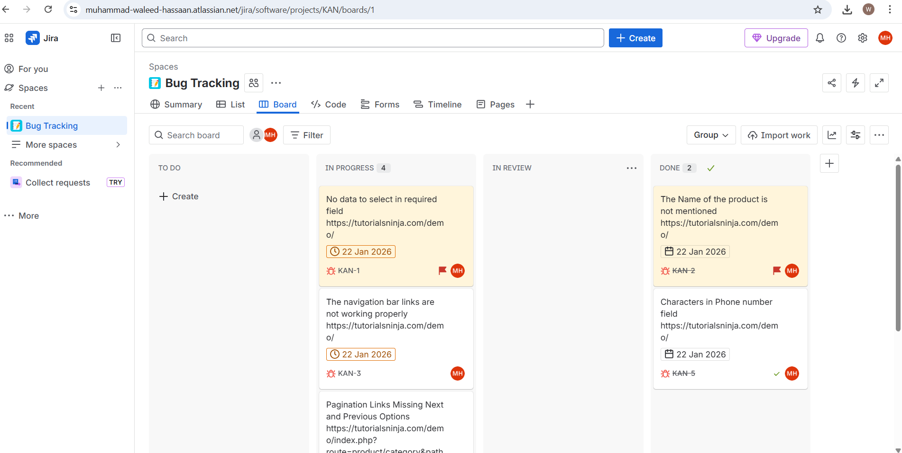

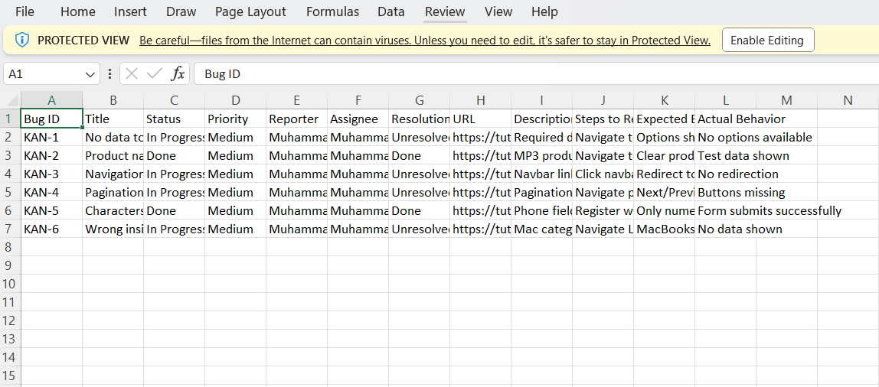
RELEASE NOTE:
