**RSA Public-Key Cryptosystem Analysis**

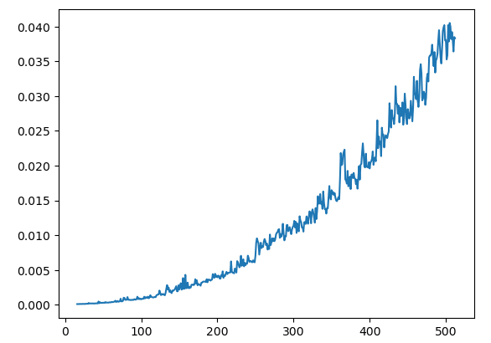

In the above image I plotted the key size (in bits) used in encryption on the x-axis versus the time elapsed in the encryption process on the y-axis

We can see that the encryption/decryption time is directly proportional to the key size (The larger key sizes, the more encryption/decryption time is required)

I used key sizes in the range from 16 to 512

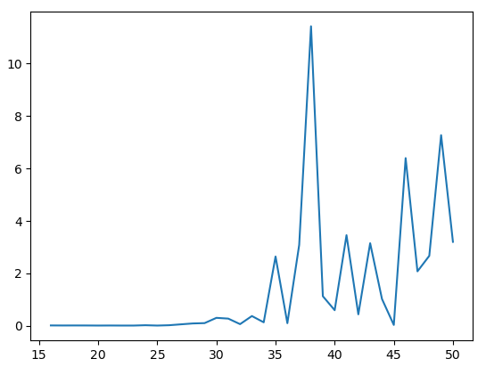

In the above image I plotted the key size (in bits) used in encryption on the x-axis versus the time elapsed in brute forcing this key on the y-axis

We can see that the brute forcing time is directly proportional to the key size

I used this package `sympy` to do the prime factorization

I used key sizes in the range from 16 to 50 and I didn’t try larger keys because it took very large time