

**THE SUPERIOR UNIVERSITY LAHORE Semester: BSSE-6C**

**Section: 6C**

**Session: S25**

**Faculty of Computer Science and Information Technology**

**Subject: MAD**

Instructor: Muhammad Hassan Total Marks: 50

**dd**

|  |
| --- |
| **Subject: MAD** |
| **Coursework title: MAD** |
| **Course Teacher:**   **Sir Daniyal Qamar** |
| **Student Name: Waleed Waheed** |
| **Roll No: SU92-BSSEM-F22-309** |

**Task 3: Routing and Margin in Flutter**

**Task 1: Routing**

**Objective: Implement navigation between two screens using**

**Flutter’s Navigator.**

**Instructions:**

**1. Create two screens: HomePage and SecondPage.**

**2. On the HomePage, place a button that navigates to**

**the SecondPage using Navigator.push().**

**3. On the SecondPage, display a message to indicate successful navigation.**

**Task 2: Margin and Padding**

**Objective: Apply margins and padding to UI components.**

**Instructions:**

**1. On the HomePage, create a container with a colored background.**

**2. Apply a margin of 20 pixels around the container to create spacing from**

**other elements.**

**3. Inside the container, place a text widget with a padding of 15 pixels to**

**space it from the container’s edges.**

**4. Ensure that the UI looks neat and properly aligned.**

**Bonus Task: Combine both tasks by placing the button inside the container on**

**the HomePage. This way, the button and the text with margins and padding**

**work together.**

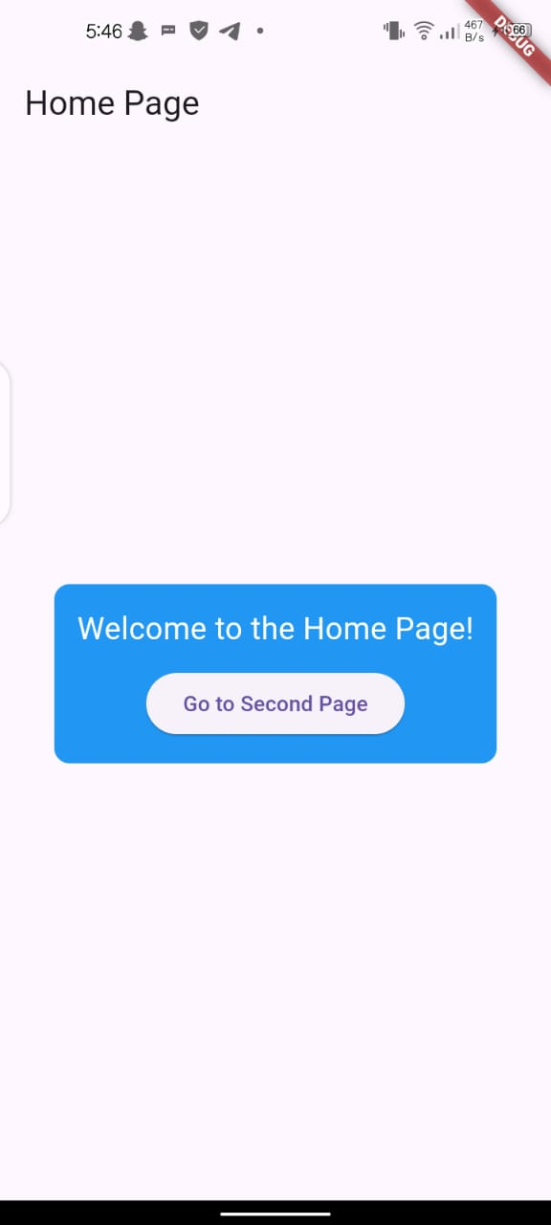

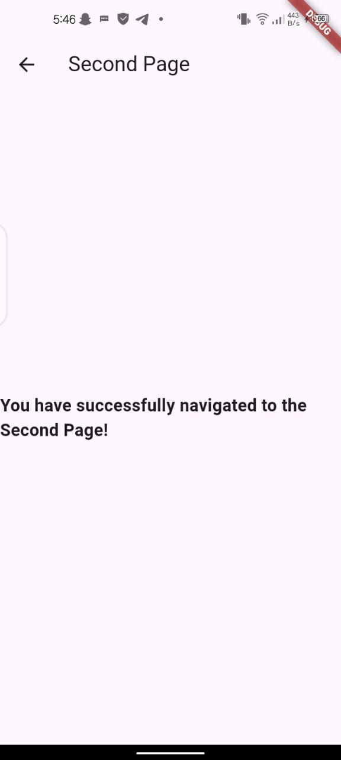

**import 'package:flutter/material.dart';**

**void main() {**

**runApp(MyApp());**

**}**

**class MyApp extends StatelessWidget {**

**@override**

**Widget build(BuildContext context) {**

**return MaterialApp(**

**home: HomePage(),**

**);**

**}**

**}**

**class HomePage extends StatelessWidget {**

**@override**

**Widget build(BuildContext context) {**

**return Scaffold(**

**appBar: AppBar(**

**title: Text('Home Page'),**

**),**

**body: Center(**

**child: Container(**

**margin: EdgeInsets.all(20), // Margin of 20 pixels around the container**

**padding: EdgeInsets.all(15), // Padding of 15 pixels inside the container**

**decoration: BoxDecoration(**

**color: Colors.blue, // Colored background**

**borderRadius: BorderRadius.circular(10), // Rounded corners**

**),**

**child: Column(**

**mainAxisSize: MainAxisSize.min, // Make the column take minimum space**

**children: [**

**Text(**

**'Welcome to the Home Page!',**

**style: TextStyle(**

**color: Colors.white,**

**fontSize: 20,**

**),**

**),**

**SizedBox(height: 10), // Spacing between text and button**

**ElevatedButton(**

**onPressed: () {**

**// Navigate to SecondPage**

**Navigator.push(**

**context,**

**MaterialPageRoute(builder: (context) => SecondPage()),**

**);**

**},**

**child: Text('Go to Second Page'),**

**),**

**],**

**),**

**),**

**),**

**);**

**}**

**}**

**class SecondPage extends StatelessWidget {**

**@override**

**Widget build(BuildContext context) {**

**return Scaffold(**

**appBar: AppBar(**

**title: Text('Second Page'),**

**),**

**body: Center(**

**child: Text(**

**'You have successfully navigated to the Second Page!',**

**style: TextStyle(**

**fontSize: 18,**

**fontWeight: FontWeight.bold,**

**),**

**),**

**),**

**);**

**}**

**}**