Assumptions
To keep the implementation realistic and concrete, I made several assumptions. They are consistent with the original requirements, but they are my own and are not based on a real environment. The project is intended to demonstrate my knowledge and skills rather than to be used in production, so I trust this does not conflict with the purpose of the assessment.
- The service is a small internal microservice that provides product SKU prices to other parts of the system over internal HTTP.
- It retrieves prices from an external ERP system over HTTPS. The ERP is not part of our application and runs in an external network.
- The service is deployed to Azure App Service.

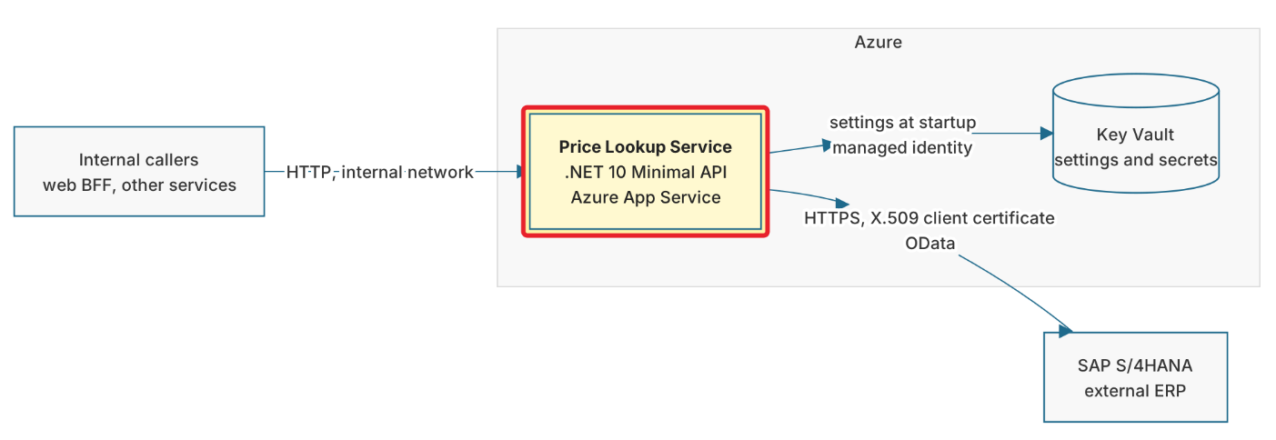

SAP S/4HANA and X.509
The choice of SAP S/4HANA as the ERP and of X.509 client certificates for authentication is largely arbitrary. The main reason is practical experience: in my experience, SAP is one of the most challenging data sources to consume and process in .NET.

Architecture
The project is written in DDD style, because the attempt to write it in the API<=>Service style failed: potential problems with further attempts to extend the functionality (for example, adding telemetry or bulk requests), and a service that was practically a god class, able both to retry and to parse the messy data from HANA.
You can find one of the architecture diagrams below. Many more are available in architecture.md.
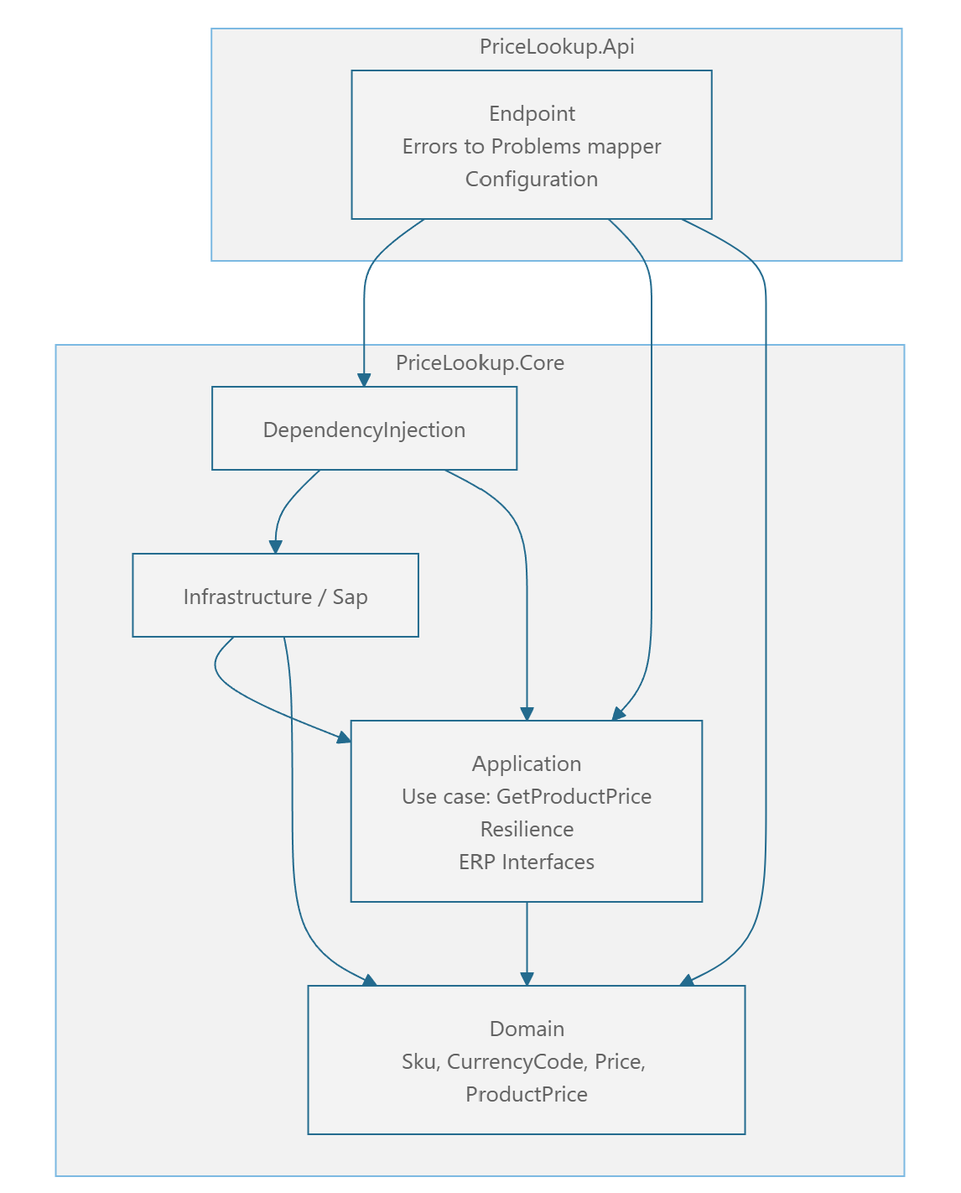

Error handling
Since the target infrastructure is unknown, errors are returned in the standard ProblemDetails format (RFC 9457) with a machine-readable code: 400, 404, 502, etc.

