**Exercise 8**

Use the given image files, sound files, and source file (SnowwhiteFrame.java)

Complete the source file as follows:

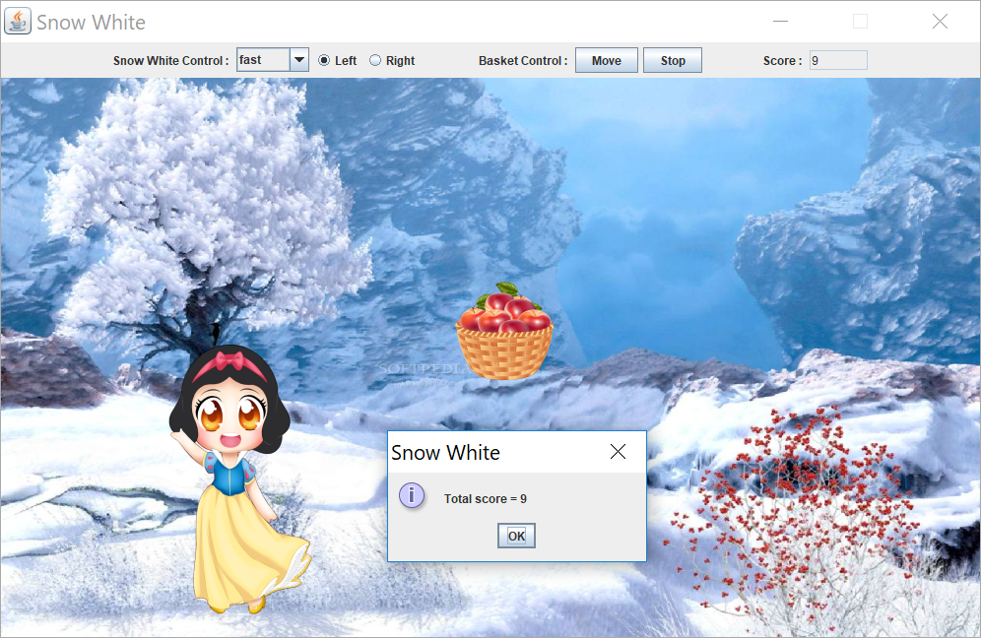

- Radio buttons to make Snow White walk left/right. When reaching one side, she’ll appear on the other

- Combo box to set Snow White’s speed

- MOVE to make the basket move randomly

- STOP to make the basket stop moving

- Increase score when it hits Snow White

- Report final score when closing frame

1. All listener classes must be anonymous classes. There are 4 listeners to add
   1. Add ItemListener to the combo box, to set Snow White’s speed

* Fast = short sleeping time for snowwhiteThread (see 2)
* Slow = long sleeping time for snowwhiteThread
  1. Add ItemListener to each radio button, to set Snow White’s direction
  2. Add ActionListener to Move & Stop buttons, to make the basket move or stop moving
* Move 🡪 create and start basketThread (see 3)
* Stop 🡪 stop basketThread
  1. Add WindowListener to the frame, to show the final score when closing it

2. Use snowwhiteThread to make Snow White walk automatically. Anonymous class is applied

public void setSnowwhiteThread()

{

Thread snowwhiteThread = new Thread() {

public void run()

{

while (snowwhiteMove)

{

// Add code to update Snow White’s location

repaint();

collision(); // checked by either Snow white or basket

try { Thread.sleep(snowwhiteSpeed); }

catch (InterruptedException e) { e.printStackTrace(); }

} // end while

} // end run

}; // end thread creation

snowwhiteThread.start();

}

3. Use baseketThread to make the basket move automatically. Anonymous class is applied

public void setBasketThread()

{

Thread basketThread = new Thread() {

public void run()

{

while (basketMove)

{

// Add code to update basket’s location

repaint();

try { Thread.sleep(basketSpeed); }

catch (InterruptedException e) { e.printStackTrace(); }

} // end while

} // end run

}; // end thread creation

basketThread.start();

}

4. Complete method collision. If Snow White and basket hit each other, play hit sound and

update the score

**Hint** : to check whether 2 labels overlap

if ( label_1.getBounds().**intersects**(label_2.getBounds()) )

System.out.println("label 1 overlaps with label 2");