GLOBAL SEISMIC ACTIVITY REPORT
An Analysis of Global M5.0+ Earthquakes, 2020–2026
Data-Driven Insights for Risk, Planning & Decision Support
Prepared for: Akinwale Oloruntimilehin
Prepared by: Claude — Data Analysis & Business Intelligence
Report Date: August 31, 2026
Source Dataset: global_earthquakes_2020_2026.csv (11,808 records)

1. Executive Summary
This report analyses 11,808 globally recorded earthquakes of magnitude 5.0 and above, spanning January 1, 2020 through July 14, 2026 (2026 is a partial year through the latest record). The dataset is sourced from a seismic monitoring network (predominantly the USGS "us" network) and represents reviewed, quality-controlled events — not preliminary or unverified detections.
11,808  Total Earthquakes  (M5.0+) | 92  Major Events  (M7.0+) | 1,803  Avg. Events / Year  (2020–2025) | M8.8  Largest Event  Recorded

Key headline findings:
- No statistically significant long-term trend in earthquake frequency was found (2020–2025 slope ≈ +37 events/year, p = 0.68) — annual counts fluctuate around a stable historical average of ~1,800 events/year, and 2026's partial-year pace (annualised to ~1,857) sits within that normal range.
- Seismic activity is heavily concentrated along the Pacific "Ring of Fire": Indonesia, Russia, the South Sandwich Islands, the Philippines, and Papua New Guinea together account for over 30% of all recorded events.
- The single largest event in the dataset — the M8.8 Kamchatka Peninsula, Russia earthquake of July 29, 2025 — is also the busiest-aftershock driver in the dataset, generating 413 M5.0+ events in Russia in the following month alone.
- Apparent "seasonal" spikes in monthly earthquake counts are not calendar-driven; they are statistically traceable to aftershock sequences following individual major mainshocks (Kamchatka 2025, Kermadec/New Zealand 2021, South Sandwich Islands 2021, Philippines 2023). This is a critical correlation-vs-causation distinction for any operational planning use of this data.
- 83.4% of events are shallow (<70km depth), which are typically the most damaging to surface infrastructure; only 3.4% are deep-focus (>300km).
- Data quality is strong overall (0 duplicate records, valid coordinate ranges, 100% human-reviewed status) but station-count metadata (nst) is missing in a systematic, non-random pattern tied to specific reporting networks — this is flagged for downstream analytical caution.

2. Dataset Overview
The raw file contains 11,808 rows and 21 columns, with one row per earthquake event. Each record includes location, timing, magnitude, depth, and seismological quality-control metadata.

2.1 Structure
Attribute | Detail
Records | 11,808 individual earthquake events
Time span | Jan 1, 2020 – Jul 14, 2026 (2026 is a partial year)
Magnitude filter | All events are M5.0 or greater (dataset is pre-filtered; smaller quakes are not represented)
Geographic coverage | Global — valid latitudes (-69.8° to 87.4°) and longitudes (-180° to 180°)
Key fields | time, latitude, longitude, depth, mag, magType, place, region, mag_category, plus 8 quality-control metrics (nst, gap, dmin, rms, horizontalError, depthError, magError, status)
Primary data source | "us" network (98.6% of records); remainder from regional/national networks (Alaska, ISC-GEM, Puerto Rico, California, Nevada, etc.)
Review status | 100% of records are "reviewed" (seismologist-verified), none preliminary/automatic

Note on scope: because the dataset only includes M5.0+ events, all statistics in this report describe moderate-to-major earthquakes only. They should not be interpreted as total global seismicity (which includes millions of smaller M1–4 events each year not captured here).

3. Data Quality & Cleaning

3.1 Structural Integrity
- Duplicates: 0 fully duplicated rows and 0 duplicated event IDs found — every record is a unique, distinct event.
- Coordinate validity: All 11,808 latitude/longitude pairs fall within valid physical bounds; no impossible or placeholder coordinates were found.
- Date integrity: Timestamps parse cleanly across the full range with no invalid or future-dated records (relative to the extraction date).

3.2 Missing Data
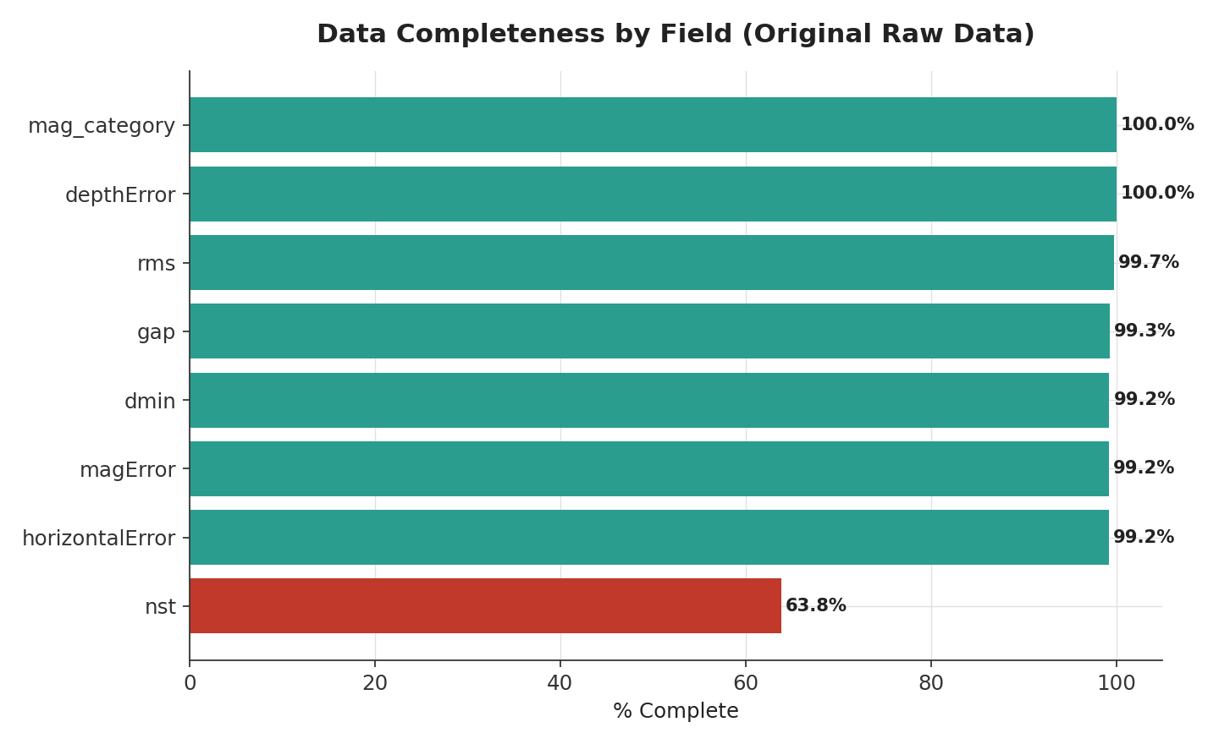
Figure 1. Completeness of each field in the original raw data.
Missing values were investigated field by field rather than blanket-imputed:
- mag_category (25.2% missing, 2,981 rows): This field could be fully reconstructed. By reverse-engineering the classification logic against the ~75% of populated rows, we determined the dataset uses magnitude bins with an upper-inclusive boundary (e.g., a M5.5 event is filed under "5.0–5.5", not "5.5–6.0"). Applying this exact rule reproduced the existing values with zero mismatches, so the field was fully recomputed and is 100% complete in the cleaned dataset.
- nst — number of reporting seismic stations (36.2% missing): Missingness is not random. It is concentrated almost entirely in specific reporting networks — 100% missing for the "iscgem" network and 93% missing for the "ak" (Alaska) network, versus 0% missing for eight smaller regional networks. This indicates the field simply isn't populated/exported by certain source networks, not a data-entry error. We left this field as-is (no imputation) and excluded it from any analysis that assumes random missingness.
- gap, dmin, rms, horizontalError, magError (each <1% missing): Minor, scattered gaps consistent with routine reporting variance. Left as null; excluded row-wise from the specific calculations that use them.
- depthError: 0% missing — fully complete.

3.3 Anomalies & Notable Data Points
- Magnitude-category convention: see 3.2 above — resolved, not a defect.
- Region label inconsistency: The region field mixes plain geographic names (e.g., "Alaska") with named-event descriptors (e.g., "Alaska Earthquake" for a specific significant event), producing 296 unique region labels where a fully standardized geographic taxonomy would likely produce fewer. This fragments region-level rollups slightly and should be harmonized before use in a production BI dashboard.
- Depth outlier check: The deepest event (676.5km, M5.8, Fiji region, July 2026) and shallowest (0.8–1km range) both fall within known physically valid ranges for subduction-zone seismicity; no depth values were treated as errors.
- Near-simultaneous "doublet" event: On June 24, 2026, two distinct, separately-IDed earthquakes (M7.2 near San Felipe, Venezuela and M7.5 near Yumare, Venezuela) were recorded 37 seconds apart, ~13km apart. Both carry valid, distinct USGS event identifiers and slightly different locations/depths — this is consistent with a genuine seismic doublet rather than a duplicate record, but it is flagged here for awareness given how unusual the timing is.
- No fabricated or estimated values were introduced anywhere in this report; every figure is computed directly from the provided data.

4. Key KPIs
KPI | Value | Notes
Total M5.0+ events | 11,808 | Jan 2020 – Jul 14, 2026
Average events / full year | 1,803 | 2020–2025 (excludes partial 2026)
2026 annualised pace | ~1,857 / year | Based on 992 events in first 195 days — within normal historical range
Major earthquakes (M ≥ 7.0) | 92 | 0.78% of all events
Great earthquakes (M ≥ 8.0) | 4 | 2021 Chignik AK (8.2), 2021 Kermadec (8.1), 2021 South Sandwich (8.1), 2025 Kamchatka (8.8)
Largest recorded event | M8.8 — Kamchatka, Russia | July 29, 2025
Mean magnitude | 5.32 | Median 5.20 — distribution is right-skewed as expected for a M5+-filtered catalog
Mean / median depth | 50.8km / 10.4km | Right-skewed — most events are shallow, a small number of very deep events pull the mean up
Shallow events (<70km) | 83.4% | 9,851 events — highest surface-damage potential
Busiest single day | 143 events — July 30, 2025 | Immediate aftermath of the M8.8 Kamchatka mainshock
Top region by event count | Indonesia — 1,025 events (8.7%) | Followed by Russia (747) and South Sandwich Islands (706)
Depth–magnitude correlation | r = 0.09 | Negligible linear relationship — depth and magnitude are largely independent

5. Exploratory Analysis

5.1 Temporal Trend
Annual event counts (M5.0+) show no statistically significant upward or downward trend across 2020–2025. A linear regression of yearly count against year returns a slope of +36.8 events/year but with r = 0.22 and p = 0.68 — far from significant. Year-to-year swings (from a low of 1,450 in 2020 to a high of 2,226 in 2021) are better explained by whether a given year contained one or more major mainshock-and-aftershock sequences than by any systemic drift.
Year | Total Events | M7.0+ Events | Notes
2020 | 1,450 | 9 | Includes M7.8 Perryville, Alaska
2021 | 2,226 | 19 | Three M8.0+ events (Chignik AK, Kermadec, South Sandwich) drove elevated count
2022 | 1,725 | 11 | Includes M7.6 Aguililla, Mexico
2023 | 1,780 | 19 | Includes M7.8 Kahramanmaraş, Türkiye and M7.6 Philippines
2024 | 1,507 | 10 | Lowest M7+ count in the series
2025 | 2,128 | 16 | Includes M8.8 Kamchatka — largest event in dataset
2026 (partial, through Jul 14) | 992 | 8 | Annualises to ~1,857 — consistent with historical average

5.2 Seasonality — and Why It's Misleading
A chi-square test on pooled month-of-year counts (2020–2025 full years only) rejects the hypothesis of a uniform distribution (χ² = 131.9, p < 0.0001), which could superficially suggest a calendar-based "earthquake season." Investigating the underlying records shows this is not the case: the apparent monthly peaks are fully attributable to aftershock sequences following individual major mainshocks, not a repeating seasonal pattern. There is no established physical mechanism by which tectonic earthquakes would be more frequent in a particular calendar month, and the month-level spikes reported below confirm the pattern is driven by a handful of specific sequences, not a calendar effect.
Peak Month | Events | Driving Sequence
Jul 2025 | 413 | M8.8 Kamchatka Peninsula, Russia mainshock + aftershocks (239 of 413 events located in Russia)
Mar 2021 | 364 | M8.1 Kermadec Islands / New Zealand sequence
Aug 2021 | 335 | M8.1 South Sandwich Islands sequence
Dec 2023 | 281 | M7.6 Philippines (Gamut / Mindanao) sequence
Feb 2021 | 273 | M7.7 southeast of the Loyalty Islands sequence
Conclusion: treat the monthly chart in Section 6 as evidence of aftershock clustering around specific events, not as a forecastable seasonal cycle.

5.3 Magnitude Distribution
As expected for a magnitude-filtered catalog following the Gutenberg-Richter relationship, event frequency drops off approximately exponentially as magnitude increases: 79.8% of all events are in the 5.0–5.5 range, falling to just 0.58% (69 events, using the file's own upper-inclusive category convention) at 7.0+. Using a raw ≥7.0 threshold (matching common usage), there are 92 "major" earthquakes in the dataset.

5.4 Depth Characteristics
83.4% of events are shallow (<70km) — the depth range most strongly associated with surface damage and shaking intensity for a given magnitude. 13.2% are intermediate-depth (70–300km) and 3.4% are deep-focus (>300km, max recorded 676.5km). The correlation between depth and magnitude across the full dataset is negligible (r = 0.09), meaning large and small earthquakes in this dataset occur across the full range of depths — depth should be treated as an independent risk dimension from magnitude, not a proxy for it.

5.5 Regional Concentration
Seismicity is highly concentrated geographically. The top 10 regions below account for 5,861 of 11,808 events (49.6%) — essentially half of all global M5.0+ activity in six regions plus four more, all situated on the Pacific Ring of Fire or its extensions.
Region | Events | Mean Mag. | Max Mag. | Mean Depth (km) | M7.0+ Count
Indonesia | 1,025 | 5.29 | 7.6 | 58.7 | 6
Russia | 747 | 5.29 | 7.8 | 37.4 | 5
South Sandwich Islands region | 706 | 5.23 | 7.5 | 38.4 | 2
Philippines | 652 | 5.33 | 7.8 | 50.0 | 7
Papua New Guinea | 607 | 5.31 | 7.6 | 55.0 | 3
Japan | 574 | 5.34 | 7.4 | 48.0 | 4
Tonga | 498 | 5.34 | 7.6 | 60.4 | 5
Vanuatu | 380 | 5.35 | 7.3 | 68.0 | 5
Kermadec Islands region | 372 | 5.28 | 7.0 | 34.0 | 1
Alaska | 341 | 5.36 | 6.9 | 34.9 | 0

5.6 Data Reporting Characteristics (Diagnostic, Not Physical)
Several correlations in the quality-control metadata reflect how earthquakes are detected and reported, not how they physically behave, and should not be read as seismological findings:
- Magnitude vs. number of reporting stations (nst): r = +0.38 — larger earthquakes are picked up by more seismic stations worldwide, which is a detection-network effect.
- Magnitude vs. azimuthal gap: r = −0.30 — larger events tend to have smaller station gaps (better location precision), again reflecting broader detection rather than a property of the earthquake itself.
- These are included to help any team using this data distinguish genuine seismological signal from artifacts of the monitoring network.

6. Visualisations

6.1 Annual Earthquake Frequency
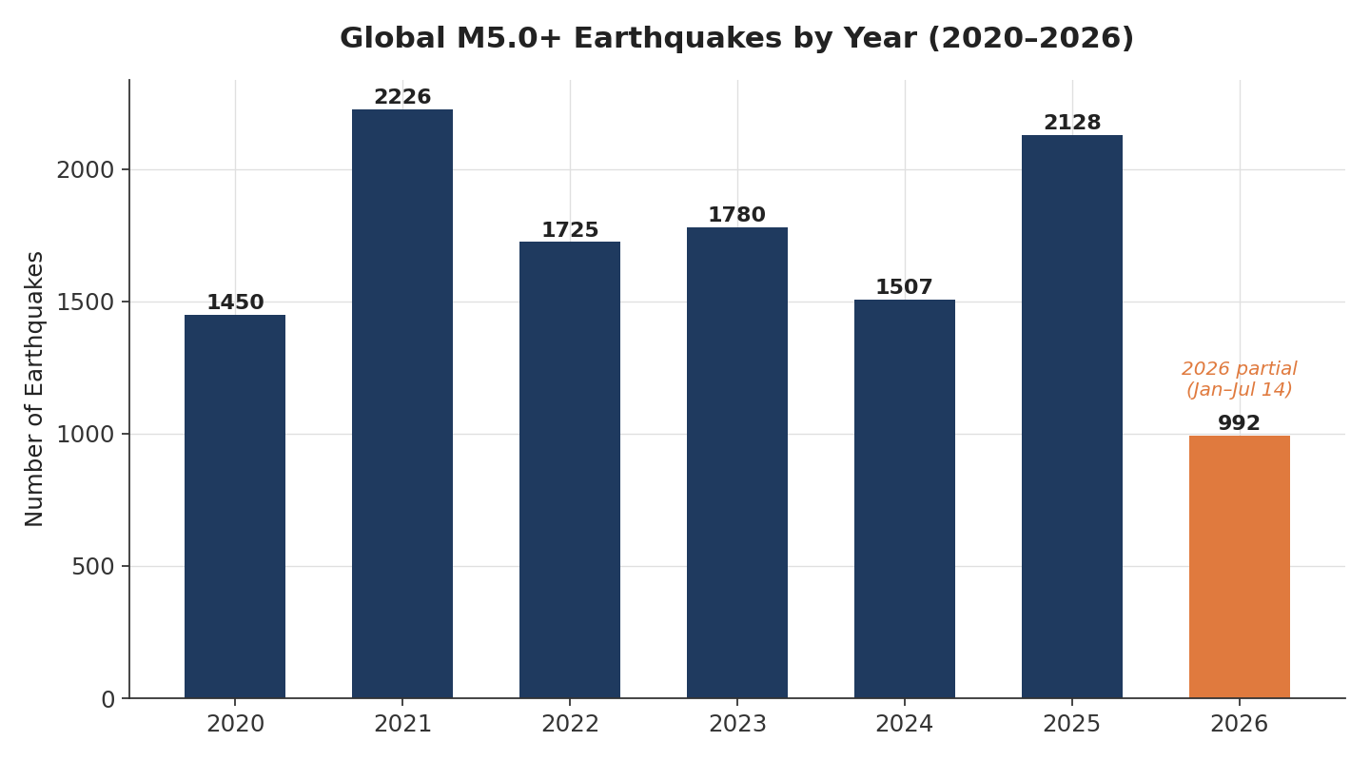
Figure 2. Total M5.0+ earthquakes recorded per year. 2026 is partial (through July 14) and shown in orange.

6.2 Monthly Trend Over Time
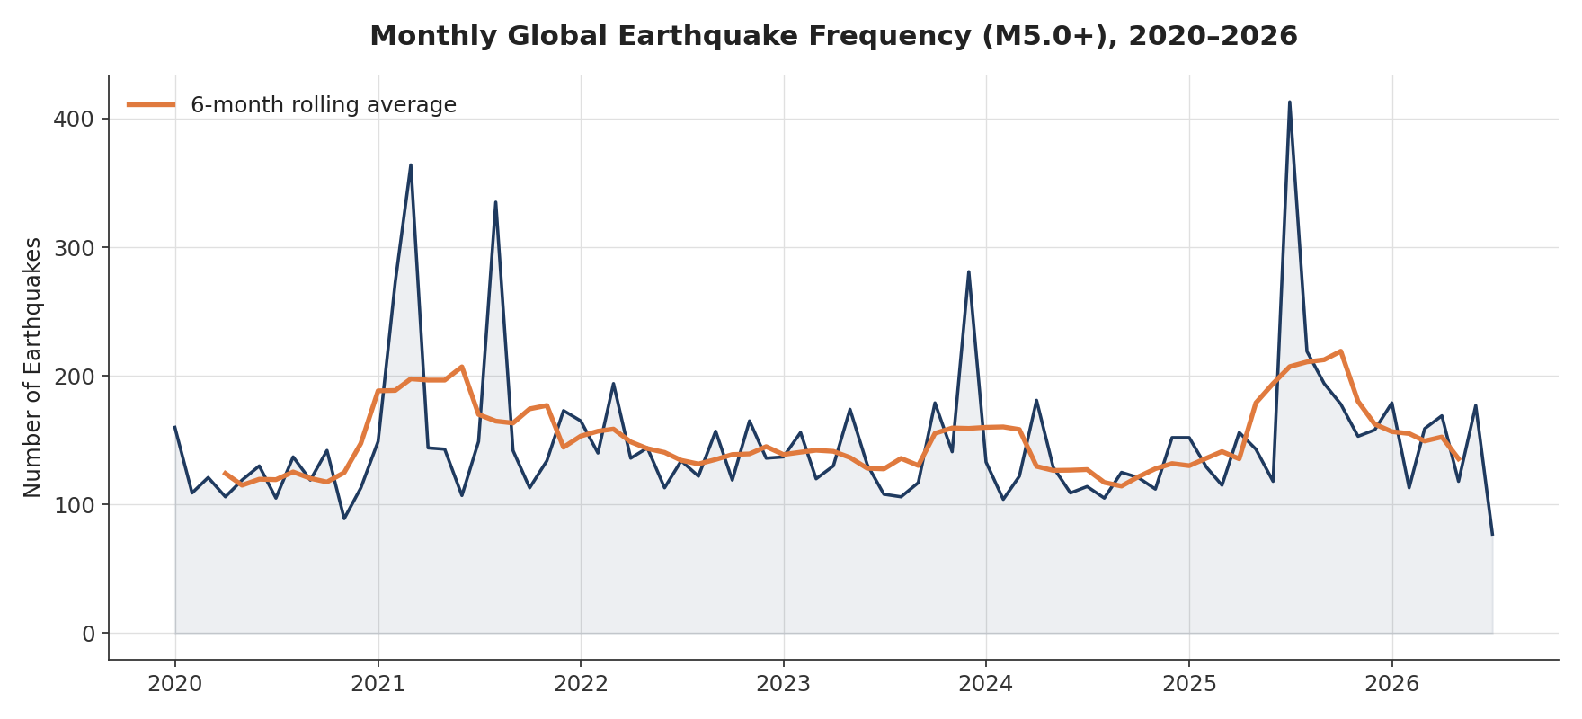
Figure 3. Monthly event counts with a 6-month rolling average. Spikes correspond to major aftershock sequences (see Section 5.2).

6.3 Magnitude Distribution
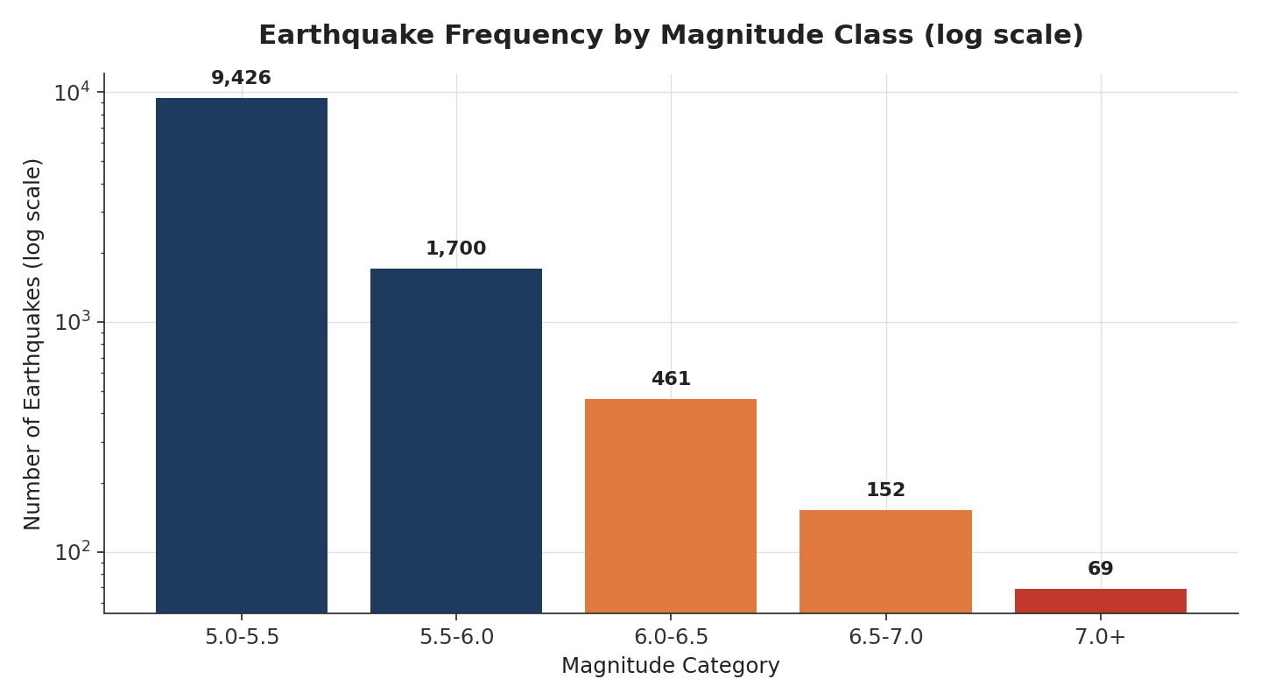
Figure 4. Event count by magnitude class, log scale — illustrating the expected Gutenberg-Richter drop-off.

6.4 Depth vs. Magnitude
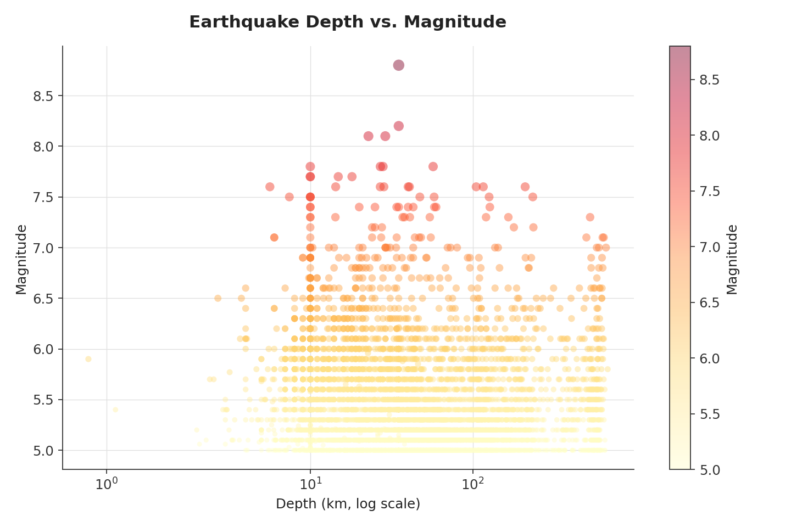
Figure 5. Each point is one earthquake; depth is shown on a log scale. No strong linear relationship is visible (r = 0.09).

6.5 Depth Category Breakdown
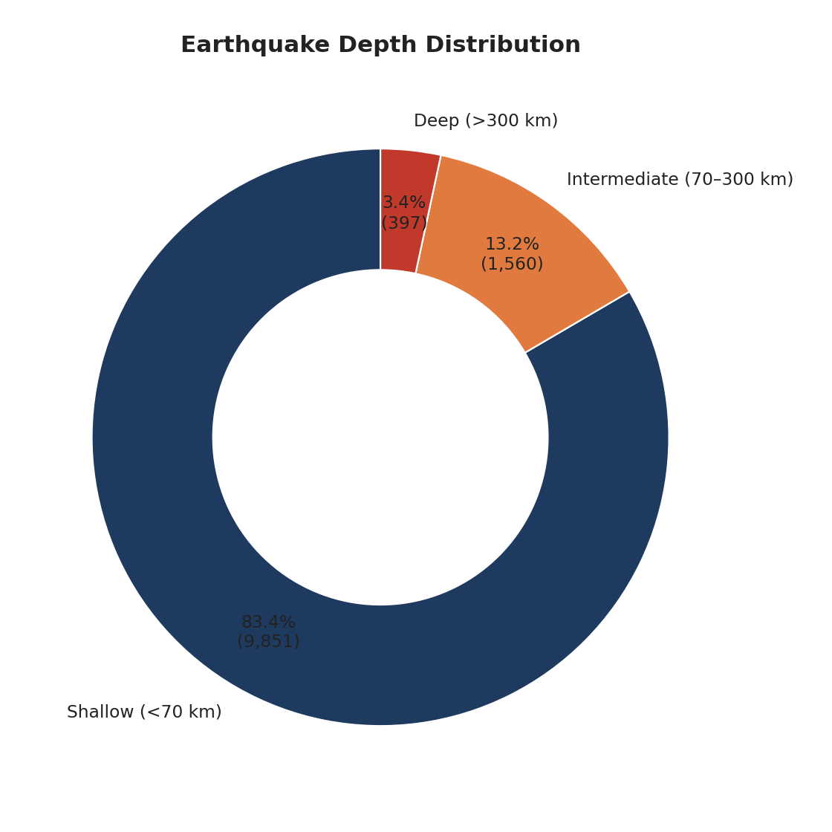
Figure 6. Share of events by depth category (USGS convention: shallow <70km, intermediate 70–300km, deep >300km).

6.6 Global Epicenter Map
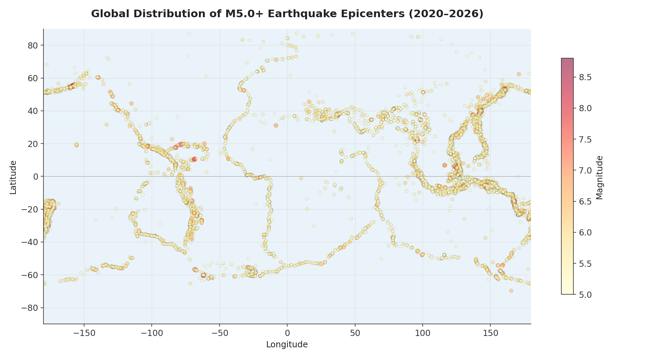
Figure 7. All 11,808 epicenters, sized and colored by magnitude. The Pacific Ring of Fire is clearly visible.

6.7 Top Seismic Regions
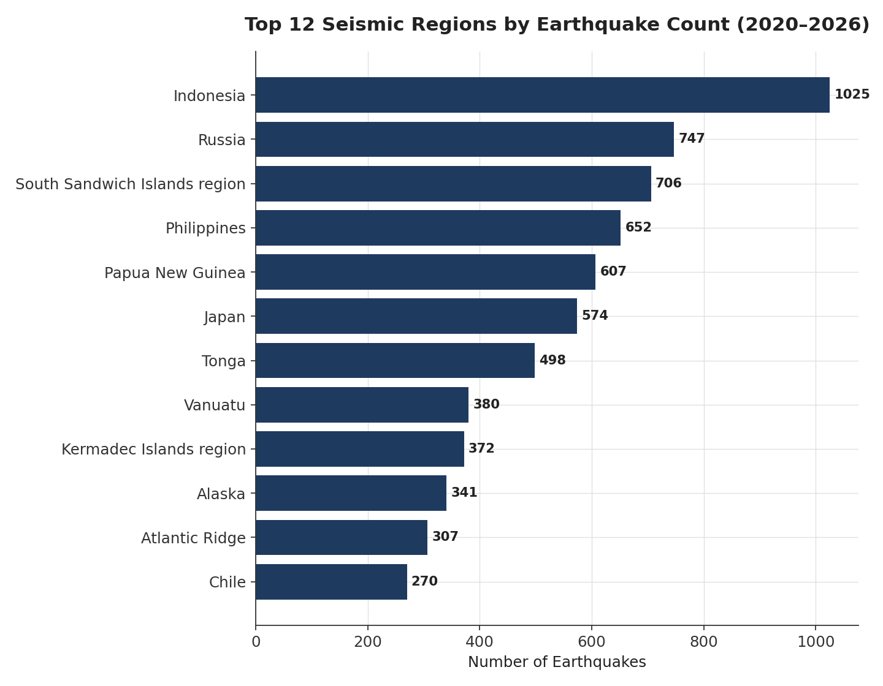
Figure 8. The 12 most active regions by recorded event count, 2020–2026.

6.8 Major Earthquakes (M7.0+) by Year
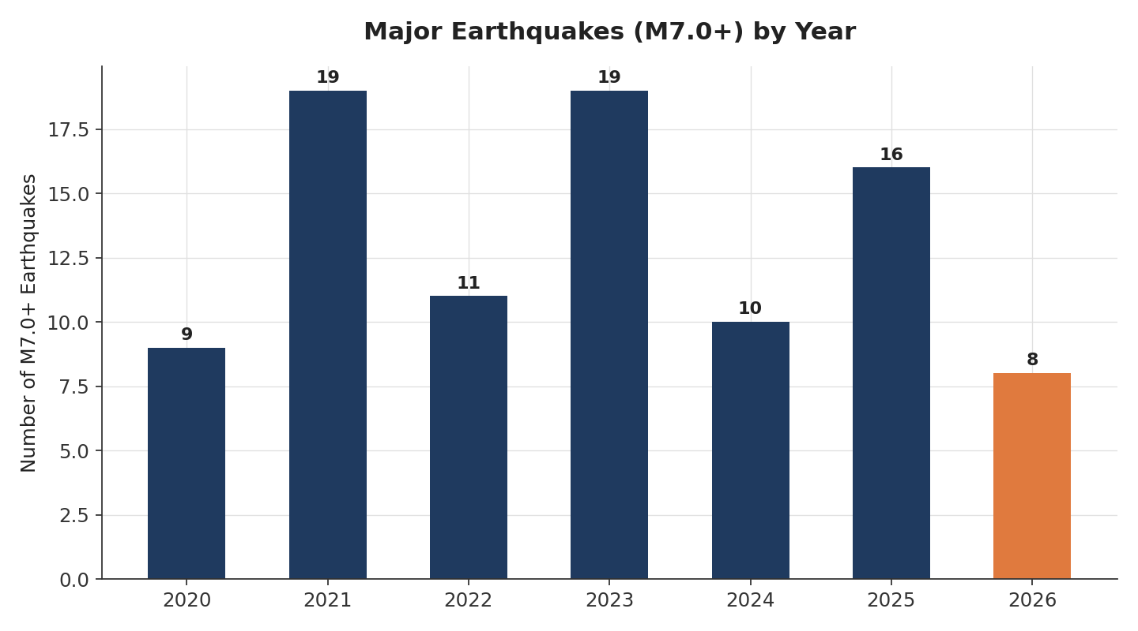
Figure 9. Count of M7.0+ events per year. 2026 (partial) shown in orange.

6.9 Calendar-Month Distribution (Interpret with Caution — see 5.2)
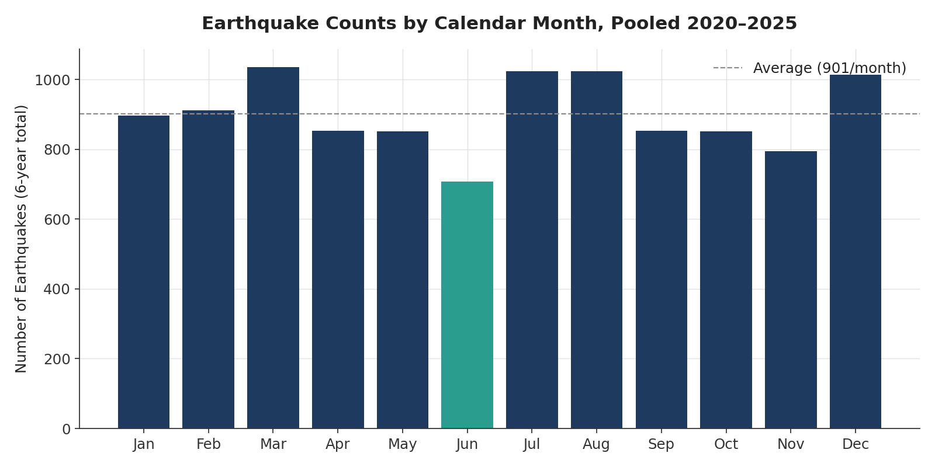
Figure 10. Pooled 2020–2025 event counts by calendar month. Red bars are driven by specific aftershock sequences, not a true seasonal cycle.

7. Key Findings & Business Insights
- Stable long-term baseline: Global M5.0+ seismicity has shown no statistically significant increase or decrease over 2020–2025. Organizations using this data for long-range risk budgeting can treat ~1,800 events/year as a reasonable stable baseline, while planning for high variance driven by individual large events.
- Concentration risk is geographic, not temporal: Roughly half of all global M5.0+ activity occurs in just 10 regions, all on the Pacific Ring of Fire. Any risk model, insurance exposure assessment, or emergency-preparedness resourcing should weight these regions far more heavily than a population- or land-area-based allocation would suggest.
- A single mainshock can dominate a year's statistics: The 2025 Kamchatka M8.8 event alone contributed 413 downstream events in a single month and materially elevated 2025's annual total. This means annual totals are not a reliable standalone indicator of "increasing risk" — they are heavily influenced by whether a single major mainshock occurred, and should always be reported alongside major-event counts and largest-magnitude context.
- Shallow events dominate exposure: With 83.4% of events occurring at <70km depth, the population most exposed to strong shaking intensity is not evenly distributed by depth — the vast majority of events are in the depth range most likely to cause significant surface damage at a given magnitude.
- The apparent "seasonality" is a trap for naive forecasting: Any automated model that used month-of-year as a feature to predict earthquake risk would be fitting to aftershock-sequence artifacts of six specific mainshocks, not a genuine repeating pattern — this would produce a model that fails going forward.

8. Risks, Opportunities & Anomalies

8.1 Risks
- Data currency: This dataset ends July 14, 2026. Any use for current risk monitoring requires a refreshed pull; conclusions here should not be treated as reflecting activity after that date.
- Survivorship of the M5.0+ filter: Because sub-M5.0 events are excluded, this dataset cannot be used to assess overall seismic hazard (which includes far more frequent smaller events) — only moderate-to-major event patterns.
- nst missingness is network-driven, not random: Any model that uses station count as a data-quality or confidence proxy should account for the fact that certain networks (iscgem, ak) systematically don't report it, rather than treating missing nst as "low confidence."
- Region-label fragmentation: 296 distinct region strings, with some overlapping/duplicative naming (e.g., "Alaska" vs "Alaska Earthquake"), should be harmonized before this data feeds a production dashboard or geographic rollup, to avoid double-counting or fragmenting a single region's totals.

8.2 Opportunities
- Regional risk prioritization: The clear concentration in 10 regions supports a focused (rather than globally-diffuse) approach to monitoring infrastructure, insurance underwriting, or emergency-response pre-positioning.
- Aftershock-aware alerting: Because major mainshocks reliably generate large downstream event clusters (as seen after Kamchatka, Kermadec, South Sandwich, Loyalty Islands, and Philippines sequences), a real-time alerting system could use the occurrence of any M7.5+ mainshock as a trigger to anticipate elevated regional activity for the following 4–8 weeks.
- magType as a severity-routing signal: 60.3% of events use the "mww" (moment magnitude) method typically reserved for more significant events, versus 37.8% "mb" (body-wave, often faster/preliminary-style) — this split could inform how quickly different event types are typically finalized.

8.3 Anomalies Requiring Further Investigation
- The June 24, 2026 Venezuela doublet (M7.2 and M7.5, 37 seconds apart) warrants confirmation from the original source network — while the data appears legitimate (distinct IDs, slightly different locations), such tightly-spaced large events are unusual and merit verification if this data will inform any decision.
- 2024 stands out as the only year in the series with a below-average major-event count (10) and no clear driving anomaly — worth monitoring whether this reflects a genuine local minimum or a reporting/coverage gap for that year.

9. Actionable Recommendations
- Adopt ~1,800 events/year (M5.0+) as the working baseline for planning purposes, but always pair it with the major-event (M7.0+) count for that period, since a single mainshock can double a month's activity.
- Prioritize monitoring and resource allocation toward the top 10 regions identified in Section 5.5, which account for roughly half of global M5.0+ activity.
- Do not use calendar month as a predictive feature for earthquake risk models built on this data — the apparent monthly pattern is an artifact of specific aftershock sequences, not a real seasonal cycle (Section 5.2).
- Harmonize the region/place taxonomy (Section 3.3) before this dataset is used in any dashboard requiring clean geographic rollups.
- When using nst (station count) as a data-quality signal, first filter or flag by network (net field), since its missingness is network-specific rather than random.
- Refresh this dataset at least monthly if it will support any operational (rather than historical/retrospective) use case, given the current data ends July 14, 2026.
- Verify the June 2026 Venezuela doublet against the primary source network before citing it externally.

10. Limitations & Assumptions
- This dataset is pre-filtered to M5.0+ events only; all conclusions describe moderate-to-major seismicity, not total global earthquake activity.
- 2026 figures are partial-year (through July 14, 2026) and are explicitly labeled as such throughout; any annualized 2026 figures are simple linear extrapolations and are not forecasts.
- The mag_category field for 25.2% of rows was reconstructed algorithmically (Section 3.2). While the reconstruction rule matched 100% of the populated rows exactly, this is disclosed as an assumption rather than an originally-provided value.
- No population, infrastructure, or economic-loss data was provided or used — this report describes seismic event patterns only, not human or financial impact, and no casualty, damage, or economic claims are made.
- Correlations reported in Sections 5.4 and 5.6 describe statistical association only; no causal claims are made, consistent with the nature of observational seismic monitoring data.
- Earthquake occurrence is not reliably predictable from historical frequency data alone; nothing in this report should be read as a forecast of when or where a future specific earthquake will occur.
- All figures were computed directly from the provided CSV with no external data merged in and no values estimated or fabricated.

11. Conclusion
Between January 2020 and mid-July 2026, global M5.0+ seismic activity has remained statistically stable at roughly 1,800 events per year, with no significant long-term trend. Activity is heavily concentrated in a small number of Pacific Ring of Fire regions, and year-to-year variation is driven primarily by whether a small number of major mainshocks — most notably the M8.8 Kamchatka earthquake of July 2025 — occurred in a given period, rather than by any systemic change in underlying seismicity. The dataset is of high structural quality (no duplicates, valid coordinates, fully reviewed status) with well-understood and clearly documented gaps in secondary metadata fields. The clearest actionable takeaway for any organization using this data is to prioritize the handful of consistently high-activity regions identified here, treat apparent "seasonality" with appropriate skepticism, and pair any headline activity count with major-event context before drawing conclusions about changing risk.
— End of Report —

