

**DEPARTMENT OF COMPUTER SCIENCE**

**ASSIGNMENT OF**

**OBJECT-ORIENTED PROGRAMMING**

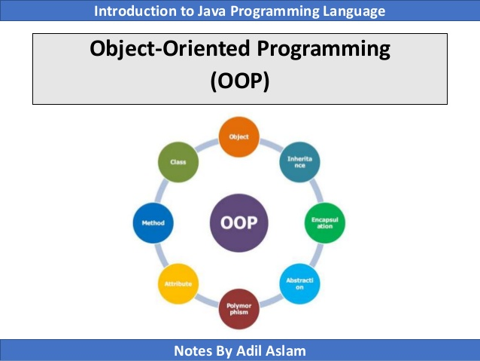

**NAME :** **Hafiz Wali- Ur- Rehman**

**ROLL NO :** **2017-CS-139**

**SECTION :** **3-C**

**SEMESTER :** **3rd SEMESTER**

**SUBMITTED TO :** **Sir Wasiq Ahmed**