

**SYNOPSIS OF PROJECT**

**Project Title : Data Concealment using techniques of LSB substitution**

**Project Guide : Mr. Sanjiv Tomar**

**Project Team :**

|  |  |  |  |
| --- | --- | --- | --- |
| **Programme - B.Tech (CSE)** | **Year / Semester:** 4th year/8th  Semester | | |
| **S. No.** | **Enrollment No.** | **Name** | **Signature** |
| **1.** | **A2305208370** | **Gaurav Walia** |  |
| **2.** | **A2305208372** | **Himalaya Monga** |  |

**Project summary:**

* Features of the application:
* Concealing *Plain text* in an *Image File.*
* Concealing *Plain text* in an *Audio FIle.*
* Concealing *Image* in an *Image File*.
* Concealing *Image* in an *Audio File.*
* Concealing *Audio* in an *Image File.*
* Concealing *Audio* in an *Audio File.*
* Concealing *Audio* in a Vide*o File.*
* Concealing Vide*o* in an *Image File.*
* Concealing Vide*o* in an *Audio File.*
* Concealing Vide*o* in a Vide*o File.*
* Concealing *Image* in a Video *File.*
* Concealing *Plain text* in a Video *File.*
* Added Features:
* Dynamic File *Compression*
* Password *Encryption* for compressed files
* Implement and demonstrate an interactive interface for multiple parties to share confidential data (Messages, Images & Audio) in a hidden shell using the techniques of LSB substitution
* The advantage of such an application is, that the data is not only encoded and sent to the user, but also sent in a hidden shell so as to reduce doubts of suspicion.
* The encoded file, inherently has an increased file size, therefore efficient algorithms for file compression are to be applied.

**Methodology to be adopted:**

* Extracting the bit array of the target file.
* Extracting the bit array of the data (which is to be concealed).
* Analyzing the LSB (Least Significant Bits) of the target array.
* Replacing the LSB with the data to be concealed, so as to cause least target data disruption.
* Using Huffman Coding, compressing the final concealed file.
* Encrypting the file with a password, for added protection.

**Resource Requirements:**

**Hardware:**

* A **Personal Computer** to be setup with following specifications:
* Intel Pentium IV Processor with 2.4 GHz processing speed
* 40 GB HDD
* 512MB of RAM
* CD R/W device, Monitor, Keyboard, Mouse, LAN Card

**Software:**

* For the **Personal computer:**
* Windows XP Professional Operating System
* NetBeans IDE 7.0.1 (Java SDK)
* Microsoft Office 2003 or higher

**­Project Schedule:**

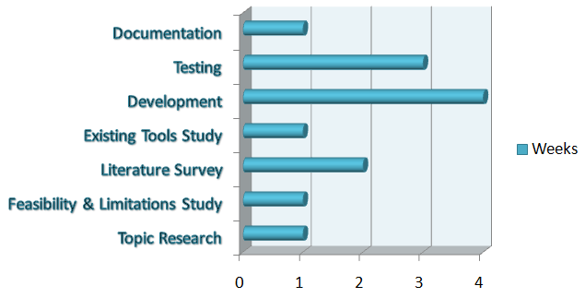

**Justification of the project:**

* To improve the present data hiding technologies.
* For government agencies, and professional groups.
* Removal of Paper based hiding methodologies.
* To provide both parties with the setup and ensure data integrity.

Mr. Sanjiv Tomar

Sr. Lecturer

Mentor