**Class** :-

Class is a blueprint which defines some properties and behaviors. An object is an instance of a class which has those properties(data Members) and behaviours(Method) attached.

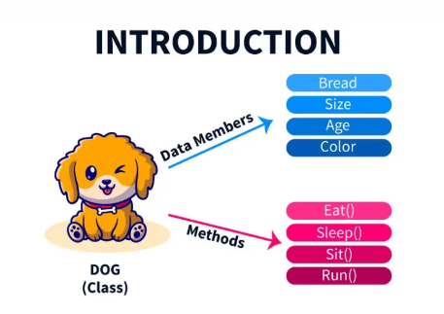

class Dog {

String bread;

Int size;

Int age;

String color;

public void eat() {

}

public void sleep() {

}

public void sit() {

}

public void run() {

}

**Object:-**

An object is an instance of a class. It represents a real-world entity or concept that the class describes. Objects have state (attribute values) and behavior (methods). You can create multiple objects from a single class, and each object will have its own set of attribute values.

To create an object in Java, you use the **new** keyword followed by the class name and parentheses

public class Main {

public static void main(String[] args) {

// Creating an object of the Dog class

Dog myDog = new Dog();

// Accessing object's attributes and invoking methods

myDog.color="Black";

myDog.age=12;

myDog.bread="Boxer";

myDog.size=12;

myDog.eat();

myDog.sleep();

myDog.run();

myDog.

}

}