**Selenium Hierarchy**

WebDriver driver = new ChromeDriver();

It will take the methods of ChromeDriver class, WebDriver Interface and SearchContext Interface

ChromeDriver driver = new ChromeDriver();

It will take the methods of chromeDriver Class, Chromium Driver class, RemoteWebDriver class, WebDriver class, SearchContext class

WebDriver driver = new RemoteWebDriver();

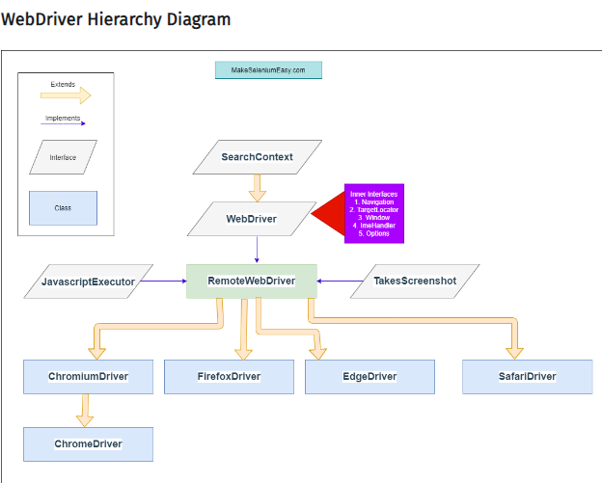

**Interface SearchContext**

SearchContext is the top most interface in WebDriver hierarchy. This interface consists of two methods findElement​(By by) and findElements(By by). This interface is extended by both WebDriver and WebElement interfaces.

**Interface WebDriver**

***WebDriver****is an interface which extends****SearchContext****interface.WebDriver is a remote control interface that enables introspection and control of user agents (browsers). The methods in this interface fall into three categories:*

* Control of the browser itself
* Selection of WebElement and WebElements
* Debugging aids

Currently, you will need to instantiate implementations of this interface directly. It is hoped that you write your tests against this interface so that you may “swap in” a more fully featured browser when there is a requirement for one ( i.e. Up cast to WebDriver).

*WebDriver interface has multiple inner interfaces which contains methods related o specific events.*

1. **ImeHandler** – An interface for managing input methods.
2. **Navigation**– An interface for provide mechanism to access browser history.
3. **Options**– An interface for managing stuff you would do in a browser menu
4. **TargetLocator**– Used to locate a given frame or window.
5. **Timeouts**– An interface for managing timeout behavior for WebDriver instances.
6. **Window**– An interface to manage browser window actions like maximize, minimize etc.

**Class RemoteWebDriver**

RemoteWebDriver is the fully implemented class i.e. non -abstract class which implements WebDriver interface. All implementations of WebDriver that communicate with the browser, or a RemoteWebDriver server shall use a common wire protocol. This wire protocol defines a RESTful web service using JSON over HTTP.

*Note here* that RemoteWebDriver has implementation to call RESTful Web Services of Selenium WebDriver which hits to respective browser server. It has no mechanism to perform any browser specific action.

Selenium 3 doesn’t have the ChromiumDriver class

Selenium 4 have the ChromiumDriver class.