Advanced PHP

Amjahdi Walid
2334452
ISI S5

TP 7 : PDO CRUD in PHP

Objectifs du Projet:
Ce projet consiste à concevoir et développer une application web de gestion des utilisateurs en PHP et MySQL. L'objectif principal est de maîtriser les opérations fondamentales du CRUD (Create, Read, Update, Delete) tout en garantissant la sécurité des données (validation des entrées, protection contre les injections SQL via PDO).

Base de Données:

La base de données contient une table unique nommée users structurée comme suit :
- id : Identifiant unique (INT, Clé primaire, Auto-Incrémenté)
- cin : Numéro de CIN (CHAR(8))
- full_name : Nom complet de l'utilisateur (VARCHAR)
- tel : Numéro de téléphone (CHAR(10))
- email : Adresse e-mail (VARCHAR)
- birth : Date de naissance (DATE)

Architecture et Structure des Fichiers:
- config.php : Établit la connexion sécurisée à la base de données via l'extension PDO.

<link rel="stylesheet" href="index.css"/>

<?php

$dsn = "mysql:host=localhost;dbname=php_crud;charset=utf8mb4";

try {
$pdo = new PDO($dsn,"root","walid");
echo "<h4 class=\"success\">Connected Successfully to DB</h4> <br>";
}
catch (\PDOExeption $e)
{
echo "<h4 class=\"error\">Error while connecting to DB</h4> <br>";
echo "<h4 class=\"error\">Message Error : {$e->getMessage()}</h4> <br>";
}

?>

- index.php : Page d'accueil affichant la liste de tous les utilisateurs dans un tableau dynamique, ainsi que les liens vers l'ajout, la modification et la suppression.

<?php
require_once "config.php";
$stmt = $pdo->query("select * from users");
$users = $stmt->fetchAll();

if (isset($_GET['success']) && $_GET['success'] == 1):
?>
<h4 class="success">User added successfully!</h4>
<?php
elseif (isset($_GET['updated']) && $_GET['updated'] == 1):
?>
<h4 class="success">User updated successfully!</h4>
<?php
elseif (isset($_GET['deleted']) && $_GET['deleted'] == 1):
?>
<h4 class="success">User deleted successfully!</h4>
<?php
endif;
?>

<!DOCTYPE html>
<html lang="en">
<head>
<meta charset="UTF-8">
<meta name="viewport" content="width=device-width, initial-scale=1.0">
<title>Users List</title>
<link rel="stylesheet" href="index.css"/>
</head>
<body>
<div class="add-div">
<h1>Users List</h1>
<a href="add.php" class="add-user-link">
Add User
</a>
</div>

<table>
<thead>
<tr>
<th>ID</th>
<th>CIN</th>
<th>Full Name</th>
<th>Tel</th>
<th>Email</th>
<th>Birthdate</th>
<th>Actions</th>
</tr>
</thead>
<tbody>
<?php if (empty($users)): ?>
<tr><td colspan="7" style="text-align: center;">No users found yet.</td></tr>
<?php else: ?>
<?php foreach ($users as $user): ?>
<tr>
<td><?= ($user['id']) ?></td>
<td><?= ($user['cin']) ?></td>
<td><?= ($user['full_name']) ?></td>
<td><?= ($user['tel']) ?></td>
<td><?= ($user['email']) ?></td>
<td><?= ($user['birth']) ?></td>
<td class="action">
<a href="modify.php?id=<?= $user['id'] ?>" class="modify">Modify</a>
<a href="delete.php?id=<?= $user['id'] ?>" class="delete">Delete</a>
</td>
</tr>
<?php endforeach; ?>
<?php endif; ?>
</tbody>
</table>

</body>
</html>
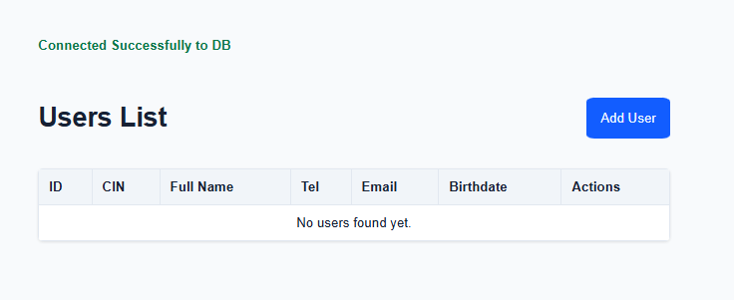

- add.php : Contient le formulaire d'ajout et le traitement sécurisé de l'insertion (validation par expressions régulières).

<?php
require_once "config.php";
?>

<!DOCTYPE html>
<html lang="en">
<head>
<meta charset="UTF-8">
<meta name="viewport" content="width=device-width, initial-scale=1.0">
<title>Add User</title>
<link rel="stylesheet" href="index.css"/>
</head>
<body>
<h1>Add User Infos</h1>
<form method="POST">
<label for="CIN">CIN :</label>
<input type="text" name="cin" id="CIN" placeholder="AB123456" required>

<label for="name">Full Name :</label>
<input type="text" name="full_name" id="name" required>

<label for="tel">Tel :</label>
<input type="text" name="tel" id="tel" placeholder="0612345678" required>

<label for="email">Email :</label>
<input type="email" name="email" id="email" required>

<label for="birth">Birthdate :</label>
<input type="date" name="birth" id="birth" required>
<br><br>
<button class="add-user" type="submit" name="submit">Save User</button>
</form>
</body>
</html>

<?php

if (isset($_POST['submit']) && $_SERVER["REQUEST_METHOD"] == "POST")
{
$formData = [];
foreach ($_POST as $key => $value)
{
$formData[$key] = trim($value);
}

$cin = $formData["cin"] ?? '';
$full_name = $formData["full_name"] ?? '';
$tel = $formData["tel"] ?? '';
$email = $formData["email"] ?? '';
$birth = $formData["birth"] ?? '';

if (preg_match("/^[A-Z]{2}[0-9]{6}$/", $cin) == 0)
{
exit("Invalid CIN format (e.g., AB123456)");
}
if (preg_match("/^[A-Za-z0-9.]+@[A-Za-z]+\.[a-z.]+$/", $email) == 0)
{
exit("Invalid Email format");
}
if (preg_match("/^0[567]{1}[0-9]{8}$/", $tel) == 0)
{
exit("Invalid Tel format (e.g., 0612345678)");
}

try
{
$stmt = $pdo->prepare("INSERT INTO users (cin, full_name, tel, email, birth) VALUES (?, ?, ?, ?, ?)");
$stmt->execute([$cin, $full_name, $tel, $email, $birth]);

header("Location: index.php?success=1");
exit();

} catch (\PDOException $e)
{
exit("Database Error: " . $e->getMessage());
}
}
?>

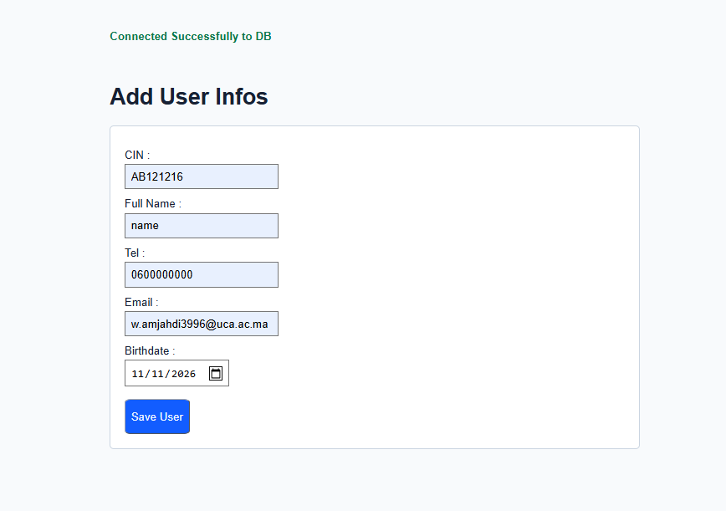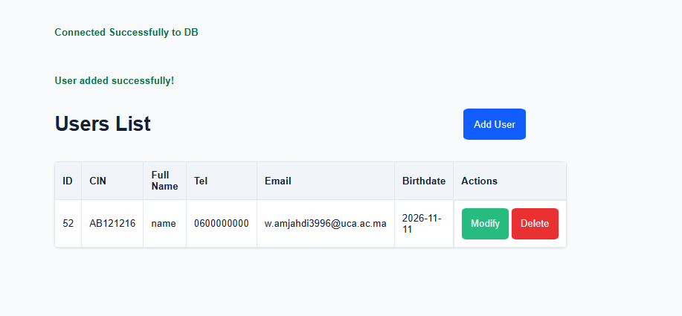
- modify.php : Permet de récupérer les données existantes d'un utilisateur, de pré-remplir le formulaire et de mettre à jour l'enregistrement.

<?php
require_once "config.php";

if (!isset($_GET['id'])) {
header("Location: index.php");
exit();
}

$id = $_GET['id'];

$stmt = $pdo->prepare("SELECT * FROM users WHERE id = ?");
$stmt->execute([$id]);
$user = $stmt->fetch();

if (!$user) {
header("Location: index.php");
exit();
}

if (isset($_POST['submit']) && $_SERVER["REQUEST_METHOD"] == "POST")
{
$formData = [];
foreach ($_POST as $key => $value)
{
$formData[$key] = trim($value);
}

$cin = $formData["cin"] ?? '';
$full_name = $formData["full_name"] ?? '';
$tel = $formData["tel"] ?? '';
$email = $formData["email"] ?? '';
$birth = $formData["birth"] ?? '';

if (preg_match("/^[A-Z]{2}[0-9]{6}$/", $cin) == 0)
{
exit("Invalid CIN format (e.g., AB123456)");
}
if (preg_match("/^[A-Za-z0-9.]+@[A-Za-z]+\.[a-z.]+$/", $email) == 0)
{
exit("Invalid Email format");
}
if (preg_match("/^0[567]{1}[0-9]{8}$/", $tel) == 0)
{
exit("Invalid Tel format (e.g., 0612345678)");
}

try
{
$stmt = $pdo->prepare("UPDATE users SET cin = ?, full_name = ?, tel = ?, email = ?, birth = ? WHERE id = ?");
$stmt->execute([$cin, $full_name, $tel, $email, $birth, $id]);

header("Location: index.php?updated=1");
exit();

} catch (\PDOException $e)
{
exit("Database Error: " . $e->getMessage());
}
}
?>

<!DOCTYPE html>
<html lang="en">
<head>
<meta charset="UTF-8">
<meta name="viewport" content="width=device-width, initial-scale=1.0">
<title>Modify User</title>
<link rel="stylesheet" href="index.css"/>
</head>
<body>
<h1>Modify User Infos</h1>
<form method="POST">
<label for="CIN">CIN :</label>
<input type="text" name="cin" id="CIN" value="<?= htmlspecialchars($user['cin']) ?>" placeholder="AB123456" required>

<label for="name">Full Name :</label>
<input type="text" name="full_name" id="name" value="<?= htmlspecialchars($user['full_name']) ?>" required>

<label for="tel">Tel :</label>
<input type="text" name="tel" id="tel" value="<?= htmlspecialchars($user['tel']) ?>" placeholder="0612345678" required>

<label for="email">Email :</label>
<input type="email" name="email" id="email" value="<?= htmlspecialchars($user['email']) ?>" required>

<label for="birth">Birthdate :</label>
<input type="date" name="birth" id="birth" value="<?= htmlspecialchars($user['birth']) ?>" required>
<br><br>
<button class="update-user" type="submit" name="submit">Update User</button>
</form>
</body>
</html>
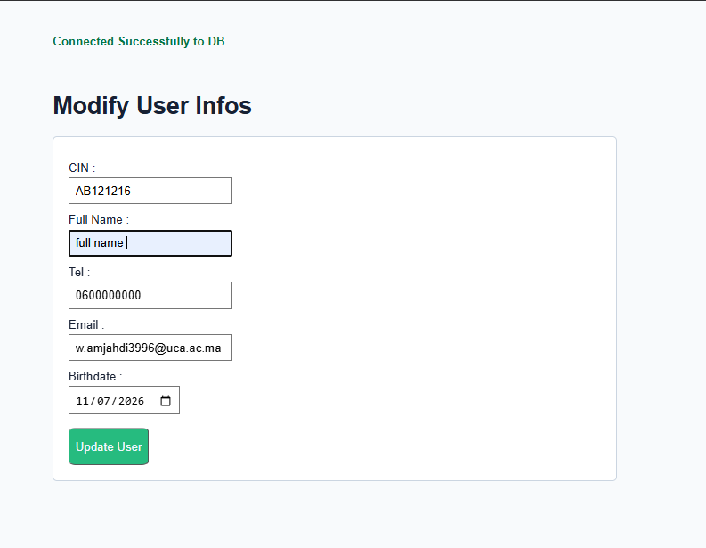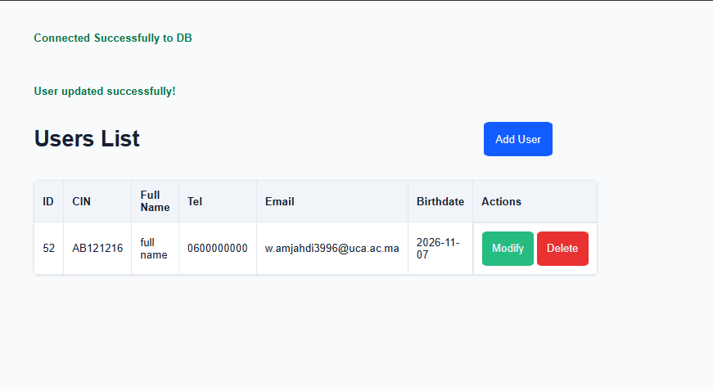
- delete.php : Script de traitement en arrière-plan qui supprime un utilisateur de manière sécurisée via son ID.

<?php
require_once "config.php" ;
if (isset($_GET["id"]))
{
$id = $_GET["id"];

try
{
$stmt = $pdo->prepare("delete from users where id = ?");
$stmt->execute([$id]);
header("Location: index.php?deleted=1");
exit();
}
catch (\PDOException $e)
{
exit("Database Error: " . $e->getMessage());
}
}
else
{
header("Location: index.php");
exit();
}
?>


