

Faculty of Computers and Artificial Intelligence

Computer Science Department

2022/2023

**CS 496 Selected Topics in CS-4**

**Research Project**

Report Submitted for Fulfillment of the Requirements for Selected Topics in CS-4 course

|  |  |  |  |
| --- | --- | --- | --- |
|  | ID | Name | Grade |
|  | 201900950 | وليد شعبان عبد الحليم رضوان |  |
|  | 201900005 | ابراهيم السيد محمد حنور |  |
|  | 201900353 | سمير احمد محمد رضوان |  |
|  | 201900477 | عزت علي عبد الرحمن علي |  |
|  | 20150017 | احمد أشرف احمد ابوهيبة |  |
|  | 201900605 | ماريهان رأفت يس |  |
|  | 201900482 | على احمد فتحي دسوقي |  |
|  | 201900662 | محمد خالد صالح محمد |  |

Delivered to: **Dr. Wessam El-Behaid**

**Paper details**:

* **Authors**: Yuwei Xiang, Qianxiao Fei
* **Paper name**: Car, Cyclist, and Pedestrian Object Detection Based on YOLOv5
* **Publisher name:** [Francis Press, UK](https://francis-press.com/)
* **Publication in 2022**

**The paper used the KITTI** **dataset, which contains 7481 road images.**

* Implementation algorithm:

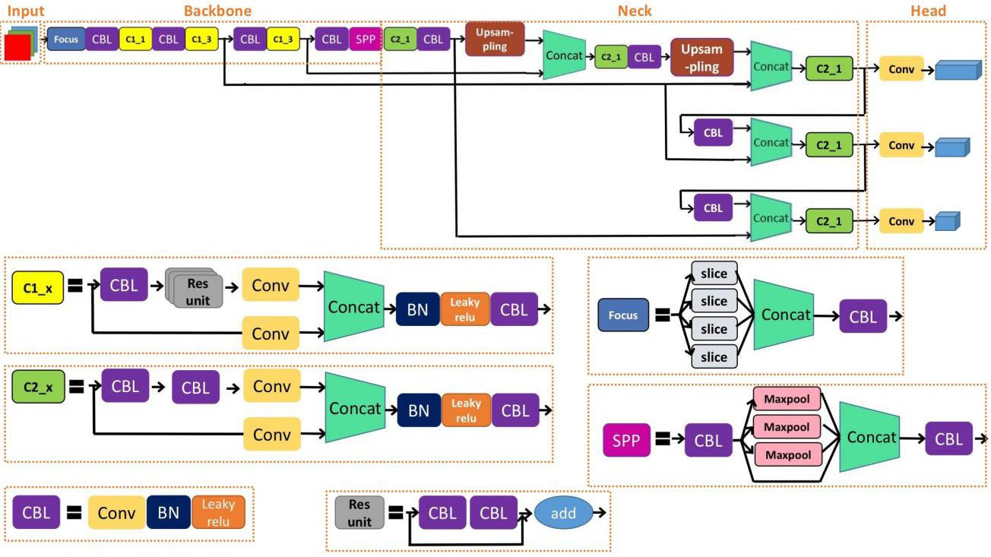

* Results:

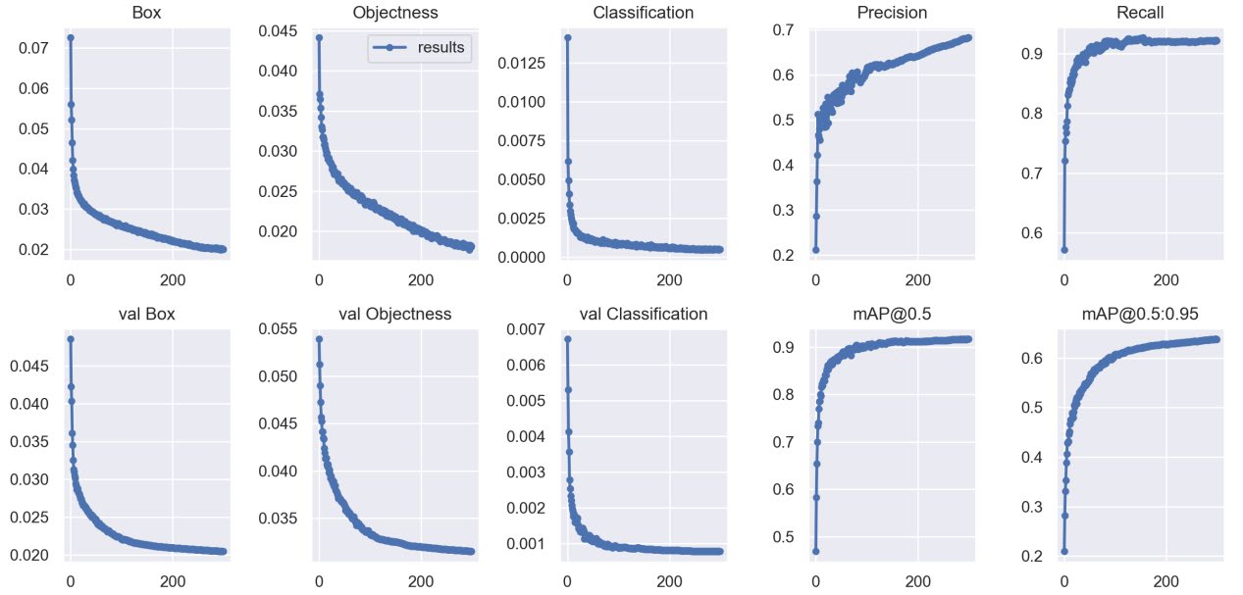

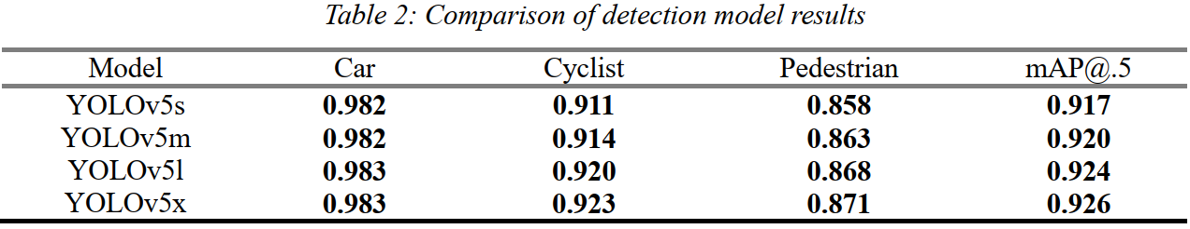

Project Description Document:

* General Information:
* We used the [**Cyclist dataset**](https://www.kaggle.com/datasets/semiemptyglass/cyclist-dataset), the data contains **13.7 K**, and the dimension of whole images is **2048*1024**.
* Implementation details:
  + **Training: 9571 (70%)**
  + **Validation: 1368 (10%)**
  + **Testing: 2735 (20%)**
* Block diagram:
* **Hyper-parameters: -**

**Epoch: 10**

**Batch-size: 32**

**Image-size: 640*640**

**number of GPU workers: 24**

**confidence threshold: 25%**

Models Results:

* Recall: 0.846
* Precision: 0.895
* mean average precision in confidence threshold 50 (map50): 0.911
* average mean average precision in confidence thresholds from 50 to 95 (map50-95): 0.714

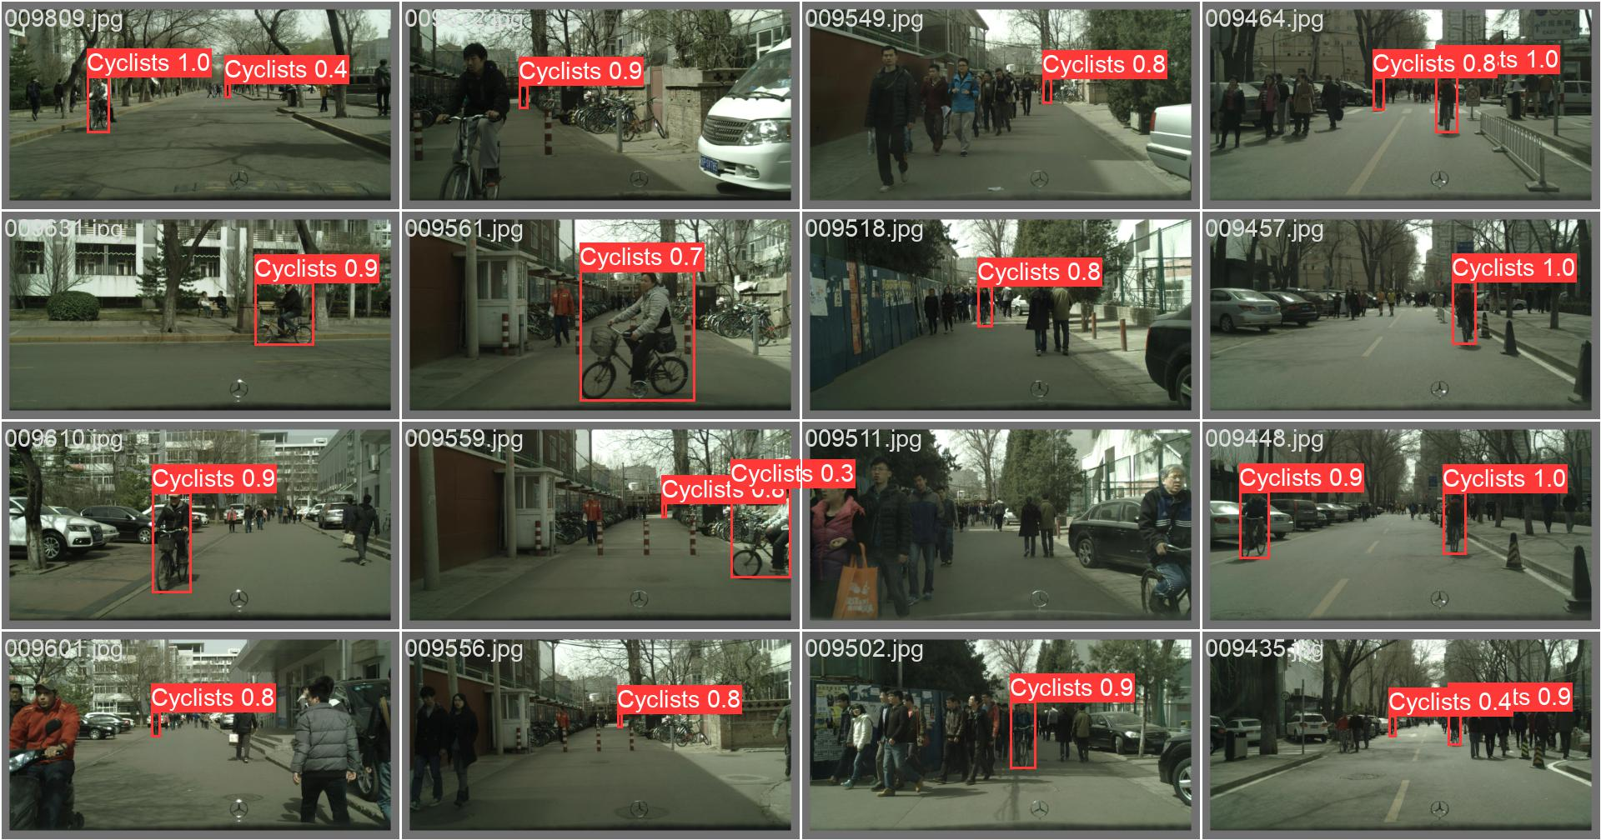

* Recall confidence curve:

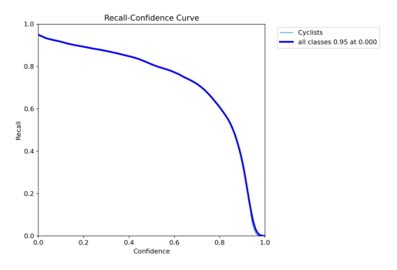

* Precision confidence curve:

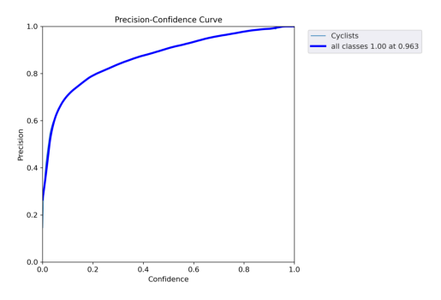

* Precision-Recall curve:

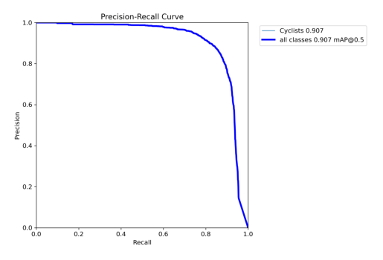

* F1-Score confidence curve:

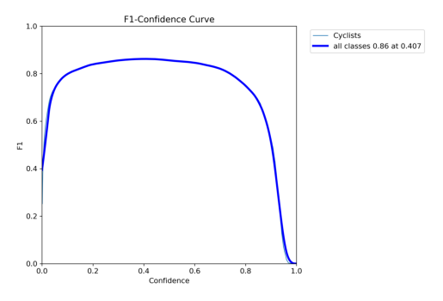

* Confusion matrix:

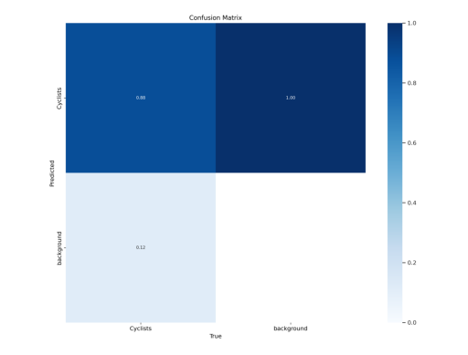

* Result Vs Epochs

