**Bonnes pratiques base de données Global Sales Database**

Création de la base de donnée et les collections

use globalDb

var collectionList = ["all-sales", "categories", "customers", "employees", "employeeterritories", "orderdetails", "orders", "regions", "products", "shippers", "suppliers", "territories"];

collectionList.forEach(function(collectionName) {db.createCollection(collectionName)})

Importer les fichiers csv ci-joint dans votre base de données

mongoimport --type csv -d globalDb -c allsales --headerline --drop All-sales.csv

mongoimport --type csv -d globalDb -c categories --headerline --drop categories.csv

mongoimport --type csv -d globalDb -c customers --headerline --drop customers.csv

mongoimport --type csv -d globalDb -c employees --headerline --drop employees.csv

mongoimport --type csv -d globalDb -c employee-territories --headerline --drop employee-territories.csv

mongoimport --type csv -d globalDb -c order-details --headerline --drop order-details.csv

mongoimport --type csv -d globalDb -c orders --headerline --drop orders.csv

mongoimport --type csv -d globalDb -c regions --headerline --drop regions.csv

mongoimport --type csv -d globalDb -c products --headerline --drop products.csv

mongoimport --type csv -d globalDb -c shippers --headerline --drop shippers.csv

mongoimport --type csv -d globalDb -c suppliers --headerline --drop suppliers.csv

mongoimport --type csv -d globalDb -c territories --headerline --drop territories.csv

 Le nom de base de données est un mot en minuscule et se termine par db

db.getName()

globalDb

 Le nom d’une collection est un mot en pluriel et en minuscule

db.getCollectionNames()

all-sales

categories

customers

employees

employeeterritories

orderdetails

orders

regions

products

shippers

suppliers

territories

Les champs de documents sont en « camel case »

db.all-sales.validate()

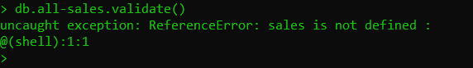

db.adminCommand( { renameCollection: "globalDb.all-sales", to: "globalDb.allsales" } )

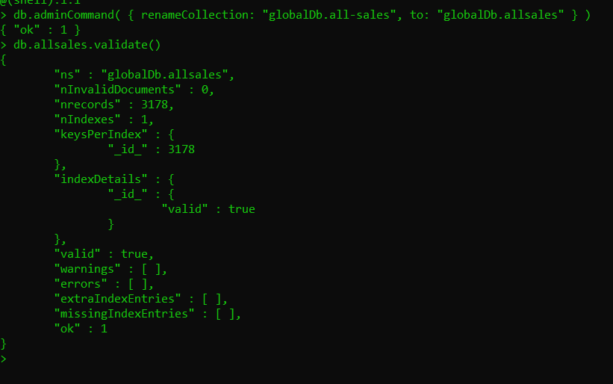

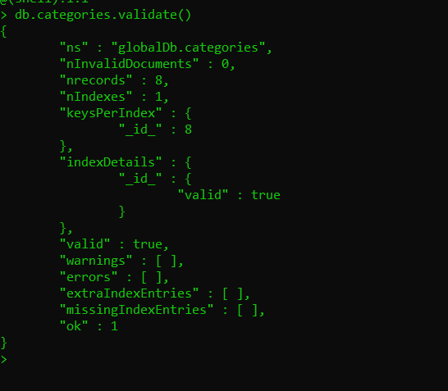

Créer des règles de validation

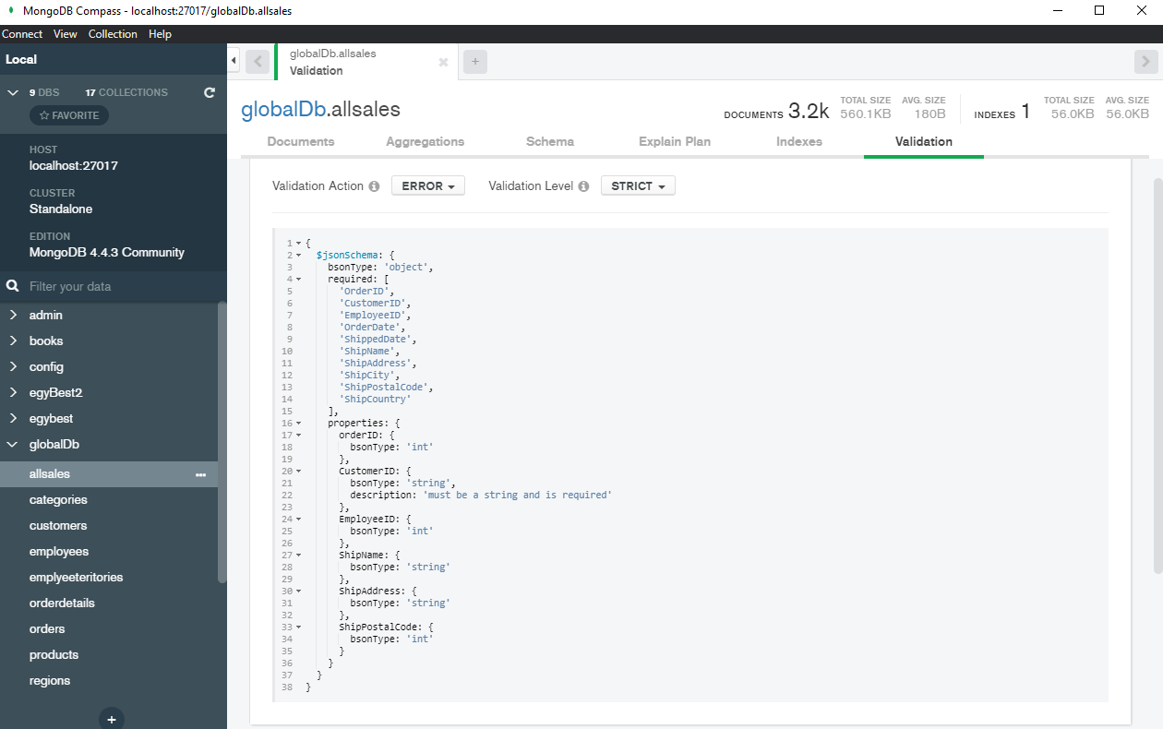

 Implémenter les bonnes pratiques de sécurité pour votre base de données, à l’instar :

* Activer les control d’accès et exiger une authentification.

use admin

db.createUser(

{

user: "Admin2",

pwd: "123456",

roles: [ { role: "userAdminAnyDatabase", db: "admin" }, "readWriteAnyDatabase" ]

}

)

Db.shutdownServer()

mongod --auth

Dans le fichier de la configuration

Sécurité:

autorisation: activée

Connection et authentification en tant que Admin2

mongo --port 27017 -u "myTester" --authenticationDatabase "test" -p

* Configurer des rôles

db.createRole(

{

role: "globalUser",

privileges: [

{ resource: { db: "globalDb", collection: "" }, actions: [ "find" ,"createCollection","collStats"] },

{ resource: { db: "globalDb", collection: "allsales" }, actions: [ "update", "insert"] },

{ resource: { db: "globalDb", collection: "categories" }, actions: [ "update", "insert"] },

{ resource: { db: "", collection: "" }, actions: [ "find" ] }

],

roles: []

}

)

* Bonnes pratiques de sauvegarde et restauration

mongodump --db=globalDb --out=C:\data\backup\dump --authenticationDatabase "admin" -u "Admin2" -p "123456"

mongorestore dump/ --authenticationDatabase "admin" -u "Admin2" -p "123456"

* Créer des utilisateurs dans les règles de l’art des normes de la sécurité

db.createUser(

{

user: "myUser",

pwd: "abc123",

roles: [ { role: "globalUser", db: "admin" }]

}

)

Les veilles TEC

* Database fine tuning

**Database tuning** describes a group of activities used to optimize and homogenize the performance of a [database](https://en.wikipedia.org/wiki/Database). It usually overlaps with [query](https://en.wikipedia.org/wiki/Query_language) tuning, but refers to design of the database files, selection of the [database management system](https://en.wikipedia.org/wiki/Database_management_system) (DBMS) application, and configuration of the database's environment ([operating system](https://en.wikipedia.org/wiki/Operating_system), [CPU](https://en.wikipedia.org/wiki/CPU), etc.).

Database tuning aims to maximize use of system resources to perform work as efficiently and rapidly as possible. Most systems are designed to manage their use of system resources, but there is still much room to improve their efficiency by customizing their settings and configuration for the database and the DBMS.