Why UdaPeople Needs CI/CD?

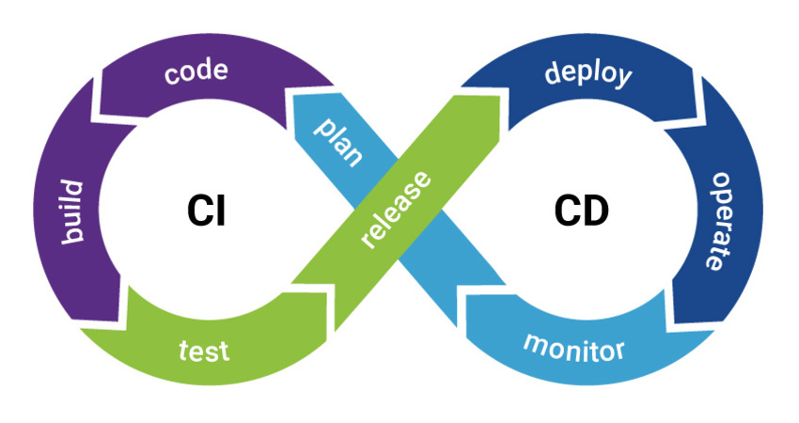

*By Walid RAHALI*

*Introduction*

The advantages of having a complete CI/CD (continuous integration / continuous deployment) pipeline for UdaPeople are numerous. In this presentation, I will show some of them, especially the ones related to revenue protection and costs reducing.

*1) Downtime*



On average, companies facing downtimes due to infrastructure dysfunction lose $163,674 per year.

In addition to this loss of money due to unavailability of the product during downtime, human costs must also be taken into account. According to studies, developers and sys admins had to spend 1 to 12 hours of working time to repair production incidents.

In addition, the trust to our products and the reputation of udaPeople will be eventually questionable, especially if this kind of incidents happens often. Personally, I think customer’s trust is priceless.

With CI/CD in place, we can reduce downtime significantly and reach a high availability of service.

*2) Time to value*

**

The delay from when code is written to running in production is the time to value, and is a bottleneck for many organizations. CI/CD put in place can help to overcome this barrier to quick deployments;we can reduce this time significantly as whenever we finish a new feature and we push it to master branch, it will be merged with the rest of the code, tested against a suite of tests and if it passes with no regression, it will be deployed to production and reaches the customers a lot quicker than deploying once per several weeks.

Of course, reaching the market fast makes our clients even more satisfied with our product and makes us in a better position with our competitors.

*3) Build Confidence and increase productivity*

**

By having CI/CD pipeline, developers are much more confident about their new code and features as there will be a suit of tests to run against it during continuous integration phase.

There will be no fear or anxiety when we deploy new releases as we know, even if this something goes wrong after deploying, with good monitoring put in place, we are sure that we can figure out the problem very fast and fix it quickly.

This state of confidence will unleash creativity and willingness to optimize our code base or try something new.

Eventually we will have better code quality and robust product, which make talented developers want to stay in udaPeople and be more productive.

*Conclusion*

*Finally, I want thank you for attending this presentation and I hope it had clarified the importance of CI/CD and especially its financial benefits.*