Products-to-eBay

**Version**: 1.0

**Requires at least [word press]**: 3.0

**Tested up to**: 4.3.1

**products-to-eBay** is a plugin for pushing WooCommerce Products to eBay using eBay API

**Description :**

["Products-to-eBay is active"]

1. firstly you should enter your setting to connect with API then , enter number of products to publish.

2. if there is no product to publish , show a message that informs you that all products are already published.

["Setting Page"]

firstly,

1. you must have an account on eBay Developer and generate keys to get your configuration to connect with eBay API

there are some details that you must ensure that you have it like [ DEVID - AppID - CertID ...etc ].

2. you must have a paypal account.

finally , enter your configuration in setting page then click "save changes" to save your setting

["WooCommerce is inactive"]

"Woo Commerce plugin is inactive and products-to-eBay is active" > show a message that informs you that woo commerce plugin is inactive and you should active it to connect and push your products.

**Installation :**

1. Upload your plugin folder to the '/wp-content/plugins/' directory.

2. Activate the plugin through the 'Plugins/' menu in WordPress.

3. Make sure that WooCommerce Plugin is active.

**Screenshots :**

1. Setting page

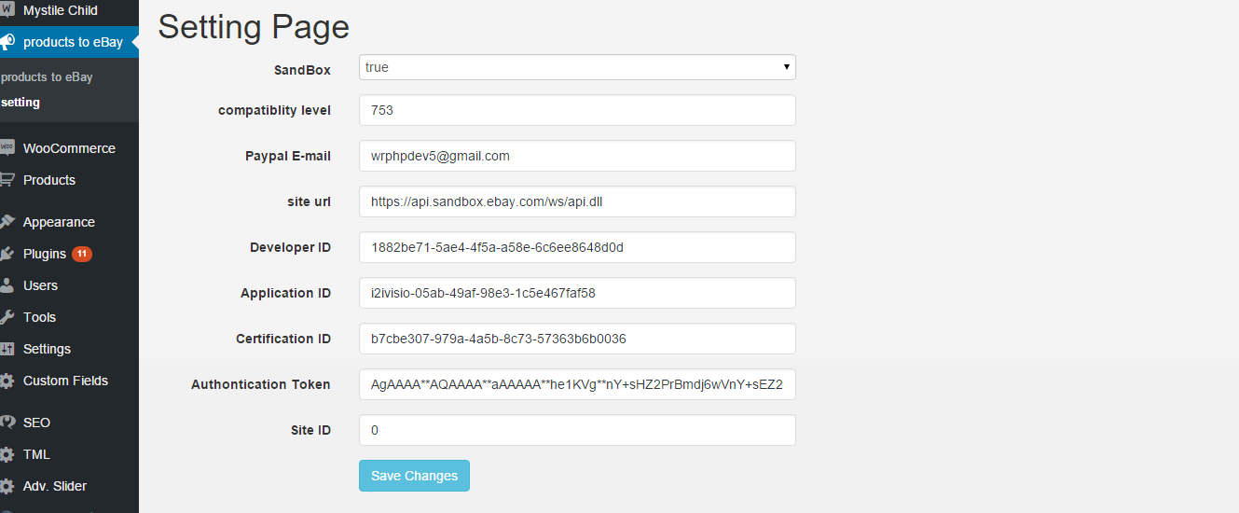

1. Push Products

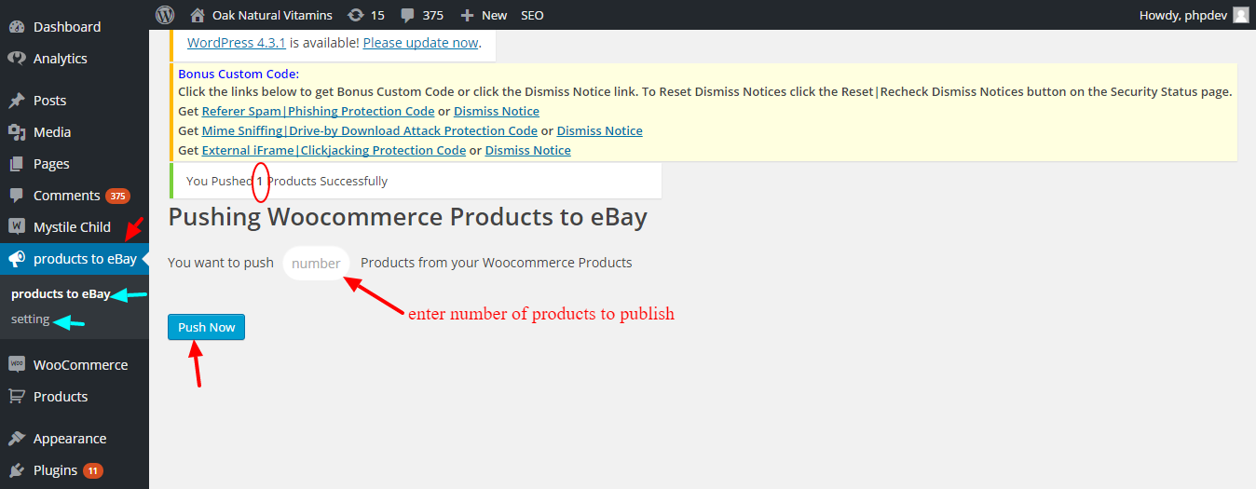

1. If all products are published

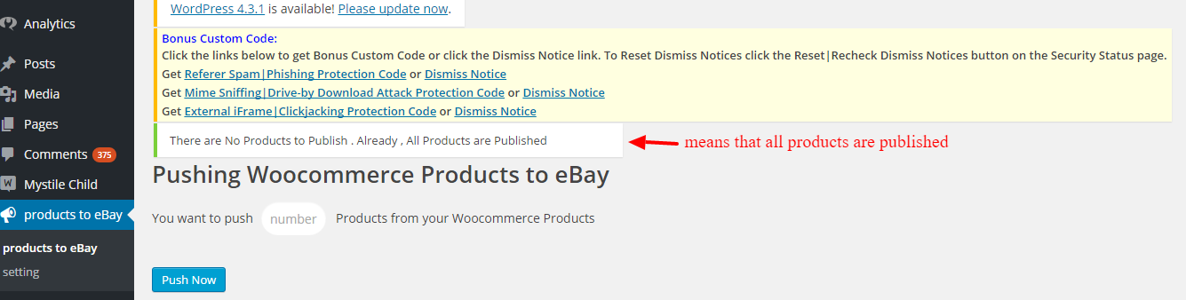

1. Add coloumn to products table that inform you which are products published

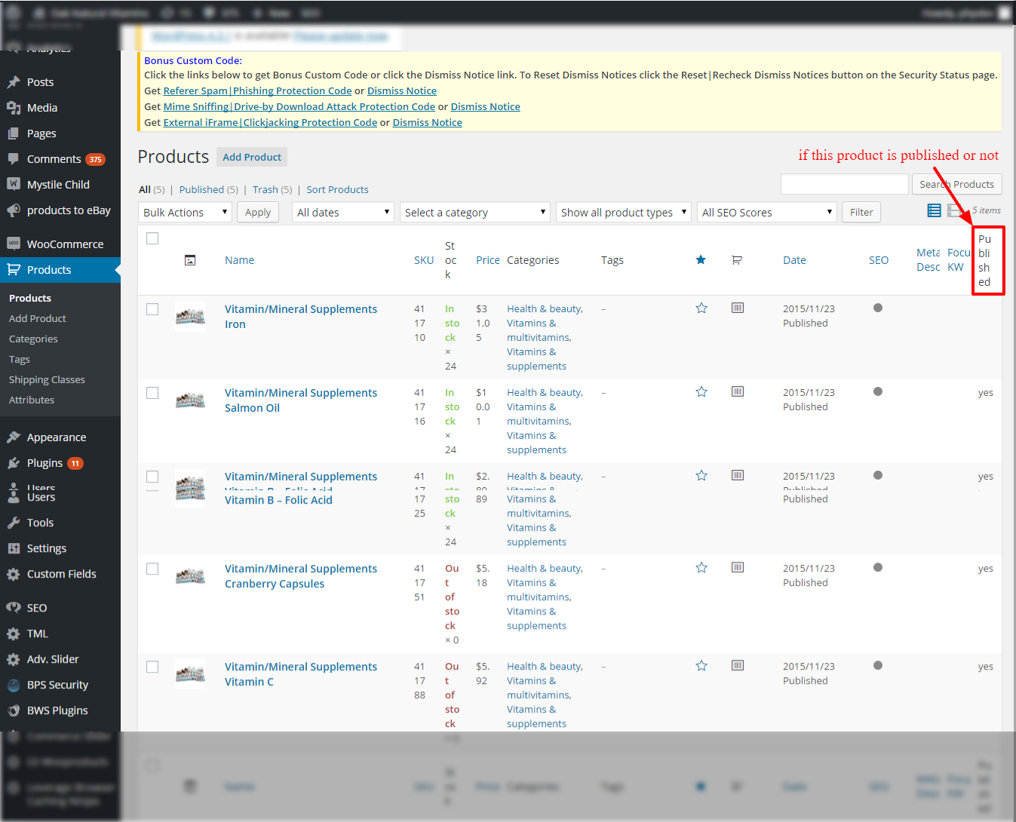

1. When WooCommerce Plugin is inactive

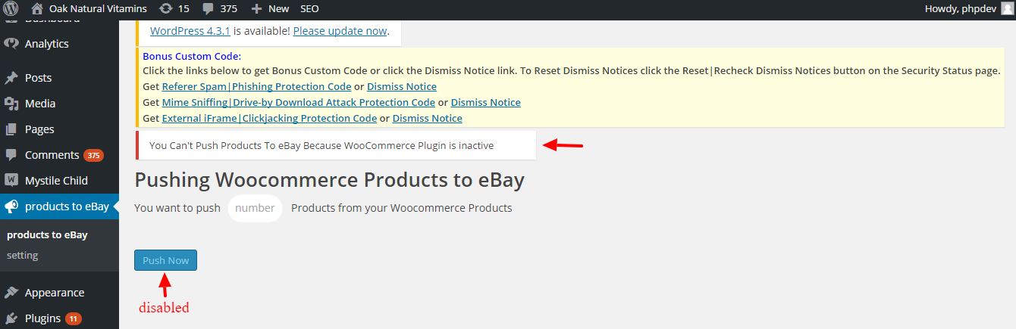

1. Finally , products in eBay

