TIC

SECTION B – G3

FINAL PROJECT

**(Information and Communication Technologies) and technologies related to TIC (Google services, Microsoft**

**tools, Git and GitHub ...etc).**

No index entries found.

**INTRODUCTION TO TIC**

**I – GOOGLE SERVICES**

**II – MICROSOFT TOOLS**

**III – GIT AND GITHUB**

**IV – ARTIFICIAL INTELLIGENCE**

**V – INTERNET OF THINGS “IoT”**

**VI – CYBERSECURITY**

**TABLE CONTAINING IMPORTANT TECHNOLOGIES RELATED TO TIC**

**CONCLUSION**

**CONTENT TABLE**

**INTRODUCTION TO TIC**

**“INFORMATION AND COMMUNICATION TECHNOLOGIES”**

* ***Definition of TIC*** : TIC, or Information and Communication Technologies, refers to a broad range of technologies that facilitate communication and the processing and transmission of information. This includes hardware, software, networks, and digital platforms.
* ***Overview of TIC :*** TIC encompasses various technological tools and systems, such as computers, telecommunications equipment, software ,applications, and the internet, enabling users to access, store, transmit, and manipulate digital information.
* ***Importance of TIC*** : TIC plays a pivotal role in shaping modern society, revolutionizing communication, business operations, education, healthcare, and entertainment. It fuels innovation, drives efficiency, and enhances global connectivity and collaboration

**I – GOOGLE SERVICES**

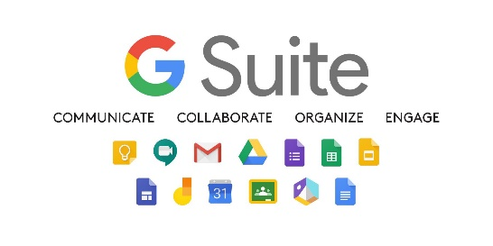

* ***G Suite:*** Formerly known as Google Apps, G Suite offers a suite of cloud-based productivity tools, including Gmail, Google Drive, Google Docs, Sheets, and Slides. These applications enable real-time collaboration, document sharing, and seamless communication.



* ***Google Cloud Platform (GCP):*** Google's cloud computing services provide scalable and flexible infrastructure, storage, and machine learning capabilities. GCP supports businesses in building, deploying, and scaling applications.

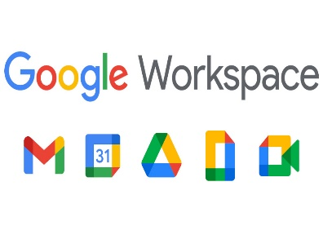

* ***Google Workspace:*** An integrated platform that combines productivity tools, including Gmail, Calendar, Drive, Docs, and Meet, fostering efficient communication

**II – MICROSOFT TOOLS**

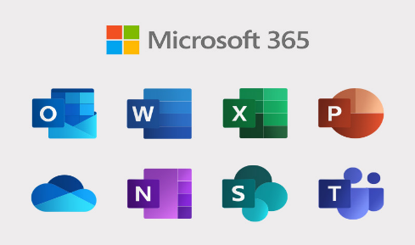

* ***Microsoft 365:*** A comprehensive suite of productivity tools, including Word, Excel, PowerPoint, and Teams. Microsoft 365 facilitates document creation, collaboration, and communication, emphasizing seamless integration across devices.

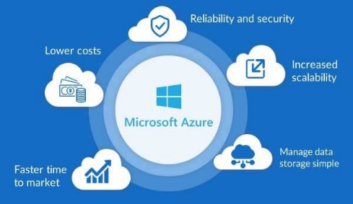

* ***Azure Cloud Services***: Microsoft's cloud computing platform provides a range of services, from virtual computing to analytics and artificial intelligence. Azure enables businesses to build, deploy, and manage applications and services.
* ***GitHub:*** Acquired by Microsoft, GitHub is a web-based platform for version control and collaboration using Git. It is widely used for source code management and collaborative software development.

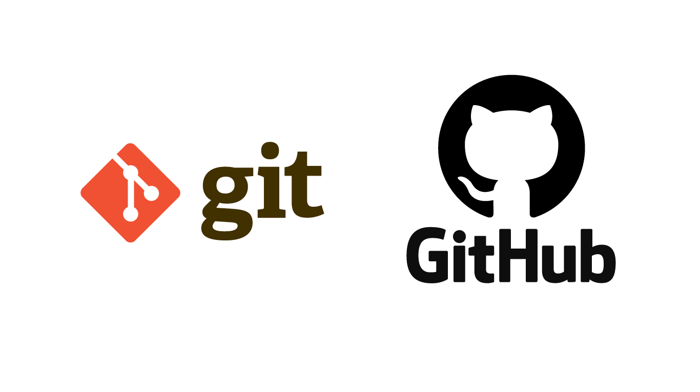

**III – GIT AND GITHUB**

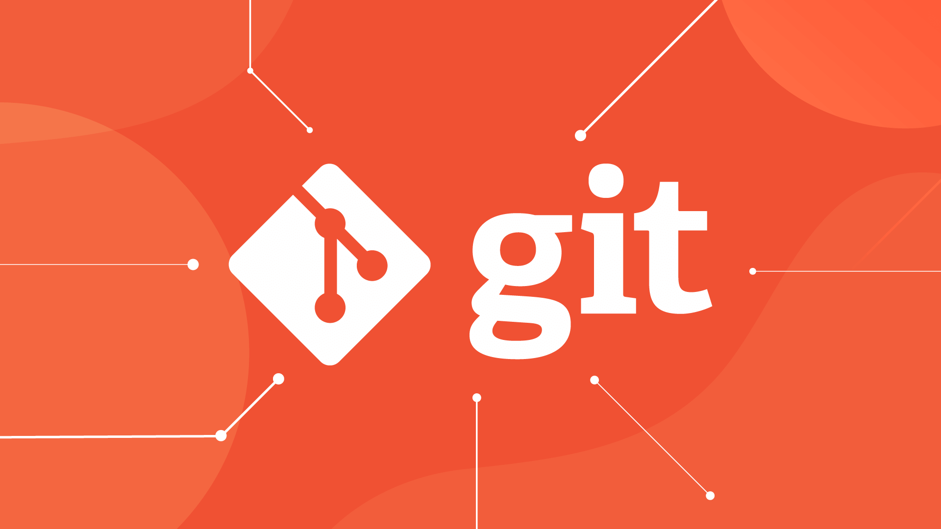

* ***Git:*** A distributed version control system that allows multiple developers to work on a project simultaneously. Git tracks changes in source code during software development, enabling collaboration and version management.

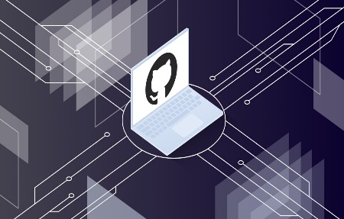

* ***GitHub:*** A web-based hosting service for Git repositories. GitHub enhances collaboration by providing features such as pull requests, code review, and issue tracking. It is a central hub for open-source development and collaborative coding.
* ***Version control with Git and GitHub:*** Git and GitHub enable version control, allowing developers to track changes, manage revisions, and collaborate on code projects efficiently, ensuring code integrity and facilitating seamless integration of contributions.
* ***Collaborative development with Git and GitHub:*** Git and GitHub foster collaborative development by providing a platform for developers to share, review, and merge code contributions, promoting teamwork, transparency, and code quality.
* ***Workflow with Git and GitHub:*** Git and GitHub streamline the development workflow by enabling branching, merging, issue tracking, and continuous integration, facilitating agile development practices and efficient code management.

**IV – ARTIFICIAL INTELLIGENCE**

* **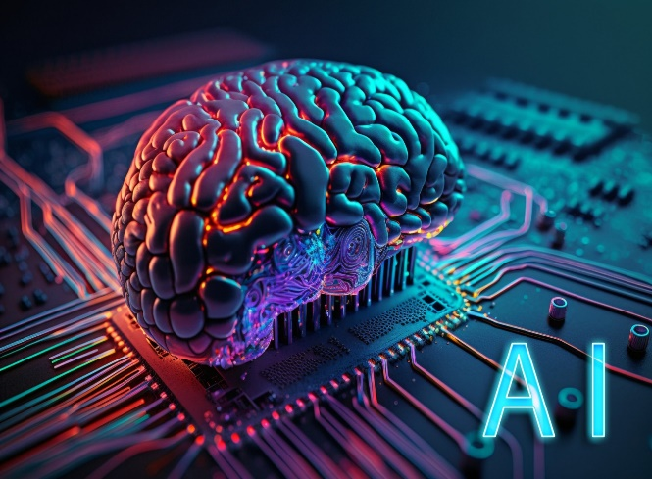*Overview:*** Artificial Intelligence (AI) involves the development of computer systems that can perform tasks that typically require human intelligence, such as visual perception, speech recognition, decision-making, and language translation.
* ***Applications:*** AI is applied across various sectors, including healthcare, finance,

manufacturing, and customer service, to automate processes, analyze complex data, detect patterns, and enhance productivity.

* ***Impact:*** The impact of AI spans from improved efficiency and accuracy in decision-making to creating new opportunities for innovation and disruption across industries, leading to significant advancements in technology and the way businesses operate.

**IV – INTERNET OF THINGS “IoT”**

* ***Definition***: The Internet of Things (IoT) refers to the network of interconnected physical devices, vehicles, home appliances, and other objects embedded with sensors, software, and connectivity to enable them to collect and exchange data, creating opportunities for automation, efficiency, and enhanced experiences.
* ***Examples:*** Examples of IoT applications include smart home devices, wearable fitness trackers, industrial sensors, connected vehicles, and environmental monitoring systems, all of which leverage IoT technology to gather and act on data for improved functionality and user experiences.
* ***Benefits:*** IoT technology offers benefits such as real-time insights, autonomous operations, predictive maintenance, and data-driven decision- making, enabling organizations and individuals to optimize processes and streamline operations

**VI – CYBERSECURITY**



* ***Importance:*** Cybersecurity is crucial for protecting sensitive data, safeguarding digital assets, maintaining user privacy, and preserving the integrity of systems and networks against unauthorized access, cyber attacks, and data breaches.
* ***Threats:*** Common cybersecurity threats include malware, phishing attacks, ransomware, insider threats, and distributed denial-of-service (DDoS) attacks, posing significant risks to organizational security and data confidentiality.
* ***Solutions:*** Effective cybersecurity solutions encompass measures such as encryption, multi- factor authentication, network monitoring, regular security updates, and employee training to mitigate vulnerabilities and proactively defend against emerging threats.

| **Category** | **Components/Technologies** |
| --- | --- |
| Hardware | Computers, Servers, Networking Devices, Storage |
| Software | Operating Systems, Applications, Middleware |
| Networking | Routers, Switches, Hubs, Firewalls, Modems |
| Internet Technologies | Web Browsers, Search Engines, Cloud Computing |
| Mobile Technologies | Smartphones, Tablets, Mobile Operating Systems |
| Security | Antivirus Software, Firewalls, Encryption |
| Data Storage | Hard Drives, SSDs, Cloud Storage, NAS |
| Programming Languages | Java, Python, C++, JavaScript, SQL |
| Web Development | HTML, CSS, JavaScript, Frameworks (e.g., React) |
| Wireless Technologies | Wi-Fi, Bluetooth, RFID, NFC |
| Multimedia | Audio/Video Codecs, Graphics Software |
| ICT Standards | IEEE, ISO, ITU-T, W3C |
| Project Management | Agile, Scrum, Waterfall, Project Management Tools |
| Virtualization | Virtual Machines, Hypervisors |
| Emerging Technologies | Artificial Intelligence, Internet of Things (IoT), Blockchain |

**TABLE CONTAINING IMPORTANT TECHNOLOGIES RELATED TO TIC**

**CONCLUSION**

Information and Communication Technologies, along with related technologies such as Google services, Microsoft tools, and Git/GitHub, have become fundamental pillars of the digital era. The continuous evolution of these technologies is reshaping the way individuals and organizations interact, collaborate, and innovate. Staying abreast of these developments and embracing technological advancements will be essential for navigating the dynamic landscape of ICT in the future.