AI IMPACT ON JOBS AND SALARIES
Big Data Analysis using Hadoop HDFS, Apache Pig and Java MapReduce
Submitted by: Walid Talal
ID: 0222220005101045
Submitted to: MD Tamim Hossain
Lecturer, Department of Computer Science & Engineering
Premier University
Dataset: ai_jobs_salaries.csv (71,913 records, 17 attributes)
Technologies: Apache Hadoop, HDFS, Java MapReduce, Apache Pig 0.18.0

Table of Contents
1. Problem Statement 3
2. Dataset Description 3
3. Summary of Data Analysis 3
4. Map Reduce Analysis 4
4.1 Highest Salary by Job Role 4
4.2 Job Count by Experience Level 9
4.3 Top 10 Highest-Paid Individual Job Records 13
5. Pig AI Jobs and Salaries Data Analysis 19
5.1 Top 10 Highest-Paying Job Roles 19
5.2 Salary Analysis by Experience Level 22
5.3 Job Distribution by Work Mode 24
5.4 Top 10 Job Locations 27
5.5 Salary Comparison by Employment Type 29

1. Problem Statement
Analyze the AI Jobs and Salaries Big Data dataset using Hadoop (Java MapReduce) and Apache Pig, based on different column fields such as job role, experience level, employment type, work mode and company location, to provide comprehensive insights into how salaries in AI-related roles vary across the workforce.

2. Dataset Description
Dataset file: Dataset/ai_jobs_salaries.csv (approximately 71,913 records, 17 attributes)
Field | Description
work_year | Year the salary was reported
experience_level_label | Decoded experience level (Entry / Mid / Senior / Executive)
employment_type_label | Decoded employment type (Full-time / Part-time / Contract / Freelance)
job_title | Original raw job title as self-reported
role_family | Manually grouped role family derived from job_title
salary_in_usd | Salary converted to USD (primary comparable field)
work_mode | On-site / Hybrid / Remote, decoded from remote_ratio
company_size | Company size band as reported (S / M / L)
company_location | Company's country (ISO code, as provided by source)
salary_outlier_flag | True if salary_in_usd falls outside the 1.5×IQR range (flagged, not removed)
isco_group_hint | Approximate ISCO-08 occupational group hint (manual mapping, not authoritative)
Source: foorilla/ai-jobs-net-salaries (CC0 1.0). Salary data is self-reported survey data, not verified payroll data.

3. Summary of Data Analysis
The following Java MapReduce programs are implemented on the dataset:
1. Highest Salary by Job Role — maximum salary_in_usd for each role_family
2. Job Count by Experience Level — number of records for each experience_level_label
3. Top 10 Highest-Paid Individual Job Records — top 10 individual salary records using a priority queue
The following Apache Pig analyses are performed on the dataset:
1. Top 10 Highest-Paying Job Role Families
2. Salary Analysis by Experience Level (average, maximum, minimum)
3. Job Distribution by Work Mode (on-site / hybrid / remote, with percentage)
4. Top 10 Job Locations by number of AI jobs
5. Salary Comparison by Employment Type (average, maximum, minimum)

4. Map Reduce Analysis
Three Java MapReduce programs were developed and executed on Hadoop. Each program uses a Mapper class to parse and emit relevant fields from the CSV records, and a Reducer class to aggregate the results. Programs were compiled, packaged as runnable JAR files, and submitted to the Hadoop cluster via the hadoop jar command against the dataset stored on HDFS.

4.1 Highest Salary by Job Role : Returns the maximum salary recorded for each job role family (HighestSalaryByRole)
This analysis comprises of:
1. Mapper Class : Parses each CSV record and emits role_family of type Text and salary_in_usd of type DoubleWritable
2. Reducer Class : Emits role_family as a key of type Text and the maximum salary of type DoubleWritable
3. Driver Class : Sets up configuration for the Mapper and Reducer classes
Mapper Class
public static class SalaryMapper
extends Mapper<Object, Text, Text, DoubleWritable> {

private final Text roleFamily = new Text();
private final DoubleWritable salary = new DoubleWritable();

@Override
public void map(
Object key,
Text value,
Context context)
throws IOException, InterruptedException {

String line = value.toString();

if (line.startsWith("work_year,")) {
return;
}

String[] fields = line.split(",", -1);

// Dataset must contain all required columns
if (fields.length < 16) {
return;
}

try {

double salaryInUsd = Double.parseDouble(fields[6].trim());

String role = fields[15].trim();

if (role.isEmpty()) {
return;
}

roleFamily.set(role);
salary.set(salaryInUsd);

context.write(roleFamily, salary);

} catch (NumberFormatException e) {
}
}
}
Reducer Class
public static class SalaryReducer
extends Reducer<Text, DoubleWritable, Text, DoubleWritable> {

private final DoubleWritable maximumSalary =
new DoubleWritable();

@Override
public void reduce(
Text key,
Iterable<DoubleWritable> values,
Context context)
throws IOException, InterruptedException {

double maxSalary = Double.MIN_VALUE;

for (DoubleWritable value : values) {

if (value.get() > maxSalary) {
maxSalary = value.get();
}
}

maximumSalary.set(maxSalary);

context.write(key, maximumSalary);
}
}
Driver Class
public static void main(String[] args)
throws Exception {

if (args.length != 2) {

System.err.println(
"Usage: HighestSalaryByRole <input> <output>");

System.exit(-1);
}

Configuration configuration = new Configuration();

Job job = Job.getInstance(
configuration,
"Highest Salary by Job Role");

job.setJarByClass(HighestSalaryByRole.class);

// Mapper
job.setMapperClass(SalaryMapper.class);

// Reducer
job.setReducerClass(SalaryReducer.class);

// Output types
job.setOutputKeyClass(Text.class);
job.setOutputValueClass(DoubleWritable.class);

// Input / Output paths
FileInputFormat.addInputPath(
job,
new Path(args[0]));

FileOutputFormat.setOutputPath(
job,
new Path(args[1]));

System.exit(
job.waitForCompletion(true)
? 0
: 1);
}
}
Execution
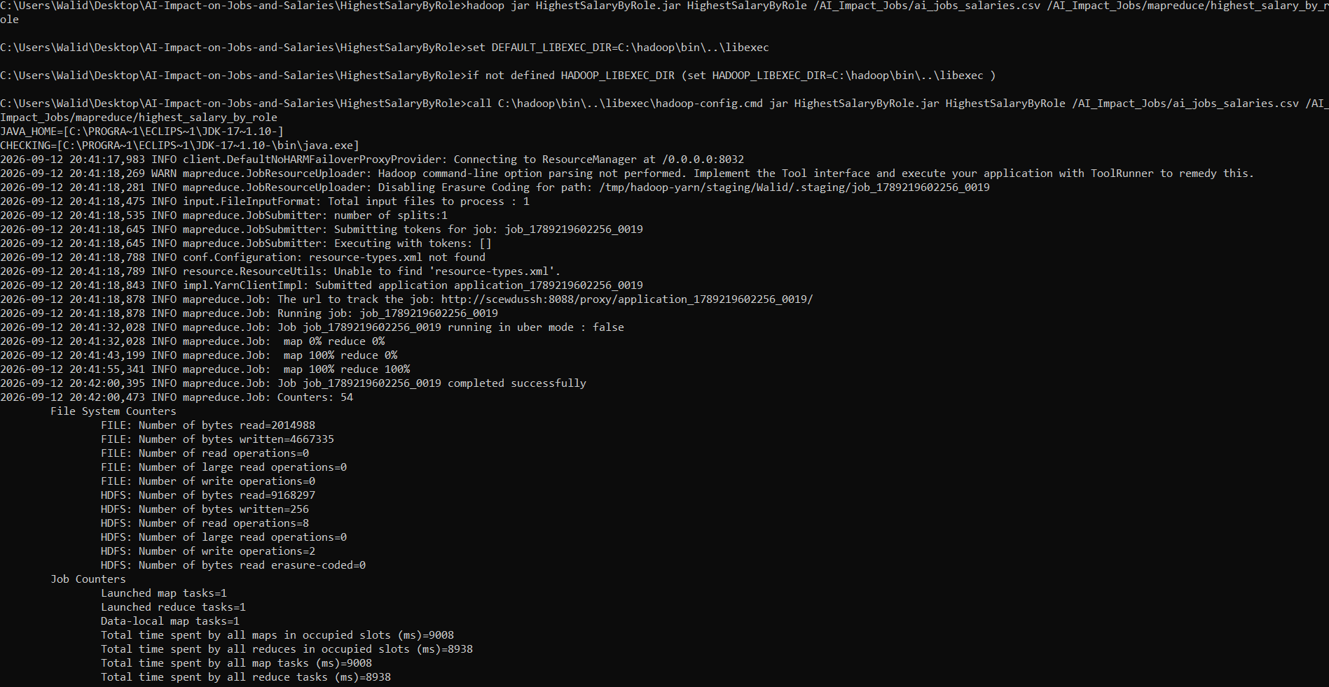
Job submission and execution
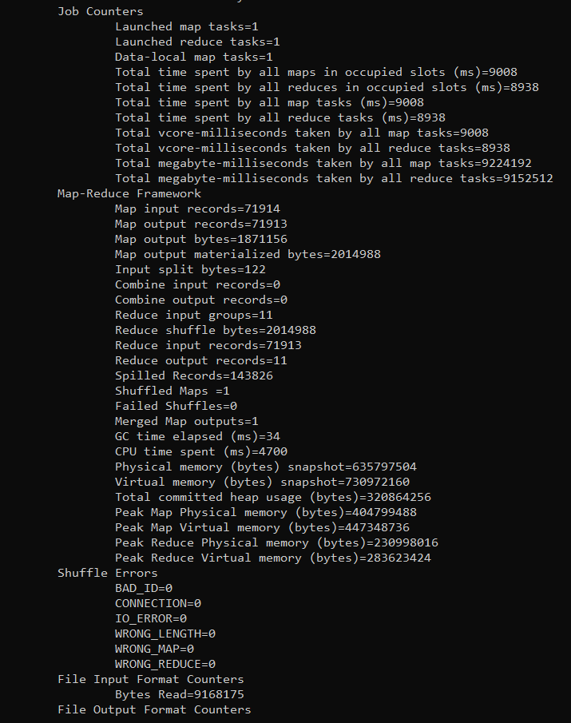
Job completed successfully
Output
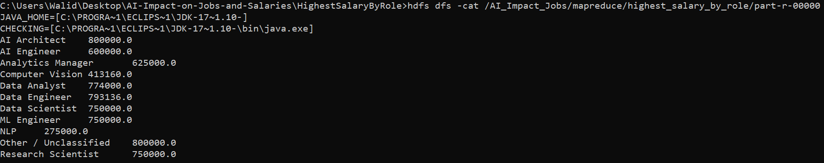
Highest Salary by Job Role — HDFS output (part-r-00000)
AI Architect 800000.0
AI Engineer 600000.0
Analytics Manager 625000.0
Computer Vision 413160.0
Data Analyst 774000.0
Data Engineer 793136.0
Data Scientist 750000.0
ML Engineer 750000.0
NLP 275000.0
Other / Unclassified 800000.0
Research Scientist 750000.0

4.2 Job Count by Experience Level : Returns the total number of job records for each experience level (JobsByExperienceLevel)
This analysis comprises of:
1. Mapper Class : Emits experience_level_label of type Text and 1 of type IntWritable for every record
2. Reducer Class : Emits experience level as a key of type Text and its total occurrence of type IntWritable
3. Driver Class : Sets up configuration for the Mapper and Reducer classes
Mapper Class
public static class ExperienceMapper
extends Mapper<Object, Text, Text, IntWritable> {

private final Text experienceLevel = new Text();
private final IntWritable one = new IntWritable(1);

@Override
public void map(
Object key,
Text value,
Context context)
throws IOException, InterruptedException {

String line = value.toString();

if (line.startsWith("work_year,")) {
return;
}

String[] fields = line.split(",", -1);

if (fields.length < 12) {
return;
}

// Column 11 = experience_level_label
String experience = fields[11].trim();

if (experience.isEmpty()) {
return;
}

experienceLevel.set(experience);

context.write(experienceLevel, one);
}
}
Reducer Class
public static class ExperienceReducer
extends Reducer<Text, IntWritable, Text, IntWritable> {

private final IntWritable totalJobs = new IntWritable();

@Override
public void reduce(
Text key,
Iterable<IntWritable> values,
Context context)
throws IOException, InterruptedException {

int sum = 0;

for (IntWritable value : values) {
sum += value.get();
}

totalJobs.set(sum);

context.write(key, totalJobs);
}
}
Driver Class
public static void main(String[] args)
throws Exception {

if (args.length != 2) {

System.err.println(
"Usage: JobsByExperienceLevel <input> <output>");

System.exit(-1);
}

Configuration configuration = new Configuration();

Job job = Job.getInstance(
configuration,
"Job Count by Experience Level");

job.setJarByClass(JobsByExperienceLevel.class);

// Mapper
job.setMapperClass(ExperienceMapper.class);

// Reducer
job.setReducerClass(ExperienceReducer.class);

// Output types
job.setOutputKeyClass(Text.class);
job.setOutputValueClass(IntWritable.class);

// Input path
FileInputFormat.addInputPath(
job,
new Path(args[0]));

// Output path
FileOutputFormat.setOutputPath(
job,
new Path(args[1]));

System.exit(
job.waitForCompletion(true)
? 0
: 1);
}
}
Execution
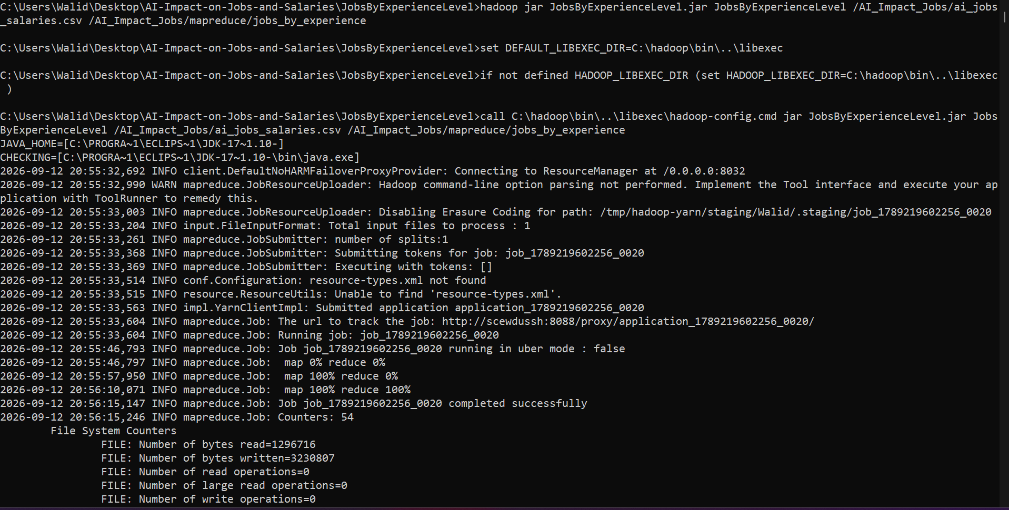
Job submission and execution
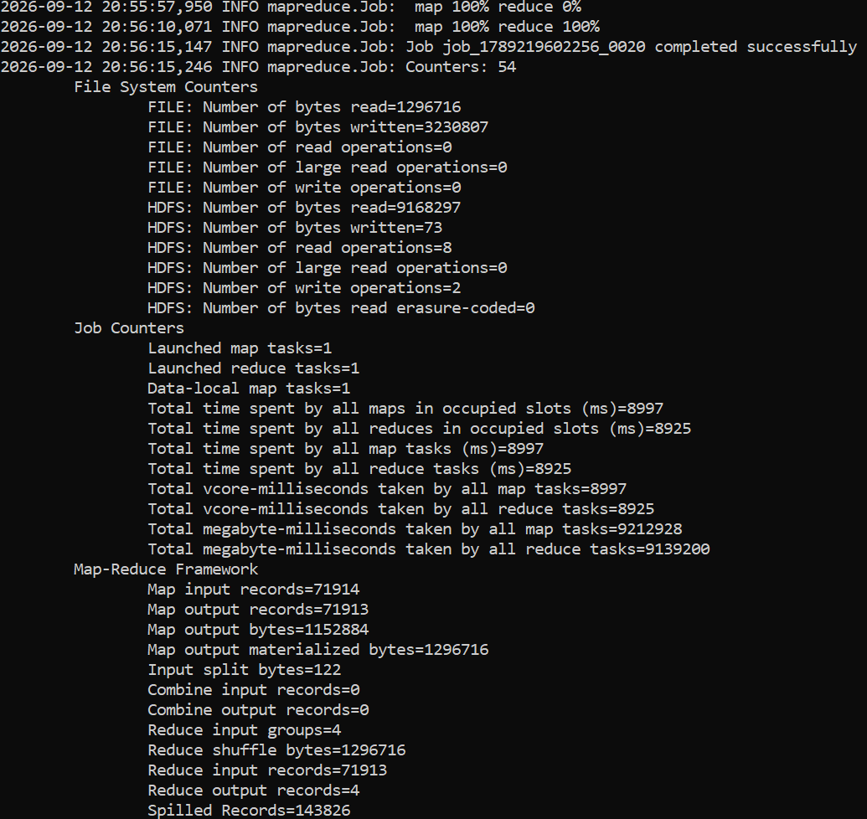
Job completed successfully
Output
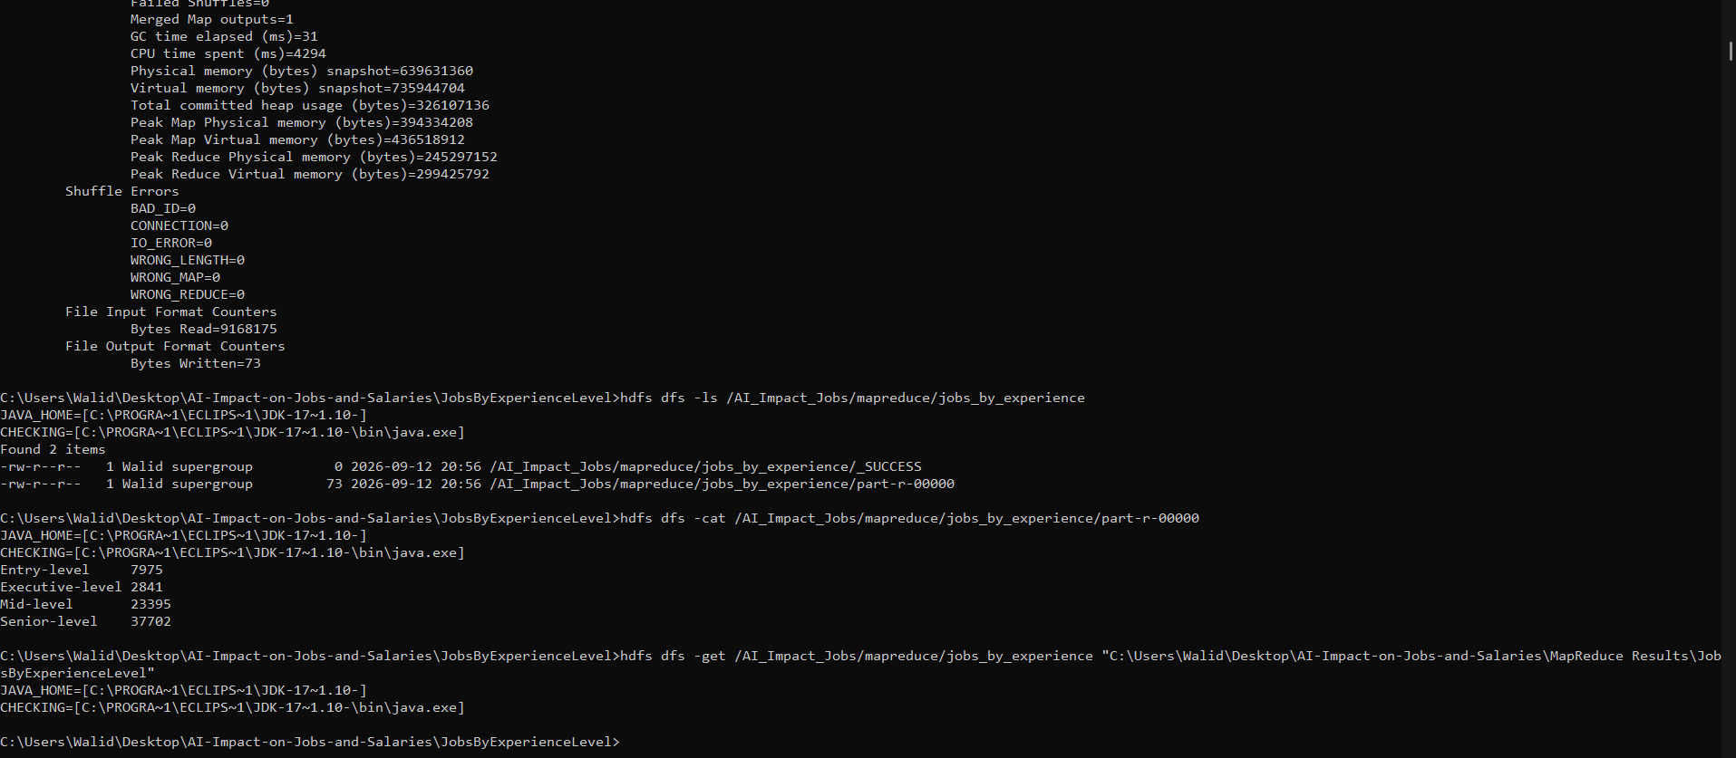
Job Count by Experience Level — HDFS output (part-r-00000)
Entry-level 7975
Executive-level 2841
Mid-level 23395
Senior-level 37702

4.3 Top 10 Highest-Paid Individual Job Records : Returns the top 10 individual job records with the highest salary (Top10HighestPaidJobs)
This analysis comprises of:
1. Mapper Class : Emits salary_in_usd as the key of type Text and job_title, experience level, company location and work mode (tab separated) as the value of type Text
2. Reducer Class : Maintains a size-10 min-heap PriorityQueue keyed on salary; when the queue exceeds 10 entries the lowest salary is removed, so only the top 10 highest-paid records survive; results are emitted in descending order in the cleanup phase
3. JobRecord Class : Small helper (POJO) class holding a salary value and its associated job details string
4. Driver Class : Sets up configuration for the Mapper and Reducer classes
Mapper Class
public static class SalaryMapper
extends Mapper<Object, Text, Text, Text> {

private final Text outputKey = new Text();
private final Text outputValue = new Text();

@Override
public void map(
Object key,
Text value,
Context context)
throws IOException, InterruptedException {

String line = value.toString();

if (line.startsWith("work_year,")) {
return;
}

String[] fields = line.split(",", -1);

if (fields.length < 16) {
return;
}

try {

// Column 6 = salary_in_usd
double salary = Double.parseDouble(
fields[6].trim());

// Column 3 = job_title
String jobTitle = fields[3].trim();

// Column 11 = experience_level_label
String experienceLevel = fields[11].trim();

// Column 9 = company_location
String companyLocation = fields[9].trim();

// Column 13 = work_mode
String workMode = fields[13].trim();

outputKey.set(String.valueOf(salary));

String jobRecord =
jobTitle + "\t"
+ experienceLevel + "\t"
+ companyLocation + "\t"
+ workMode;

outputValue.set(jobRecord);

context.write(outputKey, outputValue);

} catch (NumberFormatException e) {

// Ignore records with invalid salary
}
}
}
Reducer Class
public static class Top10Reducer
extends Reducer<Text, Text, Text, Text> {

/*
* Priority queue keeps the 10 highest salaries.
*
* Smallest salary stays at the top.
* When the queue becomes larger than 10,
* the smallest salary is removed.
*/

private PriorityQueue<JobRecord> top10;

@Override
protected void setup(Context context) {

top10 = new PriorityQueue<>(
10,
(a, b) -> Double.compare(
a.salary,
b.salary));
}

@Override
public void reduce(
Text key,
Iterable<Text> values,
Context context)
throws IOException, InterruptedException {

double salary = Double.parseDouble(
key.toString());

for (Text value : values) {

JobRecord record =
new JobRecord(
salary,
value.toString());

top10.add(record);

if (top10.size() > 10) {
top10.poll();
}
}
}

@Override
protected void cleanup(Context context)
throws IOException, InterruptedException {

/*
* Convert PriorityQueue to an array
* and sort from highest salary to lowest.
*/

JobRecord[] records =
top10.toArray(
new JobRecord[0]);

java.util.Arrays.sort(
records,
(a, b) -> Double.compare(
b.salary,
a.salary));

int rank = 1;

for (JobRecord record : records) {

context.write(
new Text(
String.valueOf(rank)),
new Text(
record.salary
+ "\t"
+ record.details));

rank++;
}
}
}
JobRecord Helper Class
public static class JobRecord {

double salary;
String details;

JobRecord(
double salary,
String details) {

this.salary = salary;
this.details = details;
}
}
Driver Class
public static void main(String[] args)
throws Exception {

if (args.length != 2) {

System.err.println(
"Usage: Top10HighestPaidJobs <input> <output>");

System.exit(-1);
}

Configuration configuration =
new Configuration();

Job job = Job.getInstance(
configuration,
"Top 10 Highest-Paid Individual Jobs");

job.setJarByClass(
Top10HighestPaidJobs.class);

// Mapper
job.setMapperClass(
SalaryMapper.class);

// Reducer
job.setReducerClass(
Top10Reducer.class);

// Mapper output
job.setMapOutputKeyClass(
Text.class);

job.setMapOutputValueClass(
Text.class);

// Final reducer output
job.setOutputKeyClass(
Text.class);

job.setOutputValueClass(
Text.class);

// Input
FileInputFormat.addInputPath(
job,
new Path(args[0]));

// Output
FileOutputFormat.setOutputPath(
job,
new Path(args[1]));

System.exit(
job.waitForCompletion(true)
? 0
: 1);
}
}
Execution
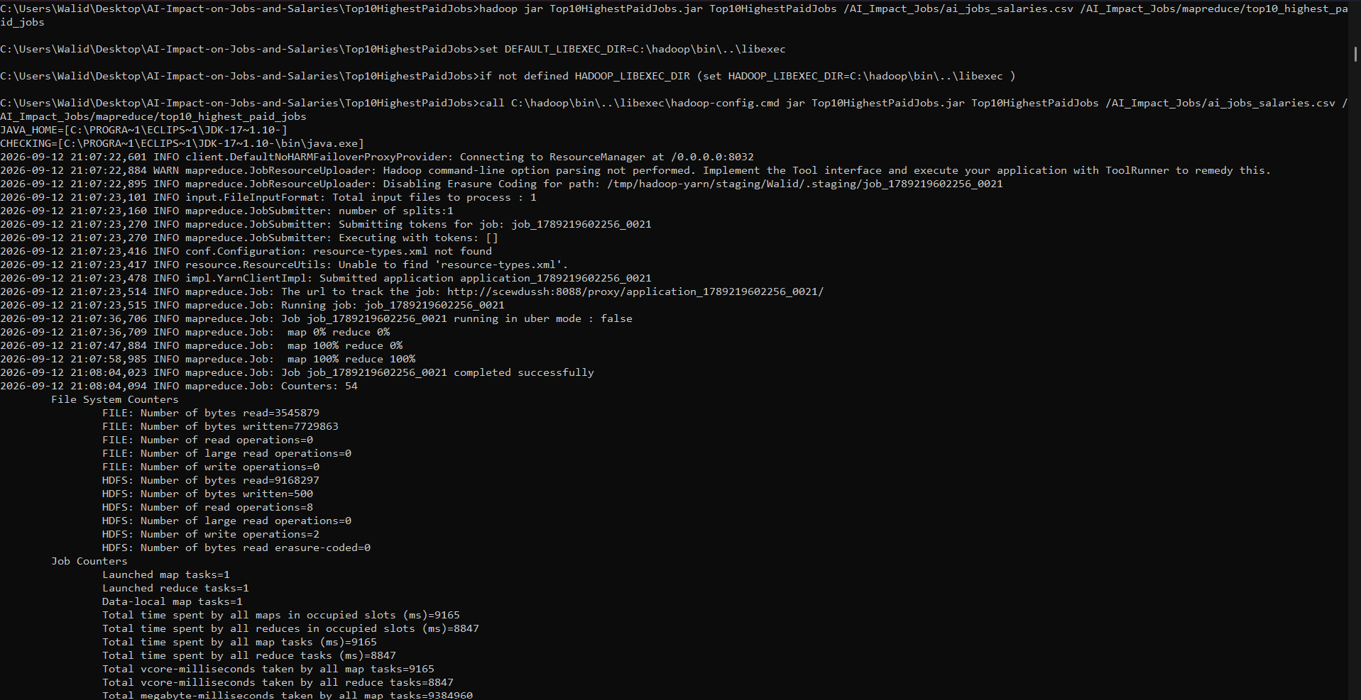
Job submission and execution

Job completed successfully
Output
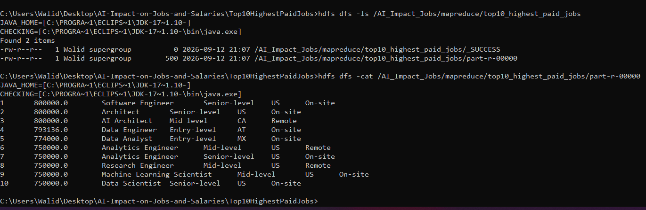
Top 10 Highest-Paid Individual Job Records — HDFS output (part-r-00000)
1 800000.0 Software Engineer Senior-level US On-site
2 800000.0 Architect Senior-level US On-site
3 800000.0 AI Architect Mid-level CA Remote
4 793136.0 Data Engineer Entry-level AT On-site
5 774000.0 Data Analyst Entry-level MX On-site
6 750000.0 Analytics Engineer Mid-level US Remote
7 750000.0 Analytics Engineer Senior-level US On-site
8 750000.0 Research Engineer Mid-level US Remote
9 750000.0 Machine Learning Scientist Mid-level US On-site
10 750000.0 Data Scientist Senior-level US On-site

5. Pig AI Jobs and Salaries Data Analysis
Five Apache Pig scripts were written and executed in local mode against the dataset. Each script loads the CSV using PigStorage, applies GROUP / FOREACH / ORDER / LIMIT operations as needed, and stores the result back using PigStorage with a pipe ('|') or comma (',') delimiter.

5.1 Top 10 Highest-Paying Job Roles : Returns the Top 10 highest-paying job role families
Groups all records by role_family, calculates the average salary_in_usd per group, sorts the groups in descending order of average salary, and limits the result to the top 10 role families.
Script
-- ============================================================
-- PIG OPERATION 1
-- Top 10 Highest-Paying Job Role Families
-- ============================================================

-- Load the AI Jobs and Salaries dataset from HDFS
jobs = LOAD '/AI_Impact_Jobs/ai_jobs_salaries.csv'
USING PigStorage(',')
AS (
work_year:int,
experience_level:chararray,
employment_type:chararray,
job_title:chararray,
salary:double,
salary_currency:chararray,
salary_in_usd:double,
employee_residence:chararray,
remote_ratio:int,
company_location:chararray,
company_size:chararray,
experience_level_label:chararray,
employment_type_label:chararray,
work_mode:chararray,
salary_outlier_flag:chararray,
role_family:chararray,
isco_group_hint:chararray
);

-- Group all records by role family
grouped_roles = GROUP jobs BY role_family;

-- Calculate the average salary for each role family
average_salary = FOREACH grouped_roles GENERATE
group AS role_family,
AVG(jobs.salary_in_usd) AS average_salary;

-- Sort role families by average salary in descending order
sorted_roles = ORDER average_salary BY average_salary DESC;

-- Select the top 10 highest-paying role families
top_10_roles = LIMIT sorted_roles 10;

-- Store the final result in HDFS
STORE top_10_roles
INTO '/AI_Impact_Jobs/pig/top10_highest_paying_roles'
USING PigStorage(',');
Execution
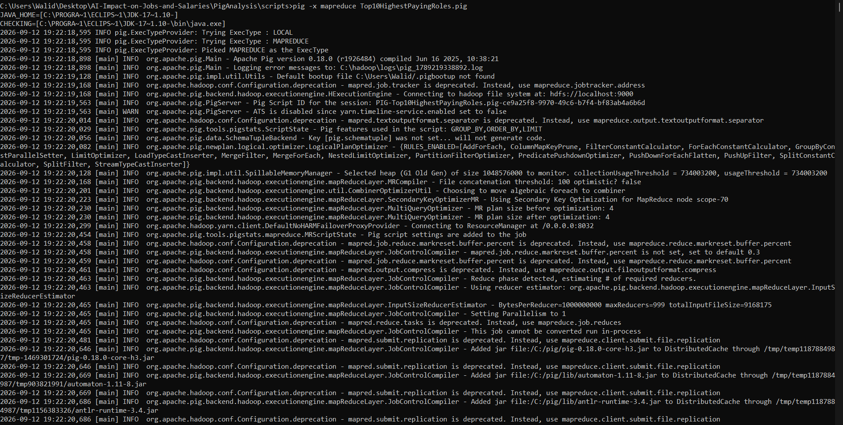
Script execution
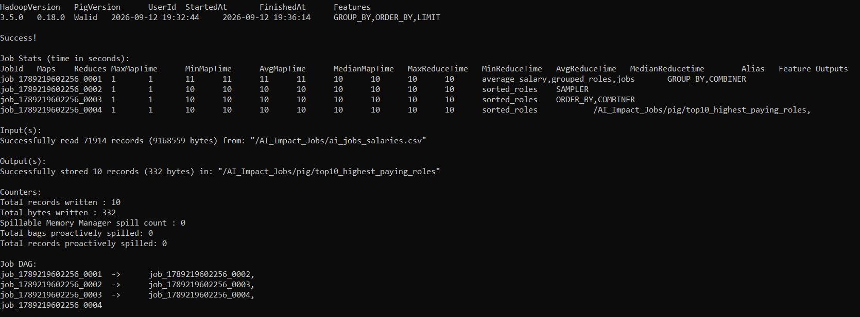
Successful completion
Output
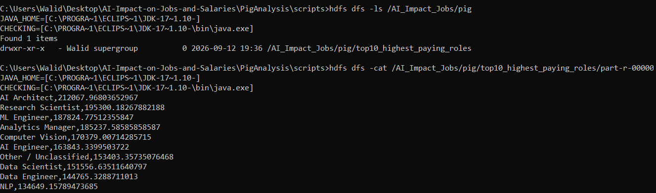
Top 10 Highest-Paying Job Roles — output

5.2 Salary Analysis by Experience Level : Returns average, maximum and minimum salary for each experience level
Groups all records by experience_level_label and calculates the average, maximum, and minimum salary_in_usd for each group, sorted from highest to lowest average salary.
Script
-- ============================================================
-- PIG OPERATION 2
-- Salary Analysis by Experience Level
-- ============================================================

jobs = LOAD '/AI_Impact_Jobs/ai_jobs_salaries.csv'
USING PigStorage(',')
AS (
work_year:int,
experience_level:chararray,
employment_type:chararray,
job_title:chararray,
salary:double,
salary_currency:chararray,
salary_in_usd:double,
employee_residence:chararray,
remote_ratio:int,
company_location:chararray,
company_size:chararray,
experience_level_label:chararray,
employment_type_label:chararray,
work_mode:chararray,
salary_outlier_flag:chararray,
role_family:chararray,
isco_group_hint:chararray
);

-- Remove CSV header
jobs = FILTER jobs BY work_year IS NOT NULL;

-- Group jobs by experience level
grouped_experience = GROUP jobs BY experience_level_label;

-- Calculate salary statistics
salary_analysis = FOREACH grouped_experience GENERATE
group AS experience_level,
AVG(jobs.salary_in_usd) AS average_salary,
MAX(jobs.salary_in_usd) AS maximum_salary,
MIN(jobs.salary_in_usd) AS minimum_salary;

-- Sort by average salary from highest to lowest
sorted_experience = ORDER salary_analysis BY average_salary DESC;

-- Store result in HDFS
STORE sorted_experience
INTO '/AI_Impact_Jobs/pig/salary_by_experience'
USING PigStorage(',');
Execution
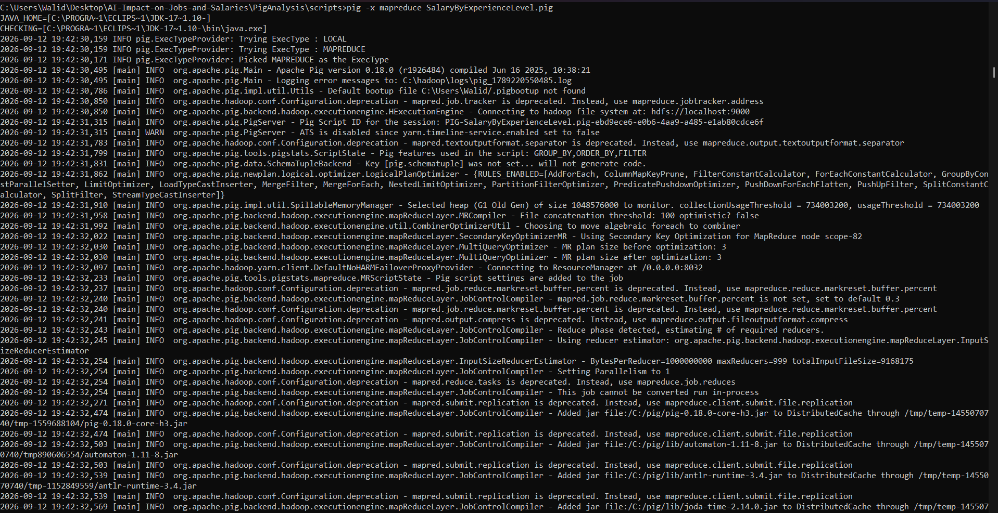
Script execution
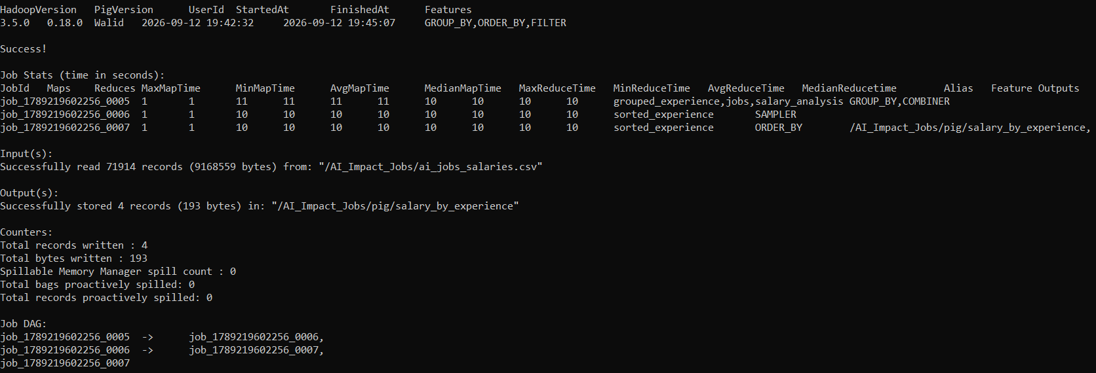
Successful completion
Output
Executive-level,202080.47,625000.0,15000.0
Senior-level,167807.96,800000.0,15645.0
Mid-level,136267.01,800000.0,15000.0
Entry-level,98017.08,793136.0,15000.0
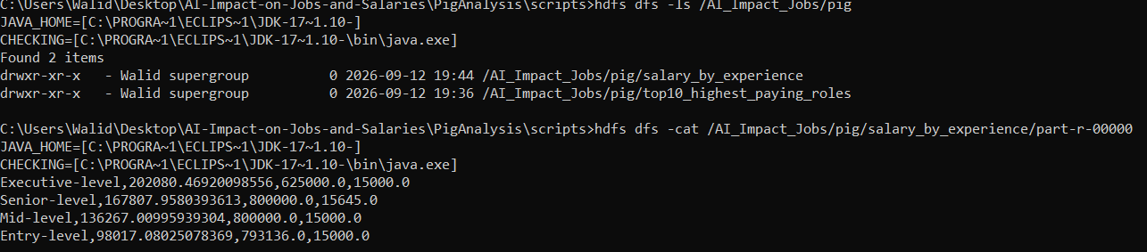
Salary Analysis by Experience Level — output

5.3 Job Distribution by Work Mode : Returns job count and percentage share for each work mode
Groups all records by work_mode, counts the jobs per group, and cross-joins against the overall total job count to calculate each work mode's percentage share, sorted by job count.
Script
-- ============================================================
-- PIG OPERATION 3
-- Job Distribution by Work Mode
-- ============================================================

jobs = LOAD '/AI_Impact_Jobs/ai_jobs_salaries.csv'
USING PigStorage(',')
AS (
work_year:int,
experience_level:chararray,
employment_type:chararray,
job_title:chararray,
salary:double,
salary_currency:chararray,
salary_in_usd:double,
employee_residence:chararray,
remote_ratio:int,
company_location:chararray,
company_size:chararray,
experience_level_label:chararray,
employment_type_label:chararray,
work_mode:chararray,
salary_outlier_flag:chararray,
role_family:chararray,
isco_group_hint:chararray
);

jobs = FILTER jobs BY work_year IS NOT NULL;

grouped_work_mode = GROUP jobs BY work_mode;

work_mode_count = FOREACH grouped_work_mode GENERATE
group AS work_mode,
COUNT(jobs) AS job_count;

total_jobs_group = GROUP jobs ALL;

total_jobs = FOREACH total_jobs_group GENERATE
COUNT(jobs) AS total_count;

crossed_data = CROSS work_mode_count, total_jobs;

work_mode_percentage = FOREACH crossed_data GENERATE
work_mode,
job_count,
(job_count * 100.0 / total_count) AS percentage;

sorted_work_mode = ORDER work_mode_percentage BY job_count DESC;

STORE sorted_work_mode
INTO '/AI_Impact_Jobs/pig/jobs_by_work_mode'
USING PigStorage(',');
Execution
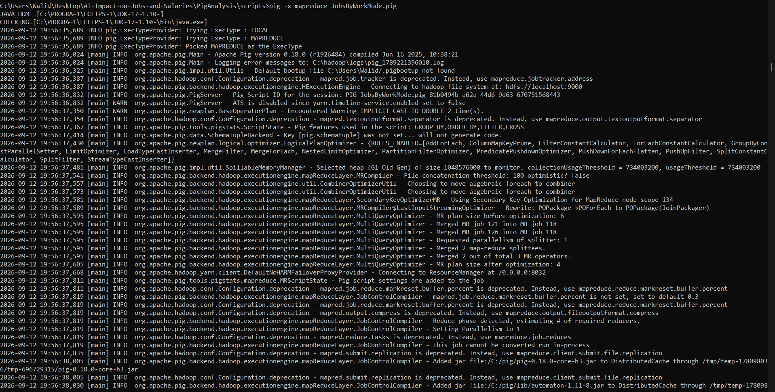
Script execution
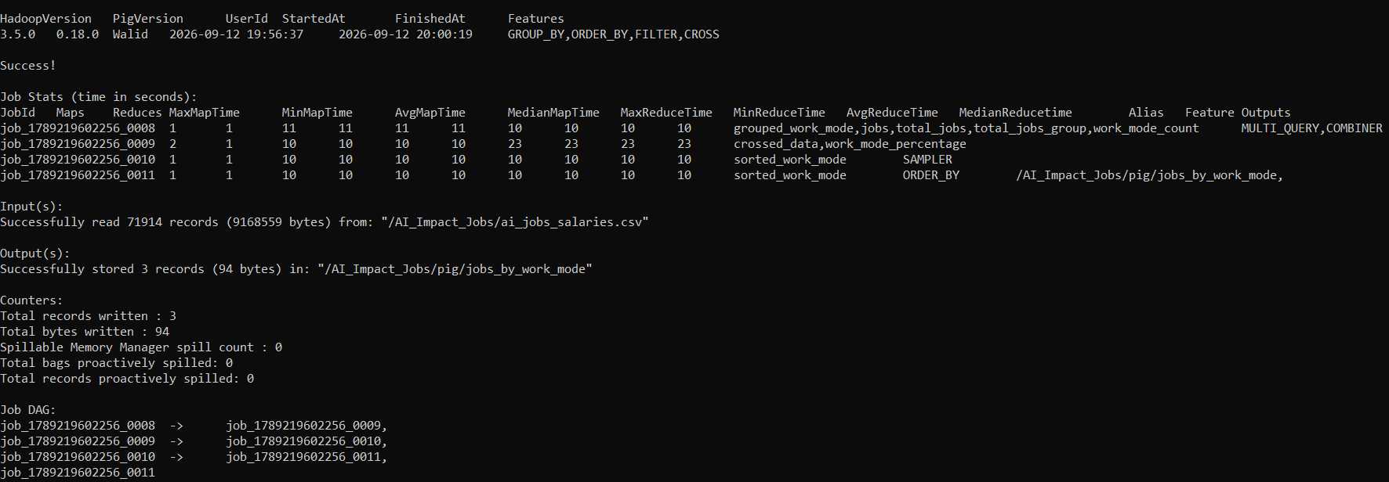
Successful completion
Output
On-site,54081,75.20%
Remote,17505,24.34%
Hybrid,327,0.45%
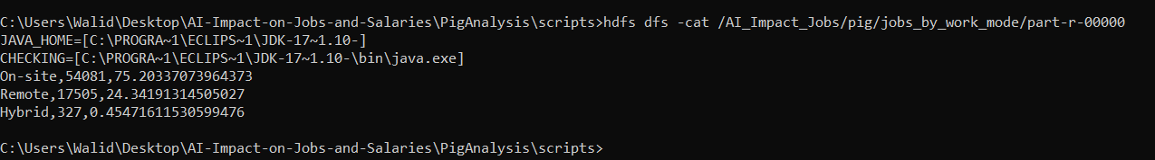
Job Distribution by Work Mode — output

5.4 Top 10 Job Locations : Returns the top 10 company locations by number of AI jobs
Groups all records by company_location, counts the number of jobs per location, sorts the groups in descending order of job count, and limits the result to the top 10 locations.
Script
-- ============================================================
-- PIG OPERATION 4
-- Top 10 Company Locations by Number of AI Jobs
-- ============================================================

jobs = LOAD '/AI_Impact_Jobs/ai_jobs_salaries.csv'
USING PigStorage(',')
AS (
work_year:int,
experience_level:chararray,
employment_type:chararray,
job_title:chararray,
salary:double,
salary_currency:chararray,
salary_in_usd:double,
employee_residence:chararray,
remote_ratio:int,
company_location:chararray,
company_size:chararray,
experience_level_label:chararray,
employment_type_label:chararray,
work_mode:chararray,
salary_outlier_flag:chararray,
role_family:chararray,
isco_group_hint:chararray
);

jobs = FILTER jobs BY work_year IS NOT NULL;

grouped_locations = GROUP jobs BY company_location;

location_count = FOREACH grouped_locations GENERATE
group AS company_location,
COUNT(jobs) AS job_count;

sorted_locations = ORDER location_count BY job_count DESC;

top_10_locations = LIMIT sorted_locations 10;

STORE top_10_locations
INTO '/AI_Impact_Jobs/pig/top10_job_locations'
USING PigStorage(',');
Execution
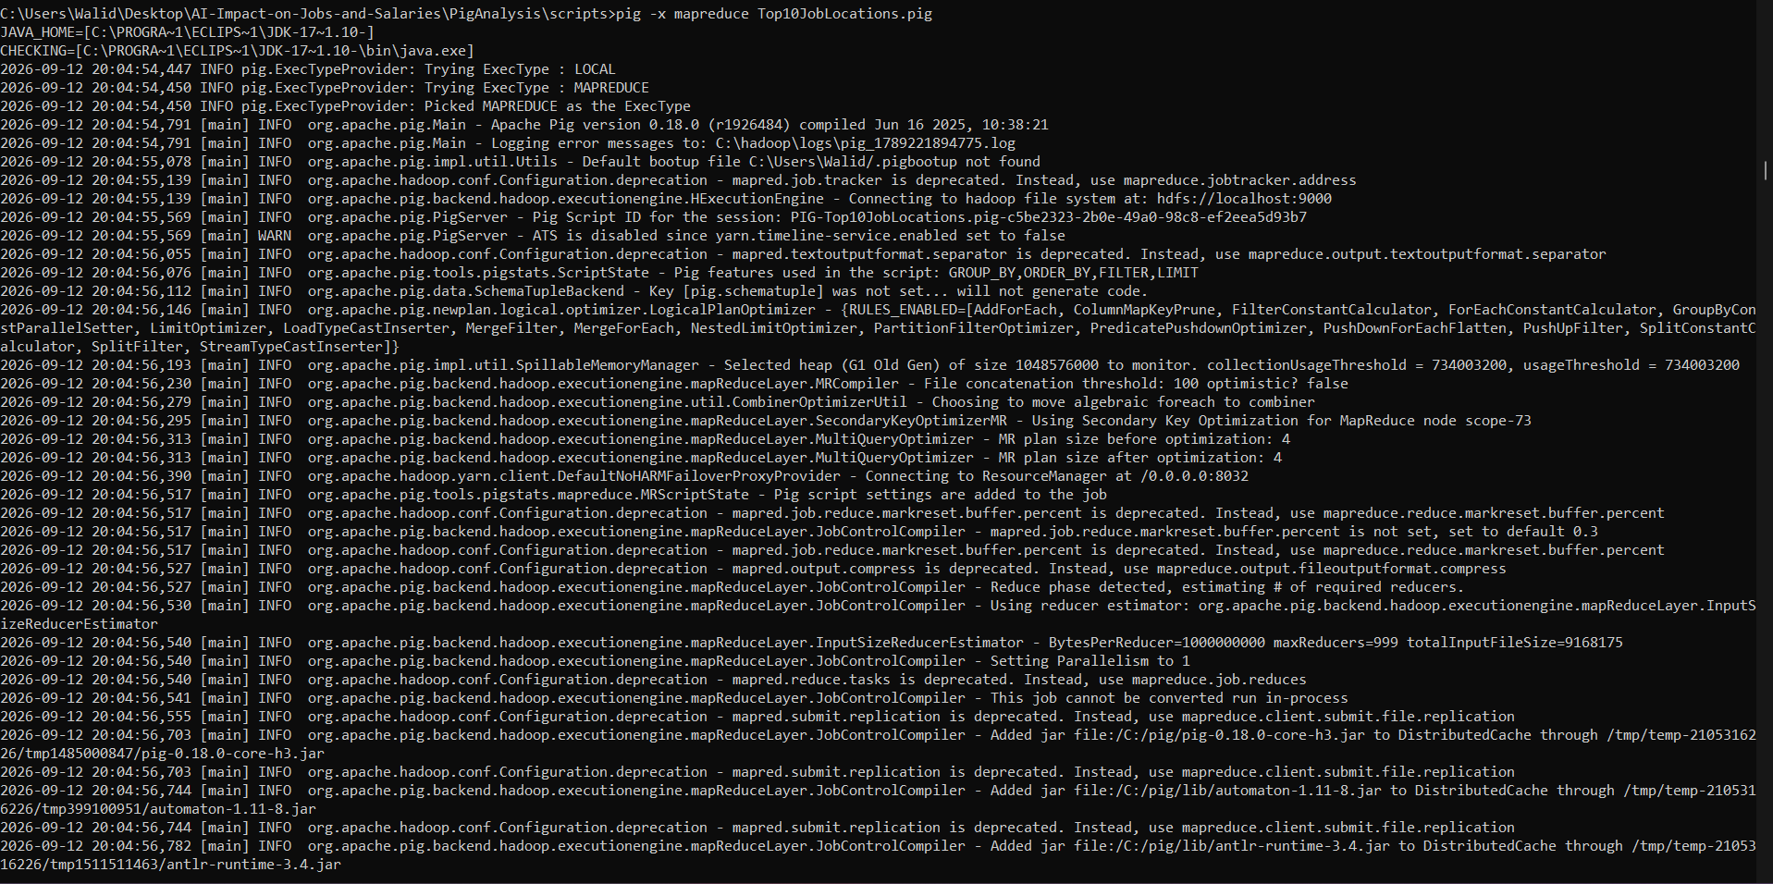
Script execution
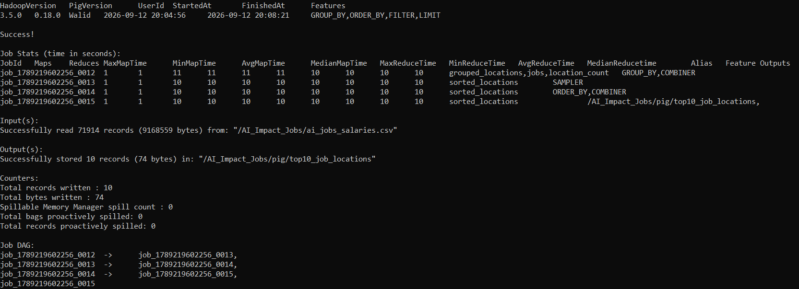
Successful completion
Output
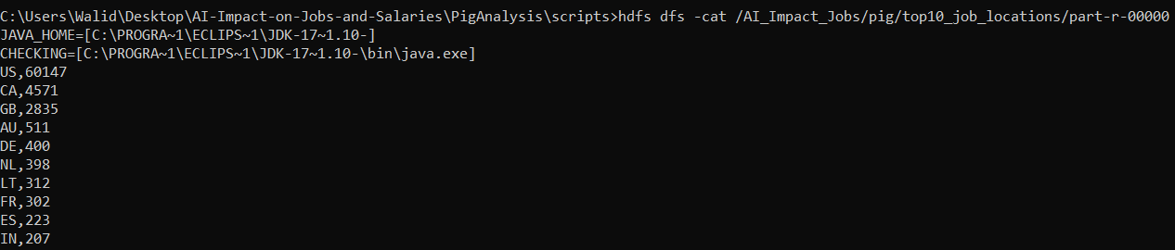
Top 10 Job Locations — output

5.5 Salary Comparison by Employment Type : Returns average, maximum and minimum salary for each employment type
Groups all records by employment_type_label and calculates the average, maximum, and minimum salary_in_usd for each group, sorted by average salary in descending order.
Script
-- ============================================================
-- PIG OPERATION 5
-- Salary Comparison by Employment Type
-- ============================================================

jobs = LOAD '/AI_Impact_Jobs/ai_jobs_salaries.csv'
USING PigStorage(',')
AS (
work_year:int,
experience_level:chararray,
employment_type:chararray,
job_title:chararray,
salary:double,
salary_currency:chararray,
salary_in_usd:double,
employee_residence:chararray,
remote_ratio:int,
company_location:chararray,
company_size:chararray,
experience_level_label:chararray,
employment_type_label:chararray,
work_mode:chararray,
salary_outlier_flag:chararray,
role_family:chararray,
isco_group_hint:chararray
);

jobs = FILTER jobs BY work_year IS NOT NULL;

grouped_employment = GROUP jobs BY employment_type_label;

salary_comparison = FOREACH grouped_employment GENERATE
group AS employment_type,
AVG(jobs.salary_in_usd) AS average_salary,
MAX(jobs.salary_in_usd) AS maximum_salary,
MIN(jobs.salary_in_usd) AS minimum_salary;

sorted_employment = ORDER salary_comparison BY average_salary DESC;

STORE sorted_employment
INTO '/AI_Impact_Jobs/pig/salary_by_employment_type'
USING PigStorage(',');
Execution
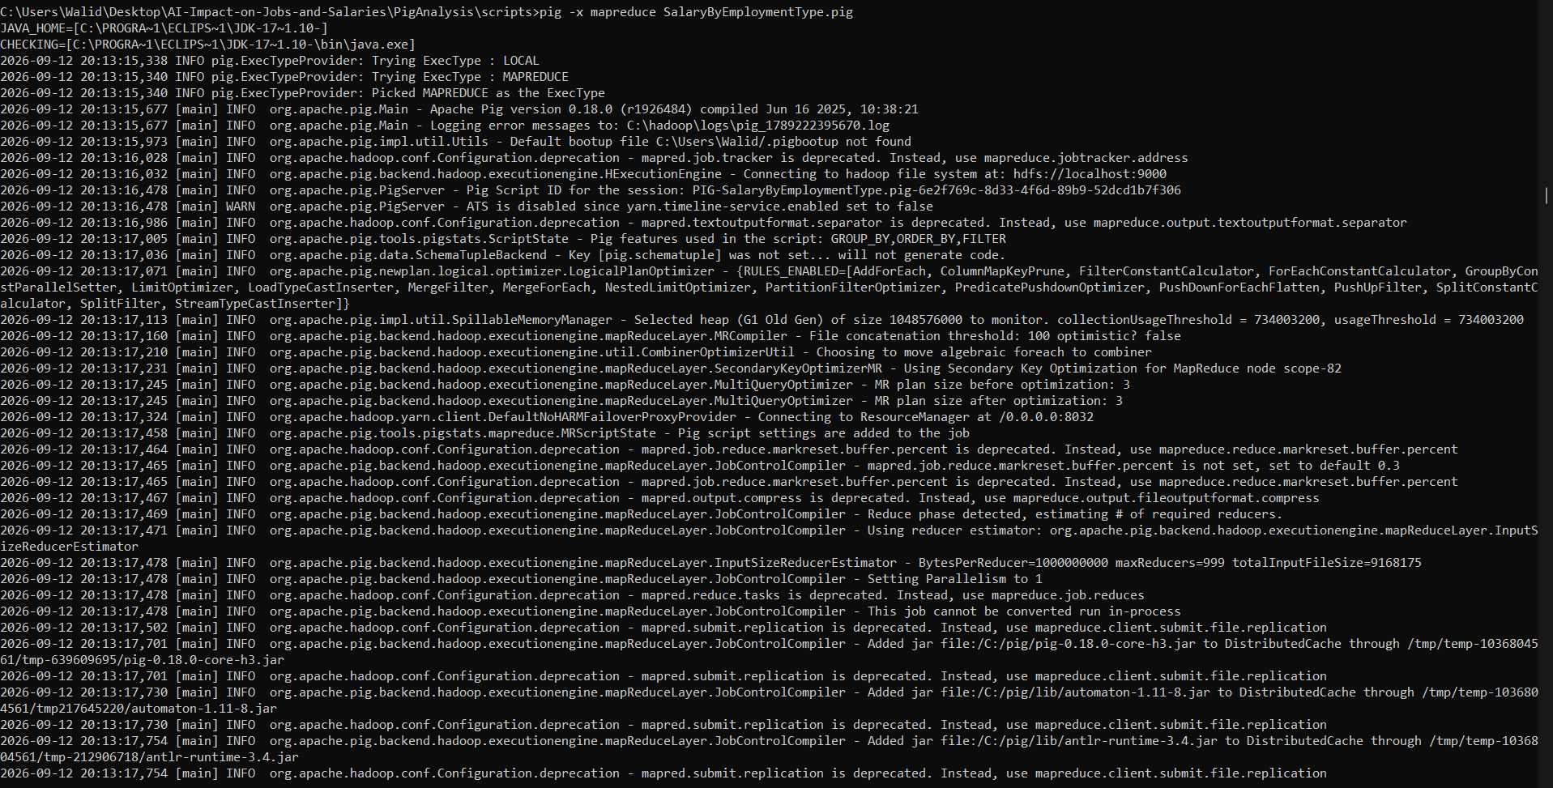
Script execution
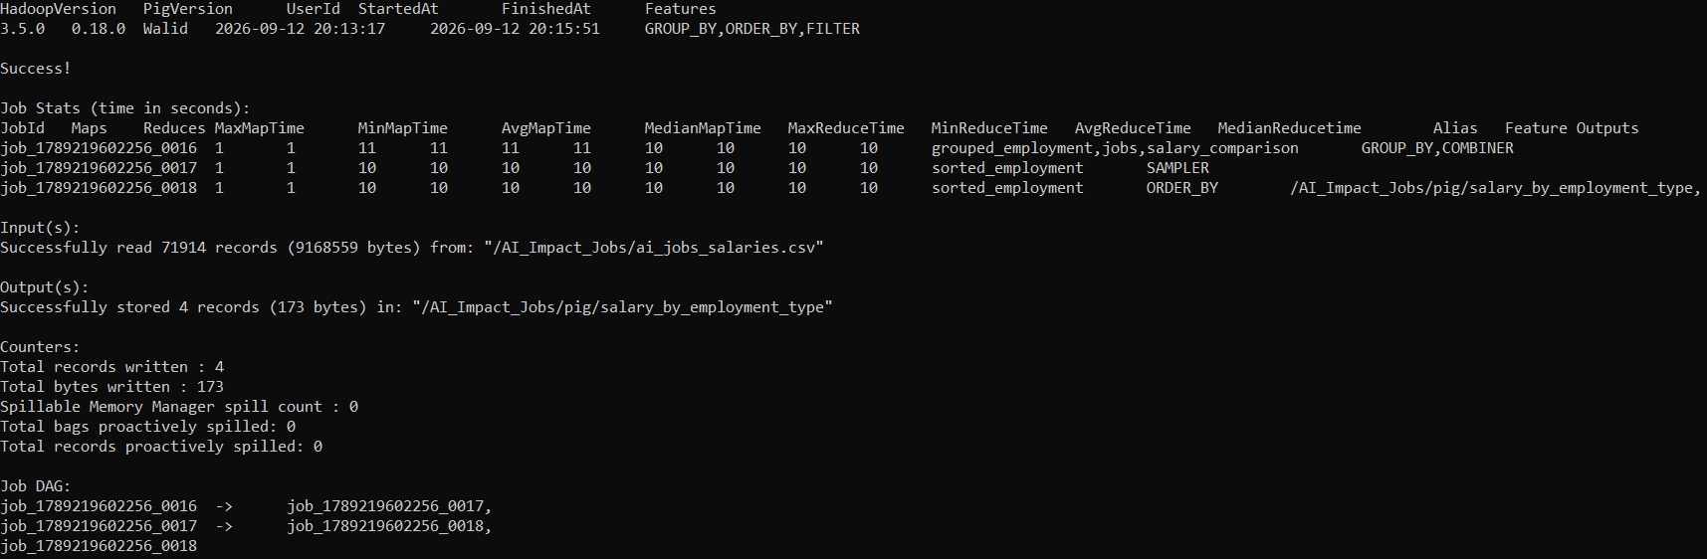
Successful completion
Output
Full-time,151785.78,800000.0,15000.0
Contract,104232.66,500000.0,16000.0
Part-time,80330.19,405000.0,15966.0
Freelance,50651.56,100000.0,20000.0
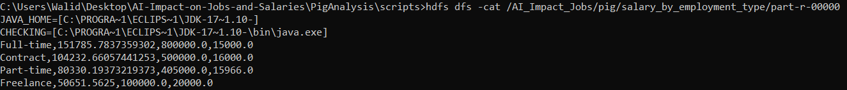
Salary Comparison by Employment Type — output

