CS 255 Project One: Business Requirements Document

System Components and Design

Purpose

• DriverPass needs a cloud-based training and scheduling system that helps customers prepare for their local DMV driving exam through online classes, practice tests, and optional on-the-road training.
• The system will support DriverPass customers, the owner, the IT officer, the secretary, and driving instructors by keeping student information, training progress, appointments, drivers, vehicles, packages, and activity records in one place.
• The project is intended to give DriverPass a reliable way to manage its business while giving students easier access to training from a computer or mobile device.

System Background

• DriverPass was created because many students are not adequately prepared for the DMV driving test. The company wants to provide more complete preparation than simply studying previous tests.
• The system must support online classes and practice tests, scheduling for two-hour driving lessons, student registration, package selection, driver and vehicle assignments, driver notes, reports, and account administration.
• The system also needs to receive DMV-related updates so DriverPass can keep its rules, policies, practice material, and sample questions current.
• The system will be web-based and preferably hosted in the cloud so DriverPass can focus on running the business instead of maintaining local backup and security infrastructure.

Objectives and Goals

• Provide secure account access for customers and employees with different roles and permissions.
• Allow customers or the secretary to create, change, and cancel driving lesson reservations.
• Track each reservation by customer, two-hour lesson time, assigned driver, and assigned vehicle.
• Support the three current DriverPass packages and allow management to disable a package when it should no longer be available for new registrations.
• Track online practice-test progress, including test name, time taken, score, and status such as not taken, in progress, failed, or passed.
• Store driver notes and lesson start and end times as part of the student record.
• Provide activity reporting that identifies who created, canceled, or last modified a reservation.
• Allow DriverPass to receive notification of DMV updates that could affect training content.
• Provide downloadable reports or information that management can work with outside the system, such as in Excel.

Requirements

Nonfunctional Requirements

Performance Requirements

• The system will run as a web-based, cloud-hosted application that can be reached from common computers and mobile devices.
• The system should respond quickly enough for normal business tasks such as logging in, opening student records, scheduling lessons, taking practice tests, and running reports without noticeable delays during normal use.
• Data changes will occur while the user is online so the system maintains one current source of data and avoids conflicting or duplicate offline records.
• DMV-related content and notifications should be updated when new information is received from the connected DMV source.
• The cloud environment should provide routine availability, backup, and recovery services appropriate for normal business operations.

Platform Constraints

• The primary platform will be a browser-based web application rather than a program tied to one desktop operating system.
• The back end will require a database to store accounts, student records, packages, reservations, lesson assignments, practice-test results, notes, and activity history.
• The application should work on standard desktop/laptop computers and mobile devices through a supported web browser.
• Management must be able to download selected reports or information in a format that can be used with tools such as Microsoft Excel.
• The transcript does not identify a required operating system, database product, cloud provider, or web framework, so those technology choices remain open during design.

Accuracy and Precision

• Each person will use an individual account so the system can distinguish customers and employees and apply the correct role and access rights.
• Reservation records must accurately identify the student, driver, vehicle, date, and time connected to each lesson.
• Practice-test records must accurately show the test name, time taken, score, and current status.
• Activity history must identify who created, canceled, or last modified a reservation so DriverPass can trace changes when a problem occurs.
• The system should validate required registration and scheduling information before saving a record. The interview does not define exact case-sensitivity rules or alert thresholds, so those details must be finalized during detailed design.
• Errors involving account access, failed updates, or invalid scheduling data should be logged so the IT officer can review and resolve problems.

Adaptability

• Authorized staff should be able to add, remove, disable, or modify user accounts through administration functions without requiring a source-code change.
• The IT officer needs full account-management access, including the ability to reset accounts and block access for former employees.
• Management must be able to disable an existing training package without changing the application code.
• Future creation or removal of major package modules may require a developer or systems analyst, as discussed in the interview, so that capability is outside the current release.
• The web-based design should be maintained so browser, cloud, and platform updates can be handled centrally rather than requiring users to install a new desktop application.

Security

• Users must authenticate with an account before accessing protected functions or personal records.
• Access will be role-based so customers, the secretary, the owner, drivers, and the IT officer only see the functions and information needed for their responsibilities.
• The IT officer will have full administrative access to accounts and must be able to reset or block employee access when needed.
• Customers who forget a password must have a secure self-service password-reset option.
• Sensitive information exchanged between the user and the cloud system, including personal and payment information, must use secure encrypted connections.
• Repeated failed login attempts should be logged and temporarily restricted or escalated for administrative review to reduce brute-force risk.
• The exact payment processor, password rules, lockout threshold, and data-retention rules are not specified in the interview and must be finalized during detailed security design.

Functional Requirements

• The system shall allow customers and authorized employees to log in using individual user accounts.
• The system shall assign access rights based on the user's role.
• The system shall allow the IT officer to reset accounts and block employee access.
• The system shall allow customers to reset a forgotten password through an automated process.
• The system shall allow a student or secretary to create and maintain a student profile with contact information and pickup/drop-off information.
• The system shall support the current DriverPass training packages and track the training included in each package.
• The system shall allow management to disable a package so new customers cannot register for it.
• The system shall allow customers to schedule a driving lesson online.
• The system shall allow the secretary to schedule a driving lesson for a customer who calls or visits the office.
• The system shall allow authorized users to modify or cancel a driving lesson reservation.
• The system shall schedule driving lessons in two-hour sessions.
• The system shall associate each driving reservation with a student, date and time, driver, and vehicle.
• The system shall store lesson start time, end time, and driver comments in the student's record.
• The system shall provide online class content to customers whose package includes that access.
• The system shall provide online practice tests to eligible customers.
• The system shall track practice-test name, time taken, score, and status for each student attempt.
• The system shall receive or import DMV updates for rules, policies, and sample questions when the connected source provides new information.
• The system shall notify authorized DriverPass staff when DMV information is updated.
• The system shall record who created, canceled, or last modified a reservation.
• The system shall generate an activity report showing reservation changes and the users responsible for those changes.
• The system shall allow management to download reports and selected information for offline review in tools such as Excel.
• The system shall provide a contact page and a method for authorized staff to contact a student.

User Interface

• The interface will be browser-based and usable from desktop/laptop computers and mobile devices.
• Customers will need screens for account access, profile information, package information, appointment scheduling, appointment changes or cancellations, online class content, practice tests, and test progress.
• The secretary will need forms to register students, enter or update student information, and create or maintain appointments for customers who call or visit the office.
• Drivers will need access to assigned lessons and a way to record lesson times and driver comments.
• The owner will need management views for student information, schedules, packages, activity reports, and downloadable business information.
• The IT officer will need administrative screens for account management, access control, password resets, blocked accounts, and system maintenance.
• The student progress view should show practice-test name, time taken, score, and status. The student record should also show driver notes, lesson times, contact information, and other information shown in Liam's interface sketch.
• Forms should clearly identify required fields and give understandable feedback when information is missing or invalid.

Assumptions

• Users are assumed to have access to a modern web browser and an internet connection when creating or changing system data.
• Offline work is assumed to mean downloading reports or information for later review; the live system database will not be edited offline.
• The initial scheduling design is based on DriverPass's current operation of 10 cars, with each car having a driver, while still allowing the database to grow if the business expands.
• Driving lessons are assumed to remain two hours per session unless DriverPass approves a future requirement change.
• The customer's drop-off location is assumed to be the same as the pickup location, as stated in the interview.
• A reliable method for receiving DMV updates will be available, although the transcript does not define the technical interface or data format.
• A cloud service will provide the hosting environment and basic infrastructure services, but the specific vendor and service-level agreement have not been selected.

Limitations

• The system will not support live editing of business data while offline because offline changes could create conflicting or duplicate records.
• The first release will allow management to disable packages, but adding or removing major package modules may require future developer work.
• The project scope is limited to the features described in the current interview; future features have not yet been defined by DriverPass.
• The system depends on internet access and the availability of the cloud environment for normal online operation.
• DMV update functions depend on the availability and reliability of the external DMV information source.
• The project schedule assumes customer approval on March 10-11 without major requested changes. Significant revisions could move later development and testing dates.
• The interview does not provide a project budget, final technology stack, payment-processing provider, or detailed service-level targets, so those constraints must be confirmed before implementation.

Gantt Chart

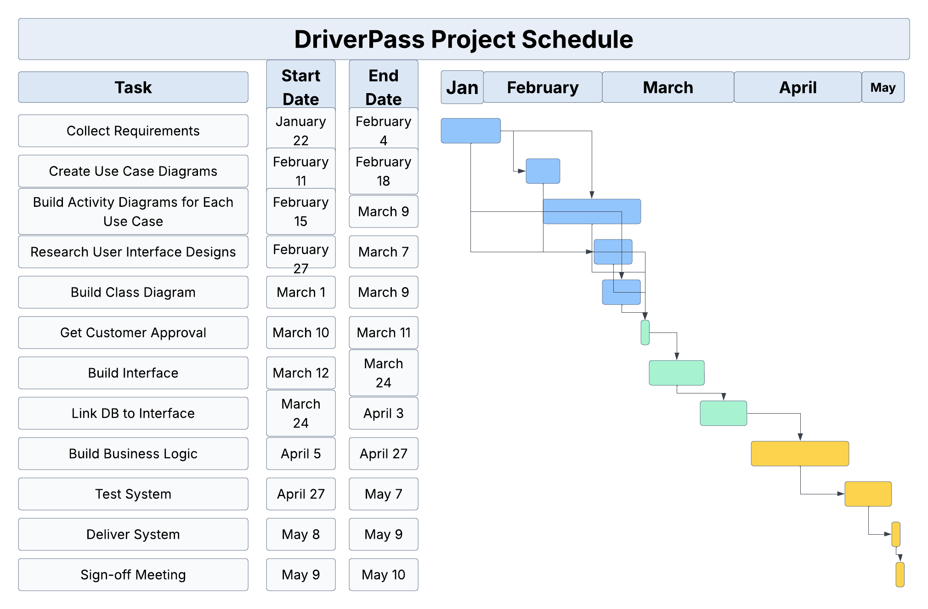

Figure 1. DriverPass project schedule based on the finalized task/date table in the interview transcript.

