DriverPass System Design Document
Wali Johnson | CS 255 Project Two | Southern New Hampshire University
Purpose: Describe the proposed DriverPass system design using the five UML diagrams developed in Lucidchart and identify the technical resources necessary to meet the business requirements from Project One.

UML Diagrams

UML Use Case Diagram
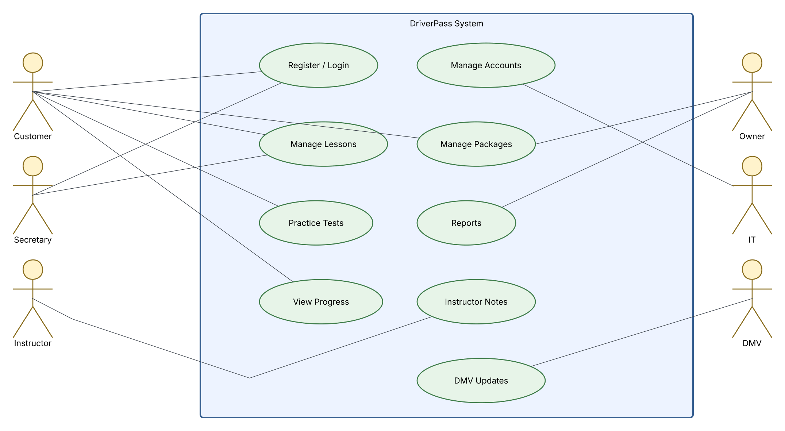
Figure 1. DriverPass UML Use Case Diagram

UML Activity Diagram 1 - Schedule a Driving Lesson
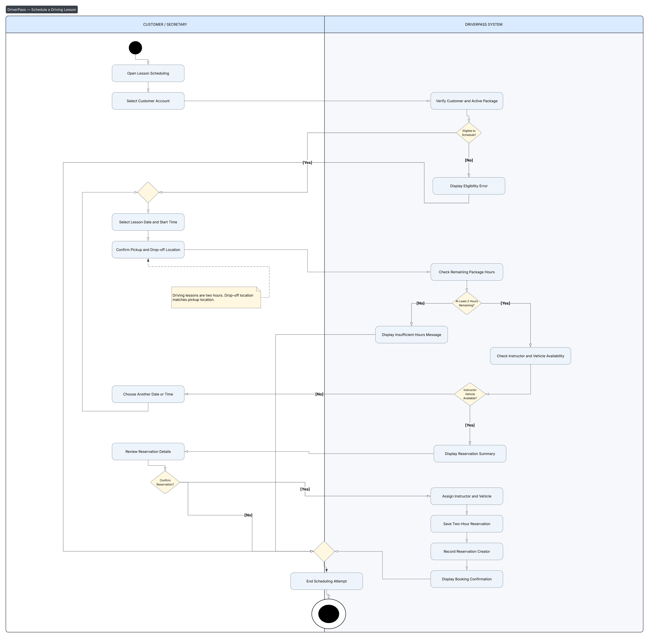
Figure 2. UML Activity Diagram - Schedule a Driving Lesson

UML Activity Diagram 2 - Modify or Cancel a Driving Lesson
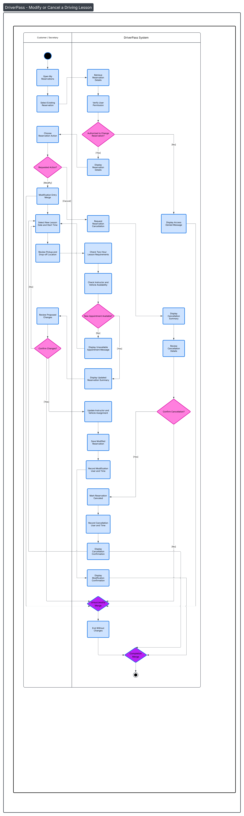
Figure 3. UML Activity Diagram - Modify or Cancel a Driving Lesson

UML Sequence Diagram - Schedule a Driving Lesson
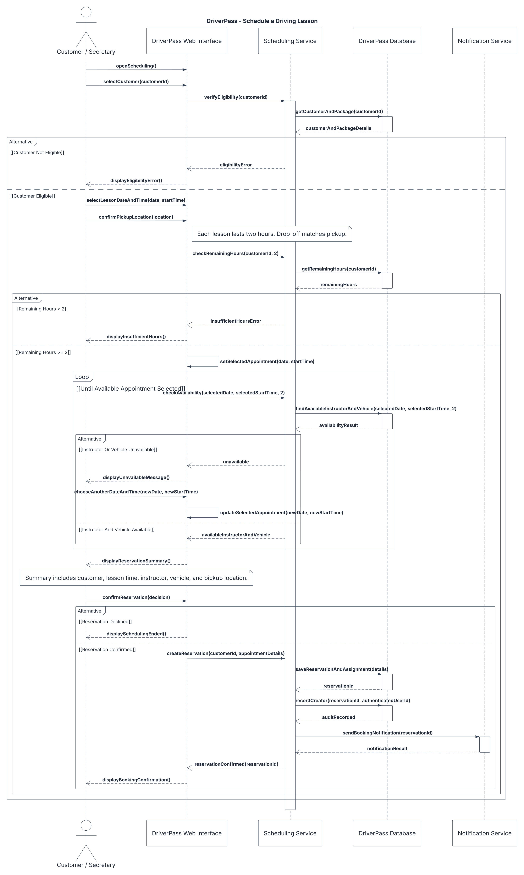
Figure 4. UML Sequence Diagram - Schedule a Driving Lesson

UML Class Diagram
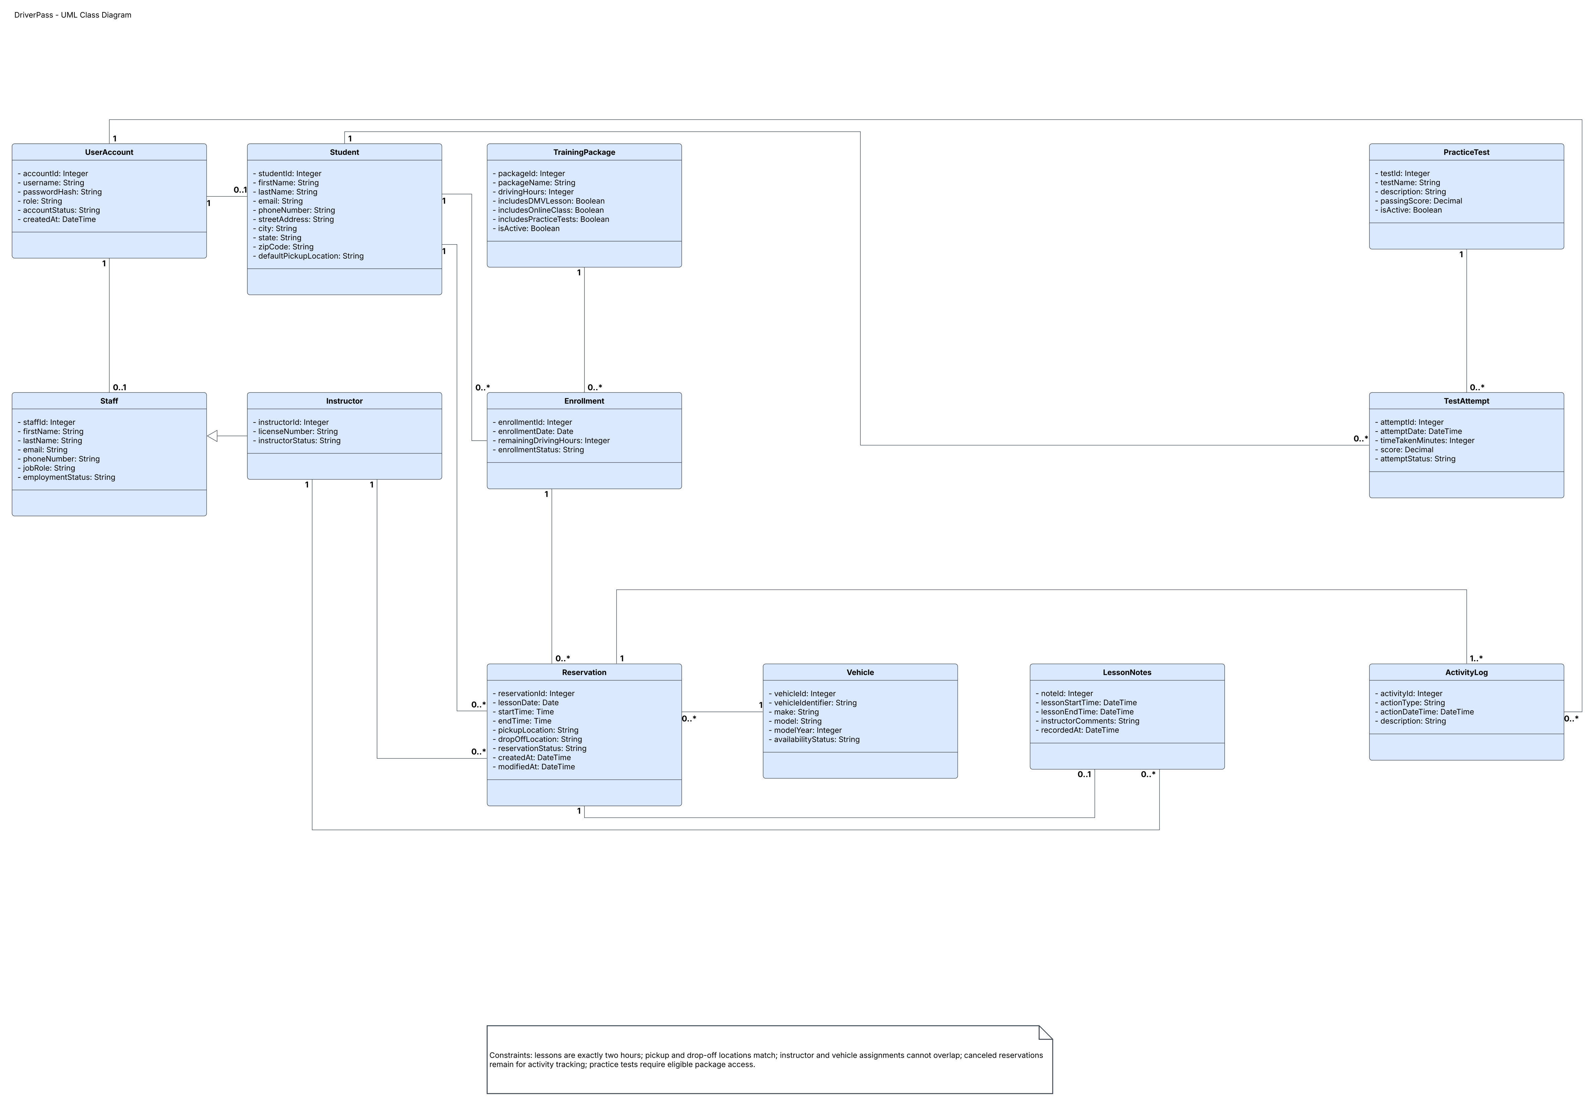
Figure 5. DriverPass UML Class Diagram

Technical Requirements
The DriverPass system is designed as a browser-based, cloud-hosted application. Students and approved employees will access the same current information through desktop and mobile browsers. These technical choices support the requirements documented in Project One without tying the design to a particular vendor.

Hardware and End-User Devices
Customers and staff will need an internet-connected computer, laptop, tablet, or smartphone with a current web browser. The secretary will need a workstation for student registration and scheduling; instructors will need an approved device to view assignments and enter lesson notes. The business should maintain reliable internet service for ordinary use and use an office printer if printed reports are required. DriverPass initially has ten cars with drivers; vehicle records must be maintained as the fleet grows.

Application Software
The solution needs a responsive web interface for account registration, package selection, scheduling, lesson changes, and eligible online classes and practice tests. Server-side services must enforce user permissions, two-hour lesson duration, package eligibility and remaining hours, and availability checks before a booking is saved. Administrative screens must allow the IT officer to manage accounts and allow management to disable a training package for new enrollment. Authorized instructors must be able to record start/end times and comments. Reports should be downloadable in an Excel-compatible format such as CSV.

Database and Information Management
A central database will store student and staff accounts, package definitions, enrollments, driving-hour balances, reservations, instructor and vehicle assignments, lesson notes, practice tests and attempts, and activity records. Each reservation will link to one student, instructor, and vehicle, with safeguards against overlapping assignments. The system must record the authenticated user responsible for creating, modifying, or canceling a reservation. The class diagram shows a proposed organization of these records; it does not require any specific database product.

Cloud Infrastructure and Availability
Cloud hosting should provide the web application, application services, database hosting, secure network access, routine backups, monitoring, and recovery capabilities. Hosting responsibility should be defined with the provider so DriverPass is not left managing local servers. Data updates must occur while online to reduce conflicting versions. Management may download reports for offline viewing or analysis, but those downloaded copies must not be treated as editable live records. The cloud provider, performance targets, backup schedule, recovery objectives, and expected availability are not currently specified and must be chosen before implementation.

Security and Access Control
All protected functions require individual user accounts and role-based access. Customers must only reach their own records; secretaries manage permitted customer scheduling; instructors access their assigned lesson information; management accesses reporting and package controls; and the IT officer manages account access, password resets, and blocked accounts. Use encrypted connections for browser traffic and protect stored passwords with secure password hashing. Account recovery should verify the requester. Reservation changes and access failures should be logged. Because the interview mentions payment information, the design should use an approved payment-processing service and avoid storing card security codes. The payment provider and detailed payment workflow are not currently verified.

Integration and Training Content
The application needs a controlled process for receiving or importing DMV rules, policy changes, and practice questions when a usable source is available. Authorized staff should receive an update notification and be able to review the changed content. Practice-test progress must store each test name, completion status, time taken, and score. Online classes and practice tests must be available only to customers whose packages include them. The exact DMV interface and update format are not currently verified.

Development and Operational Tools
Lucidchart is the CASE tool used to prepare the UML design diagrams. Implementation will require a web development environment, source control, a supported database management tool, automated testing, deployment tools, and monitoring. The development team should test each role, booking validation, resource conflicts, audit trail, report export, password reset, backup restoration, and mobile-browser behavior before launch. Project One did not specify a programming language, framework, cloud vendor, or database brand; these are design choices for the development team.

Current Scope and Limitations
DriverPass may download and examine information offline, but cannot modify live reservations offline. The initial release supports enabling or disabling existing packages; creating or removing major package modules may require later developer work. Booking availability depends on the internet connection and cloud service. DMV updates depend on the external source. Cancellation penalties, refund policies, payment provider, detailed service targets, and future module designs remain unspecified and should not be assumed.

Design Notes
The source interview and Project One requirements establish the business needs. Specific technical constructs shown in the diagrams—including the separate scheduling service, notification service, enrollment class, and certain validation and logging details—are proposed design decisions. They are not verified implementation choices or independently approved DriverPass business policies.

References
Southern New Hampshire University. (n.d.). CS 255 DriverPass interview transcript [Course material].
Johnson, W. (2026). CS 255 Project One: Business requirements document [Unpublished coursework].
Johnson, W. (2026). DriverPass UML diagrams [Lucidchart diagrams prepared for CS 255 Project Two].

