 Start-Work Checks | Confined Space Entry

Start Work Authority: Confirm below are in place and verified prior to starting work
Save Your Life Actions  All exposed persons performing work must confirm each action below |  |  |  | Person(s) Performing Work (initial) | Start-Work  Verifier  (initial) | 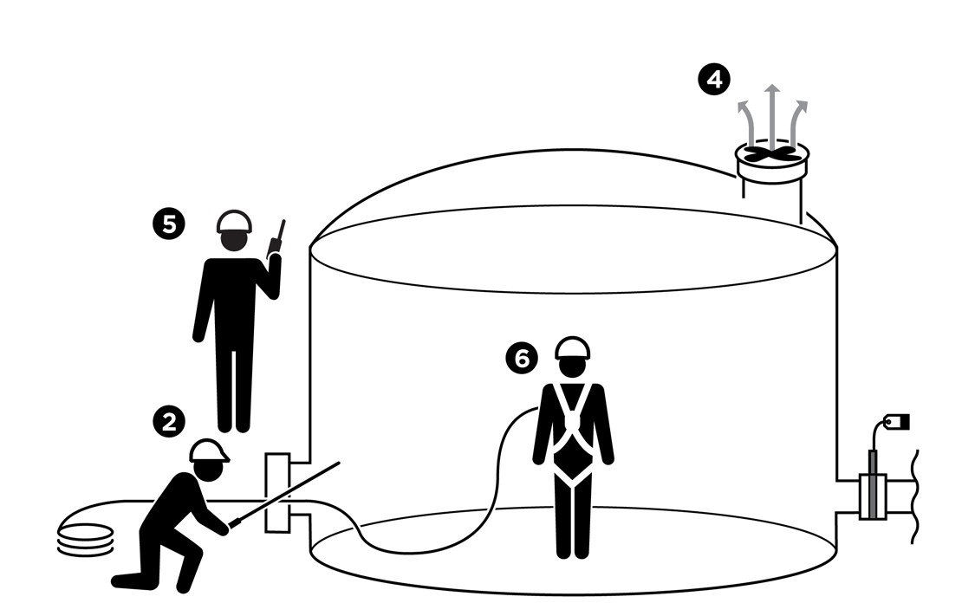
Isolation of Hazardous Energy
I have confirmed:
1 | Confined Space Entry has been evaluated for Isolation of Hazardous Energy (IHE) requirements.  Does Confined Space Entry require IHE?  □ Yes □ No  If yes: Complete IHE Start-Work Checks.  If no: Continue to Step 2.
Prior to Confined Space Entry
I have confirmed:
2 | The atmosphere is within allowed limits for entry.  Oxygen: between 19.5–23.5%  LEL: less than 10%  H₂S: less than 5 ppm  Other gas tested:
3 | Gas testing frequency has been established.
4 | Ventilation is in place and working.
5 | Entry watch has been assigned and communication plan agreed to.
6 | All entrants are wearing rescue equipment required in rescue plan.

Stop and seek help if any of the above safeguards are not in place
Role |  | Printed Name | Date
Start -Work Verifier

Save Your Life Actions | Confined Space Entry

Start Work Authority: I will not start work until I confirm…
Actions |  | How to (examples) | 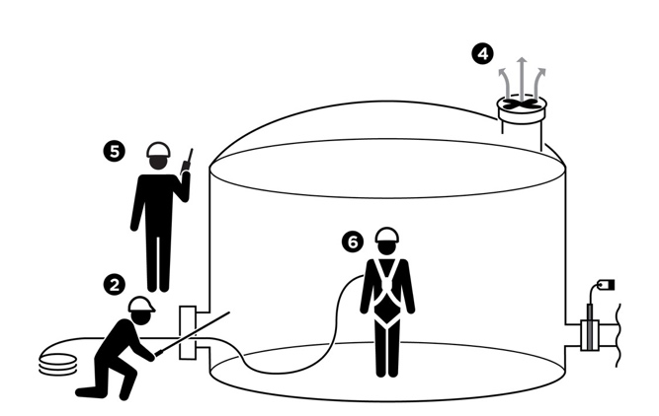
Isolation of Hazardous Energy
1 | Confined Space Entry has been evaluated for Isolation of Hazardous Energy (IHE) requirements. | - Physically inspect job site using isolation diagrams, P&IDs or Process Flow Diagrams to identify potential hazardous material and energy sources.  - Evaluate if confined space has the potential to contain actual or potential hazardous atmospheres.  - Evaluate if confined space requires lockout/tagout to eliminate actual or potential hazards.  - Confirm confined space is isolated from other equipment, piping, etc., using approved methods (e.g., isolation blinds).
Prior to Confined Space Entry
2 | The atmosphere is within allowed limits for entry. | - Ask Qualified Gas Tester to explain how they know the gas meter is working as designed.  - Watch initial gas testing and confirm results on meter are within acceptable limits.  - Confirm Qualified Gas Tester has tested for stratified atmospheres.
3 | Gas testing frequency has been established. | - Ask gas tester to explain follow up frequency and confirm follow up frequency is documented on permit prior to starting work.  - Confirm no more than 30 minutes will pass after the initial gas testing before starting work.
4 | Ventilation is in place and working. | - Confirm confined space is ventilated (natural and/or mechanical) to dilute the air from containing dust, fumes, mist, vapors, gases, heat etc.  - If using mechanical ventilation, confirm the flexible ducting is arranged so there are no dead spaces.  - Confirm ventilation will be continuous.  - Confirm mechanical ventilation equipment is bonded and/or grounded to prevent static electricity hazards.  - Confirm ventilation exhaust outlets are not near an ignition source and will not draw exhausted air back into the space.  - Confirm ventilation inlets will not be affected by wind/weather conditions and will not have flow restrictions.
5 | Entry watch has been assigned and communication plan agreed to. | - Confirm an entry watch has been assigned and is at the job site.  - Ask the entry watch to describe their responsibilities, which include:  - Visually monitoring personnel in the confined space  - Documenting entry and exits from the confined space  - Monitoring the confined space for changing conditions  - Discuss communication plan with entry watch prior to entry.  - Confirm communication strategy has been agreed to (e.g., hand signals, radio).
6 | All entrants are wearing rescue equipment required in rescue plan. | - Confirm the rescue plan is at the job site and has been shared with the crew.  - Confirm the crew are wearing the rescue equipment as described in the rescue plan (e.g., harnesses, retrieval device).

