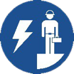 Start-Work Checks | De-Energised Electrical Work

Start Work Authority: Confirm below are in place and verified prior to starting work
Save Your Life Actions  All exposed persons performing work must confirm each action below. |  |  |  | Person(s) Performing Work (initial) | Start-Work  Verifier  (initial) | 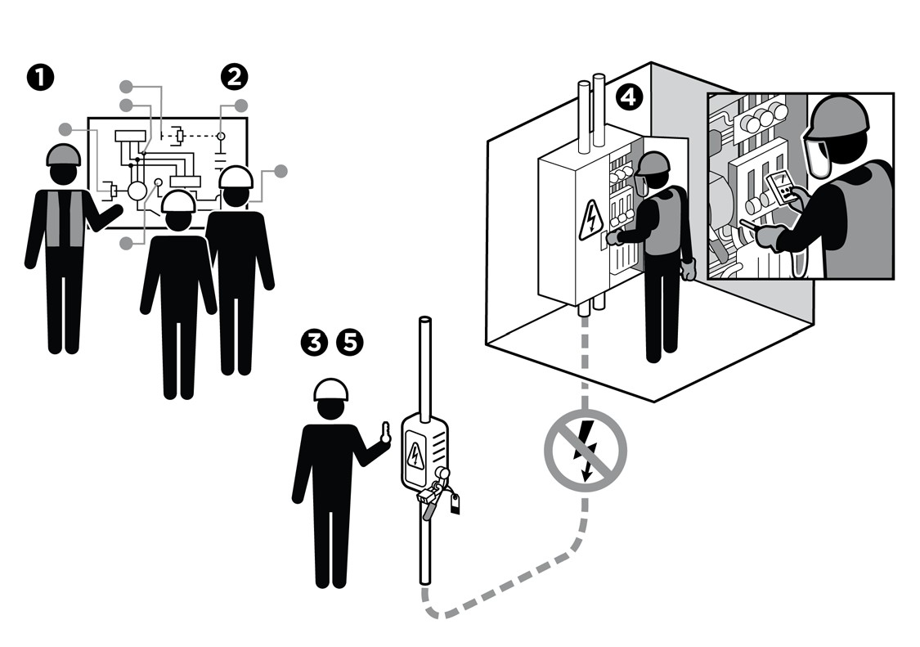
I have confirmed:
1 | Circuit/equipment to be worked on is the one identified in the plan.
2 | Isolation points are identified per diagram and/or plan.
3 | Isolation devices are set in the identified position per diagram and/or plan.
4 | Electrical components are placed in an electrically safe condition.
5 | Isolation points are:  a. Locked and/or tagged; and  b. Keys are controlled by me or my crew supervisor.
6 | Identify and mitigate hazards on adjacent live parts.

Stop and seek help if any of the above safeguards are not in place
Role |  | Printed Name | Date
Start -Work Verifier

Save Your Life Actions | De-Energised Electrical Work

Start Work Authority: I will not start work until I confirm…
Actions |  | How to (examples)
1 | Circuit/equipment to be worked on is the one identified in the plan. | Confirm equipment to be worked on is correct using tag numbers or cable markings.
2 | Isolation points are identified per diagram and/or plan. | Use the isolation diagram and/or Equipment Isolation Procedure to physically confirm all isolations are in place and tagged or marked.
3 | Isolation devices are set in the identified position per diagram and/or plan. | Confirm all switches are open or closed per the diagram and/or plan.  Confirm Switchgear or Motor Control Center (MCC) equipment switches are locked out and tagged.  Confirm crew has physically inspected the equipment for other potential energy sources not previously identified or isolated.
4 | Electrical components are placed in an electrically safe condition. | Wear appropriate level of PPE based on the shock and arc flash risk assessment until the equipment is confirmed to be de-energised.  Conduct a test for absence of voltage.  Confirm grounds have been applied per plan and rated for the fault current.
5 | Isolation points are:  Locked and/or tagged; and  Keys are controlled by me or my crew supervisor. | Confirm locks, tags or securing devices are on all isolation points.  Confirm keys are in a designated secure location.
6 | Identify and mitigate hazards on adjacent live parts. | If no insulating materials exist, then install temporary insulating materials such as rubber matting or screening.

