 Start-Work Checks | Excavation

Start Work Authority: Confirm below are in place and verified prior to starting work
Save Your Life Actions  All exposed persons performing work must confirm each action below |  |  |  | Person(s) Performing Work (initial) | Start-Work  Verifier  (initial) | 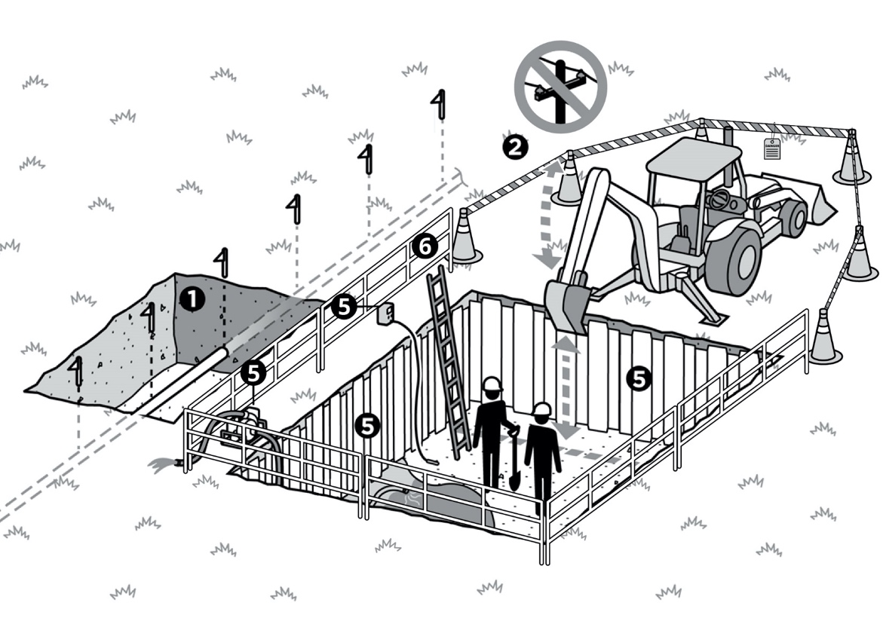
I have confirmed:
1 | Underground utilities are visibly marked (e.g., pipelines, cables, communications, power).
2 | Excavation equipment maintains minimum clearances from overhead obstructions.
3 | Excavation area is secured and barriers are in place to prevent unauthorised access.
Hold Point: Continue if personnel enter excavation
4 | Excavation has been evaluated to determine if it is a confined space. Is Excavation a Confined Space?  □ Yes □ No  If yes: Complete Confined Space Entry Start-Work Checks.  If no: Continue to Step 5.
5 | Plan is in place to protect personnel entering the excavation from:  a. Cave in;  b. Hazardous atmosphere; and  c. Water accumulation.
6 | Excavations deeper than 1.2 meters (4 feet) have access and egress.

Stop and seek help if any of the above safeguards are not in place
Role |  | Printed Name | Date
Start -Work Verifier

Save Your Life Actions | Excavation

Start Work Authority: I will not start work until I confirm…
Actions |  | How to (examples) | 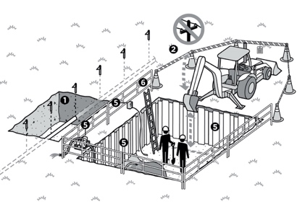
1 | Underground utilities are visibly marked (e.g., pipelines, cables, communications, power). | Confirm local utilities have been notified of the dig so they can identify their lines (e.g., One-Call).  Confirm underground utilities are visibly identified with flagging or paint.  Confirm depth and width of pipeline are known before digging, or non-mechanical means are used to find lines.
2 | Excavation equipment maintains minimum clearances from overhead obstructions. | Ask crew members if they know the exact location, height and voltage of overhead power lines.  - Applying the overhead power line proximity calculation  - (load length + equipment height + at least 10 feet),  - Using goal posting barriers on overhead power lines or  - Maintaining a minimum of 6 meters (20 feet) distance between equipment and energy source for unknown voltages
3 | Excavation area is secured and barriers are in place to prevent unauthorised access. | - Confirm excavation area is visibly identified with caution tape, silt fencing or other visual identification.  - Confirm excavation site is secure from unauthorised access.  - Confirm a competent person assessed the soil type to define the excavation.  - Confirm no personnel are in line-of-fire hazards (e.g., swing radius, discharge side of trencher).  - Confirm personnel will not be allowed to enter or occupy excavations while heavy equipment is digging.  - Confirm essential personnel in the crew who need to be in the area.
Hold Point: Continue if personnel enter excavation
4 | Excavation has been evaluated to determine if it is a confined space. | Confirm the excavation area has been evaluated to determine if it is a confined space (trench depths greater than or equal to 1.2 meters or 4 feet with vertical walls and limited access/egress).  If the excavation area is a confined space follow the CSE standard and complete the CSE Start-Work Check.
5 | Plan is in place to protect personnel entering the excavation from:  Cave in;  Hazardous atmosphere; and  Water accumulation. | Cave in  - Protective systems include but are not limited to bracing, shoring, underpinning, benching, retaining devices or shield systems.  - Confirm daily inspection to identify hazards and changing conditions will be performed.  - Assure crew will report collapse, contamination, water build up or utilities encountered.  Hazardous atmosphere  - Ask for gas testing if you have unexpected odors, leaks or equipment.  - Ask Qualified Gas Tester to explain how they know the gas meter is working as designed.  - Watch initial gas testing and confirm results on meter are within acceptable limits.  - Confirm that follow-up frequency is documented on permit prior to starting work.  - Confirm that no more than 30 minutes will pass after the initial gas testing before starting work.  - Confirm Qualified Gas Tester has tested for stratified atmospheres.  Water accumulation  - Confirm crew will conduct daily inspection to identify hazards and changing conditions.
6 | Excavations deeper than 1.2 meters  (4 feet) have access and egress. | Confirm there is a safe means of access and egress when entering an excavation greater than 1.2 meters (4 feet) in depth, up to 7.6 meters (25 feet) of lateral travel.  Examples are ladder, stairways, ramps, sloping for ingress/egress.

