 Start-Work Checks | Heavy Equipment and Vehicle Operations

Start Work Authority: Confirm below are in place and verified prior to starting work
Save Your Life Actions  All exposed persons performing work must confirm each action below |  |  |  | Person(s) Performing Work (initial) | Start-Work  Verifier  (initial) | 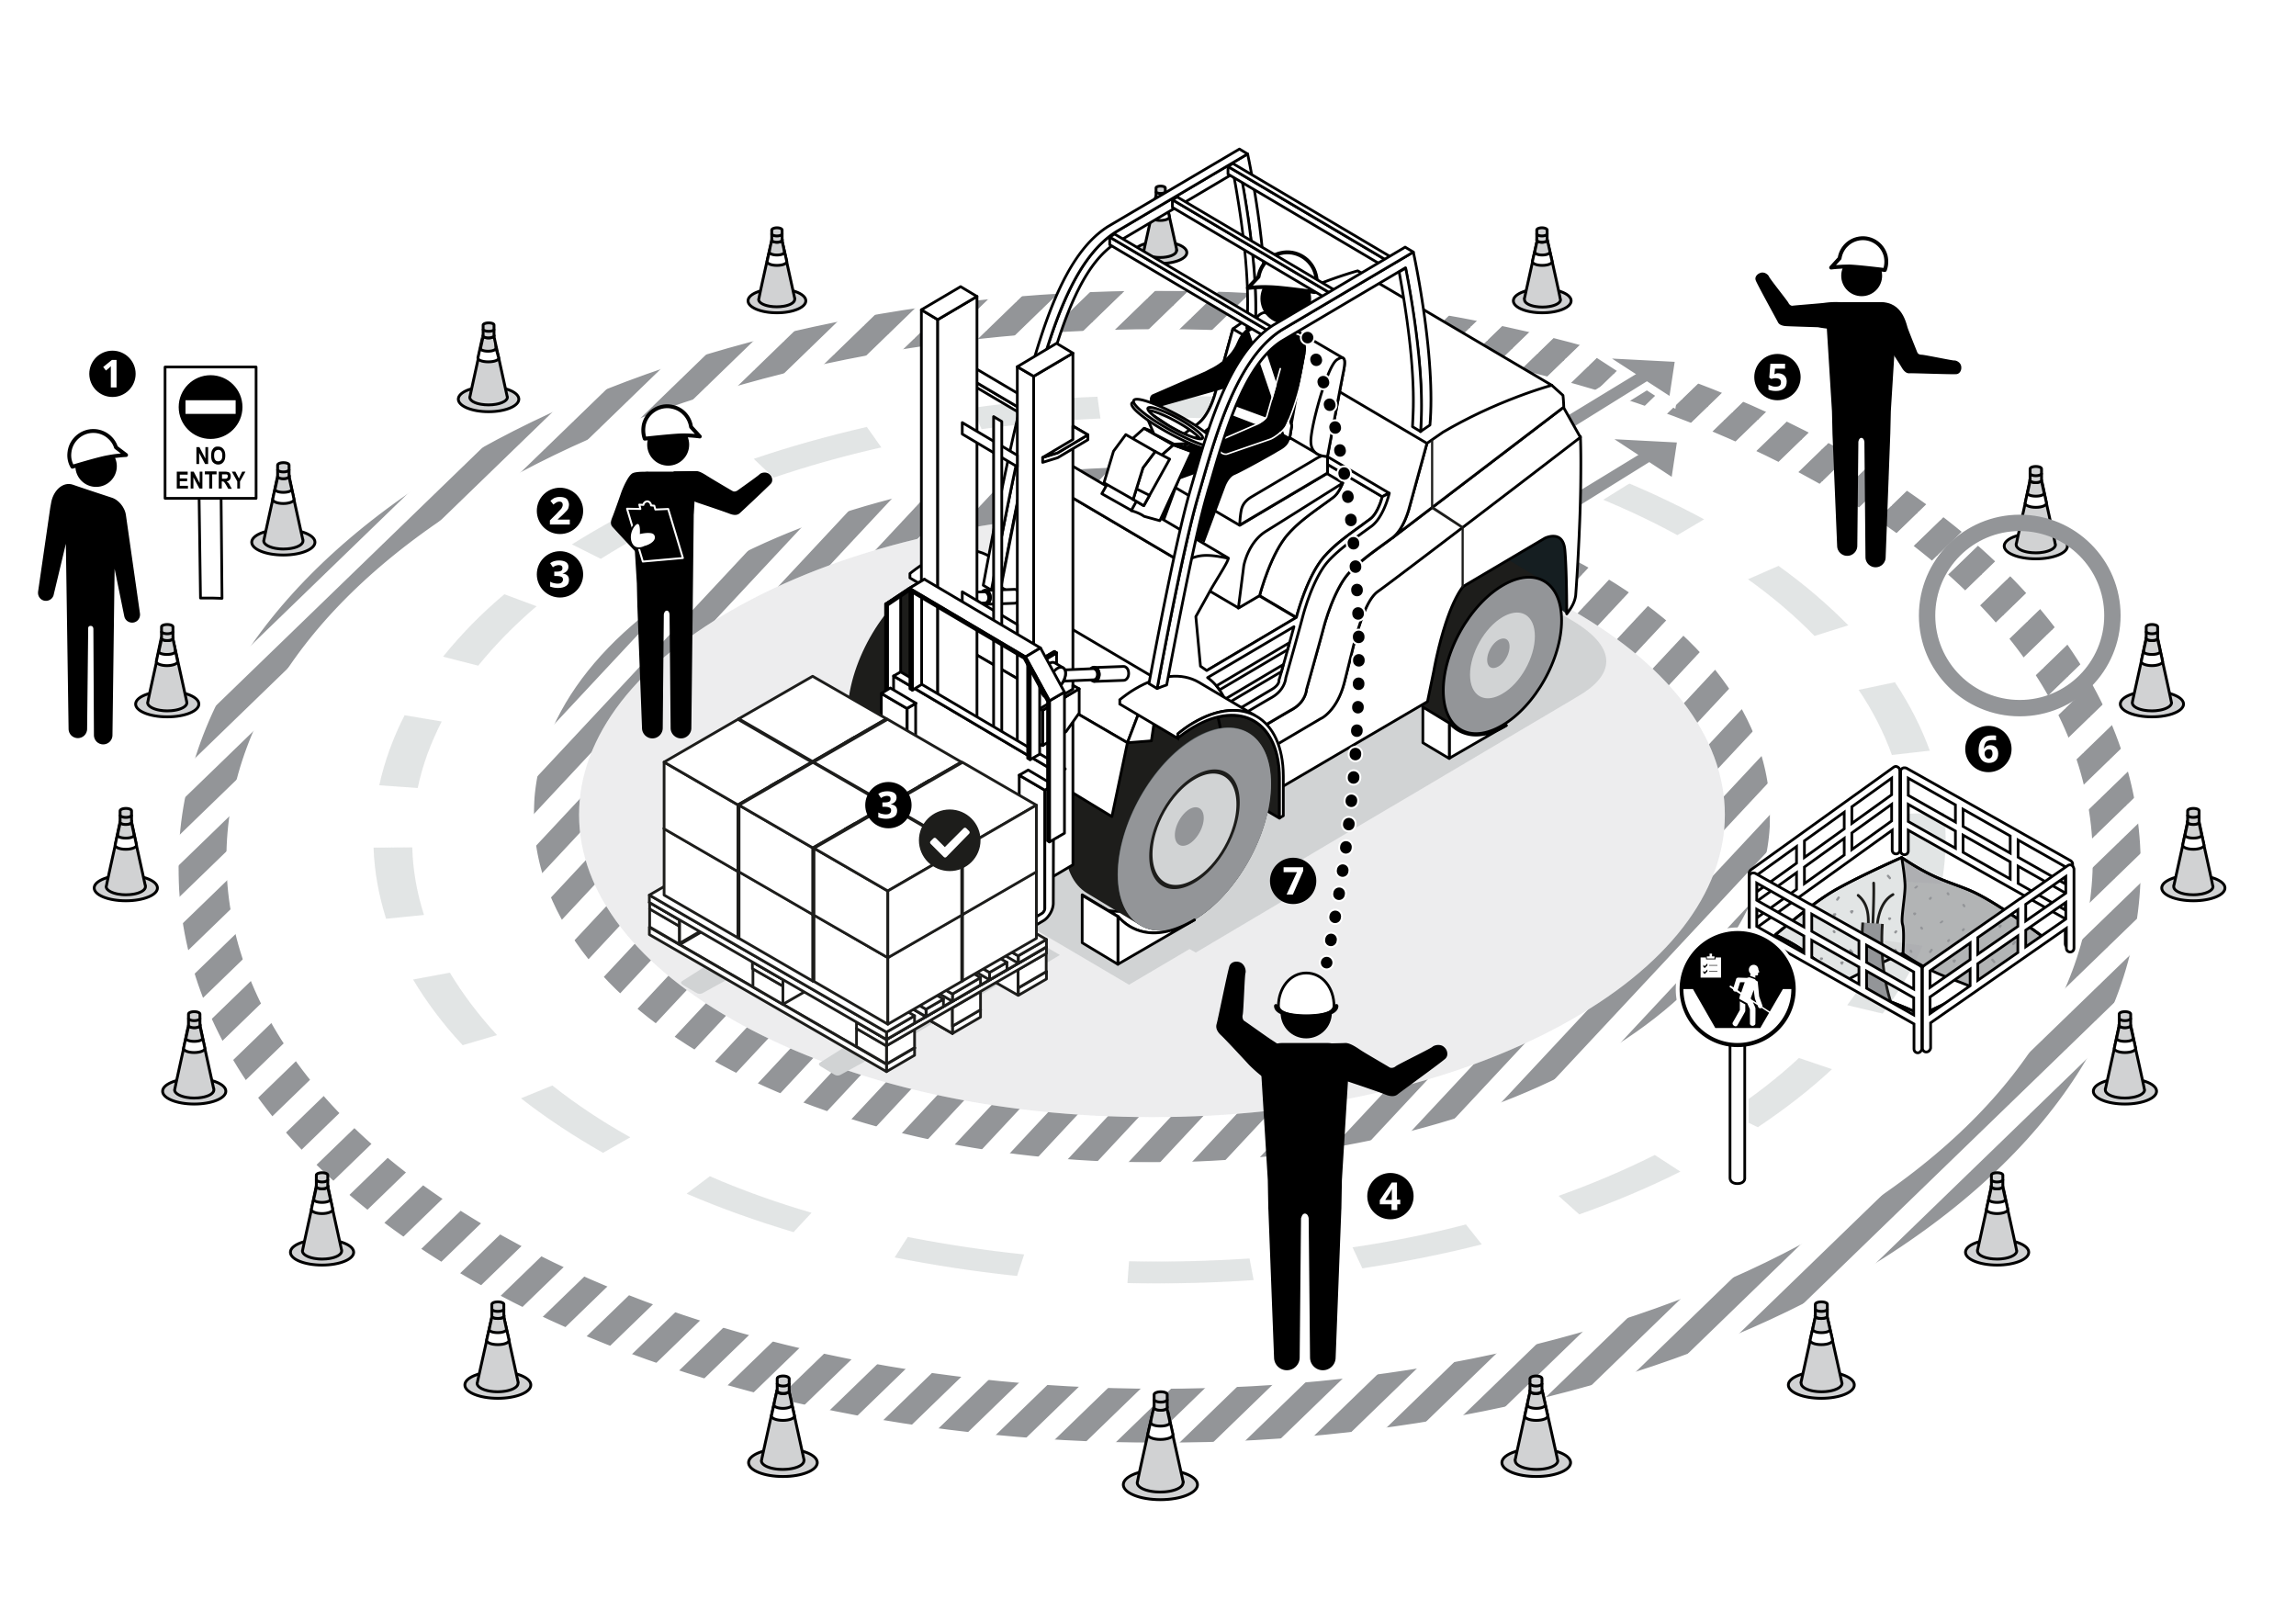
I have confirmed:
1 | Controls are in place to segregate pedestrians from mobile equipment and vehicle roadways.
2 | Vehicle / Equipment is properly certified for duty, and daily inspections are completed and recorded.
3 | Loads are assessed for stability, securement and capacity for the vehicle / equipment being used.
4 | An authorised and competent person is assigned to aid in control of vehicle / equipment movement as required (i.e. Flagman, Banksman, Spotter).
5 | Blind-spots are identified and mitigated, and controls are in place to minimise and manage all equipment and vehicle reversing.
6 | Controls are in place to manage proximity of equipment and vehicles from excavations, overhead lines, and underground infrastructure.
7 | Vehicles / Equipment are positioned with conditions and controls in place to prevent unintentional movement.

Stop and seek help if any of the above safeguards are not in place
Role |  | Printed Name | Date
Start -Work Verifier

Save Your Life Actions | Heavy Equipment and Vehicle Operations

Start Work Authority: I will not start work until I confirm…
Actions |  | How to (examples)
1 | Controls are in place to segregate pedestrians from mobile equipment and vehicle roadways. | A plan to segregate mobile equipment and vehicle roadways from pedestrians is in place. Personnel involved with the activity understand the plan requirements
2 | Vehicle / Equipment is properly certified for duty, and daily inspections are completed and recorded. | Equipment is certified to regulatory requirements and maintenance is up to date. Equipment has been inspected in accordance with a quarterly inspection programme. A daily inspection has been completed and recorded by equipment operator. Pre-mobilisation survey is conducted for newly hired equipment. All installed safety devices are working. Operators check for equipment maintenance / lock-out tags. Operators check and wear appropriate PPE and restraints including seat belts.
3 | Loads are assessed for stability, securement and capacity for the vehicle / equipment being used. | Loads have been assessed for stability, securing, and capacity compatibility with the equipment that will be used.
4 | An authorised and competent person is assigned to aid in control of vehicle / equipment movement as required (i.e. flagman, banksman, spotter). | An authorised and competent person has been assigned to control equipment movement (i.e. flagger). The flagger and operator have an agreed method of communicating during operation of equipment. Flagger(s) in control of the equipment movement are easily identified. Activity supervisors and flaggers are in place to keep people out of the line of fire during equipment movement.
5 | Blind-spots are identified and mitigated, and controls are in place to minimise and manage all equipment and vehicle reversing. | Alternatives to reversing have been assessed and eliminated prior to allowing reverse operation of equipment. Audible warnings are working on equipment for reverse operations. Flaggers are positioned out of the line of fire and in a position to monitor reversing operations. Physical barriers are in place in accordance with the activity plan.
6 | Controls are in place to manage proximity of equipment and vehicles from excavations, overhead lines, and underground infrastructure. | Equipment should be working at the safe distance established for any excavations. Equipment should be working at the safe operational distance established for any overhead powerlines. Equipment should be working at the safe distance established for any underground infrastructure. Minimum Approach Distances (MAD) in HSSE CF Electrical Safety Guide
7 | Vehicles / Equipment are positioned with conditions and controls in place to prevent unintentional movement. | Equipment is positioned on flat ground where possible and vehicle wheels are chocked when there is potential for movement. Equipment is positioned in dedicated parking areas, and in accordance with OEM instructions. Booms, attachments and accessories are lowered or secured to prevent energy release.

