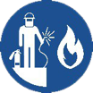 Start-Work Checks | Hot Work

Start Work Authority: Confirm below are in place and verified prior to starting work
Save Your Life Actions  All exposed persons performing work must confirm each action below |  |  |  |  | Person(s) Performing Work (initial) | Start-Work  Verifier  (initial) | 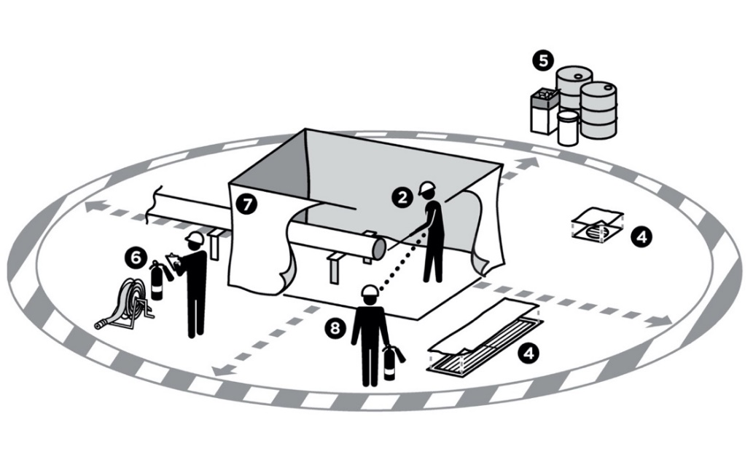
Isolation of Hazardous Energy
I have confirmed:
1 | Confined Space Entry has been evaluated for Isolation of Hazardous Energy (IHE) requirements.  Does hot work require IHE?  □ Yes □ No  If yes: Complete IHE Start-Work Checks.  If no: Continue to Step 2.
Hot Work
I have confirmed:
2 | The atmosphere is within allowed limits for entry.  Oxygen: between 19.5–23.5%  LEL: less than 10%  H₂S: less than 5 ppm  Other gas tested:
3 | Gas testing frequency has been established.
4 | Drains, openings and vents are sealed.
5 | All combustible materials have been removed, covered or drenched.
6 | Firefighting equipment has been inspected and is at hot work site.
7 | Heat, slag or sparks will be contained.
8 | Dedicated Fire Watch is in place.

Stop and seek help if any of the above safeguards are not in place
Role |  | Printed Name |  | Date
Start -Work Verifier
Save Your Life Actions | Hot Work

Start Work Authority: I will not start work until I confirm…
Actions |  |  | How to (examples) |  |  |  | 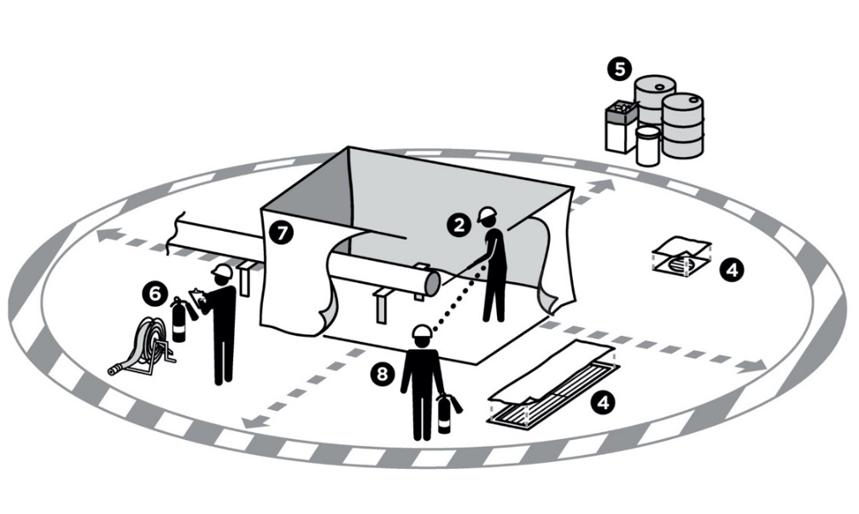
Isolation of Hazardous Energy
1 | Hot work has been evaluated for Isolation of Hazardous Energy (IHE) requirements. |  | Confirm all potential energy sources have been identified, isolated, and locked and tagged.  Confirm the system has been flushed, drained or purged to remove explosive materials or gases.
Hot Work
2 | The atmosphere is within allowed limits prior to hot work. |  | Ask Qualified Gas Tester to explain how they know the gas meter is working as designed.  Watch the initial gas testing and confirm results are within acceptable limits.  Confirm Qualified Gas Tester has performed atmospheric testing, including:  - At all openings below and above the hot work area  - At a minimum of 15 meters (50 feet) around the hot work area
3 | Gas testing frequency has been established. |  | Confirm follow-up frequency has been established by reviewing the Hot Work Permit/Certificate.  Confirm that no more than 30 minutes will pass after the initial gas testing before starting hot work.
4 | Drains, openings and vents are sealed. |  | Look for drains within the hot work area and verify they are sealed and/or covered.  Look for vents within the hot work area and verify they are routed away from the work area or are isolated.  Walk surrounding area to identify gaps and openings in tanks or piping and verify they are sealed.
5 | All combustible materials have been removed, covered or drenched. |  | Walk the surrounding 15 meters (50 feet) area and ensure all combustible materials have been removed or that measures are in place to either cover them, shield them or keep them wet.
6 | Firefighting equipment has been inspected and is at hot work site. |  | Review the hot work certificate and confirm the firefighting equipment listed is on site and inspected to ensure it is fully functional.
7 | Heat, slag or sparks will be contained. |  | Confirm fire blankets are used to cover combustible materials.  Confirm barriers are in place to prevent sparks from reaching a potential source.phone, etc.).
8 | Dedicated Fire Watch is in place. |  | Confirm a Fire Watch has been designated and is on-site.

