 Start-Work Checks | Isolation of Hazardous Energy (De-Energise & Re-Energise)

Start Work Authority: Confirm below are in place and verified prior to starting work
Save Your Life Actions  All exposed persons performing work must confirm each action below |  |  |  | Person(s) Performing Work (initial) | Start-Work  Verifier  (initial) | 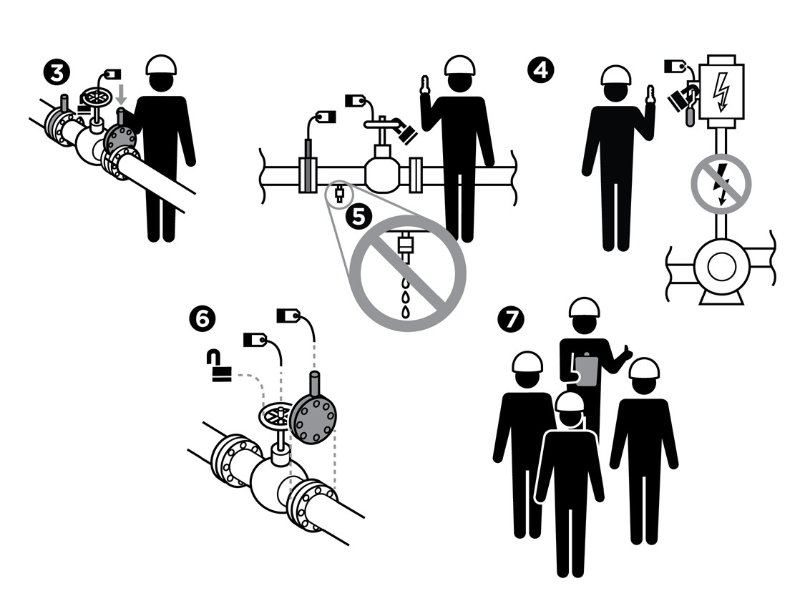
De-Energise
I have confirmed:
1 | Isolation points are identified per plan and the lines have been walked.
2 | Isolation equipment is rated for the energy source.
3 | Isolation devices are set in the identified position per diagram and/or plan.
4 | Isolations points are:  a. Locked and tagged; and  b. Keys are controlled by me or my crew supervisor.
5 | Equipment is de-energised and tested for residual or stored energy.
Re-Energise
I have confirmed:
6 | Isolation devices are removed per plan.
7 | All personnel exposed to energy source have been told equipment is ready to be re-energised.
8 | Equipment is ready to be put back in service.

Stop and seek help if any of the above safeguards are not in place
Role |  | Printed Name | Date
Start -Work Verifier

Save Your Life Actions | Isolation of Hazardous Energy (De-Energise & Re-Energise)

Start Work Authority: I will not start work until I confirm…
Actions |  | How to (examples)
De-Energise
1 | Isolation points are identified per plan. | Use the Equipment Isolation Procedure, P&IDs, or Process Flow Diagrams to physically confirm all isolations are in place and tagged or marked.  Confirm crew has physically inspected the equipment for other potential energy sources not previously identified or isolated.
2 | Isolation equipment is rated for the energy source. | Confirm blinds, spades and skillets are stamped or certified for the pressure rating of the equipment.
3 | Isolation devices are set in the identified position per plan. | Confirm valves are open or closed per plan.  Confirm blinds, spades and skillets are installed per plan.  Confirm switchgear or Motor Control Center (MCC) equipment switches are open and locked out.
4 | Isolation points are:  Locked and tagged; and  Keys are controlled by me or my crew supervisor. | Confirm locks, tags or securing devices are on isolation points.  Confirm keys are in a designated secure location.
5 | Equipment is de-energised and tested for residual or stored energy. | Ask crew/operations to attempt to start up equipment.  Confirm systems (lines, gauges, etc.) have been tested for residual or stored energy by:  - Opening bleed and vent points to release stored energy  - Pressure testing  - Air gapping of lines  Confirm gas testing and atmospheric monitoring will occur when opening piping, equipment, etc.
Re-Energise
6 | Isolation devices are removed per plan. | Physically inspect:  - Equipment to confirm scope of work was completed  - Work area to confirm all mechanical, process and electrical isolations were removed  Bleed and vent points to confirm they are closed.
7 | All personnel exposed to energy source have been told equipment is ready to be re-energised. | Ask work crews in and near the work area if they are aware equipment is ready to be re-energised.
8 | Equipment is ready to be put back in service. | Ask work crews in and near the work area if they are aware equipment is ready to be put back in service.

