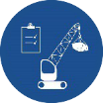 Start-Work Checks | Lifting & Rigging

Start Work Authority: Confirm below are in place and verified prior to starting work
Save Your Life Actions  All exposed persons performing work must confirm each action below |  |  |  | Person(s) Performing Work (initial) | Start-Work  Verifier  (initial) | 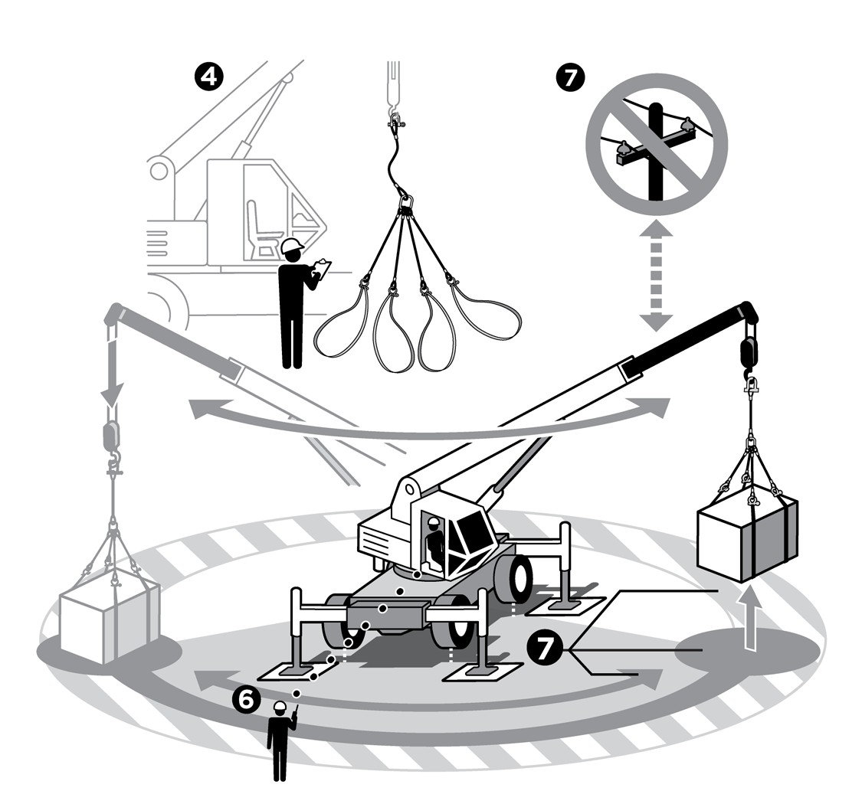
I have confirmed:
1 | Written lift plan required? □ Yes □ No  If yes: All workers agreed to follow the written lift plan.  Note: Written lift plan needed for blind, complex, complicated, heavy and personnel lifts.
2 | Equipment operator and rigger are qualified to do the lifting and rigging task.
3 | Load weight is within the range of the equipment’s safe working limit.
4 | Lifting and rigging equipment is certified, inspected and rated for the task.
5 | Lifting and rigging equipment safety devices are in place and working.
6 | Communication plan is agreed by all workers involved.
7 | Plan is in place to prevent and mitigate:  - Load shifts  - Dropped objects  - Load path obstructions  - Overhead obstructions and power line  - Working under suspended loads.
8 | Lifting equipment is stable per manufacturer specifications.

Stop and seek help if any of the above safeguards are not in place
Role |  | Printed Name | Date
Start -Work Verifier

Save Your Life Actions | Lifting & Rigging

Start Work Authority: I will not start work until I confirm…
Actions |  | How to (examples) | 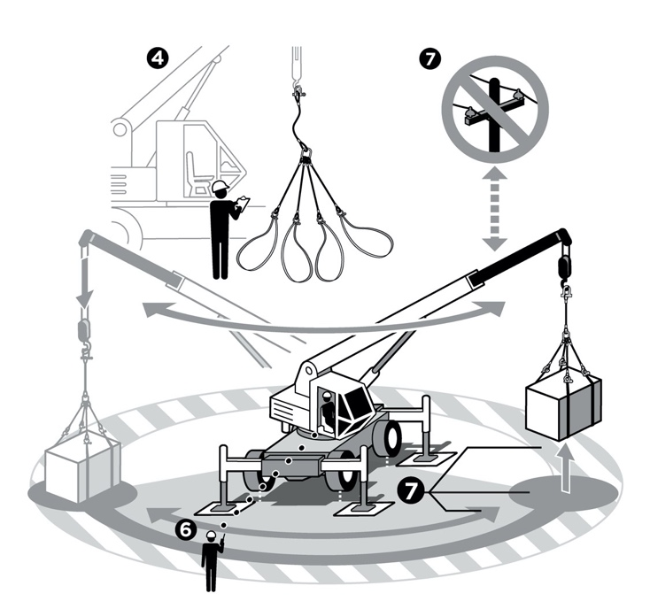
1 | Written lift plan required? | Confirm equipment operator and rigger have discussed the written lift plan prior to making a lift. Confirm additional safeguards required for the following specialised lifts have been documented in the written lift plan and are in place and working:  - Blind Lifts  - Complex Lifts  - Complicated Lifts  - Heavy Lifts  - Personnel Lifts
2 | Equipment operator and rigger are qualified to perform the lifting and rigging task. | Review qualification records of crane operator and riggers.
3 | Load weight is within the range of the equipment’s safe working limit. | Refer to manufacturer’s load chart for reference. Ask the equipment operator and rigger to explain how the weight of the load was determined and calculated. If load chart does not exist, assume equipment is not rated for the lift, stop work and identify alternative lifting equipment that is rated for the load.
4 | Lifting and rigging equipment is certified, inspected and rated for the task. | Inspect slings, shackles, cables, etc., for wear/defects.  Confirm the lifting and rigging equipment certifications have not expired.  Complete pre-use check of lifting and rigging equipment.  Confirm equipment has not been altered, modified or field-fabricated.
5 | Lifting and rigging equipment safety devices are in place and working. | Complete a pre-use crane inspection and review manufacturer's recommendations for safety equipment (e.g., emergency shut down equipment, booms, stop, anti-two block, brake, weight indicators and load limiting devices).  Follow the Bypassing Critical Protection standard when lifting and rigging safety devices are bypassed.
6 | Communication plan is agreed by all workers involved. | Examples of communication methods:  - Hand signals  - Radio communications  Agree on emergency stop signals during pre-job meeting.  Agree on communication methods for blind lifts.  Ask crew to demonstrate communication plan.
7 | Plan is in place to prevent and mitigate the following:  - Load shifts  - Dropped objects  - Load path obstructions  - Overhead obstructions and power line  - Working under suspended loads. | Establish exclusion zones considering the cone of exposure/line of fire.  Erect barricades to protect exclusion zone as needed.  Identify and mitigate
8 | Lifting equipment is stable, per equipment manufacturer specifications. | Confirm ground is stable and level for the lifting equipment.  Confirm matting is stable and level for the lifting equipment.  Confirm restraints (e.g., hold-down bolts, fasteners) are secure.  Confirm there is enough space for outrigger deployment.

