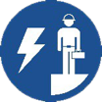 Start-Work Checks | Energised / Live Electrical Work

Start Work Authority: Confirm below are in place and verified prior to starting work
Save Your Life Actions  All exposed persons performing work must confirm each action below |  |  |  | Person(s) Performing Work (initial) | Start-Work  Verifier  (initial) | 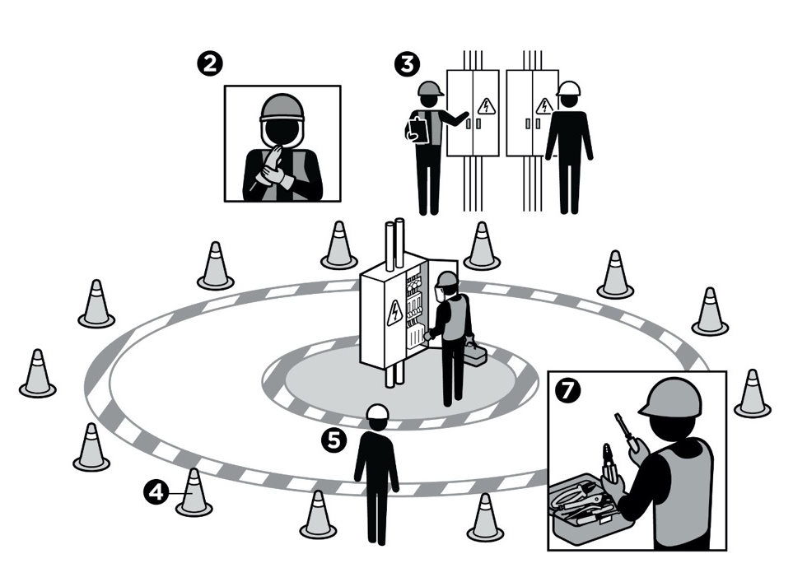
I have confirmed:
1 | The authorised work scope has been reviewed and agreed to.
2 | Personnel are wearing PPE rated for:  a. The arc flash per the arc flash hazard analysis.  b. The electrical voltage prior to entering the restricted approach boundary.
3 | Circuit/equipment to be worked on is the one identified in the plan.
4 | Safe work zones have been identified and visually barricaded.
5 | Electrical standby person has been assigned and emergency response plan has been agreed to.
6 | Communication plan with the standby person has been agreed to, including stop work signals.
7 | Insulated tools and testing equipment have been inspected for damage and are rated for the task.

Stop and seek help if any of the above safeguards are not in place
Role |  | Printed Name | Date
Start -Work Verifier

Save Your Life Actions | Energised / Live Electrical Work

Start Work Authority: I will not start work until I confirm…
Actions |  | How to (examples) | 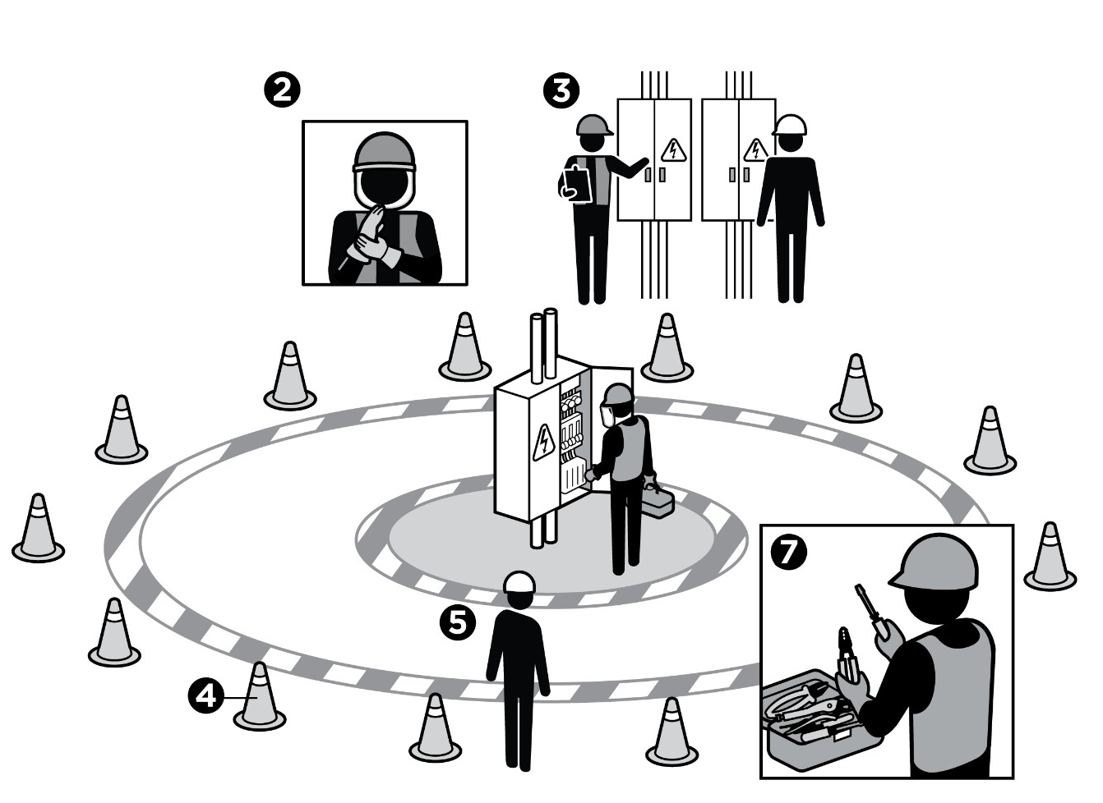
1 | The authorised work scope has been reviewed and agreed to. | Review work scope per the approved work permit.  Ask crew to repeat back the work instructions.  Agree to stop work if work scope changes in any way.
2 | Personnel are wearing PPE rated for:  The arc flash per the arc flash hazard analysis.  The electrical voltage prior to entering the limited approach boundary. | Ask crew what arc flash or electrical voltage they should be prepared for.  Confirm personnel are wearing PPE rated for the arc flash per the arc flash hazard analysis.  Confirm personnel are wearing PPE rated for the electrical voltage prior to entering the restricted approach boundary.
3 | Circuit/equipment to be worked on is the one identified in the plan. | Confirm equipment to be worked on is correct using tag numbers or cable markings.
4 | Safe work zones have been identified and visually barricaded. | Erect barriers to limit access to the work area.  Confirm standby person will monitor the area to keep unauthorised personnel out of the work area.
5 | Electrical standby person has been assigned and emergency response plan has been agreed to. | Identify the standby person at the site.  Confirm emergency equipment such as safety hooks, insulated gloves, etc., are at the worksite.
6 | Communication plan with the standby person has been agreed to, including stop work signals. | Discuss communication plan with qualified electricians.  Confirm communication plans have been agreed to.  Ask crew to test communication plan.
7 | Insulated tools and testing equipment have been inspected for damage and are rated for the task. | Confirm insulating materials such as rubber matting or screening are in place.  If no insulating materials exist, install temporary insulating materials such as rubber matting or screening.  Confirm only insulated tools that have been rated/certified for the equipment’s maximum voltage will be used.  Conduct voltage function test prior to using testing equipment.

