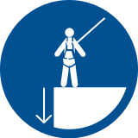 Start-Work Checks | Working at Heights

Start Work Authority: Confirm below are in place and verified prior to starting work
Save Your Life Actions  All exposed persons performing work must confirm each action below |  |  |  | Person(s) Performing Work (initial) | Start-Work  Verifier  (initial) | 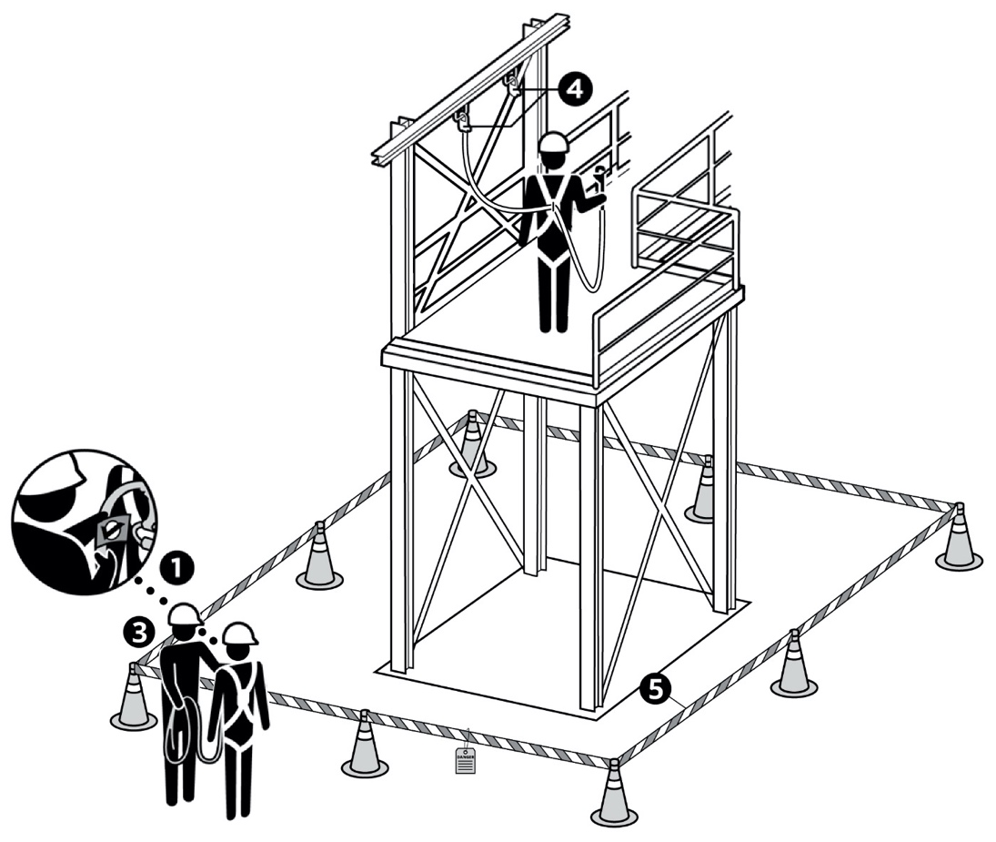
I have confirmed:
1 | Fall protection equipment (fall arrest and fall restraint) is certified, inspected and rated for the task.
2 | Rescue plan has been reviewed with work crew and rescue equipment is available.
3 | Fall protection equipment is adjusted to fit the worker.
4 | Work crew agreed to be 100% tied off to the identified, approved anchorage point(s).
5 | Fall path is clear of obstructions or mitigations have been implemented to address hazards.
6 | Potential dropped objects have been identified and mitigated.
7 | Work crew has agreed that no team member will work at height alone.

Stop and seek help if any of the above safeguards are not in place
Role |  | Printed Name | Date
Start -Work Verifier

Save Your Life Actions | Working at Heights

Start Work Authority: I will not start work until I confirm…
Actions |  | How to (examples) | 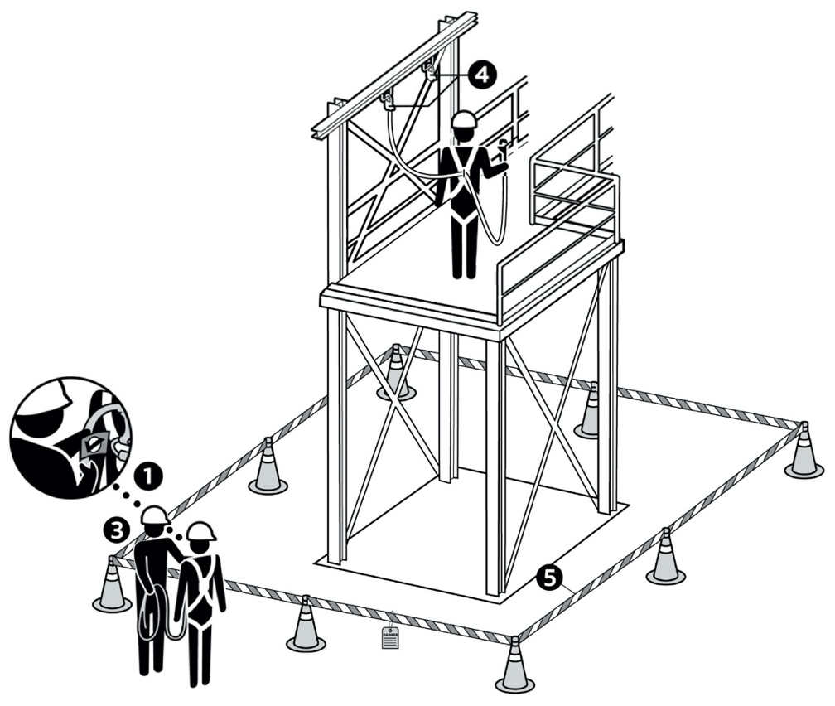
1 | Fall protection equipment (fall arrest and fall restraint) is certified, inspected and rated for the task. | Check every strap, buckle, fitting and/or grommet for signs of wear.  Destroy fall protection equipment if the inspection shows evidence of excessive wear/damage or a mechanical malfunction.  Confirm fall protection equipment has been inspected and certified within the past 2 years.  Note:  - Fall arrest contains a self-retracting lifeline and is a system designed to support and hold a person in the event of a fall  - Fall restraint contains a fixed lifeline that prevents workers from falling
2 | Rescue plan has been reviewed with work crew and rescue equipment is available. | Confirm the crew has discussed the rescue plan, including:  How to contact responders  Location of rescue equipment and responders
3 | Fall protection equipment is adjusted to fit the worker. | Confirm only full body harnesses are used (use of body belts is not allowed).  Confirm crew are wearing PPE properly:  Straps are not twisted  Body straps are adjusted for correct fit
4 | Work crew agreed to be 100% tied off to the identified, approved anchorage point(s). | Confirm the anchor point selected has been approved by a Competent Person (for reference the anchor point must withstand a 22.2 kilonewtons [5,000 lb force]).  Pull on lanyard to test if attachment is secure.  Confirm the worker will not be placed in a fall path that contains hazards.  Confirm the workers know they must be 100% tied off at all times (e.g., at least one hook must be anchored at all times).
5 | Fall path is clear of obstructions or mitigations have been implemented to address hazards. | Measure the potential fall distance and ensure fall arrest is shorter than the fall distance.  If obstructions are in the fall path, mitigate the obstructions. If obstructions cannot be mitigated, select fall restraint protection equipment.
6 | Potential dropped objects have been identified and mitigated. | Perform a potential dropped object review and erect barricades as necessary to provide protection to workers in the area.  Where possible, use debris nets, lanyards, etc., to prevent objects from falling to grade below.
7 | Work crew has agreed that no team member will work at height alone. | Confirm someone on the crew has been assigned to be a standby/spotter.

