DKS 2846 2019

Mixing water for concrete - Specification for sampling, testing and assessing the suitability of water, including water recovered from processes in the concrete industry, as mixing water for concrete

©KEBS 2019 First Edition 2019

TECHNICAL COMMITEE REPRESENTATION

The following organizations were represented on the Technical Committee:

- Architectural Association of Kenya
- Bamburi Cement
- CHRYSO Eastern Africa Limited
- Concrete Products (K)Ltd
- Consumer Information Network
- Howards Humprey East Africa LTD
- Institute of quantity surveyors of Kenya
- Kenya Industrial Research and Development Institute (KIRDI
- Kenya Institute of Highways and Building Technology (KIHBT)
- Ministry of Transport, Infrastructure, Housing and Urban Development.
- National Environment Management Authority
- National Housing Corporation
- Technical University of Kenya
- University of Nairobi
- Kenya Bureau of Standards — Secretariat

REVISION OF KENYA STANDARDS

In order to keep abreast of progress in industry, Kenya Standards shall be regularly reviewed. Suggestions for improvements to published standards, addressed to the Managing Director, Kenya Bureau of Standards, are welcome.

© Kenya Bureau of Standards, 2019

Copyright. Users are reminded that by virtue of Section 25 of the Copyright Act, Cap. 12 of 2001 of the Laws of Kenya, copyright subsists in all Kenya Standards and except as provided under Section 26 of this Act, no Kenya Standard produced by Kenya Bureau of Standards may be reproduced, stored in a retrieval system in any form or transmitted by any means without prior permission in writing from the Managing Director.

Mixing water for concrete - Specification for sampling, testing and assessing the suitability of water, including water recovered from processes in the concrete industry, as mixing water for concrete

KENYA BUREAU OF STANDARDS (KEBS)

Head Office: P.O. Box 54974, Nairobi-00200, Tel.: (+254 020) 605490, 602350, Fax: (+254 020) 604031
E-Mail: info@kebs.org, Web:http://www.kebs.org

Coast Region Lake Region Rift Valley Region
P.O. Box 99376, Mombasa-80100 P.O. Box 2949, Kisumu-40100 P.O. Box 2138, Nakuru-20100
Tel.: (+254 041) 229563, 230939/40 Tel.: (+254 057) 23549, 22396 Tel.: (+254 051) 210553, 210555
Fax: (+254 041) 229448 Fax: (+254 057) 21814

Foreword

This Kenya Standard was revised by the Concrete Technical Committee, under the guidance of the standards Projects Committee, and it is in accordance with the procedures of the Kenya Bureau of Standards.
The quality of the mixing water for production of concrete can influence the setting time, the strength development of concrete and the protection of the reinforcement against corrosion.

When assessing the suitability of water of unknown quality for the production of concrete, both the composition of the water and the application of the concrete to be produced should be considered.

KENYA STANDARD DKS 2846 2019
Mixing water for concrete - Specification for sampling, testing and assessing the suitability of water, including water recovered from processes in the concrete industry, as mixing water for concrete

1 Scope

This Standard specifies the requirements for water that is suitable for making concrete that conforms to
EN 206-1 and describes methods for assessing its suitability.

2 Normative references

This Standard incorporates by dated or undated reference, provisions from other publications. These normative references are cited at the appropriate places in the text, and the publications are listed hereafter. For dated references, subsequent amendments to or revisions of any of these publications apply to this Standard only when incorporated in it by amendment or revision. For undated references the latest edition of the publication referred to applies (including amendments).

EN 196-1, Methods of testing cement — Part 1: Determination of strength.
EN 196-2, Methods of testing cement — Part 2: Chemical analysis of cement.
EN 196-3, Methods of testing cement — Part 3: Determination of setting time and soundness.
EN 196-21, Methods of testing cement — Part 21: Determination of the chloride, carbon dioxide and alkali content of cement.
EN 206-1:2000, Concrete — Part 1: Specification, performance, production and conformity.
EN 12390-2, Testing hardened concrete — Part 2: Making and curing specimens for strength tests.
EN 12390-3, Testing hardened concrete — Part 3: Compressive strength of test specimens.
EN ISO 9963-2, Water quality — Determination of alkalinity — Part 2: Determination of carbonate alkalinity (ISO 9963-2:1994).
ISO 4316, Surface active agents — Determination of pH of aqueous solutions — Potentiometric method.
ISO 7890-1, Water quality — Determination of nitrate — Part 1: 2,6-Dimethylphenol spectrometric method.

3 Classification of types of water

In general the suitability of water for the production of concrete depends upon its origin. The following types may be distinguished:

3.1 Potable water

This water is considered as suitable for use in concrete. Such water needs no testing.

3.2 Water recovered from processes in the concrete industry

(This water, defined in A.2.1, will normally be suitable for use in concrete, but shall conform to the requirements of annex A.

3.3 Water from underground sources
This water may be suitable for use in concrete, but shall be tested.

3.4 Natural surface water and industrial waste water
This water may be suitable for use in concrete, but shall be tested.

3.5 Sea water or brackish water
This water may be used for concrete without reinforcement or other embedded metal, but is in general not suitable for the production of reinforced or prestressed concrete.

For concrete with steel reinforcement, or embedded metal, the permitted total chloride content in the concrete is the determining factor.

3.6 Sewage water
This water is not suitable for use in concrete.

4 Requirements

4.1 General
Water for use in concrete shall conform to the requirements of 4.2, 4.3.1, 4.3.2 and 4.3.3. The water shall also conform to either the chemical requirements in 4.3.4, or the requirements for setting time and compressive strength in 4.4.

Water supplied as potable water is deemed to conform to the requirements in this standard.

When waters are to be combined (see A.2.2), the requirements apply to the combined water.

4.2 Preliminary assessment
The water shall be examined in accordance with the test procedures stated in Table 1. Water not conforming to one or more of the requirements in Table 1 may be used only, if it can be shown to be suitable for use in concrete, in accordance with 4.4.

Table 1 — Requirements and test procedures for preliminary inspection of mixing water

 |  | Requirement | Test procedure
1 | Oils and fats | Not more than visible traces. | 6.1.1
2 | Detergents | Any foam should disappear within 2 minutes. | 6.1.1
3 | Colour | Water not from sources classified in 3.2: The colour shall be assessed qualitatively as pale yellow or paler. | 6.1.1
4 | Suspended matter | Water from sources classified in 3.2 | A.4
4 | Suspended matter | Water from other sources: | 6.1.1
4 | Suspended matter | Maximum 4 ml. sediment. | 6.1.1
5 | Odour | Water from sources classified in 3.2.  No smell, except the odour allowed for potable water and a slight smell of cement and where blastfurnace slag is present in the water, a slight smell of hydrogen sulphide. | 6.1.1
5 | Odour | Water from other sources. No smell, except the odour  allowed for potable water. No smell of hydrogen sulphide after addition of hydrochloric acid. | 6.1.1
6 | Acids | pH ≥ 4 | 6.1.1
 | Humic matter | The colour shall be assessed qualitatively as yellowish  brown or paler, after addition of NaOH. | 6.1.2

4.3 Chemical properties

4.3.1 Chlorides
The chloride content of the water, tested in accordance with 6.1.3, and expressed as Cl-, shall not exceed the levels given in Table 2, unless it can be shown that the chloride content of the concrete will not exceed the maximum value for the specified class selected from 5.2.7 of EN 206-1:2000.

Table 2 — Maximum chloride content of mixing water

End use | Max. chloride content mg/l | Test procedure
Prestressed concrete or grout | 500 | 6.1.3
Concrete with reinforcement or embedded metal | 1.000 | 6.1.3
Concrete without reinforcement or embedded metal | 4.500 | 6.1.3

4.3.2 Sulphates
The sulphate content of the water, tested in accordance with 6.1.3 and expressed as SO₄^{2–} shall not exceed 2 000 mg/l.

4.3.3 Alkali
If alkali-reactive aggregates are expected to be used in the concrete, the water shall be tested for its alkali content in accordance with 6.1.3. The equivalent sodium oxide content of the water shall not normally exceed 1 500 mg/l. If this limit is exceeded, the water may be used only if it can be shown that actions have been taken to prevent deleterious alkali-silica reactions.

4.3.4 Harmful contamination
In the first instance qualitative tests for sugars, phosphates, nitrates, lead and zinc may be carried out. If the qualitative tests show a positive result, either the quantity of the substance concerned shall be determined or tests for setting time and compressive strength shall be performed.

If chemical analysis is chosen, the water shall conform to the limits given in Table 3.

Table 3 — Requirements for harmful substances

Substance | Maximum content  (mg/l) | Test procedure
Sugars | 100 | 6.1.3
Phosphates; expressed as P₂O₅ | 100 | 6.1.3
Nitrates; expressed as NO₃  – | 500 | 6.1.3
Lead; expressed as Pb₂₊ | 100 | 6.1.3
Zinc; expressed as Zn₂₊ | 100 | 6.1.3

4.4 Setting time and strength

When tested in accordance with 6.1.4 the initial setting time obtained on specimens made with the water shall be not less than 1 hour and not differ by more than 25 % from the initial setting time obtained on specimens made with distilled or de-ionised water. The final setting time shall not exceed 12 hours and not differ by more than 25 % from the final setting time obtained on specimens made with distilled or de-ionised water.

The mean compressive strength at 7 days of the concrete or mortar specimens, prepared with the water, shall be at least 90 % of the mean compressive strength of corresponding specimens prepared with distilled or de-ionised water.

5 Sampling

A sample of water of not less than 5 litres shall be taken. The sample shall be correctly identified and representative of the water to be used, due regard being given to the possible effects of seasonal fluctuations.

The sample shall be stored in a clean and sealed container. The container shall be rinsed out with water from the source prior to filling to capacity with the water sample.

The water shall be tested within 2 weeks of sampling.

6 Testing

6.1 Test methods

6.1.1 Preliminary assessment

A small sub sample shall be assessed as soon as possible after sampling for oil and fats, detergents, colour,suspended matter, odour and humic matter.

Bring any material that may have settled back into suspension by shaking the sample. Pour 80 ml of the sample into a 100 ml measuring cylinder. Seal with a suitable stopper and shake the cylinder vigorously for 30 seconds.

Smell the sample for any odours other than those of clean water. If in doubt about the odour, test the water for its odour level in accordance with regulations for potable water. The odour level of the water shall be lower than the maximum level accepted for potable water. Observe the surface for foam. Stand the cylinder in a place free from vibration and allow standing for 30 min. After 2 minutes check for the continuing presence of foam and signs of any oils or fats. At the end of 30 minutes note the apparent volume of the settled solids and the colour of the water. Measure the pH using indicator paper or a pH meter. Then add 0.5 ml hydrochloric acid, mix then and smell or test for the presence of hydrogen sulphide.

6.1.2 Humic matter

Put 5 ml of the sample into a test tube. Bring it to a temperature between 15 °C and 25 °C by allowing it to stand indoors. Add 5 ml of 3 % sodium hydroxide solution shake and leave for 1 hour. Observe the colour.

6.1.3 Chemical tests

The following test methods describe the reference procedures for the mentioned chemical tests. If other methods are used it is necessary to show that they give results equivalent to those given by the reference methods. In case of a dispute, only the reference procedures shall be used:

Chlorides Relevant extracts of EN 196-21
Sulphates Relevant extracts of EN 196-2
Alkali Relevant extracts of EN 196-21
Sugars According to standards valid in the place of use.
Phosphates According to standards valid in the place of use.
Nitrates ISO 7890-1
Lead According to standards valid in the place of use.
Zinc According to standards valid in the place of use.

6.1.4 Setting time and strength

The following test methods shall be applied:
Setting time of paste EN 196-3
Strength of mortar prisms EN 196-1
Making concrete specimens EN 12390-2
Testing concrete specimens EN 12390-3
For strength testing, three mortar or concrete specimens shall be made using the water under investigation and tested. The test results shall be compared with the results of tests on similar specimens made using distilled or deionized water.

6.2 Frequency for testing
The following frequencies for testing water apply:

Potable water
no testing;

Water recovered from processes in the concrete industry (as defined in A.2.1)
test in accordance with annex A;

Water from underground sources, natural surface water and industrial waste water
test before first use and thereafter monthly until such time that a clear insight in the fluctuation of the water composition has been established. Thereafter a lower frequency may be adopted;

Sea water and brackish water
test before first use, thereafter once per year and whenever necessary.

6.3 Conformity evaluation
The requirements given in this standard are expressed as absolute values. For conformity the mixing water shall conform to the requirements given in clause 4.

7 Report

The test report shall contain the following information:
a) a description of the type and source of the water;
b) the place of sampling;
c) the time and date of sampling;
d) the name of laboratory and of the person responsible for the test;
e) the date of testing;
f) the test results and the comparison with the requirements of this standard.

Annex A
(normative)
Requirements for the use of water recovered from processes
in the concrete industry

A.1 Scope
Water, recovered from processes in the concrete industry used alone or combined with other water as mixing water.

A.2 Terms and definitions

A.2.1 Water recovered from processes in the concrete industry

Water, recovered from processes in the concrete industry comprises:
⎯ water which was part of any surplus concrete;
⎯ water used to clean the inside of stationary mixers, mixing drums of truck mixers or agitators and concrete pumps;
⎯ process water from sawing, grinding and water blasting of hardened concrete;
⎯ water extracted from fresh concrete during concrete production.
The water may be taken from:
⎯ basins provided with suitable equipment that distributes the solid matter evenly throughout the water;
⎯ sedimentation basins or similar installations, provided the water is left in the basin for sufficient time to allow the solids to settle properly.

NOTE Water recovered from processes in the concrete industry contains varying concentrations of very fine particles the size of which is generally less than 0.25 mm.

A.2.2 Combined water

Combined water is a mixture of water recovered from processes in the concrete industry and water of some other origin.

A.2.3 Surplus concrete and mortar

Surplus concrete is fresh concrete, left over after placing or discharged from concrete mixers during cleaning at the concrete plant. Surplus concrete also includes any fresh concrete that is recovered during cleaning of concrete trucks and pumps.

Surplus mortar may be treated in the same way as surplus concrete.

A.2.4 Recovered aggregates

Recovered aggregates are aggregates, recovered from recycling processes.
NOTE Recovered aggregates can be used in accordance with EN 206-1:2000, 5.2.3.3.

A.3 Limitations on the use of water recovered from processes in the concrete industry

Water recovered from processes in the concrete industry or combined water may be used as mixing water for concrete with or without reinforcement or embedded metal and also for prestressed concrete, provided the following requirements are met:

1) The additional mass of solid material in the concrete resulting from the use of water recovered from
processes in the concrete industry shall be less than 1 % (m/m) of the total mass of aggregates present in
the concrete.

2) The possible influence of the use of this water shall be taken into account if there are special requirements for the concrete to be produced e. g. architectural concrete, prestressed concrete, air entrained concrete, concrete exposed to aggressive environments etc.

3) The amount of recovered water shall be spread as evenly as possible over a days’ production.
For some production processes a greater quantity of solid material may be used, provided satisfactory performance in concrete can be demonstrated.

A.4 Requirements

A.4.1 General

All water recovered from processes in the concrete industry or combined water used in concrete shall conform to the requirements specified in clause 4 and the following requirements.

A.4.2 Storage

Water in storage shall be adequately protected against contamination.

A.4.3 Distribution of solid material in the water

A suitable means of ensuring uniform distribution of the solid material in recovered water with a density greater than 1.01 kg/l shall be provided.

Water with a density less than or equal to 1.01 kg/l may be assumed to contain negligible amounts of solid material.

A.4.4 The mass of solid material present in the recovered water

The mass of solid material present in the recovered water shall be estimated from Table A.1, on the basis of its density. The solid material and the water shall be taken into account in the design of the concrete.

Table A.1 — Solid material in water

Density of the water  (kg/l) | Mass of solid material  (kg/l) | Volume of mixing water
1.02 | 0.038 | 0.982
1.03 | 0.057 | 0.973
1.04 | 0.076 | 0.964
1.05 | 0.095 | 0.955
1.06 | 0.115 | 0.945
1.07 | 0.134 | 0.936
1.08 | 0.153 | 0.927
1.09 | 0.172 | 0.918
1.10 | 0.191 | 0.909
1.11 | 0.210 | 0.900
1.12 | 0.229 | 0.891
1.13 | 0.248 | 0.882
1.14 | 0.267 | 0.873
1.15 | 0.286 | 0.864

In the calculation a particle density of 2.1 kg/l has been used for estimating the solid material present in the water. If other densities are measured the table may be recalculated according to the following formula:
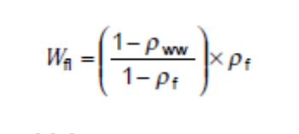In which:
W_{fl} mass of solid material present in the water, (in kg/l);
ρ_{WW} density of the water, (in kg/l);
ρ_{f} particle density of the solid material, (in kg/l).

A.5 Inspection

A.5.1 Density
The density of the water recovered from processes in the concrete industry or combined water shall be determined on homogenised samples taken from the basin containing the water.

When in use for concrete production the density of this water shall be determined at least daily at the time at which the highest density is most likely to occur, unless other procedures to monitor the density are stated in theproducers quality manual.

Automatic devices may be used; in which case the concrete producer’s quality manual shall describe the method of use and their calibration.

A.5.2 Suitability
The suitability of the water recovered from processes in the concrete industry or combined water shall be
determined in accordance with clause 4.

Annex B
(informative)
Testing scheme for mixing water for concrete

NOTE This testing scheme is only meant to suggest a practical way of testing water samples. The provisions of the
standard will always prevail.
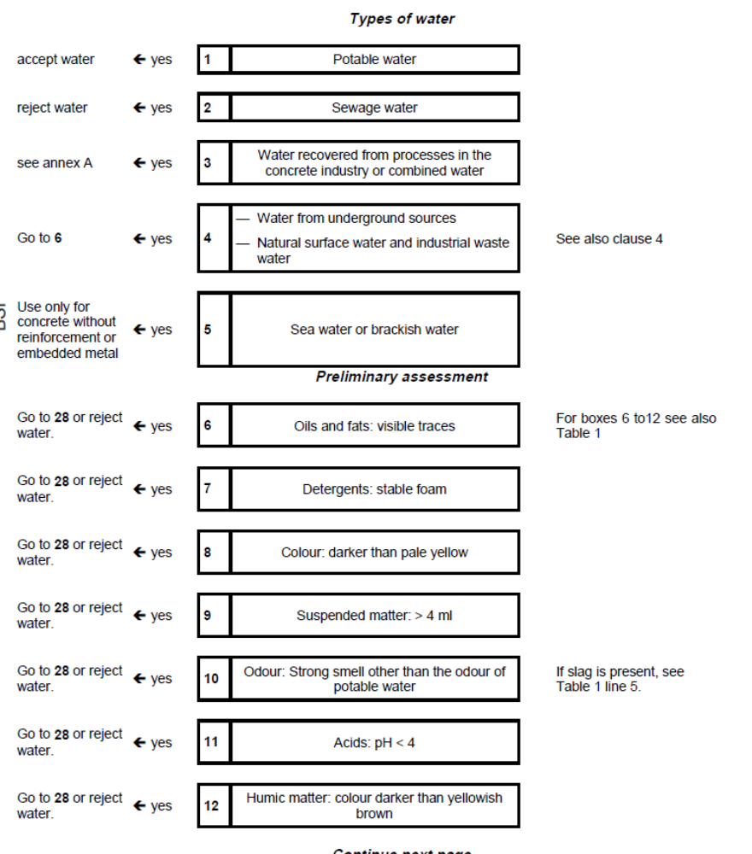
Chemical tests

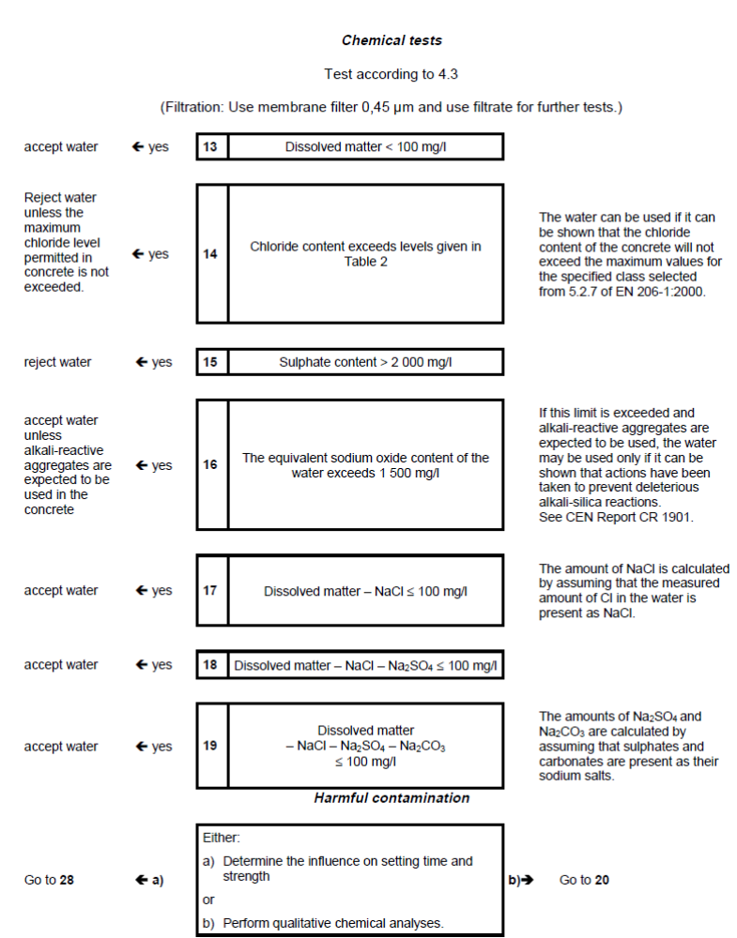

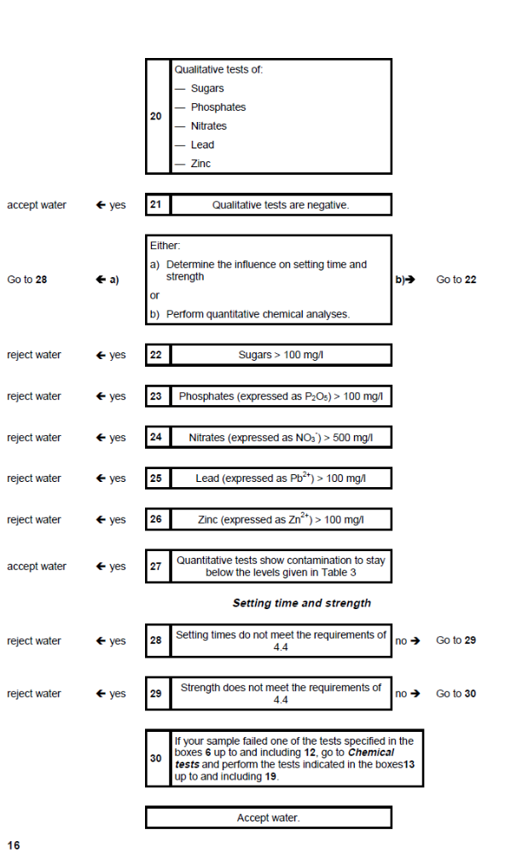

Annex C
(informative)
Recommended test methods
Where not mentioned in the test or in the reference standards in clause 2 the following test methods can be used:
