Guidelines for Sustainable Management and Harvesting of bamboo species

© KEBS 201 9 First Edition 2019

TECHNICAL COMMITTEE REPRESENTATION
The following organizations were represented on the Technical Committee:

1. Kenya Forest Service
2. Kenya Building Research Centre
3. Back To Basics(BTB)
4. Bamboo Trading Company
5. Alogo Enterprises
6. Kenya Forest Research Institute
7. Green Pot Enterprises Limited
8. International Network for Bamboo and Rattan(INBAR)
9. Kenya Bureau of Standards – secretariat

REVISION OF KENYA STANDARDS

In order to keep abreast of progress in industry, Kenya Standards shall be regularly reviewed. Suggestions for improvements to published standards, addressed to the Managing Director, Kenya Bureau of Standards, are welcome.

© Kenya Bureau of Standards, 2015
Copyright. Users are reminded that by virtue of Section 25 of the Copyright Act, Cap. 12 of 2001 of the Laws of Kenya, copyright subsists in all Kenya Standards and except as provided under Section 26 of this Act, no Kenya Standard produced by Kenya Bureau of Standards may be reproduced, stored in a retrieval system in any form or transmitted by any means without prior permission in writing from the Managing Director.

Guidelines for Sustainable Management and Harvesting of bamboo species

KENYA BUREAU OF STANDARDS (KEBS)

Head Office: P.O. Box 54974, Nairobi-00200, Tel.: (+254 020) 605490, 602350, Fax: (+254 020) 604031
E-Mail: info@kebs.org, Web:http://www.kebs.org

Coast Region Lake Region Rift Valley Region
P.O. Box 99376, Mombasa-80100 P.O. Box 2949, Kisumu-40100 P.O. Box 2138, Nakuru-20100
Tel.: (+254 041) 229563, 230939/40 Tel.: (+254 057) 23549, 22396 Tel.: (+254 051) 210553, 210555
Fax: (+254 041) 229448 Fax: (+254 057) 21814

Foreword

This Kenya Standard was prepared by the Bamboo and Rattan Technical Sub - Committee and under the guidance of the Standards Projects Committee, and it is in accordance with the procedures of the Bureau.
Bamboo is an important non-timber resource and a proven substitute for wood in the manufacture of industrial products for construction, paper, furniture, energy among other uses. In Kenya, the predominant indigenous bamboo species is the Oldeania alpina (Previously Yushania alpina). It is estimated to cover about 150,000 ha, located mainly at altitudes ranging from 2,400 to 3,400 meters above sea level in the Aberdares, Mt. Elgon, Mt. Kenya, Mau Complex and Cherangany. There is renewed interest in farmland bamboo
In this regard, utilisation of bamboo in natural forest areas and farmlands marks a turning point in the way bamboo resources require to be managed. It is for this reason that these guidelines have been developed to support sustainable management of bamboo.
In the preparation of this standard, reference was made to the following publications:
ARS/AES 03:2014 Forestry — Sustainability and eco-labelling— Requirements

The assistance derived from this source is hereby acknowledged

Guidelines for Sustainable Management and Harvesting of bamboo species

- Scope
This Standard provides requirements for the sustainable production, harvesting and processing of bamboo forest products. The standard can be applied to any defined forest area irrespective of scale or type of ownership, or whether natural forests or plantation. The relevance of particular clauses will therefore vary according to the circumstances of the site, particularly the size of the forest or bamboo stand, the scale of operation, and the objectives of the forest or bamboo stand owner.

The standard requirements encompass the entire bamboo forest environment, which may include open areas, water bodies such as rivers, lakes and ponds, and shrub species in addition to the bamboo themselves. They apply to the planning and management of forests within the wider landscape and land-use context, and to all Kenyan bamboo forest types and management systems, including the collective bamboo cover in urban areas. The scope does not extend to the management of orchards, ornamental bamboo and bamboo nurseries.

- Normative references

The following referenced documents are indispensable for the application of this document. For dated references, only the edition cited applies. For undated references, the latest edition of the referenced document (including any amendments) applies. Information on currently valid national and international standards can be obtained from the Kenya Bureau of Standards.

- Definitions
For the purposes of this standard, the definitions given in KS 2854 shall apply

- Species
The commonly available bamboo species in the country include: Bambusa bambos, B. nutans, B. tulda, B. vulgaris, B. vulgaris var. vittata, Cephalostachyum pergracile, Dendrocalamus asper, D. brandisii, D. hamiltonii, D. membranaceus,Giganteus, Bambusa multiplex, D. Yunnanesis, D.strictus, Oxytenanthera abyssinica and Thyrsostachys siamensis.

- Propagation
Growing bamboo starts with obtaining the materials for planting. Such materials may come in the form of seeds, wildings, offsets or cuttings that may be gathered from forests. Tissue-cultured plantlets provide other forms of planting materials. Such planting materials can be obtained and raised in the nursery as described below
  - Propagation by Seed
Bamboos generate seeds when they flower. For many tropical bamboos, flowering intervals range from 40 to 80 years. There are two types of flowering in bamboos, gregarious flowering and sporadic flowering. When gregarious flowering occurs, the clumps of an entire species flower, produce seed, and then die. Although large quantities of seed are produced during gregarious flowering, they are viable only for a short period, sometimes only for a few days or months. Sporadic flowering occurs in many species, including Yushania alpina, Dendrocalamus giganteus, Dendrocalamus strictus, Dendrocalamus hamiltonii, Bambusa tulda, and Guaduaangustifolia, among many others. In this type of flowering, seeds are produced but the clumps generally survive. What triggers the flowering of bamboo is not yet scientifically understood and the onset of flowering is therefore not predictable.

Because of the long flowering intervals of bamboo, seeds are very seldom available and not always a viable method for large scale propagation. If seeds of a certain bamboo species become available, it is highly advisable to buy only from reputable vendors or specialized organizations that can guarantee the provenance and viability of the seeds.

Once a bamboo stand or clump has flowered, seeds can be collected within the flowering period and seedlings raised as outlined below:
- Because of poor viability of seed, it is more desirable to collect and sow the seed without delay.
- Sow seeds in the nursery bed or in polyethylene containers. Cover with a thin layer of soil and water daily. Watering should be done carefully using a fine rose can.
- When germinated, seedlings should attain a height of 3 cm before they are carefully transplanted into soil filled boxes or polyethylene tubes.
- After 8-12 months, good-sized transplants can be obtained. It has however been observed with some species that seedlings over one-year-old establish better. Where-rhizomes of seedlings have not developed well due to inadequate supply of water or soil nutrients, such seedlings may be maintained in the nursery for over one year.

  - Use of Wildings
Apart from raised seedlings, wildings of bamboo from indigenous forest stands can be collected and used for raising a bamboo plantation. There are a few places in the cold areas of Mt. Elgon, Mau and Aberdare ranges where wildings of Yushania alpina have been found.

Young clusters of bamboo wildings can be scooped using a spade and taken to the nursery for individual pricking into polyethylene tubes. Care should be taken to avoid disturbing intact small wildings which resemble a mass of grass in the field. Small wildings of bamboo that are pricked into tubes and kept under shade generally establish well. This method can raise many seedlings. Once in the nursery and under shade, watering can be done regularly using a fine rose-can. Direct planting of large bamboo wildings has not been practised in Kenya. Most likely establishment would be poor due to disturbance of the rooting system during the uprooting from the forest.

  - Vegetative Propagation
When seeds or wildings are not available, bamboos can be propagated vegetatively. This offers a better source of planting material. Offsets (rhizome with attached section of stem) are commonly used but their extraction is laborious and time consuming, and it is difficult to collect large quantities of planting materials. During extraction, damage may also occur to the roots, buds and rhizomes of mother clumps. Offsets are bulky and also difficult to transport. Only small annual planting programmes may therefore be possible when using offset materials.
Use of culm cuttings is a viable alternative and has several advantages. Multiplication of several clumping species is possible by this method. When outplanted, vegetative materials raised from cuttings develop to clumps much faster than offsets and even seedlings. The local species of bamboo, Yushania alpina and Oxytenanthera abyssinica, have however proved difficult to propagate in this manner. Bamboos with leptomorph rhizomes cannot be propagated by means of culm cuttings. Success rate is however very high by means of offsets.
  - Using Culm Cuttings
- Good cuttings are obtained from 2 to 3 years old culms of healthy clumps.
- Double node or triple node cuttings are then prepared from the cut culms. The cuttings should be made leaving a space of 5-7 cm away from the nodes. A sharp cutting knife or panga is necessary. For bamboos with thin walls the use of a saw is recommended to avoid splitting of the cut ends.
- The best culm cuttings are generally those that are obtained from the lower and thicker part of the culm, which has the vigour to generate roots and shoots.
- Successful rooting and shooting is generally harder to achieve with cuttings from the upper and thinner part of the culm.
- It is essential that the cuttings have either buds on the culm nodes or buds on the culm branches. All branches and leaves of the cutting should be cut off down to the first or second branch node.
- The cuttings should then be buried 6 – 10 cm horizontally on a raised nursery bed prepared with a light soil and sand mixture. For some species, there is a higher rate of success when a section of the branch with a bud is left emerging vertically from the ground. Buds at the nodes or branches should always be placed on the sideways or facing upwards and never downwards. Under warm or hot propagation conditions, buds facing downwards will normally not grow.
  - Using Offsets
At the onset of the rainy season and just before the emergence of new shoots, offsets can be obtained from bamboo stands as outlined below:
- Dig out about 30-60 cm below ground for a rhizome of one to two years old culm (for the indigenous bamboo). This can be recognized by the dark green colour and smooth downy stems.
- Once a rhizome is exposed, cut back the aerial culm to 60 cm in length and cut the rhizome off from the parent clump. Avoid injuring the junction of the culm and rhizome and the underground dormant buds at the base of-the culm (Figure 12).
- Extracted offsets should be transported to the planting site without any delay (preferably the same day or the next) and planted immediately.

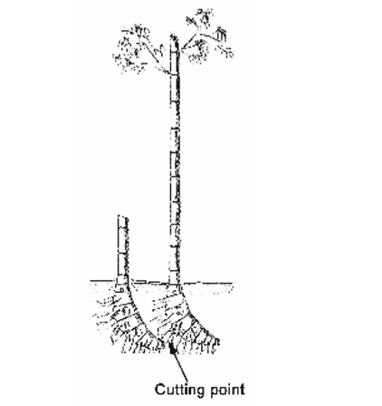
Figure 12: Point of separation of offset

  - Using Tissue Cultured Plantlets
Tissue culture (TC) is an essential method of propagating certain plant species on a large scale. Commercial TC production is done in laboratories that need to produce and sell mass quantities of plants in order to be economically viable. TC has been successfully employed in mass production of desirable species of sugarcane, banana, citrus, potato, pyrethrum and flowers in Kenya. TC can greatly enhance the production of species that are difficult to propagate by other methods. Presently, only a few commercial tissue culture labs around the world produce bamboos. A very important step prior to TC is the selection of elite mother plants with desired characteristics. When bamboos are micro propagated from the tissue of a mature plant, the result will be a clone of the mother plant. On the other hand, when seeds or the tissue of young plants are used as propagules, the properties of the resultant clones will not be predictable. TC bamboo plantlets are small and generally more vigorous than bamboos propagated by more traditional methods. They can be grown to a size of up to 50 cm and planted into the field. Alternatively, they can be further subdivided by means of rhizome division. Mass propagation of small tissue culture plants is easily achieved and much less labour intensive than propagating large cuttings. Each TC plant can be multiplied into 4 to 6 plants within a year. This allows for a rapid development of nursery stocks. When effective nursery management techniques are applied, an investment of, for example, 10,000 young TC plants supplied in the form of rooted plugs can be easily multiplied by division of small plants to produce 40,000 to 60,000 planting materials in one year. Bamboo produced by TC may be widely used to develop large scale industrial plantations for timber, biomass, or pulp and paper. Cloning bamboo plants with superior traits opens opportunities for achieving a better quality crop, either in culms or in high quality edible shoots. It is important that farmers be on the lookout for the development of this technique locally.
- Silviculture of Bamboo
Bamboo silviculture is a scientific discipline and methodology on bamboo afforestation and management, which comprises of the theories and techniques for planting, regulating the composition of bamboo stands and managing soil so as to develop bamboo stands thereby achieving economic and ecological benefits.
  - Planting procedures
    - Planting procedure for nursery plants
The following guidelines are suggested to aid the establishment of a productive plantation.
- In selecting the plantation site, check the quality of the soil. Bamboo can grow well on most soil, but deep porous fertile soil with high moisture content and a pH of 5.5 is preferable.
- Good soil drainage is very important. Verify that the land is not prone to flooding. Bamboo does not perform well on waterlogged soils. It is therefore preferable for the plantation to be situated on moderate slopes.
- Clear the land of all weeds and unwanted vegetation. Burning may be necessary during the dry season.
- Carefully plan the layout of plantation so that the planting holes are placed at the specified distances and intervals as per table 1.
- Plan the activities so that the plantation layout is completed at least 2 weeks before planting.
- The planting holes should be positioned in a north-south orientation. This will provide an optimal distribution of sunlight to all the plants.
- Planting holes with a diameter of 1m and a depth of 60cm should be dug and evenly spaced out according table 1
- Planting should coincide with the start of the rainy season. If available, organic fertilizer or manure should be placed into each hole and mixed with topsoil. The plants should be planted vertically in an erect position and the hole should be properly covered and mulched.
    - Direct planting of offset cuttings
Direct planting of offsets of Y. alpina in the plantation may be done in small plots or homestead farms. Planting should be conducted at the beginning of the rainy season. The selection and preparation of offset cuttings for direct planting follows the same procedure as that of planting stock for nursery-raised cuttings except that cuttings are directly planted in the field pits without potting.
The procedure for direct planting is as follows:
• Haul the offset cuttings to the planting site.
• Loosen the soil in previously prepared planting pits/holes.
• Place the cuttings in the hole in a vertical position. The lowest node of the culm offset should be above the ground.
- Position the cutting at the center of the planting hole and fill up the pit with soil, ensuring that the culm stands firmly in place.
• Water the soil thoroughly and mulch around the planting hole.

Table 1: Plant Spacing and Plants per Hectare
Spacing (m) | Plants per Hectare | Bamboo diameter | Examples of Species
4 X 4 M | 625 | Small diameter bamboo(< 6 cm diameter at DBH) | Oxytenanthera abyssinica, Dendrocalamus strictus
5 X 5 M | 400 | Medium diameter (6-10 cm) | Yushania alpina, Bambusa vulgaris, Dendrocalamus hamiltonii, Dendrocalamus membranaceus
7 X 7 M | 200 | Large diameter (> 10 cm) | Dendrocalamus giganteus, Dendrocalamus asper, Dendrocalamus latiflorus,
    - Replanting
Not all transplanted seedlings and cuttings will survive the new environment. The plantation should therefore be visited regularly to check on the survival of plants. Dead seedlings and cuttings should be replaced. Replanting should be done immediately at the start of the rainy season
    - Intercropping
During the first two years from the time of planting the bamboo, intercropping of cash crops and vegetables may be done between the rows of bamboo. Intercropping serves several purposes. Vegetables provide a source of income to farmers. When cultivated between rows of newly planted bamboo, vegetable crops provide greater stability to the soil and help control erosion. Intercropping also creates an incentive for farmers to control weeds and pests in the plantation. In order to care for their vegetables, farmers will be involved with maintenance activities that are favorable to the growth of the bamboo plants.
When the bamboo canopy has developed, sunlight will be fully absorbed and the cultivation of vegetables will no longer be viable. During the third year after planting the bamboo, leguminous species may be planted to serve as ground cover in between the lines of bamboo.
  - Weeding
Weeds compete with bamboo plants by absorbing nutrients, water, and sunlight. Weeds have rhizomes which sprout again if not removed. Measures to control weeds include a thorough preparation of the soil before sowing and the use of sowing media and manure which are free of weed seeds. The removal of weeds growing within the vicinity is also strongly advised in order to lower the occurrence of seed dispersal by wind or water.
The following are recommended practices in weeding:
• Weeding should be done thoroughly, systematically and regularly.
• When removing weeds from soil, no portion of the root system should be left behind.
• Weeding should be done only when the soil is moist.
• Weeds that have been removed should be properly disposed off in a rubbish heap.
• Wherever practical and convenient, mechanical weeding tools may be used.
Weeding of other vegetative growth including weeds, climbers and shrubs should be done one to two months before the active rains.
All dead and dry culms should be removed. All broken, live stems, less than 2.5m in length should be removed except in clumps containing less than 10 culms. In the latter case, even shorter broken culms may be retained for support of new culms;
  - Soil loosening and sun Basking:
Soil loosening is done loosening up to top 20 cm of soil to improve soil ventilation. There is need for soil loosening of the compacted soil using hand tools such as mattock, pick axe, grab hoe and mounding the soil around the culm base and cover exposed rhizome parts;
1-2 months before active rainfall season, remove the soil cover (dig up soil cover starting from outside to clump center). Expose the bamboo rhizome and shoot buds to sunlight. Remove messy roots around shoot buds and expose the shoot buds / eyes to direct sunlight and wind. This promotes burgeoning of shoot buds resulting in early sprouting and increase in number of shoots.
  - Mulching
Mulching is a proven way of improving the growth of bamboo. In drier areas, with rainfall less than 1000 mm, mulching around plants greatly encourages growth through reduced evaporation of soil water. Mulching is achieved by uniformly spreading a layer of leaf litter or other organic material on the surface of the soil around the bamboo clump. Mulching is an effective way of preventing weed growth. It helps conserve soil moisture and contributes organic nutrients to the plant.
Mulching is absolutely necessary for the production of good quality bamboo shoots. The mulch protects young shoots from direct sunlight and keeps them moist, thus allowing them to grow to an optimal size without hardening and losing their edible quality.
  - Age-Marking System (especially for on-farm bamboo):
Bamboos lack the vascular cambium layer and thus lack secondary growth in diameter as in trees. Under field conditions, it is not always easy to distinguish the age of a bamboo culm, since culms in a mature clump tend to have the same girth, length and nodal structure.
The culm age can be identified based on certain features of the culm sheath, development of branches and leaves, external colour of the culm, position of new culms, etc. For example, in sympodial bamboos, younger/current year culms are usually on the outer side, while older culms are toward the inner side. Culm sheaths are usually absent on older culms. The accuracy of such a distinction is, however, dependent on the skill and experience of the person and is not always reliable.
Therefore, other guaranteed methods have to be adopted to determine the age of bamboo. Age can also be determined by marking the culms (a) with different colour paints, (b) writing year and month of shoot emergence using colour/paint and (c) inscribing the year of shoot emergence. Alternately, other innovative approaches can be adopted too.
- Different colour paints: Three different colour paints are required, one for each year of a three-year cycle. Culms that are older than 3-4 years should be harvested, as they become weak and brittle and can be expected to die. After the culms attain full height during the first year, they are marked with paint. A scheme for identifying culm age are shown in the below table for illustration. Please note, this is mostly suitable for on-farm bamboo plantation as well as intensely managed forest plantation.

Colour scheme for identifying the age of culms
Colour | Age (year) | Rotation-2
Red | Current: 0-1 years (2018) | Current: 0-1 years (2021)
Yellow | 1-2 years (2019) | 1 – 2 years (2022)
Blue | 2-3 years (2020) | 2 – 3 years (2023)
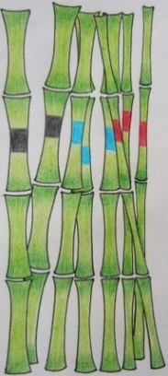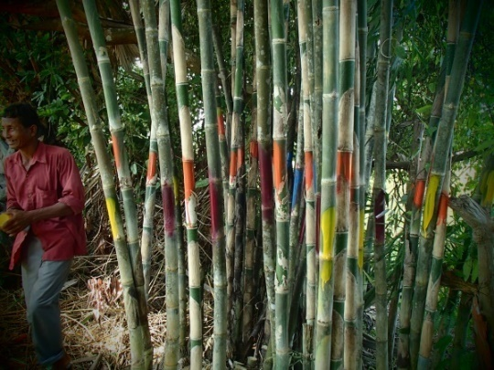
Different colours /year marking used for identifying culm ages
- Writing year and month of shoot emergence: Using single colour paint (black), write the year and month of shoot emergence. This method is widely adopted in China.
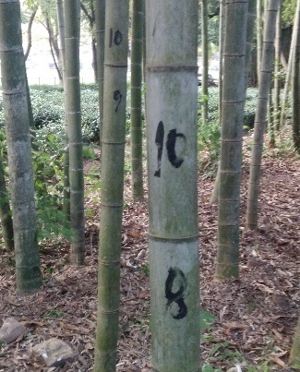
Year and month marking to identify culm age
Please note: Marking should be done after the culm attains its full height, that is, after it has stopped growing. The indication of the stoppage of further dimensional growth (length) is when branches begin to appear, normally first in the upper portion of the culm.
- Detach the culm sheath from the culm before beginning to paint.
- Mark the different-aged culms with the thick paint by making a two to three-inch band at breast height in the inter-nodal portion of the culm, taking care that paint should not drip down the culm.
- Use different colours (as given in Table /Figure) for marking different ages.
For sustainable management of bamboo culms and to ensure bamboo poles of the right age are supplied to industries, it is important to adopt age marking. Instead of paints, scratches on the culm skin or indelible writing can also be done.
  - Clump management
The proper maintenance of the clump not only improves productivity but also eases the job of the plantation worker. Clump management is partly a maintenance task and partly a result of harvesting. As a maintenance activity, it involves removing unwanted culms to prevent clump congestion. This is particularly necessary with densely tufted species such as Y. alpina.
About 90% of new culms emerge in the outer borders of the clump. New shoots and culms cause the clump to widen in diameter. Culms at the periphery of the clump are generally new or young, while older culms stand towards the interior of the clump. Understanding this is important for maintaining a bamboo clump such that its productivity and vigor is maximized.
In maintaining a bamboo clump, it is necessary to extract the oldest culms in the interior of the clump. This is facilitated by creating an opening in the clump and shaping the clump in the form of a horseshoe or “C shape”.
Unless properly managed, clumping bamboos tend to get congested resulting in deterioration both in quality and quantity. It is difficult to extract culms from congested clumps. Preventing clump congestion is important so that harvesting can be done with greater ease. Thinning the clump is essential to provide space for the emergence of new shoots. It is sometimes necessary to sacrifice a few young culms in order to allow for better shoot production in the clump.
Removal of old and rotting culms is also necessary to promote the healthy growth of shoots and new culms. Special attention should be placed on rotting in the stumps of culms that have been harvested. If rotting becomes apparent, it is advisable to dig around the stub and completely remove it. Likewise rotting culms should be extracted. Symptoms of disease or fungal infections should be noted and a plant pathologist should be advised for possible remedies and control measures.
In case of sporadic or gregarious flowering, all flowered clumps which have shed their seeds should be harvested;
  - Pest and animal control
The presence of pests and grazing animals should be thoroughly controlled. Most bamboo species are palatable to animals, especially in dry grazing. It may be necessary to carry out protection against goats and antelopes by partial or total fencing of the plantation. Every available means should be taken to prevent animals from grazing in the plantation. In small homesteads, fencing is a solution, but for a large plantation, it is costly.
Careful supervision in this regard is therefore crucial. It is necessary to patrol the plantation, check for damage, seek the cause, and find suitable means to eliminate the problem.
  - Rules for Managing New shoots
- Always retain the shoots from the last and deepest bud as they are the strongest
- Keep the earliest shoots, the ones that shoot at the onset of the rains. Don’t keep the shoots that generate during the end of the rains as they will take away the essential food from the clump and will still not grow to their full height.
- Keep the thick shoots and destroy the tin ones
- Remove shoots when they are still small; about a few days old. This is before they take the sugars that are much needed for the new shooting culms to attain greater diameter and greater height
  - Fallen and dead bamboo
Culms that have already undergone flowering are poor in their mechanical properties and pulping quality. They should be taken out as they pose as a great danger (fire hazard) and serve as a hiding place for pests in the forest due to their sugar content.
In order to achieve a variety of management objectives including stand hygiene, fallen and dead bamboo materials on the ground within the natural stands will be reduced. These objectives include;
(i) Creating space for the growth of young culms;
(ii) Improving the health of the natural bamboo stands; and
(iii) Reducing the level of accumulated fallen combustible materials thus reducing the level of fire hazards;
These fallen and dead bamboo materials maybe used for the manufacture of products for energy purposes. Integrated harvesting of dead bamboo separate dead and fallen from the mature.
- Bamboo harvesting
  - Harvesting mature bamboo culms
Ideally only healthy and mature culms should be selected for harvesting. Good products cannot be made from diseased and rotten culms. Bamboo poles with splits or cracks, crooked, diseases or presenting insect infestation (small holes) are not suitable as construction material. One-year old culms generally should never be harvested unless in cases where they are curved and twining around other culms or are infested by disease or insects;
In an unmanaged forest stand, selection for harvesting will be based on the colour of the culms, since the colour changes as the culms mature, and other characteristics of mature bamboo outlined in Table 2 and diagram 1. In a managed stand where the culms are already colour coded as per clause 6.5, harvesting is done depending on the use.

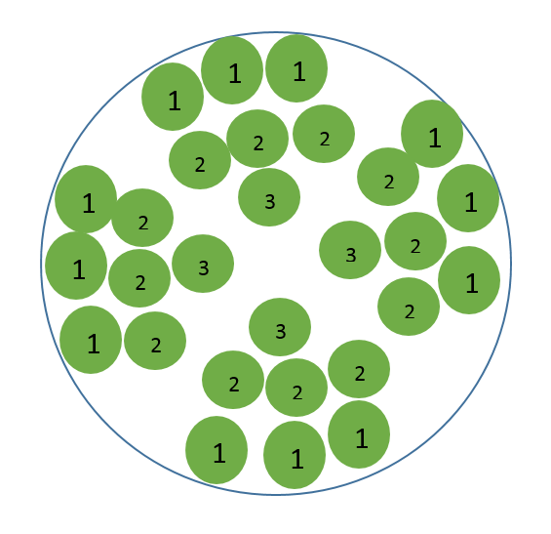
Fig 1: typical culm distribution in the clump by age

Uniformity is the basis for industrialization of bamboo, therefore bamboo with similar chemical components and ph1ysical features should be processed together in order to get uniformity.
After the forest is rehabilitated, probably within 3 to 4 years, a rational harvesting intensity that maintains sustainable yield and productivity of the stand should be in place as follows;
• Harvesting 75% of mature culms i.e. culms of age three and more is found to be optimum intensity;
• Retaining old culms that are meant to stabilize productivity should be limited to a small fraction (25% of the excising mature culms);
• One to two-year-old culms are required to maintain productivity for bamboo stands hence must not be harvested while older culms could be harvested in a certain ratio;
• Fill up extraction methods, firebreaks and roads,
• Adhere to safety guidelines
Culms should be hauled to an area where they are sorted and air-dried. Good practices to enable drying will help minimize losses due to biodegradation of the culms. The large culms should be stacked horizontally on parapets where there is good air circulation. Smaller culms may be piled horizontally at a 60° angle to form a “tepee shape” or a frame allowing air to circulate around them to aid the drying process
Bamboo possesses large amounts of sugars when actively growing. During rainy seasons, starch content is lower as new shoots are consuming all the nutrients. The sugar content also varies with age. It is lowest during the first year and highest between years 1-3
Table 2: bamboo age and role
Culm Age | Function and Condition | State
1 Year Old | - Has active nodes and is responsible for regeneration | - Mother
2 Years Old | - It also has active nodes and therefore responsible for regeneration of new shoots  - It feeds the new shoots through the starches stored up in the culm | - Old
3 Years Old | - Slight support for the remaining bamboo  - Has strong fibre. Its strongest at this age  - Chemical composition is best at this age  - Cannot contribute to regeneration | - Very Old
4 Years Old | - I weak and starts deteriorating in quality  - Can be used for low end industrial products | - Degrading
Table 3 characteristics of bamboo by age
Young Culms ( 1 and 2 Year) | Older Culms (3 and 4 Year)
Have less fibre | Have a lot of fibre
Have weaker fibre bundles | Have strong fibre bundles
Have more starch | Have little starch
Have high moisture content | Have low moisture content
Have less strength | Are very strong

  - Culm distribution
Bamboo gradually changes from the outside, which allows us to recognize four very defined states namely: (i) shoots (ii) young culms; (iii) mature culms; and (iv) old culms.
New culms are commonly produced on the periphery of the clump (young culms / rhizomes are the ones which produce new shoots (1-2 years old)). So, the tendency of the bamboo collectors, harvesters are to harvest the bamboo poles on the outside periphery of bamboo clump, which is young and immature affecting the sustainability of the clump as well as the durability of the bamboo products / poles used are low.
Mature bamboo poles in sympodial bamboo clumps are commonly found on the inner core of the bamboo clump.
In the case of sympodial bamboo with long rhizome neck such as Yushania alpina, penetrating inside the clump and harvesting mature bamboo poles are relatively easier due to its sparse nature of growth.
In the case of unmanaged sympodial bamboo with short neck rhizome (genus such as Bambusa, Oxytenanthera, Dendrocalamus, Cephalostachyum and others) bamboo clump is congested prohibiting the entry into the clump.
Evenness of culms distribution according to age – Bamboo culms of different ages have different functions that ensure that the whole clump is healthy and has optimal productivity.
An even equal number of year 1 and 2 culms should be kept in order to sustain the regeneration. A few year 3 culms should be left just to act as support for the clump
Older culms should still be harvested, but at a reduced intensity of 30%, as this stimulates production of new shoots within the clump. The number of older culms retained should not be less than the number of current year's culms.
  - Harvesting Method
Two techniques managing congested or clustered bamboo are commonly practiced. They are (a) Tunnel Technique and (b) Horse-Shoe Technique.
    - Tunnel technique
Make 60 cm wide path one end to other end of the clump. Make sure the tunnel created passes through the central part of the clump. As most of the mature bamboo poles are in the center of the clump, tunnel is created so that one can enter the enter, harvest and drag the bamboo poles.
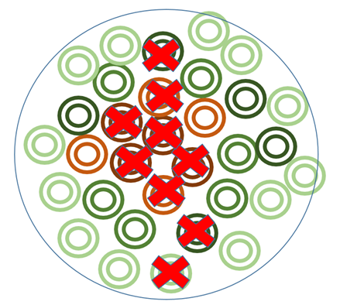

Fig 2 Illustration of bamboo clump showing bamboo culms to cut to create a tunnel

Fig 3 Illustration of a bamboo clump with a tunnel

    - Horse shoe technique
Make 60 -100 cm wide path from the periphery or outside of bamboo till the center of the clump. Select the location or side of the clump where there is minimum number of young bamboo poles, to avoid cutting of young poles.
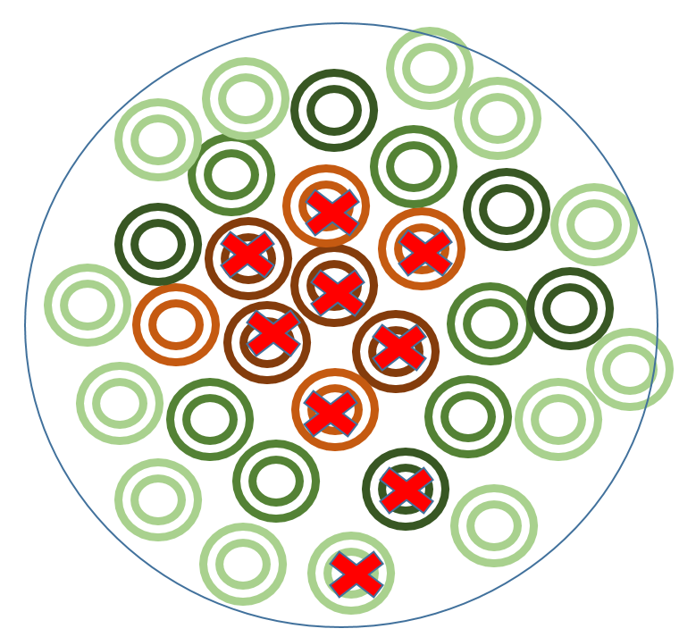
Fig 4 Illustration of bamboo clump showing bamboo culms to cut to create a horse-shoe opening


Fig 5 Illustration of a bamboo clump
Year after year, the size of the tunnel and Horse-Shoe will expand and with right culm density, harvesting operation will be easier and cost effective.
  - Felling / Cutting Method:
Cut the culms in a slanting matter (45 Degree) just above the lower most node (~ 10 -15 cm) to minimise wastage, avoid sprouting and at the same time rainwater will not stagnate in cavity of stump portion. This way, there is no receptacle in which rainwater can collect. Stagnant rainwater in the culm may cause rot and could weaken the bamboo plant system;
Avoid damage or exposure of the rhizome while harvesting. This could cause serious damage and affect the future health of the bamboo clump. Rhizomes should not be dug out;
When felling is done far above the ground, buds on the nodes of cut stump will get activated and produce branches and create bushy clumps hindering future harvesting and management operations.
Harvesting should be selective; only mature culms should be harvested using very sharp tools. It is advised to disinfect the harvesting tools to lower the risk of infection in plants. Overharvesting of clumps should be avoided and 1 to 2-year-old culms should not be harvested. A few 3-year-old culms should also be left standing so that the clump remains robust and the harvesting can be performed annually. Following this method, culms should be left standing on the clump until they mature, after which, they may be harvested.
No clear-felling. Clear felling of clumps will lead to their degeneration into a bushy form, resulting in a gap of 5 – 6 years before new extractable culms are produced. Hence, this should be avoided as far as possible;
  - Compartmentalization of highland forest bamboo stands
Bamboo stands in their natural forests sometimes occur in formations that continuously extend to several thousand hectares. To manage these stands it is paramount to subdivide the bamboo growing areas in a forest station and into progressively small areas of blocks, compartments and sub-compartments. A block will comprise several compartments while a compartment will subsequently have many sub-compartments. This subdivision will guide in the planning of silvicultural treatments and the access to the sub-compartments for harvesting operations and fire management. This requires opening of new roads and firebreaks in the bamboo zone which will also be planned to form the boundaries of the blocks, compartments and sub-compartments where suitable. The alignment of the roads and firebreaks will follow the Kenya Forest Service Technical Notes and Technical orders.
The sizes for each management unit are proposed as follows due to the nature of bamboo stands in a locality and the wide variability between localities.
 | Name | Max. Area (Ha) | Min. Area (Ha)
 | Station | Current area applies
 | Block | 500 | 200
 | Compartment | 250 | 100
 | Sub-compartment | 40 | 10
  - Cutting rules for quality culms
Sugar content in almost all plants varies with seasons. Dry season is the period of dormancy. During this period, the bamboo plant is acquiring and conserving nutrients for shoot growth in the next rainy season. Thus, starch content is at its highest level at the end of dry season. Therefore, harvesting bamboo at the end of a dry season increases the chances of borer and fungal attack.
During the rainy season, starch content is lower (since new shoots are consuming all the nutrients) but moisture content in the bamboo culms is high, which increases the possibility of subsequent splitting and cracking after harvest. This is also the period when new shoots emerge and felling operations could damage or destroy the shoots. In other words the most recommended time to harvest bamboo is at the end of rainy season - beginning of the dry season. One month before shooting and one month before dry period.
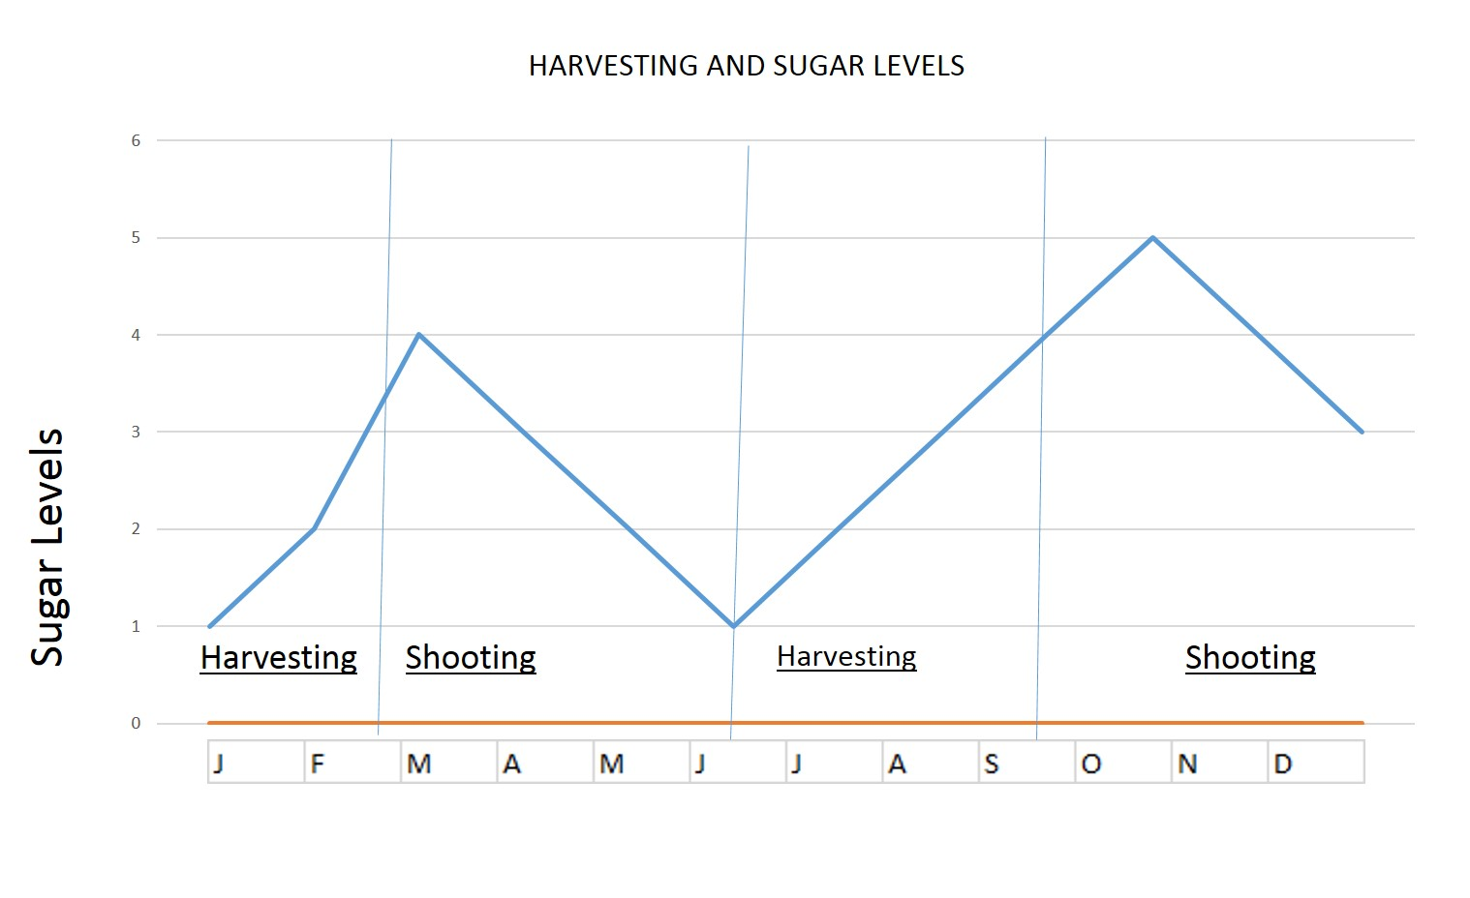
Fig t an illustration of harvesting/shooting seasons vs sugar levels

Bamboo culms should not dragged along the ground as this will cause damage to the outer layer which results in stains and blemishes. In addition, bamboo culms should not be thrown on hard ground as this may stress the culms which can induce cracks along the length of the culm.
The bamboo culm should also be cut on the first internode, approximately 15 cm from the ground. This will ensure that the cut area decays quickly and creates room for more regeneration
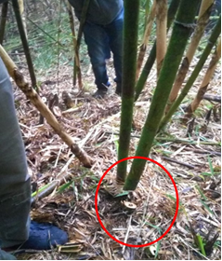
Correct harvesting
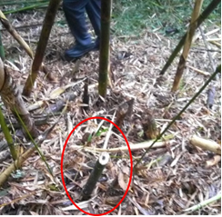
Incorrect harvesting

- Regeneration of flowered bamboo areas
It is desirable that once unambiguous indications of sporadic flowering are seen or when gregarious flowering is anticipated (as in cases where the flowering cycle is known with certainty), bamboo clumps can be harvested on a large scale for utilization but leaving at least one third (30%) of the clumps undisturbed to serve as source of seeds for repopulating the area in the next few years.
Measures should be taken for collection of sufficient seeds since there is always a surplus of seedling population of which only a proportion survive when left to nature. The seedlings form a source of propagules of known age carries an assurance of the number of years left to the next flowering.
After the setting in of seeding, the dead bamboo culms should be removed as quickly as possible. If serious seeding sets in, a carpet of green seedlings can be seen in flowered areas after the onset of rains. The area should be protected from fire and grazing to ensure proper survival and growth. The seeded clumps may be clear felled and removed only after the seeds have been collected for future use.
Raising seedlings in a separate nursery can provide insurance against accidental damage to regeneration that may be caused by fires that such areas are susceptible to.
- Conservation in Bamboo forests
Bamboo Forest management activities shall maintain and enhance the high conservation values in the forest, applying precautionary approach in decision making.
Bamboo forest can provide forest owners, local communities with environmental, economic, social, and cultural benefits.
The bamboo forest owner, through engagement with interested and affected stakeholders shall look out for the occurrence of the following areas:
(a) Areas that are habitat of migratory species.
(b) Areas having bamboo forest types or ecosystems and bamboo species which are rare, depleted or under-represented in the regional conservation reserve system.
(c) Areas containing globally, regionally or nationally significant concentrations of biodiversity values.
(d) Globally, regionally or nationally significant large landscape-level areas where viable populations of most if not all naturally occurring species exist in natural patterns of distribution and abundance.
(e) Areas that are in or contain rare, threatened or endangered ecosystem
(f) Areas that provide basic ecosystem services in critical situations (e.g. watershed protection, erosion control).
(g) Areas fundamental to meeting basic needs of local communities (e.g. subsistence, health).
(h) Areas critical to local communities’ traditional cultural identity (areas of cultural, ecological, economic or religious significance identified in cooperation with such local communities).
(i) Natural Heritage Places
(j) Steep areas (more than 60% gradient);
- Post-Harvest Treatment
  - Drying and seasoning
Drying culms is common in the processing of bamboo culm for most uses. Culms are also subjected to seasoning prior to machining, processing, and finishing products that are durable, stable and of a high quality.
Bamboo culms can be air-dried with or without sunlight or they may be kiln-dried. Air-drying is more common that kiln drying since it is more economical. Bamboo culms may be split into halves to speed up drying operations.
Bamboo culms may be thoroughly air-dried in well-ventilated shade for several weeks. Drying can be done by letting the culms stand in a covered area with good air circulation
  - Bamboo preservation
Bamboo culms are vulnerable to decay and attack by fungi or insects, especially powder post beetles. Such attacks reduce the natural durability of bamboo and diminish its value and utility.
Post-harvest treatments can help to reduce the risk of decay and attack by pests and thereby increase the useful life and value of bamboo culms.
Depending on the end use of the culm, several methods of preservation may be applied to culms prior to their sale or industrial utilization. For preservation of bamboo for structural use refer to KS 2856 and for non-structural refers to KS 2855

Annex 1
Informative
Equipment for harvesting bamboo

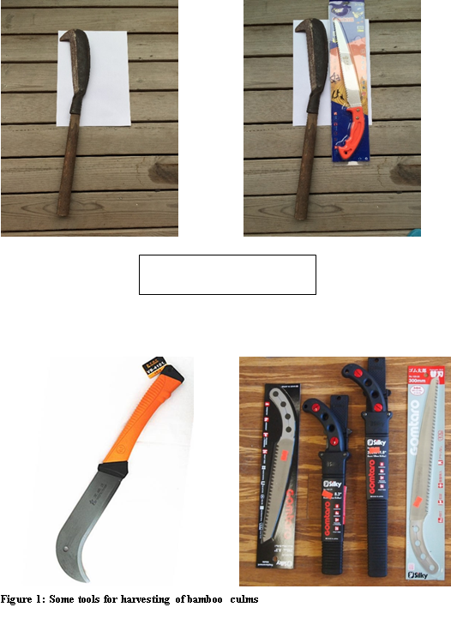

Annex 2
Informative
Age characteristic
 | AGE OF BAMBOO (YEARS)
Diagnostic feature | <1 year | 1-2 years | >2years | Mature 4-7 yrs | Over age
Internodes color | Light green | Gets yellowish or darker | Clear yellow or shiny green, | Dusty grey and dark green | Completely white or weathered
Internode cover | Covered with white flour | Powderly substance is falling off | No flour left | Small circles/specs of white fungi | Excessive amount of fungi and moss
Internode epiphytes | No internode epiphytes | Has lichen and epiphytes | Has lichen and epiphytes
Culm sheaths | All or part of the culm sheath kept | Begin to fall off  Until none are left | No culm sheath remaining
Sheath ring | Whole sheath ring or part of it kept | Remaining sheath  Ring gets harder | No culm sheath ring, it falls off, white band at knot | Hardly perceptible grey bands on the knot ring
Branches | Light colored, not tough;  no secondary branches | Existing branches  Feel soft, turning  To yellow-green or  Dark after wards | Has secondary branches
Foliage |  |  |  | Less green and shiny than younger bamboo

