ICS

Sports balls - Netballs — Specification

© KEBS 2018 First Edition 2018

TECHNICAL COMMITTEE REPRESENTATION

The following organizations were represented on the Technical Committee:

Kenya Industrial Research and Development Institute (KIRDI)

Government Chemist

Kenya Association of Leather Technologists and Scientists

Bata Shoe Company, PLC

Umoja Rubber Products limited.

Ministry of Industry, Trade and Cooperative

Environmental Institute of Kenya

Pelinks Company

Kenya Bureau of Standards — Secretariat

REVISION OF KENYA STANDARDS

In order to keep abreast of progress in industry, Kenya Standards shall be regularly reviewed. Suggestions for improvements to published standards, addressed to the Managing Director, Kenya Bureau of Standards, are welcome.

© Kenya Bureau of Standards, 2015

Copyright. Users are reminded that by virtue of Section 25 of the Copyright Act, Cap. 12 of 2001 of the Laws of Kenya, copyright subsists in all Kenya Standards and except as provided under Section 26 of this Act, no Kenya Standard produced by Kenya Bureau of Standards may be reproduced, stored in a retrieval system in any form or transmitted by any means without prior permission in writing from the Managing Director.
ICS 61.060

Sports balls - Netballs —Specification

KENYA BUREAU OF STANDARDS (KEBS)
Head Office: P.O. Box 54974, Nairobi-00200, Tel.: (+254 020) 605490, 602350, Fax: (+254 020) 604031
E-mail: info@kebs.org, Web:http://www.kebs.org

Coast Region Lake Region Rift Valley Region
P.O. Box 99376, Mombasa-80100 P.O. Box 2949, Kisumu-40100 P.O. Box 2138, Nakuru-20100
Tel.: (+254 041) 229563, 230939/40 Tel.: (+254 057) 23549, 22396 Tel.: (+254 051) 210553, 210555
Fax: (+254 041) 229448 Fax: (+254 057) 21814
Foreword

This Kenya Standard was prepared by the Technical Committee on Leather and Leather Products under the guidance of the Standards Projects Committee, and it is in accordance with the procedures of the Kenya Bureau of Standards.
This standard covers the physical requirements and leaves out all other aspects, including design. Netballs balls shall be manufactured in such a way so as to maintain their form throughout the match for consistent and predictability of their performance. They shall not be easily distorted during the match.

IS 417 Indian standards - footballs, volleyballs, basketballs, netballs, throw balls and water-polo balls—
Specification. Part 4: Netballs
KS 2777 Kenya Standard Sports balls - Volley balls

IS 4207 Indian Standard – Specifications for Leather for Football

The assistance derived from these sources is hereby acknowledged

Sports balls - Netballs —Specification

1 Scope

This Kenya Standard specifies the requirements, methods of sampling and testing for Netballs.
The standard applies to Netballs of all constructions, all types and all designs.

2 Normative references

The following referenced documents are indispensable for the application of this document. For dated references, only the edition cited applies. For undated references, the latest edition of the referenced document (including any amendments) applies.

KS 01-678, Methods of sampling and testing of leather Part 2: Chemical testing

KS 08-1038, Physical methods of test for non-woven fabrics Part 4: Tear resistance

KS ISO 2589, Leather — Test measurement of thickness

KS ISO 11644, Leather — Determination of adhesion to finish

3 Definitions

For the purposes of this standard, the following definitions shall apply:

3.1
pu coated leather
leather with a coating of polyurethane.

3.2
pvc coated textiles
textiles with a coating of polyvinylchloride.

3.3
synthetic materials
materials made of PU, PVC and other synthetic materials which are used as natural leather substitute

4 Requirements

4.1 General requirements

The method of construction shall follow the principle applicable for that type of ball. The pressure of the netball
shall be as appropriate for netballs as per the requirements of this standard. The netballs shall be manufactured
so as to meet the set specification of this standard.

4.2 Material requirements

The outer part of netball balls shall be made of stitched leather, stitched synthetic material, moulded material, rubber or any other suitable material. The ball shall be spherical case, with an extensible bladder inside, made of rubber or a similar material.

The colour of the netball may be a uniform light colour or a combination of colours.
In addition to the requirements above, the balls shall comply with the requirements given in Table 1.

4.3 Finish

Netballs shall have a smooth surface finish, free from any sharp edges.

4.4 Shape, Dimensions and mass

Shape, dimensions and mass for various grades shall be as given in table 1.

5 Packaging

Each ball shall first be wrapped in an appropriate material so as to prevent it from damage or any other
deterioration and, then packed together with other balls similarly wrapped.

6 Marking

Each ball shall be legibly and indelibly marked with the following;

- Name of the material
- Manufacturer’s name and/or registered trade mark
- Month and year of manufacture
- Country of origin or manufacturer and/or importer
- Batch number

8 Bale

Each bale shall bear the following information legibly and indelibly marked

- Name of product;

- Quantity;

- Name of manufacturer or local supplier’s name and/or registered trade mark;

- Country of manufacture or country of origin

Table 1 —Material characteristics and requirements for Netballs

Characteristic | Materials and requirements
Characteristic | Grade 1 (Size 5) |  | Test methods
Mass, g | 400 - 450 |  | ANNEX C
Inflation pressure, kPa | 76-83 |  | ANNEX B
Circumference, mm | 690 - 710 |  | ANNEX A
Sphericity,%, Max. | 1.8 |  | ANNEX A
Loss of pressure, %, max | 25 |  | ANNEX B
Water absorption test  - Average water uptake of the initial mass of the tested balls, %, max.  - Water uptake per ball, %, max. | 15  20 |  | ANNEX D
Rebound at 20-25°C,  cm | 100-150 |  | ANNEX E
Difference between lowest and highest rebound per ball tested, mm, max. | 10 |  | ANNEX E

ANNEX A
DETERMINATION OF CIRCUMFERENCE AND SPHERICITY
A.1 Principle
The circumference test indicates the dimension of the ball as an average value measured from different axes. This test is critical to ensure the ball is the correct size for the game of netball.
A.2 A typical equipment for testing circumference and sphericity of match balls
The equipment is automated and connected to a PC monitor with a measuring soft wear.

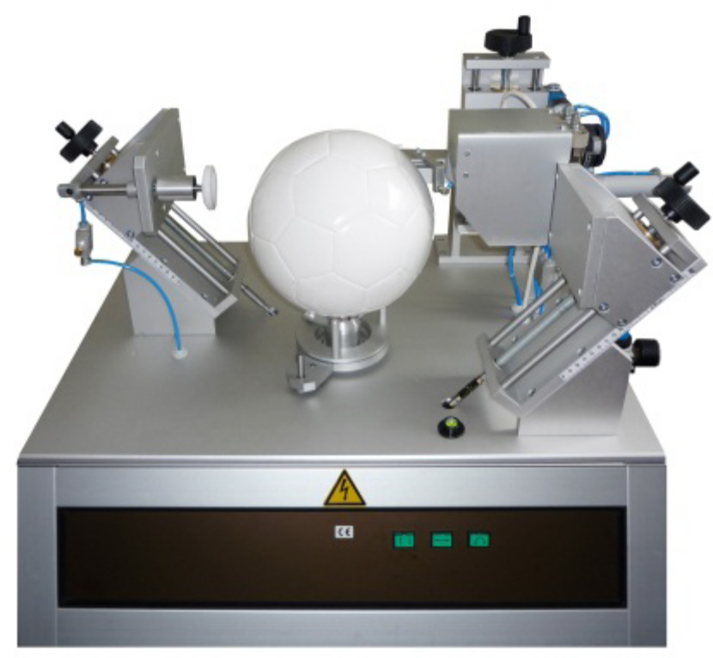

Fig 1 - A typical circumference and sphericity equipment

A.3 Procedure
A.3.1 Inflate the ball to the required pressure according to the operating manual of the equipment.
A 3.2 Place the ball in the ball holder, making sure that the valve is facing upward.
A 3.3 Adjust grippers and tangential arms to the center line of the ball.
A 3.4 Start the test according to the equipment manual and procedure

A.4 Expression of results

The results will be read off the monitor, based on the following;

- Radius measurement (rm = mean value of 3 sequences with 15 cycles)
- 4,500 points measured all over the ball (3 x 15 x 100 radius values)
- Circumference calculation: 2 x rm x π
- Sphericity calculation: - Mean value of the rdev max of the 3 sequences [%] - rdev max = max. absolute difference of rx – rm [%]

ANNEX B
DETERMINATION OF LOSS OF PRESSURE
B 1 Principle
This test measures the difference in pressure over time. The aim is to ensure that the ball does not deflate too quickly, even when not in use.
B 2. Apparatus
A calibrated pressure gauge, capable of measuring 1.5 bar and an accuracy of±0.01bar.
B. 3 Procedure
B.3.1 Inflate and condition 3 net ball samples for at least 24 hours in a standard atmosphere of temperature 20°C ± 2°C and relative humidity 65% ± 5%.
B 3.3 Measure the pressure in the balls to ensure they comply with the recommended pressure as per this standard before the commencement of the test.
B.3.4 keep the samples in the same standard atmosphere of temperature of 20°C ± 2°C and relative
humidity 65% ± 5% for 72 hours.
B3.5 After the end of this period, measure the pressure in the samples and note the difference

B 4.0 Results

Calculate the pressure difference and report to the nearest 0.01bar

ANNEX C

DETERMINATION OF WEIGHT

C 1 Principle

The weight of netballs is very important to ensure consistence for the wind resistant

C 2. Apparatus

An electronic balance, capable of measuring to the nearest 0.01g

C 3. Procedure

Select 3 pre-conditioned and inflated net balls to the recommended pressure. Weigh them in an enclosed chamber to avoid wind flow. Record the mass to the nearest 0.01g

C 4. Results

Record the average mass of the three balls

ANNEX D
WATER ABSORPTION
D 1 Principle
A inflated netball is placed in container filled with water. The ball is then compressed into the water by means of a pneumatic piston and left to soak in the water. The ball is then weighed again after 250 compression cycles and compared to the original weight.
D 2. Apparatus
The apparatus contains a variable pneumatic piston, which is capable of compressing the ball to various depths. A system of three additional small pneumatic pistons turns the netball in various directions between the compressions (one complete turn in approx. 20 compressions). Thus, the complete area of the netball comes in contact with the water during the test.
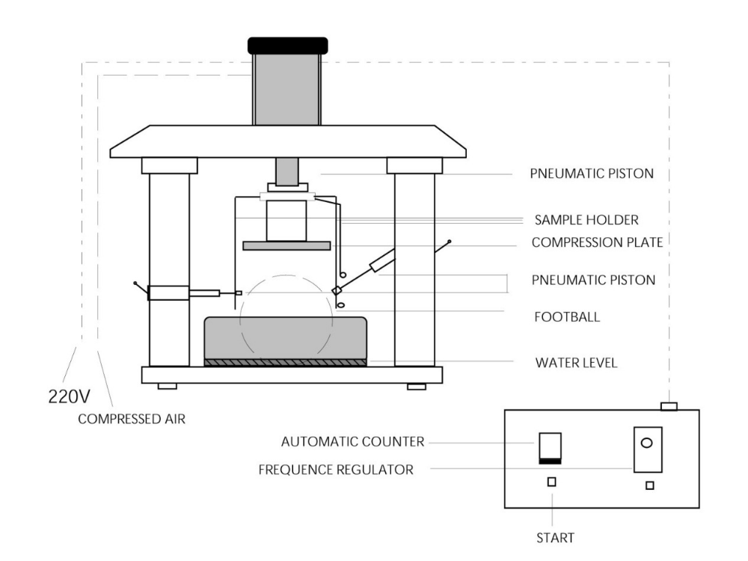
Fig 2- A typical water absorption equipment
D3. Procedure
D 3. 1 Condition at standard atmosphere of temperature of 20°C ± 2°C and relative humidity 65% ± 5%.
D 3.2 weigh the sample to the nearest 0.01g and place it in the sample holder of the equipment
D 3.3 Start the test and ensure that, the ball comes into contact with water completely after every 20 compressions.
D 3.4 After 250 compressions the ball shall be removed quickly and wiped dry on the surface using an absorbent paper or any other effective material so as to minimize additional weight. Each ball is then weighed again in the same manner as above.

Note: Amount of compression (end position of piston) will have to be adjusted for each type of ball (according to diameter determined in clause 3.1)
D 4. Results
Calculate the weight different between the initial and the final weight
M2- M1 X 100 = Y
M1
Where;
MI = Initial weight of the sample
M2 = Weight after water absorption
Y = % weight gain (amount of water absorbed)

ANNEX E.
DETERMINATION OF BALL REBOUND
E 1 Principle
The sample ball is dropped in a guided free fall with a defined velocity on to a fixed plate. The ball hits the surface at specific points in the middle of the panels, distributed over the surface of the ball. The panels shall be selected such that the number of testing points is evenly distributed on the different panel shapes.

E 2. Apparatus

Equipment capable of allowing for the ball to free fall vertically from a height of 2.00m±0.01m (measured from the bottom of the ball) without imparting any impulse of spin. The surface that the ball is to rebound on shall be metal for outdoor balls or any other suitable material.
E 3. Procedure
The ball is placed at the height of 2.00m±0.01m position and released mechanically. Record the height of rebound and repeat the procedure 10 times per ball, ensuring no two rebounds hit the same spot on the ball.
Distribute measurement points according to panel shape and ensure the rebound takes place at the center of the panel.
Determine the average rebound height after the test and record as the rebound height. Also determine the lowest and the highest rebound heights and record the difference

Note: 1. Test with a ball at the recommended temperature and pressures (atmospheric pressure and the pressure of the ball)

E 4. Results
The ball rebound height of any tested sample is the mean of 10 from the 10 performed trials from each ball in recommended conditions. The mean value of each of the three samples must fall within the requirements. In addition, the difference between the highest and lowest means shall be compared and, shall also fall within the respective requirement.

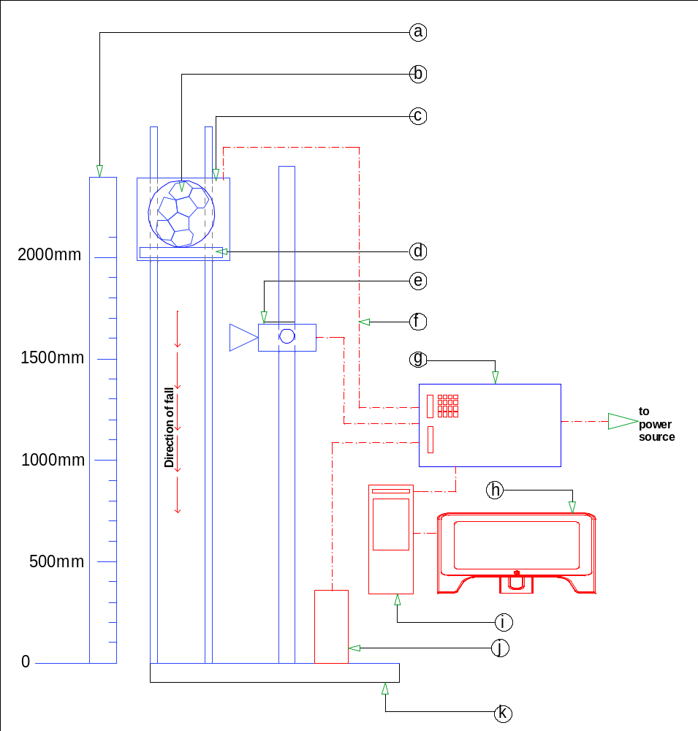
Fig. 3. A typical netball Rebound Test equipment
- Vertical scale
- Ball
- Guidance system
- Ring
- Video camera
- Connecting cables
- Control panel complete with switches
- Display screen
- digital recording system
- sensor (for determining time of impact)
- metal surface

