KENYA STANDARD DKS249: 2020

ICS 43.040.40

Automobile drum brake linings and disc brake pads– Specification

No copying of this standard without KEBS permission except as permitted by copyright law

TECHNICAL COMMITTEE REPRESENTATION

The following organizations were represented on the Technical Committee:

Toyota Kenya Ltd
D.T Dobie
Mitsumoto
Isuzu E.A
Kenya Association of Bus Manufacturers (KABM)
Kenya Motor Repairers Association (KEMRA)
Nissan
Numerical Machining Complex (NMC)
Gede Enterprises
Mobius Motors
KUMPIA
Kenya Industrial Research and development Institute (KIRDI)
Technical University of Kenya (TUK)
Motorwise Valuers
Kenya Auto Bazaar Association
Honda (Nairobi)
Egerton University
Olive Technical Services Ltd
Kenya Jua Kali Association
MCI Ltd
Kenya Bureau of Standards — Secretariat

REVISION OF KENYA STANDARDS

In order to keep abreast of progress in industry, Kenya Standards shall be regularly reviewed. Suggestions for improvements to published standards, addressed to the Managing Director, Kenya Bureau of Standards, are welcome.

© Kenya Bureau of Standards, 2020

Copyright. Users are reminded that by virtue of Section 25 of the Copyright Act, Cap. 12 of 2001 of the Laws of Kenya, copyright subsists in all Kenya Standards and except as provided under Section 26 of this Act, no Kenya Standard produced by Kenya Bureau of Standards may be reproduced, stored in a retrieval system in any form or transmitted by any means without prior permission in writing from the Managing Director.

KENYA STANDARD DKS 249:2020

ICS 43.040.40

Automobile drum brake linings and disc brake pads– Specification

KENYA BUREAU OF STANDARDS (KEBS)

Head Office: P.O. Box 54974, Nairobi-00200, Tel.: (+254 020) 605490, 602350, Fax: (+254 020) 604031
E-Mail: info@kebs.org, Web:http://www.kebs.org

Coast Region Lake Region Rift Valley Region
P.O. Box 99376, Mombasa-80100 P.O. Box 2949, Kisumu-40100 P.O. Box 2138, Nakuru-20100
Tel.: (+254 041) 229563, 230939/40 Tel.: (+254 057) 23549, 22396 Tel.: (+254 051) 210553, 210555
Fax: (+254 041) 229448 Fax: (+254 057) 21814

Foreword

This Kenya Standard was revised by the Brake linings and Pads Sub-Committee of the Motor Vehicle Components and Accessories Technical Committee under the guidance of the Mechanical Engineering Industry Standards Committee and it is in accordance with the procedures of the Bureau.

The revision was necessitated by the need to streamline certain aspects of requirements and tests in the standard which were found to be hindering proper implementation of the standard in Kenyan industry.

The test procedures have been modified to include some ISO recommendations.

During the revision of this standard, the following documents were referred to.

ISO 6311-1980 Road vehicles – Brake linings – Internal shear strength of lining material – Test procedure.

ISO 6312-1981 Road vehicles – Brake linings – Shear test procedure for disc brake pad and drum brake show assemblies.

KS 06-71: 1980 Method for Rockwell hardness test.

Acknowledgement is hereby made for the assistance derived form the use of these documents.

KENYA STANDARD

Automobile drum brake linings and disc brake pads– Specification

1. SCOPE

This Kenya Standard specifies requirements for moulded automobile drum brake linings and disc brake pads. It also gives tests for brake lining friction materials to determine mechanical characteristics.

2. DEFINITIONS

For the purpose of this standard, the following definitions shall apply:

  - rigid lining — Lining which is shaped to fit a specific brake drum diameter.

  - flexible lining — Lining which can be shaped to fit brake drums of different diameters.

3. TYPES AND CLASSES OF LININGS AND PADS

The types and classes of linings and pads applicable to the automobiles shall be as follows:

3.1 Type 1 shall be rigid linings or pads.

3.2 Type 2 shall be flexible linings.

3.3 Class A shall be medium friction, with coefficient of friction between 0.25 to 0.35 inclusive.

3.4 Class B shall be high friction, with coefficient of friction greater than 0.35.

4. PERFORMANCE REQUIREMENTS

4.1 Coefficient of friction at 50ºC shall be as specified in 3.3 and 3.4 when tested in accordance with A1.

4.2 When measured at a temperature of 200ºC the lower values of the coefficient of friction shall not decrease by more than 25 per cent of the value calculated in 4.1, but also be within the criteria laid down in 3.3 and 3.4.

4.3 The finished linings shall have no deformities on the surfaces or any other defects likely to impair their performance.

4.4 Finished linings shall be of uniform composition throughout their thickness, width and length to ensure uniform wear during service. The rate of abrasion, tested in accordance with A3 shall not exceed 0.14 mm.

4.5 Flexibility of Type 2 Linings — When the brake lining is wound around the cylinder of the diameter specified in Table 1, there shall not occur any cracks which would impair the normal performance of the lining.
4.6 When tested in accordance with A2, the recovery after the wet friction test shall not be less than 90 per cent of the value obtained at 200ºC as per 4.2.

4.7 When subjected to bonding shear strength test in accordance with A4 the shear strength of linings and pads shall not be less than 2.8 MPa.

TABLE 1. FLEXIBILITY TEST

THICKNESS OF LINING  mm | DIAMETER OF TEST  CYLINDER  mm
Below 6.5 | 200
6.5 to 10.0 | 250
Above 10.0 | 25 times thickness

4.8 When subjected to an internal shear strength test in accordance with A5, the internal shear strength of friction materials shall not be less than 2.8 MPa.

4.9 When tested in accordance with A6, Rockwell Hardness (scale R) shall be in the range 40 to 80.

5. TOLERANCE ON SIZE OF LININGS AND PADS

The tolerance on width and thickness of brake linings and pads shall be in accordance with Table 2.

TABLE 2. TOLERANCES ON SIZE

TOLERANCE
mm
Drum Brake Lining | Width | + 0  - 1.5
Drum Brake Lining | Thickness | + 0  - 0.3
Disc Brake Pad | Thickness | + 0  - 0.3

6. TESTS

Brake linings and pads shall be subjected to tests in A1 to A6 specified in Appendix A.

7. MARKING

7.1 Lining or Pad Sets — Each lining or pad shall be clearly and indelibly marked at the rear of the pad/lining with the following:

(i) manufacturer’s name and/or trade mark;

(ii) manufacture’s part number

(iii) Country of origin

  - Packaging — Packages of linings or pads or rolls of linings shall be legibly and indelibly marked with the following:

(i) manufacturer’s name and/ or trade mark;

(ii) Part number

(iii) Country of origin

Annex A

Tests

A1. FRICTION TEST

A1.1 The friction coefficient shall be tested on a test specimen not less than 25 mm x 25 mm in size cut from the centre of lining or pad. The thickness of the specimen shall be between 5 mm and 6 mm.

The specimen shall be conditioned (bedded) to the surface of the drum at a surface speed of 300 metres per minute at a pressure of 0.6 to 0.7 MPa and a maximum temperature of 100ºC for a minimum of 20 minutes to obtain at least 95 per cent contact (for a drum diameter of 300 mm).

A1.2 The sample is held against a revolving drum made of automotive cast iron under a pressure of 0.6 MPa. With the drum revolving at a surface speed of 400 metres per minute, continually drag the specimen against the drum at a pressure of 0.6 to 0.7 MPa from room temperature to 200ºC. Note the coefficient of friction at 50ºC and 200ºC.

A2. WET FRICTION TEST

The test piece after the test in A1.2 shall be placed in water for 2 hours and then removed, and the normal friction test shall be carried out as in A1.2.

A3. ABRASION TEST

A3.1 Prepare a specimen as in A1.1.

A3.2 Measure specimen

A3.3 With the drum rotating at a surface speed of 375 metres per minute continually drag the specimen against the drum at a pressure of 0.6 to 0.7 MPa for 2 hours.

The temperature shall not exceed 130 ºC.

A3.4 Measure the Specimen — The decrease in thickness shall be as specified in 4.4.

A4. SHEAR STRENGTH (BONDING) TEST

A4.1 The test shall be conducted on a compression, tension or universal testing machine or any other suitable equipment.

A4.1.1 The test machine shall be provided with equipment to register the exact applied load at the moment of shear.

A4.1.2 The rate of load application shall be controlled in such a way that the load increases at an average rate of 4 500 ± 500 N/s.

A4.2 Fixtures (see Figures 1 and 2)

A4.2.1 For drum brake linings, the fixture shall be so designed that the stamp contacts the edge of the lining for the full length and thickness within 1 ± 0.2 mm of the shoe table or rim.

A4.2.2 Load application on the stamp shall be in a parallel direction to the plane of the shoe rim. The shoe shall be supported to maintain uniform loading along the length of the lining sample.

A4.2.3 For disc brake pads, the fixture shall be so designed that:

(a) The location of the plane of the back plate is parallel to the plane of the stamp.

(b) The stamp contacts the edge of the pad within 1 ± 0.2 mm of the back plate and conforms adequately to the contours of the pad.

(c) The stamp contacts the full sample length of the pad edge parallel to the disc periphery.

(d) The load bearing edge of the back plate rests against a rigid support with a thickness equal to that of the back plate.

(e) A pressure fixture applies a pressure of 0.5 MPa at right angle to the shear load, in such a way as not to influence the shear load measurement.

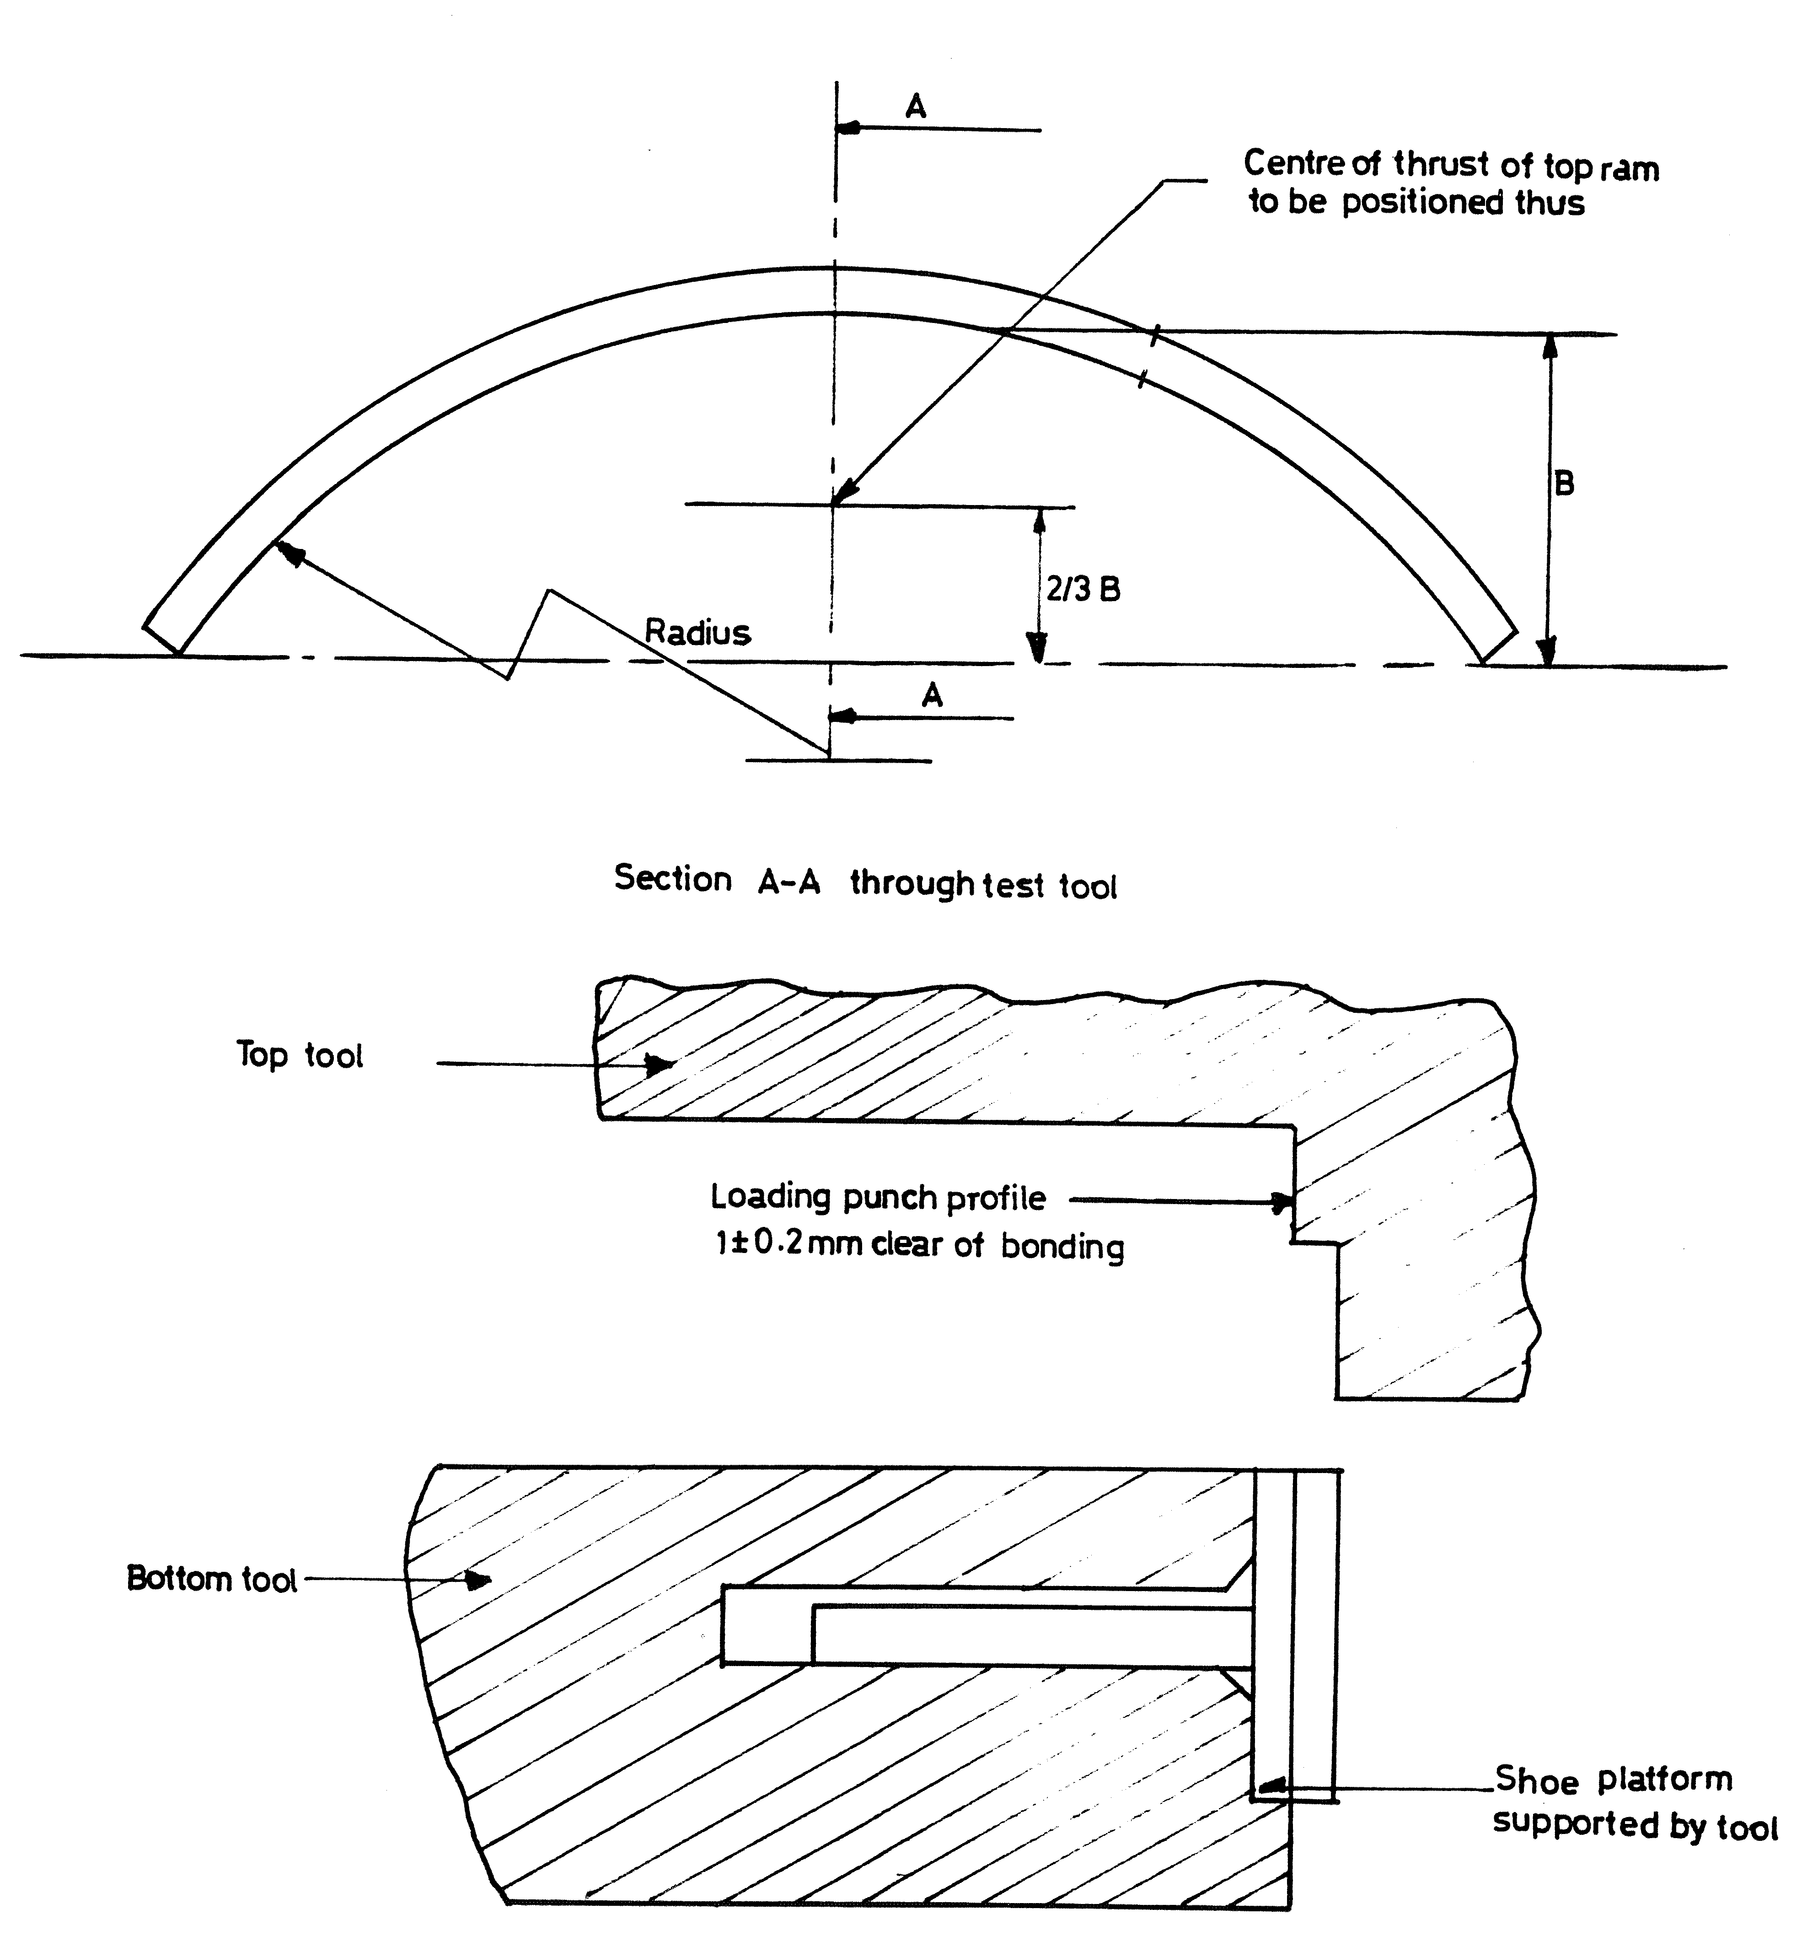

FIG. 1 — PRINCIPLES OF TEST FIXTURE – DRUM BRAKE SHOES

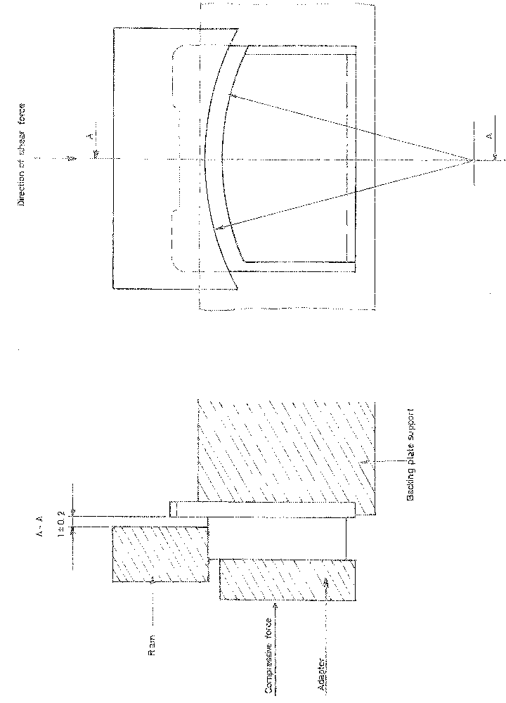

FIG. 2 — PRINCIPLES OF TEST FIXTURE – DISC BRAKE PAD

A4.3 Test Procedures

A4.3.1 Place the brake shoe or disc pad in the appropriate shear test fixture. Ensure that the fixture conforms to the requirements of A4.2.1 to A4.2.3.

A4.3.2 Apply load as specified in A4.1.2 and continue until failure occurs. The load shall be applied without shocks. Record the load at which failure or destruction occurs.

A4.4 Calculation of Shear Strength — The shear strength is calculated from the formula:

S =  N/mm² (MPa)

where,

A is the area (mm²) and F the shear force (N).

A5. INTERNAL SHEAR STRENGTH TEST

A5.1 Test specimens shall be chosen so that they will shear in a plane parallel to the plane or surface of stress at normal service conditions.

A5.2 Dimensions of test specimens shall be:

Length 20 ± 0.1 mm

Width 20 ± 0.1 mm

Thickness 5 ± 0.1 mm

Or 10 ± 0.1 mm

A5.3 Apparatus shall consist of tensile or compression test machine which is equipped with a fixture that can apply the required load in the prescribed manner (Figure 3). The machine shall be equipped so as to be able to register the load at shear.

A5.4 The rate of application of load shall be controlled within the range 4 500 ± 500 N/s.

A5.5 The fixture (Figure 3) shall consist of 2 blocks which slide with as little friction as possible against one another, with a maximum movement of 0.1 mm. The friction between the block and the guide shall be minimal or capable of being recorded so that an allowance can be made in calculating the applied load. The specimen shall fill the grooves completely to prevent tilt under load.

A5.6 It is essential that the shear force is applied through the centre of fixture and specimen and parallel to the guide within 0.1 mm at a length of 100 mm.

A5.7 Test Procedure — Place the specimen in the fixture and apply the continuously increasing load in a direction parallel to the direction of stress at normal service conditions.

The load must not be applied in shocks and the rate of increase shall be as specified in A5.4.

A5.8 Calculations —The internal shear stress is calculated as:

IS = N/mm² (MPa)

where F is the load and A the area of shear.

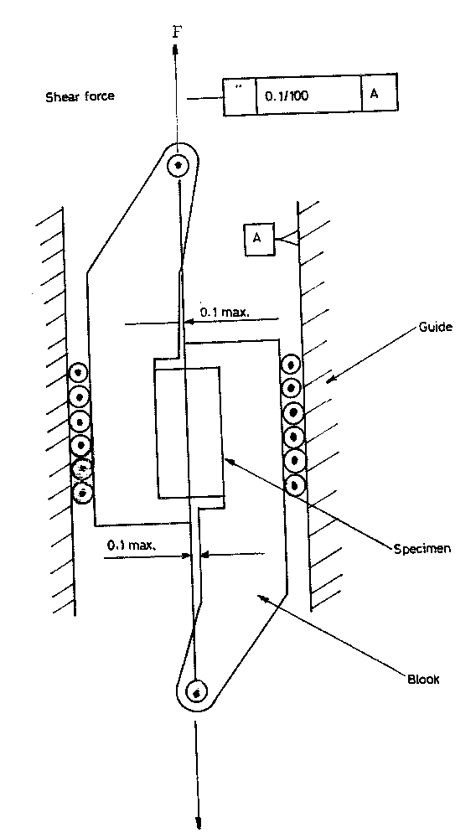

FIG. 3 — INTERNAL SHEAR TEST

A6. ROCKWELL HARDNESS

The test shall be done in accordance with KS 06-71: Part 2. Method for Rockwell Hardness test, using scale R.

