KENYA STANDARD DKS 251:2020

ICS 43.060.30

Motor vehicle radiators — Specification

No copying of this standard without KEBS permission except as permitted by copyright law

TECHNICAL COMMITTEE REPRESENTATION

The following organizations were represented on the Technical Committee:
Toyota Kenya Ltd
D.T Dobie
Mitsumoto
Isuzu E.A
Kenya Association of Bus Manufacturers (KABM)
Kenya Motor Repairers Association (KEMRA)
Nissan
Numerical Machining Complex (NMC)
Gede Enterprises
Mobius Motors
KUMPIA
Kenya Industrial Research and development Institute (KIRDI)
Technical University of Kenya (TUK)
Motorwise Valuers
Kenya Auto Bazaar Association
Honda (Nairobi)
Egerton University
Olive Technical Services Ltd
Kenya Jua Kali Association
MCI Ltd
Kenya Bureau of Standards — Secretariat

REVISION OF KENYA STANDARDS

In order to keep abreast of progress in industry, Kenya Standards shall be regularly reviewed. Suggestions for improvements to published standards, addressed to the Managing Director, Kenya Bureau of Standards, are welcome.

© Kenya Bureau of Standards, 2020
Copyright. Users are reminded that by virtue of section 25 of the Copyright Act, Cap. 12 of 2001 of the laws of Kenya, copyright subsists in all Kenya Standards and except as provided under section 26 of this act, no Kenya Standard produced by Kenya Bureau of Standards may be reproduced, stored in a retrieval system in any form or transmitted by any means without prior permission in writing from the Managing Director.

ISBN 9966-782-13-3

KENYA STANDARD DKS 251:2020

ICS 43.060.30

Motor vehicle radiators— Specification

KENYA BUREAU OF STANDARDS (KEBS)

Head Office: P.O. Box 54974, Nairobi-00200, Tel.: (+254 020) 605490, 602350, Fax: (+254 020) 604031
E-Mail: info@kebs.org, Web:http://www.kebs.org

Coast Region Lake Region Rift Valley Region
P.O. Box 99376, Mombasa-80100 P.O. Box 2949, Kisumu-40100 P.O. Box 2138, Nakuru-20100
Tel.: (+254 041) 229563, 230939/40 Tel.: (+254 057) 23549, 22396 Tel.: (+254 051) 210553, 210555
Fax: (+254 041) 229448 Fax: (+254 057) 21814

Foreword

A vehicle radiator as a heat exchanger is an important part of a vehicle. The effects of failure to dissipate heat can be disastrous, therefore radiators are considered to be a critical part of a vehicle construction. This standard, therefore, lays down the requirements considered necessary to produce radiators suitable for use in Kenya.

In the preparation of this standard, reference was made to the following documents:

IS 7611 — Specification for automotive radiators — Copper brass core construction.

IS 3331 — Specification for copper and brass strips/foils for radiator cores.

Assistance received from these sources is hereby acknowledged.

KENYA STANDARD

SPECIFICATION FOR MOTOR VEHICLE RADIATORS

1. SCOPE

This Kenya Standard covers the general requirements and methods of test for automotive radiators manufactured from copper and brass with brackets of steel for use on motor cars, trucks, tractors and off-the road vehicles such as earth moving machinery. Radiators utilizing bolted or cast header tanks are excluded.

It does not apply to radiators made of aluminium and plastics

2. DEFINITIONS

For the purposes of this standard, the following definitions shall apply:

2.1 radiator — A device used for the cooling of an engine of a motor vehicle which uses water as the cooling media which in turn is cooled by air blown through the radiator fins as the water passes through the radiator tubes.

2.2 general — Various parts of the radiator shall be as shown in Figure 3.

3. TYPES

Two types of radiators shall be considered, namely:

- Flat fin core as shown in Figure 1;

- Corrugated fin core as shown in Figure 2.

The typical construction of a radiator is shown in Figure 3. However, pressure relief/filler cap may be located on a separate header tank remote from the radiator.

4. MATERIAL REQUIREMENTS

  - The various parts of the radiator shall be manufactured from material as shown in Table 1.

TABLE 1. MATERIAL RADIATORS

ITEM | MATERIAL | HARDNESS
Tubes  Flat Fins  Corrugated Pins  Header Plates  Header Tanks  Branches  Brackets | Brass  Copper  Copper  Brass  Brass  Brass  Brass | 90/110/VPN  100/115 VPN  80/110 VPN  90/110 VPN  Drawing quality  Quarter hard-seamless  Mild of drawing quality

The material for the tubes shall be 100 per cent inspected pinholes. The surface of the material shall be free from contamination which can prevent satisfactory wetting and bonding of soldier joints under normal production conditions. It shall also be free from oxides, pinholes, blisters, flakes scratches and other such defects.

The fin shall have sufficient face strength to prevent deformation in normal handling.

4.2 The steel for the production of brackets and frames shall be cold rolled and of suitable quality to allow forming without cracking and to avoid failure due to vibration. Such sheet shall be protected against corrosion by an acceptable method such as terne coating, phosphating, etc. The steel shall be free from defects such as scale, rust, blisters and laminations.

4.3 Solder — Soft solder shall be used for joining the various parts of a radiator. Soft solder shall be made from virgin metal or clean scrap. The material shall be of uniform quality, clean and free from foreign matter.

  - The chemical composition shall be as show in Table 2.

TABLE 2. COPPER CONTENT IN THE COPPER/BRASS STRIPS

STRIP | COPPER CONTENT, PERCENTAGE
Copper  Brass | 98.0 (minimum)  61.5 (minimum)  71.5 (maximum)

5. DIMENSIONS

  - Radiators — The dimensions of radiators shall vary according to engine manufacture specifications.

  - Filler Neck — Small and medium size filler necks shall be as in Figure 4.

  - Drain Tap Seat — A good tank quality draining arrangement shall be provided on the bottom tank.

6. WORKMANSHIP AND FINISH

The radiator core assemblies shall be pickled to remove flux residues after soldering operations have been completed.

The radiator shall be free from physical defects. Joints on radiator cores and water inlet and outlet shall have no discontinuity and the soldering material shall be evenly distributed throughout. The inside of the filler neck shall be free from solder, paint, cracks and scratches. A suitable protective paint shall be used on radiators.

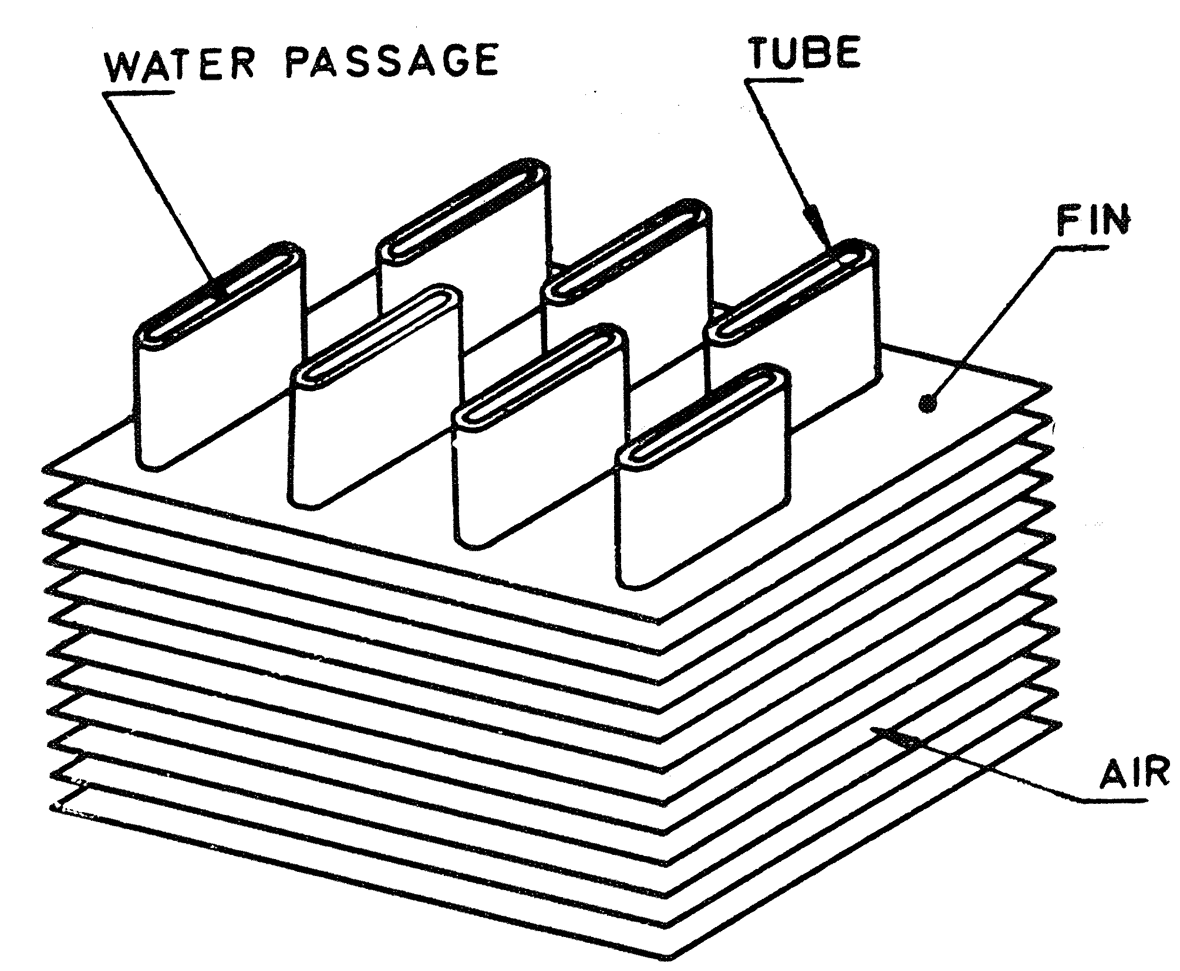

FIGURE 1 — FLAT FIN CORE (TYPE)

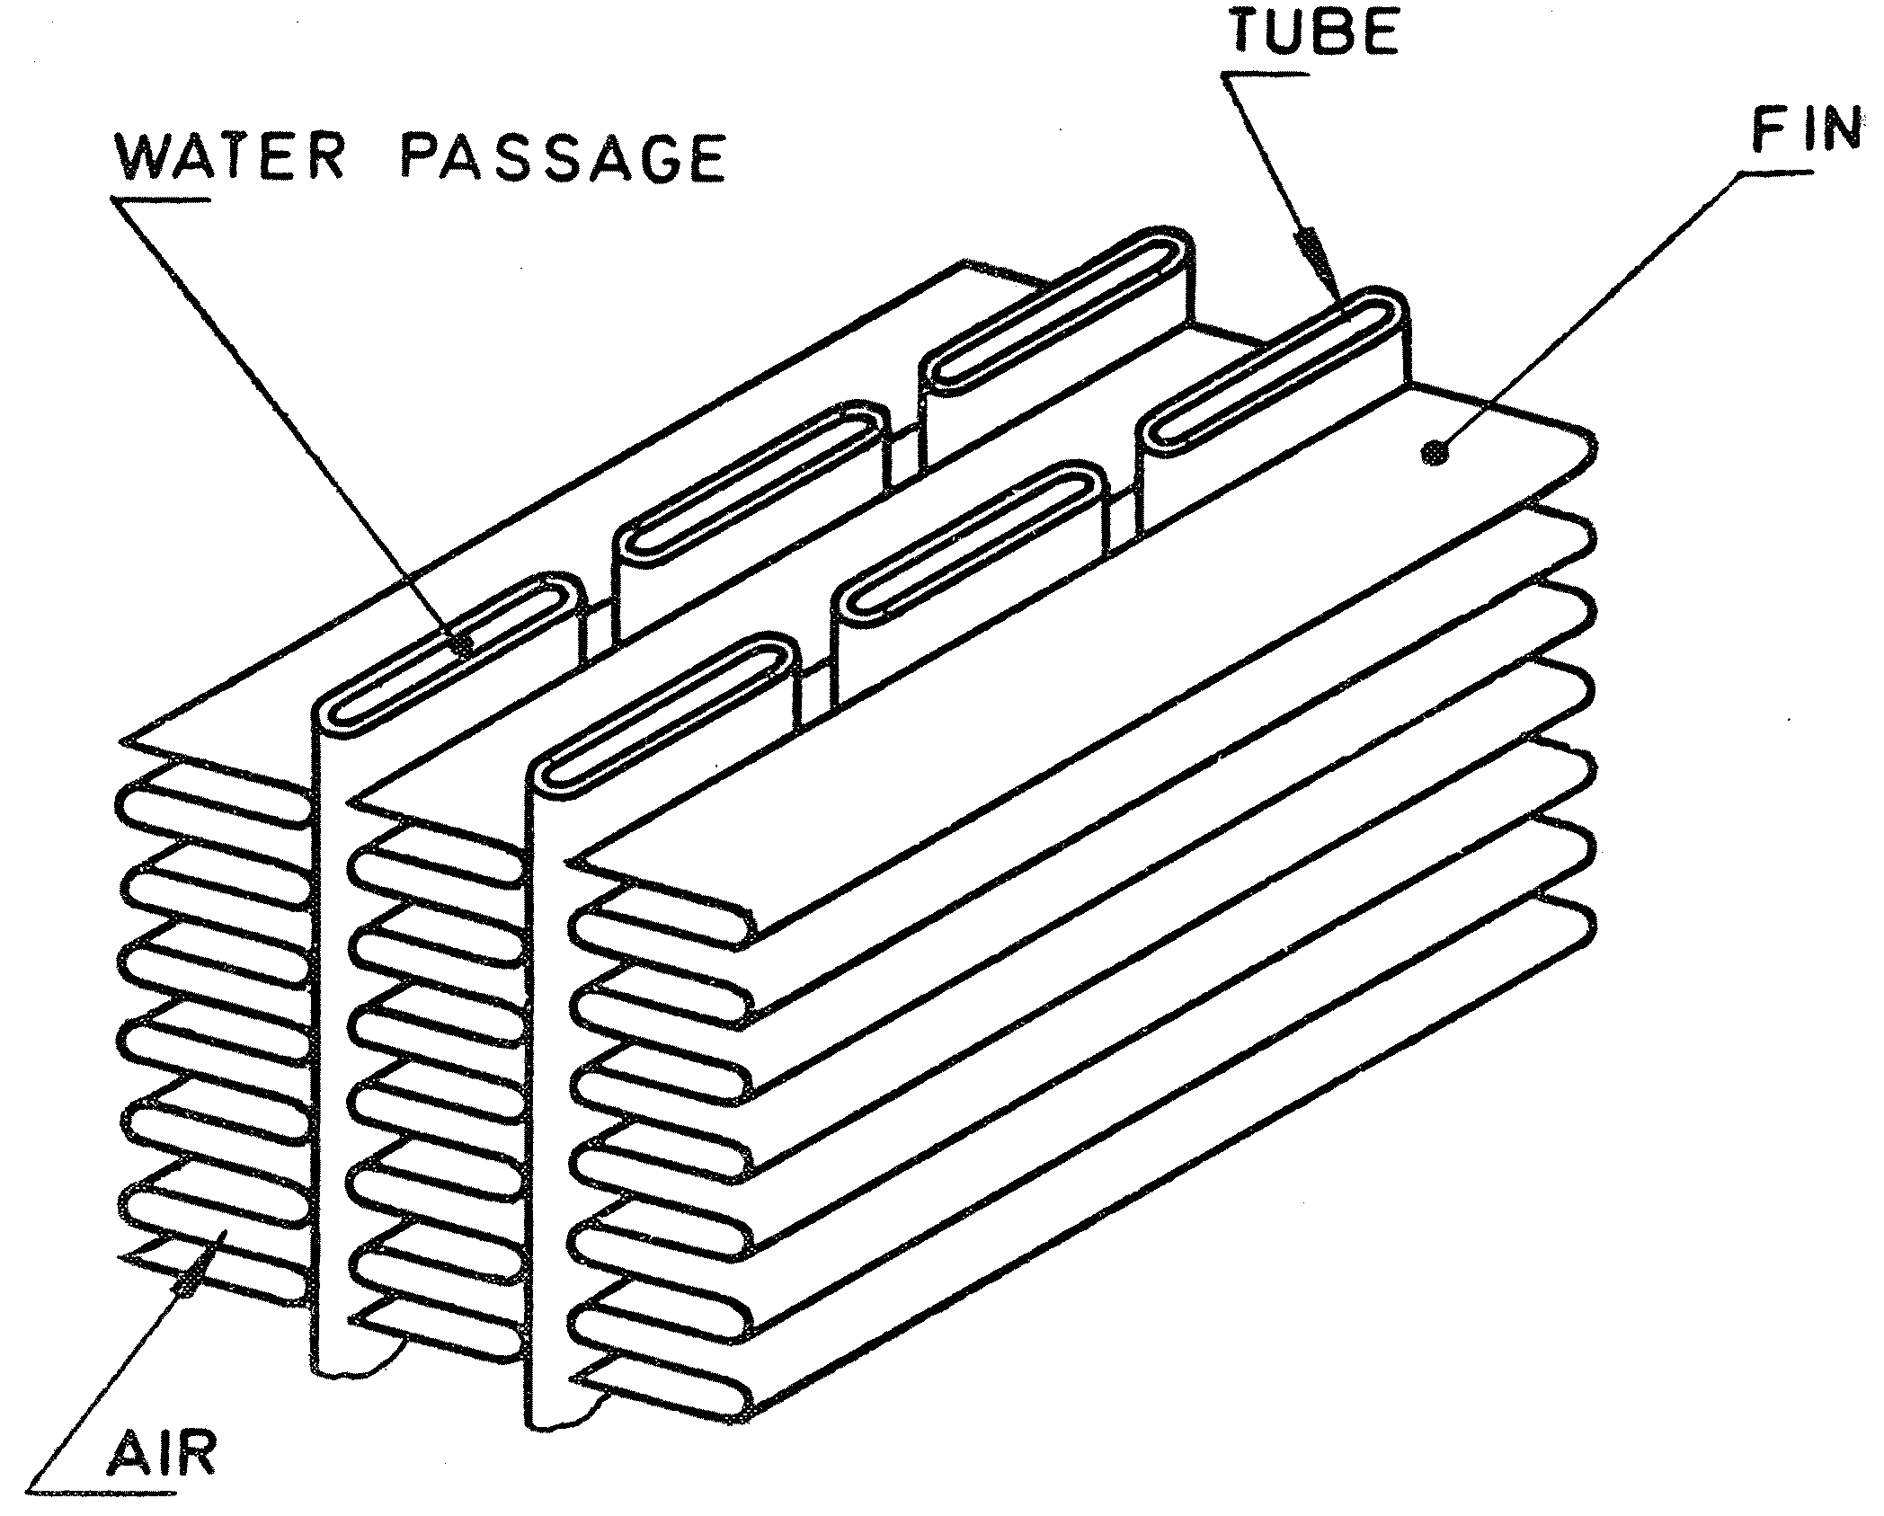

FIGURE 2 — CORRUGATED FIN CORE (TYPE)

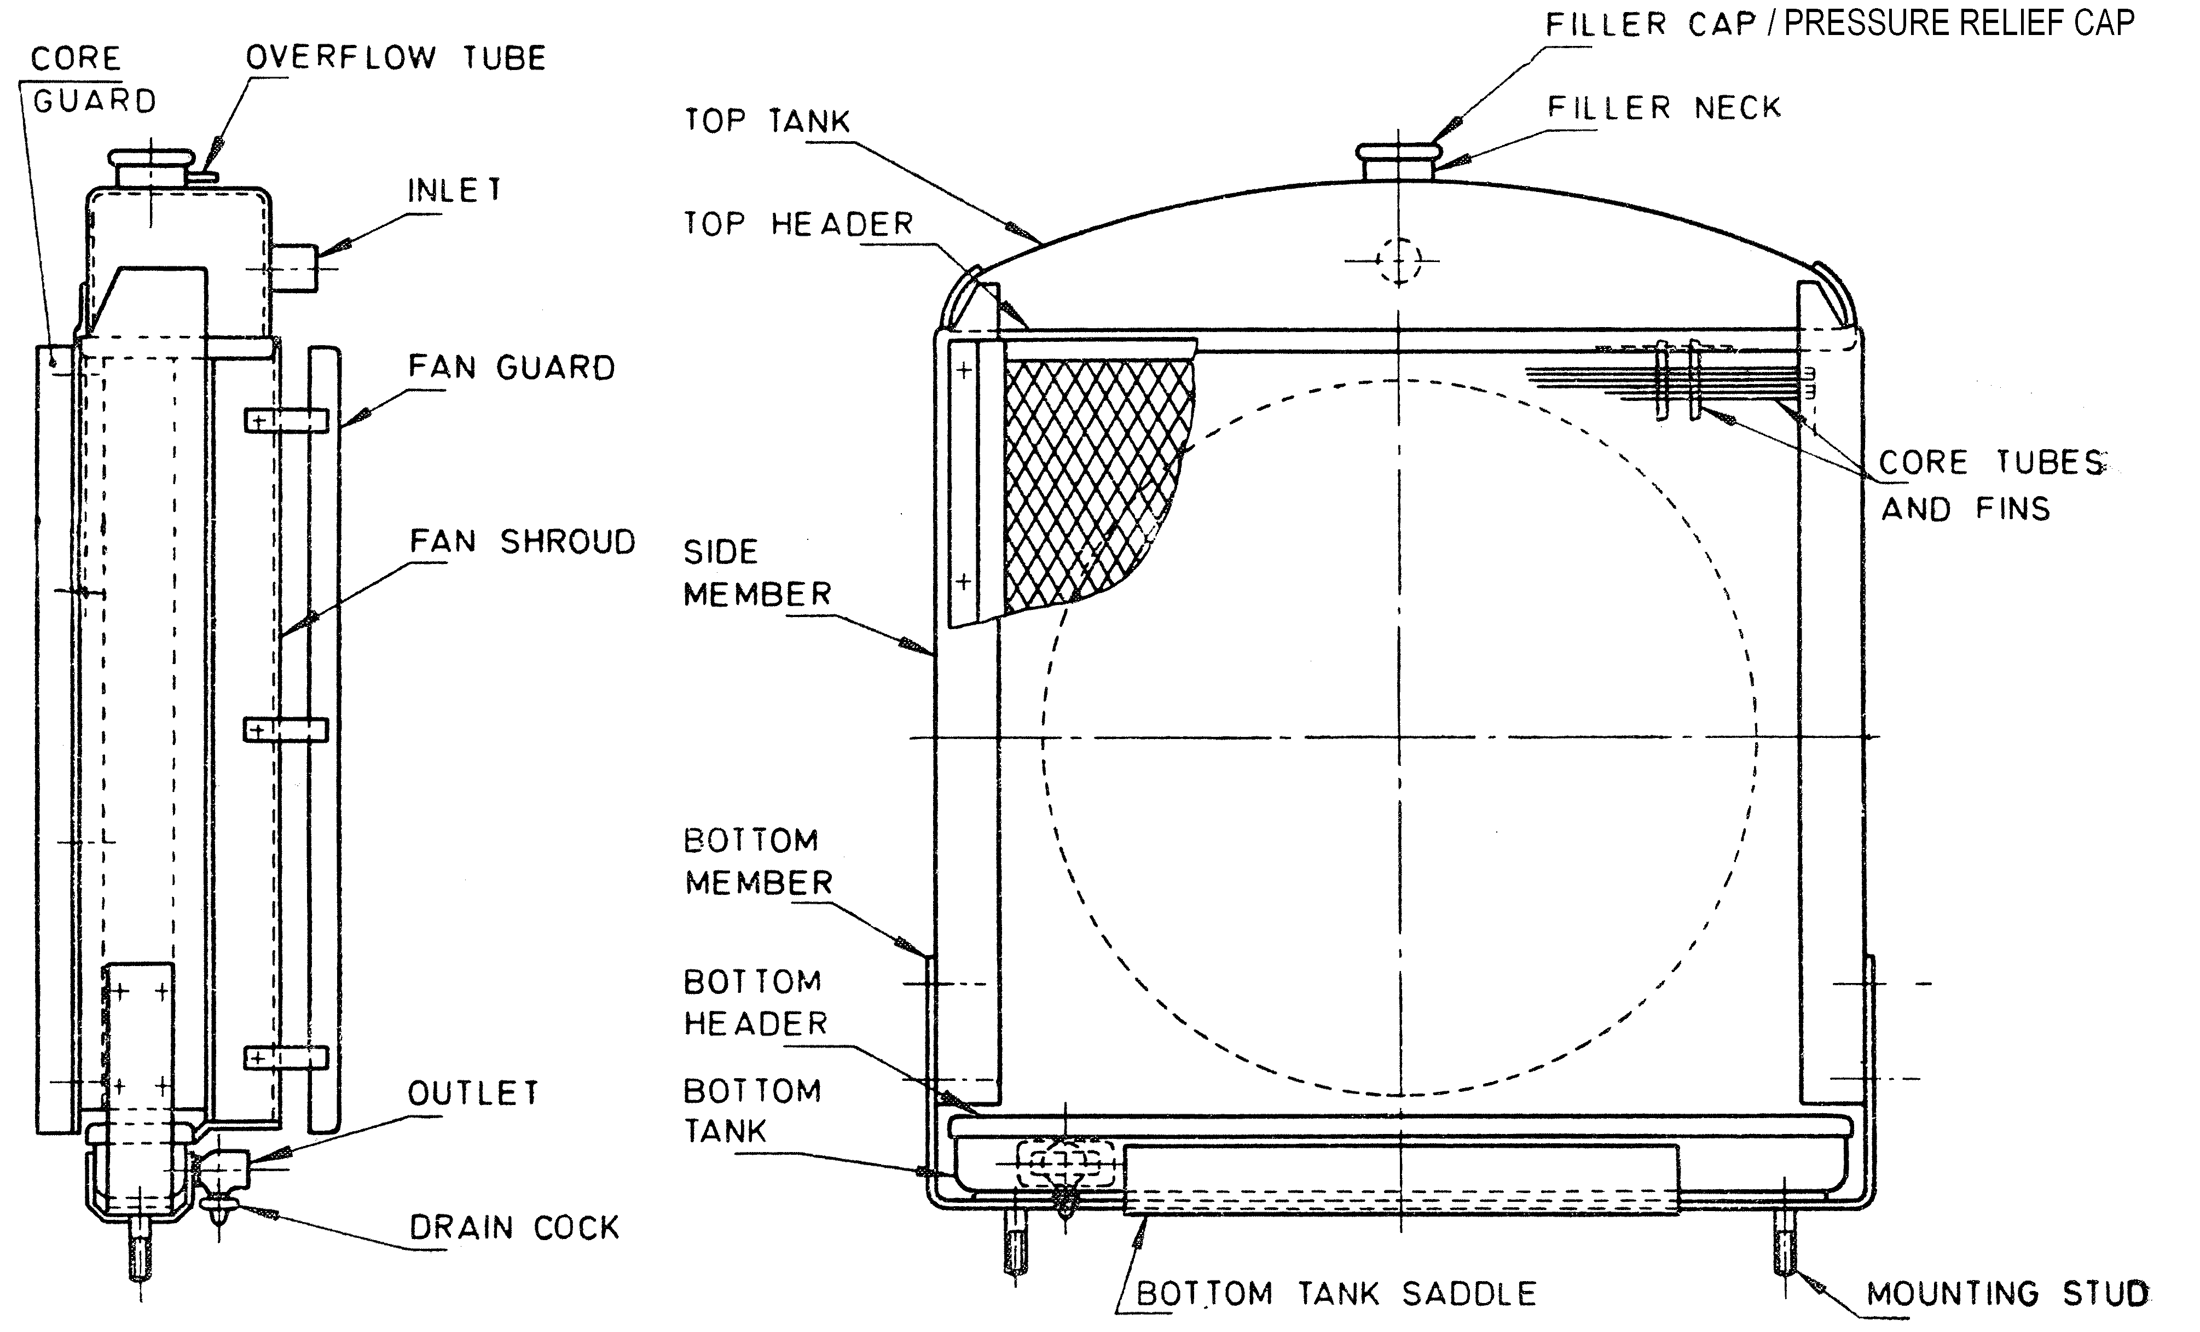

FIGURE 3 — TYPICAL ARRANGEMENT OF RADIATOR SHOWING NOMENCLATURE

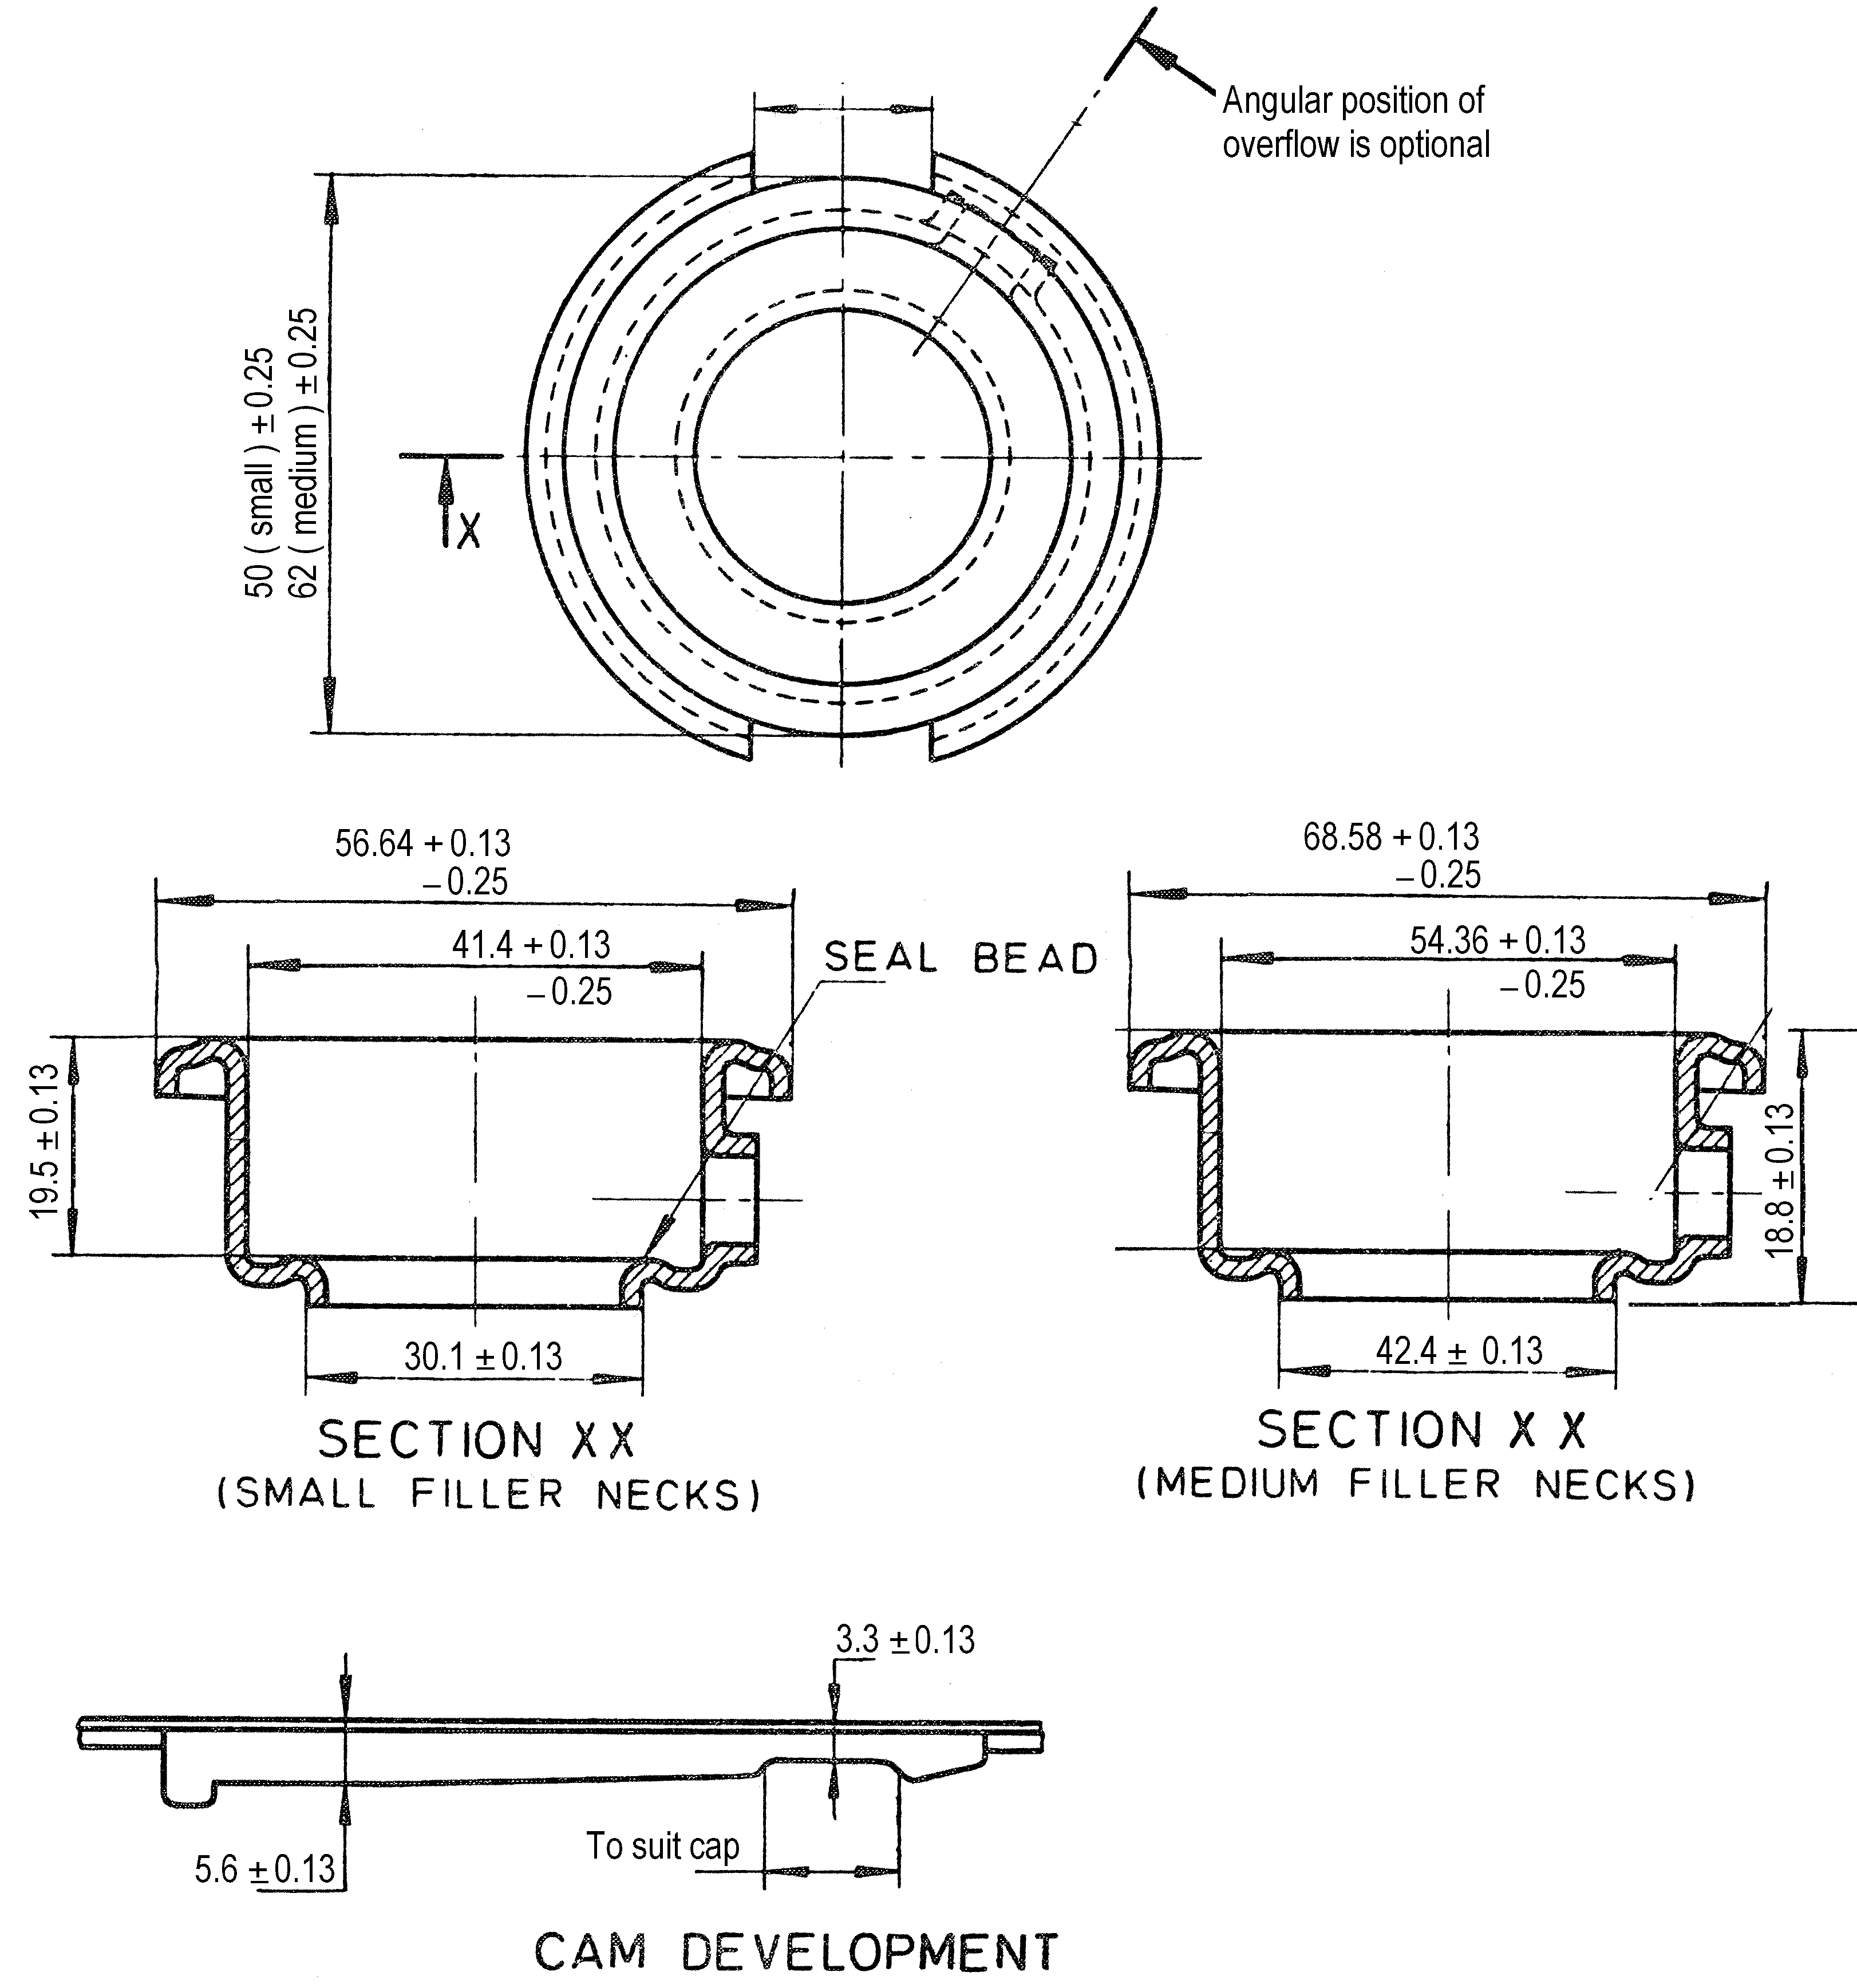

(Dimensions marked * are to suit pressure relief/filler cap.)

FIGURE 4 — FILLER NECKS

7. TESTS

The following tests shall be carried out on the radiators:
- Pressure test;
- Vibration test;
- Leakage test for filler neck seat;
- Pulsation test.

7.1 Pressure Test — This test shall be carried out on every radiator produced for method of test, see Appendix A.

  - Vibration Test — This test shall be carried out on samples from new model production to prove the durability of design. It shall also be carried out as a spot check at least one in every 500 units of same type produced.

NOTE: This test is regarded as a destructive test. For test procedure, see Appendix B.

  - Filler Neck Test — This test shall be carried out on samples from new model production. It shall also be carried out on a random basis on at least one in every 100 radiators of same type produced. For test method, see Appendix C.

  - Pulsation Test — This test shall be carried out, on samples of new model production in conjunction with tests under clause 7.2 above. Spot checks shall also be carried out at least once per 500 units of same type produced. For test procedure, see Appendix D.

NOTE: This test is regarded as a destructive test.

  - Repaired Radiators — Any radiators repaired after tests 7.1. and 7.3 shall be retested to pass the tests.

8.0 Packaging and Marking

8.1 Marking

Each radiator shall be legibly and indelibly marked on the outer casing with:

- Manufacturer’s name or trade mark;

- Part number;

- Country of origin

8.2 Packaging

8.2.1 Each radiator shall be packaged in such a manner that it is protected from damage during transportation and storage

8.2.2 Each package shall be legibly and indelibly marked with: -

- Manufacturer’s name or trade mark
- Part number
- Country of origin

Annex A

Pressure test

A1. TEST ARRANGEMENT

This test shall be conducted in a suitably sized tank full of water sufficient to immerse the radiator. Provision shall be made for connecting the radiator to a compressed air line.

A2. METHOD OF TEST

The radiator shall be immersed in water at normal temperature with all outlets blocked off and subjected to an internal air pressure of twice the cap opening pressure for at least 2 minutes.

A3. During the test no sign of air leakage shall be noticeable. Every radiator shall undergo andpass this test.

APPENDIX B

VIBRATION TEST

B1. TEST ARRANGEMENT

This test shall be conducted on a suitable rig, causing vibration in the vertical direction only.

B2. METHOD OF TEST

The radiator shall be mounted on the rig using the normal mounting points and filled with water at working pressure. The radiator shall be made to vibrate in the vertical direction to give an acceleration 3g. The test shall continue until 10⁶ vibrations are completed.

B3. During or after the test, no leakage shall be noticeable. The mountings of the radiators shall also show no cracks or failure.

APPENDIX C

LEAKAGE TEST FOR FILLER NECK SEATS

(This test shall be performed for the filler cap closed position.)

C1. METHODS OF TEST

Immerse the complete radiator assembly with pressure cap into water at room temperature and all other outlets blocked off. Apply a gradually increasing air pressure to coolant ducts.

C2. No air leaks from overflow tube shall be permitted up to a pressure of 5 kpa below the nominal pressure required to operate the pressure cap relief valve.

NOTE: The pressure cap used during this test should be previously checked for accuracy.

APPENDIX D

PULSATION TEST

D1. TEST ARRANGEMENT

This test shall be conducted on a suitable rig holding the radiator vertically by its normal mounting points. Provision shall be made for connecting the radiator to a constant hot water supply (at least 80 ºC) and also to compressed air.

D2. Hot water shall be continuously circulated through the radiator. Provision shall be made to automatically increase/decrease the internal system pressure at a controlled rate. The pressure shall be cycled from zero such to 1½ times cap opening pressure and back to zero such that one cycle is completed in 3 seconds to 5 seconds. The test shall run continuously until 30 000 cycles have been completed. During the test, the pressure relief cap (if fitted) shall be substituted with a non-opening cap.

D3. During the test, no leakage shall be noticeable.

