KENYA STANDARD DKS 649-2: 2020
ICS 81.040

Automobile windscreens - Specification

Part 2.

Laminated automobile windscreens

No copying of this standard without KEBS permission except as permitted by copyright law

TECHNICAL COMMITTEE REPRESENTATION

The following organizations were represented on the Technical Committee:

Toyota Kenya Ltd
D.T Dobie
Mitsumoto
Isuzu E.A
Kenya Association of Bus Manufacturers (KABM)
Kenya Motor Repairers Association (KEMRA)
Nissan
Numerical Machining Complex (NMC)
Gede Enterprises
Mobius Motors
KUMPIA
Kenya Industrial Research and development Institute (KIRDI)
Technical University of Kenya (TUK)
Motorwise Valuers
Kenya Auto Bazaar Association
Honda (Nairobi)
Egerton University
Olive Technical Services Ltd
Kenya Jua Kali Association
MCI Ltd
Kenya Bureau of Standards — Secretariat

REVISION OF KENYA STANDARDS

In order to keep abreast of progress in industry, Kenya standards shall be regularly reviewed. Suggestions for improvement to published standards, addressed to the Managing Director, Kenya Bureau of Standards, are welcome.

©Kenya Bureau of Standards, 2020

Copyright. Users are reminded that by virtue of Section 25 of the Copyright Act, Cap. 12 of 2001 of the Laws of Kenya, copyright subsists in all Kenya Standards and except as provided under Section 26 of this Act, no Kenya Standard produced by Kenya Bureau of Standards may be reproduced, stored in a retrieval system in any form or transmitted by any means without prior permission in writing from the Managing Director.

KENYA STANDARD KS 649-2:2020
ICS 81.040

Specification for automobile windscreens

Part 2.

Laminated automobile windscreens

KENYA BUREAU OF STANDARDS (KEBS)

Head Office: P.O. Box 54974, Nairobi-00200, Tel.: (+254 020) 605490, 602350, Fax: (+254 020) 604031
E-Mail: info@kebs.org, Web:http://www.kebs.org

Coast Region Lake Region Rift Valley Region
P.O. Box 99376, Mombasa-80100 P.O. Box 2949, Kisumu-40100 P.O. Box 2138, Nakuru-20100
Tel.: (+254 041) 229563, 230939/40 Tel.: (+254 057) 23549, 22396 Tel.: (+254 051) 210553, 210555
Fax: (+254 041) 229448 Fax: (+254 057) 21814

Foreword

This Part 2 of this Kenya Standard was prepared by the Technical Committee on Glass and Glass Products, under the guidance of the Chemical Industry Standards committee, and is in accordance with the procedures of the Bureau.

KENYA STANDARD

SPECIFICATION FOR AUTOMOBILE WINDSCREENS

PART 2. LAMINATED AUTOMOBILE WINDSCREENS

1. SCOPE

This Part 2 of this Kenya Standard specifies requirements for laminated automobile windscreen made of float glass.

NOTE: Sheet glass shall not be used for the manufacture of automobile windscreens.

2. DEFINITIONS

For the purpose of this standard, the following definition and the ones defined in Part 1 of this standard shall apply:

2.1 laminated glass — A glass consisting of two or more layers held together by two or more layers of plastics material.

3 REQUIREMENTS

3.1 Thickness — Shall comply with 3.1 of KS 649 Part 1 .

3.2 Ball Impact Test — Shall pass the ball impact test for mechanical strength prescribed in A1.

3.3 Head Form Test — Shall pass the head form test prescribed in A2.

3.4 Abrasion Test — Shall pass the abrasion test prescribed in A3.

3.5 High Temperature Test — Shall pass the test prescribed in A4.

3.6 Resistance to Radiation Test — Shall pass the test prescribed in A5.

3.7 Humidity Test — Shall pass the test prescribed in A6.

3.8 Light Transmission Test — Shall pass the test prescribed in A3 of Part 1 of this standard.

3.9 Optical Distortion Test — Shall pass the test prescribed in A4 of Part 1 of this standard.

3.10 Secondary Image Test — Shall pass the test prescribed in A5 of Part 1 of this standard.

3.11 Identification of Colours Test — Shall pass the test prescribed in 3.7 of Part 1 of this standard.

4. DEFECTS

4.1 Inspection of Defects — Inspect defects as described in 4.2 of Part 1 of this standard.

4.2 Requirements for Defects — All windscreens shall have limited defects as specified in Table 1.

TABLE 1. DEFECTS LIMITS — LAMINATED GLASS — WINDSCREENS

SL No. | DEFECTS | AREA A | AREA B | AREA C
1 | Bubbles | 4 max. of which 2 may exceed 0.8 mm dia. To a max. of 1.5 mm dia. Minimum separation 100 mm | 6 max. of which 2 may exceed 0.8 mm dia. To a max. of 1.5 mm dia.  Minimum separation 100 mm | See  Note 1
2 | Seed | 2 to a max. of 1.0 mm dia. Minimum separation 300 mm | 4 to a max. of 1.5 mm dia. Minimum separation 300 mm | “
3 | Dimple | 2 to a max. of 1.0 mm dia. Minimum separation 100 mm | 2 to a max. of 1.0 mm diameter.  Minimum separation 300 mm | “
4 | Scratches | Non visible when viewed as detailed in 4.2, KS 03-649: Part 1 | Non visible when viewed as detailed in 4.2 of Part 1 of this standard | “
5 | Hair Cracks & Sleeks | “ | “ | “
6 | Rub | “ | “ | “
7 | Dig | “ | “ | “
8 | Dirt Cullet and Scum | “ | “ | “
9 | Ripple | “ | Occasional medium.  No undue distortion | “
10 | Stones | “ | Non visible when viewed as detailed in 4.2 of Part 1 of this standard | “
11 | Fibre | Non visible when viewed as detailed in 4.2 of Part 1 of this standard | Maximum of 3 not exceeding 6 mm length | “
12 | Haze | “ | Occasional not exceeding 1.5 mm dia. | “
13 | Spot | 4 max. not exceeding 0.8 mm dia. Minimum separation 300 mm | Occasional not exceeding 1.5 mm dia.  Minimum seperation 300 mm | “
14 | Finger Marks | Non visible when viewed as detailed in 5.6. | Non visible when viewed as detailed in 5.6 | “
15 | Chips | “ | “ | “
16 | Dry Marks and Short Plastic | “ | “ | 6 mm depth and 75 mm length max. Total not to exceed 2.5 % of periphery
17 | Overlap | – | – | 0.8 mm max.

NOTE: The above glass imperfections are permitted in Area C (concealed edges) provided they do not affect the function of the glass or impair the sealing.

5. MARKING

The following particulars shall be legibly and indelibly marked on the laminated windscreen:

(a) Manufacturer’s name and/or registered trade mark

(b) The words ‘Laminated Windscreen’ or the letter ‘WL’;

c) Country of origin

Annex A1

A1. BALL IMPACT TEST

A1.1 Principle of Test

A1.1.1 The test shall be carried out by means of a falling solid ball made of hardened steel, the mass of which shall be defined for the different types of glass; the ball shall fall within 25 mm of the centre of the test piece or sample.

A.1.1.2 The ball shall be released without any impetus being given to it (e.g. by using an electromagnet).

A1.2 Supports for Samples

A1.2.1 The sample shall rest freely on a strip of rubber, of hardness 50 IRHD and about 3 mm thick, placed on a support, the width of contact all round the perimeter being about 15 mm.

A1.2.2 The support shall be rigid, shall conform to the shape of the sample, and shall be arranged in such a way that the ball strikes the outer face of the sample. Care shall be taken to ensure adequate contact between the sample and the support.

A1.2.3 The support shall rest on a sheet of rubber, of hardness 50 IRHD and about 3 mm thick, placed on a rigid base, e.g. a substantial concrete base.

A1.2.4 The ball used shall have a mass of 227 ± 2 g and a diameter of approximately 38 mm. The height of the drop (from the lower part of the ball to the upper surface of the sample) shall be 2.5 m + 5 - 0 mm.

A1.2.5 Interpretation of Results — The ball impact test shall be deemed to have given a positive result if the sample is not broken.

Annex A2

A2. HEAD FORM TEST

Carry out the head form test as described in Part 1 of this standard from a height drop of 1.5. m + 0 – 5 mm.

A2.1 International of Results — The head form test shall be deemed to have given satisfactory result if:

(a) The sample breaks displaying numerous circular cracks centre approximately on the point of impact, the nearest cracks being not more than 80 mm from the point of impact;

(b) The glass fragments remain attached (except as defined in A2.1.1) to the plastics interlayer. Partial separation from the interlayer within a distance of 4 mm on either side of a crack is permitted. Within a 60 mm diameter circle centred is permitted beyond the point of impact, partial separation is permitted beyond a distance of 4 mm on either side of a crack.

A2.1.1 On the side of the impact not more than 2 000 mm² of interlayer is exposed.

A2.1.2 A split in the interlayer does not exceed 35 mm in length.

Annex A3

A3. ABRASION TEST

A3.1 Apparatus — The following apparatus is required:

A3.1.1 Abrading Instrument*, shown diagrammatically in Figure 1, and consisting of the following:

A horizontal turntable and centre clamp which revolves counter-clockwise at 65 r/min to 75 r/min.

Two weighted parallel arms, each carrying a special abrasive wheel rotating freely on a ball-bearing horizontal spindle; each wheel rests on the specimen under the load exerted by a mass of 500 g.

The turntable of the abrading instrument shall rotate regularly and substantially in one place. The deviation from this plane shall be not greater than 0.05 mm at a distance of 1.6 mm from the turntable periphery.

A3.2 Preparation of Test Pieces

A3.2.1 Immediately before and after the abrasion, clean the test pieces in the following manner:

(a) Wipe with a linen cloth under clean running water;

(b) Rinse with distilled or deminerilized water;

(c) Blow dry with oxygen or nitrogen;

(d) Remove possible traces of water by dabbing softly with a damp linen cloth; if necessary, dry by pressing lightly between two linen cloths.

Any treatment with ultrasonic equipment shall be avoided.
After cleaning, the test pieces shall be handled only by their edges and shall be stored to prevent damage to, or contamination of, their surfaces.

A3.2.2 Condition the test specimens prior to testing for a minimum time of 48 h at 20 ± 5 °C and 50 ± 2 per cent relative humidity.

A3.3 Test Method

A3.3.1 Immediately after completion of the conditioning period place the test piece against the entrance port of the integrating sphere. The angle between the normal to the surface of the test piece and the axis of the beam shall not exceed 8°.

Take four readings as indicated in Table 2.

TABLE 2. READINGS REQUIRED FOR ABRASION RESISTANCE TEST

READING | WITH SPECIMEN | WITH LIGHT TRAP | WITH REFLECTANCE STANDARD | QUANTITY REPRESENTED
T₁ | No | No | Yes | Incident light
T₂ | Yes | No | Yes | Total light transmitted by test specimen
T₃ | No | Yes | No | Light scattered by instrument
T₄ | Yes | Yes | No | Light scattered by instrument and test piece

Repeat reading for T_{1,} T₂, T₃, and T₄ with additional specified position of the test piece to determine uniformity

The wheels shall be mounted in such a way that, when they are in contact with the rotating test specimen, they rotate in contrary direction so as to exert a compressive and abrasive action along curved lines over an annular area of about 300 mm², twice during each rotation of the test specimen.

A3.3.2 Abrasive wheels*, each 45 mm to 50 mm in diameter and 12.5 mm thick, composed of a special finely screened abrasive embedded in a medium-hard rubber. The wheels shall have an IRHD hardness of 72 ± 5, measured at four points equally spaced on the centre line of the abrading surface with the pressure applied vertically along a diameter of the wheel, the readings being taken 10 s after full application of the pressure.

The abrasive wheels shall be prepared for use by very slow rotation against a sheet of flat glass.

A3.3.3 Light source. consisting of an incandescent lamp, the filament of which is contained within a parallel piped 1.5. mm x 1.5 mm x 3 mm. The voltage at the lamp terminals shall be such that the colour temperature is 2 856 ± 50 K. This voltage shall be stabilized within ± per cent. The instrument used to check the voltage shall be of appropriate accuracy.

A3.3.4 Optical system, consisting of a lens with a focal length of at least 500 mm an corrected for chromatic aberrations. The clear aperture of the lens shall be adjusted in order to obtain a light beam that is substantially parallel.

A diaphragm shall be inserted to limit the diameter of the light beam to 7 ± 1 mm. This diaphragm shall be situated at a distance of 100 ± 50 mm from the lens on the side remote from the light source.

A3.3.5 Equipment for measuring scattered light (hazemeter) (see Figure 2), consisting of a photoelectric cell with an integrating sphere of diameter of 200 mm to 250 mm. The sphere shall be equipped with entrance and exit ports for the light. The entrance port shall be circular and have a diameter at least twice that of the light beam. The exit port of the sphere shall be provided with a light trap and with a reflectance standard. The light trap shall absorb all the light when no test specimen is inserted in the light beam.

The axis of the light beam shall pass through the centre of the entrance and exit ports. The diameter, b, of the light exit port shall be equal to 2a tan 4⁰, where a is the diameter of the sphere. The photoelectric cell shall be mounted in such a way that it cannot be reached by light coming directly from the entrance port or from the reflectance standard.

The surfaces of the interior of the integrating sphere and the reflectance standard shall be of substantially equal reflectance, and shall be matt and non-selective.

The output of the photoelectric cell shall be linear within 2 per cent over the range of luminous intensity used. The design of the instrument shall be such that there is no galvanometer deflection when the sphere is dark. The whole apparatus should be checked at regular intervals by means of calibration standards of defined haze.

If haze measurements are made using equipment or methods differing from the above, the results shall be corrected in order to be in agreement with those obtained by the apparatus described.

A3.4 Test Pieces — The test pieces shall be flat squares of side 100 mm having both surfaces substantially plane and parallel, and with a 6.5 ± 0.1 mm diameter hole drilled in the centre.

A3.4.1 Determine the initial haze of the test specimen at a minimum of four equally spaced points in the un-braded area in accordance with the formula in A4.5.1.

Average the results for each test specimen. As an alternative to making four separate measurements an average value may be obtained by rotating the test piece uniformly at 3 r/s or more.

A.3.4.2 For each type of safety glass, carry out three tests with the same load on the side representing the outer surface of the glass. Use the haze as a measure of the surface abrasion after the test piece has been subjected to abrasion for 1 000 cycles.

A.3.4.3 Determine the light scattered in the abraded track at a minimum of four equally spaced points along the track in accordance with the formula in A4.5.1. Average the results for each test piece. As an alternative to making four separate measurements an average value may be obtained by rotating the test piece uniformly at 3 r/s or more.

A3.5 Calculation and Interpretation of Results

A3.5.1 Calculate the total transmittance T_{t} = T₂/T₁.

Calculate the diffuse transmittance T_{d} as follows:

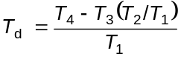

Calculate the percentage haze or light scattered, or both, as follows:

Haze or light scattered, or both = 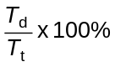

A3.5.2 Subtract the average initial haze from the average total light scattered, the difference representing the light scattered as a result of abrading the test piece. Calculate the difference for the surface abrasion.

A3.5.3 Safety glass shall be considered satisfactory from the point of view of abrasion resistance if the light scattered as a result of abrading the test piece does not exceed 2 per cent.

Annex A4

A4. HIGH TEMPERATURE TEST

A4.1 Test Method

A4.1.1 The test pieces shall be immersed vertically for 3 min in water at approximately 66 °C, then plunged rapidly in the same way into boiling water and kept there for 2 h.

A4.1.2 If the test is carried out on a test piece cut from a windscreen, the surface area shall be not less than 300 mm x 300 mm, bounded on one side by the upper edge of the windscreen.

A4.2 Interpretation of Results

A4.2.1 The test shall be deemed to have given a positive result if bubbles or other defects are not formed more than 15 mm from the outer edge of the test piece or more than 10 mm from any cracks which may occur during the test.

A4.2.2 No account shall be taken of bubbles or defects within 25 mm of the cut edge of a test piece cut from a windscreen.

A P P E N D I X A5

A5. RESISTANCE TO RADIATION TEST

A5.1 Purpose of Test — The purpose of this test is to determine whether exposure to radiation over an extended period of time produces any appreciable decrease in regular luminous transmittance or any pronounced discoloration of the safety glass.

A5.2 Apparatus

A5.2.1 Radiation source consisting of a medium-pressure mercury vapour are lamp with a tubular quartz bulb of ozone-free type; the bulb axis shall be vertical. The nominal dimensions of the lamp shall be 360 mm in length by 9.5 mm in diameter. The arc length shall be 300 mm ± 14 mm. The lamp shall be operated at 750 ± 50 W.

Any other source of radiation which produces the same effect as the lamp specified above may be used. To check that the effects of another source are the same, a comparison shall be made by measuring the amount of energy emitted within a wavelength range of 300 mm to 450 mm, all other wavelengths being removed by the use of suitable filters. The alternative source shall then be used with these filters.

In the case of safety glass for which there is no satisfactory correlation between this test and the conditions of use it will be necessary to review the test conditions.

A5.2.2 Power supply transformer and capacitor capable of supplying to the lamp (A5.2.1) a starting peak voltage of 1 100 V minimum and an operating voltage of 500 ± 50 V.

A5.2.3 Device for mounting and rotating the test specimens at 1 rev/min to 5 rev/min about the centrally located radiation source in order to ensure even exposure.

A5.3 Test Specimen — The size of the test specimens shall be 76 mm x 300 mm.

A5.4 Procedure — Check the regular light transmittance, determined according to A3 of Part 1 of this standard, of three test specimens before exposure. Protect a portion of each test specimen from the radiation, and then position the test specimen in the test apparatus 230 mm from, and with its 300 mm dimensions parallel to, the lamp axis. Maintain the temperature of the test specimens at 45 ± 5 °C throughout the test. That face of each test specimen which would represent the glazed exterior part of the motor vehicle shall face the lamp. For the type of lamp specified in A5.2.1, the exposure time shall be 100 h.

After exposure, measure the light transmittance again on each test specimen in the exposed area.

A5.4.1 Interpretation of Result — The test for resistance to radiation shall be deemed to have given positive result when the total luminous transmittance does not fall below 9 per cent of the original valve before irradiation or below 70 per cent, the transmittance being measured in accordance with Clause A3 of Part 1 of this standard.

A P P E N D I X A6

A6. HUMIDITY TEST

A6.1 Purpose of Test — The purpose of this test is to determine whether the safety glass will successfully withstand the effects of humidity in the atmosphere over an extended period of time.

A6.2 Procedure — Keep one or more test specimens of at least 300 mm x 300 mm vertically for 2 weeks in a closed container in which the temperature is maintained at 50 ± 2 °C and the relative humidity at 95 ± 4 per cent.

NOTE: These test conditions exclude any condensation on test specimens.

In the event that several test specimens are tested at the same time, adequate spacing shall be provided between the test specimens.

Precautions shall be taken to prevent condensate from the walls and ceiling of the test chamber from falling on the test specimens.

If the test specimens are cut from windscreens, one edge of the test specimen shall be part of an edge of the windscreen.

A6.3 Expression of Results — The resistance to humidity shall be evaluated visually by reference to change in the appearance of the safety glass after testing, i.e.:

— separation of materials;

— loss of transparence according to Clause A3 of Part 1 of this standard.

The changes shall be assessed over the whole test specimen, except within 10 mm of the uncut edges or within 15 mm of the cut edges.

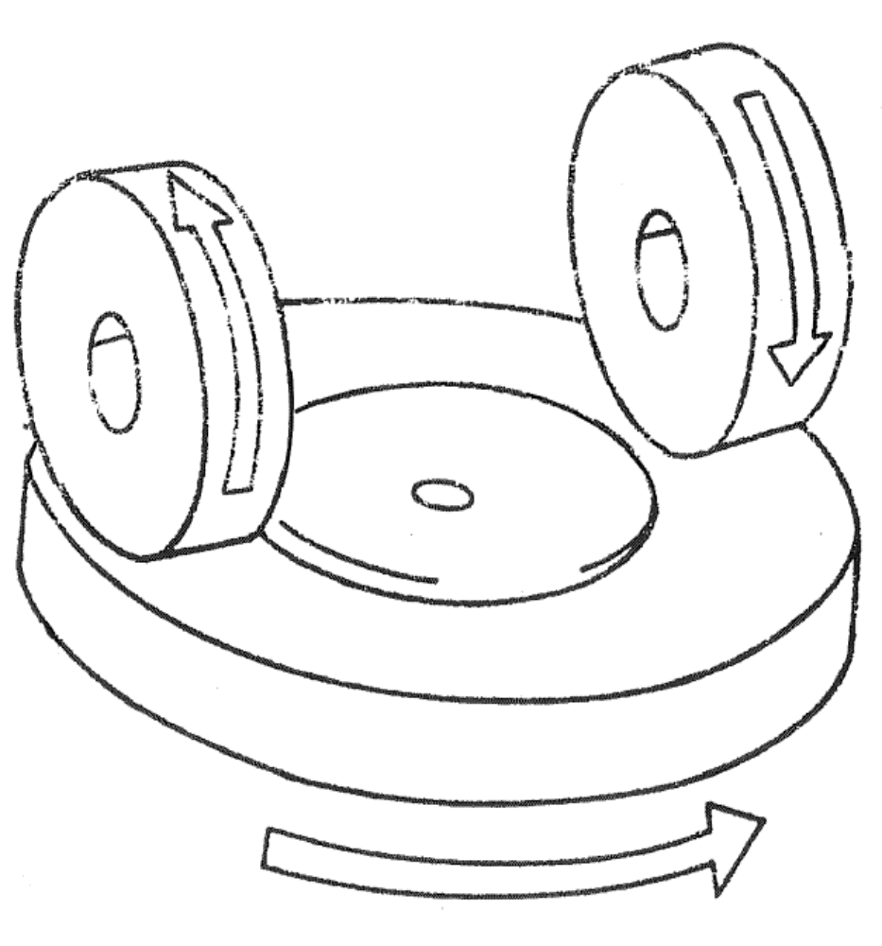

FIG. 1 — DIAGRAM OF ABRADING INSRUMENT

* A suitable abrading instrument is supplied by Teledyne Taber (USA) from whom abrasive wheels may also be obtained.

