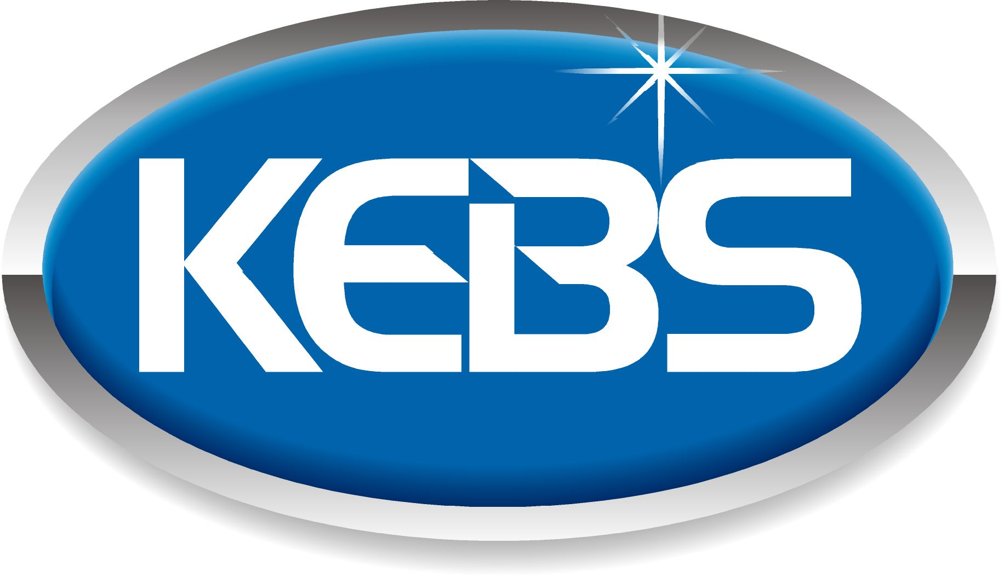 | Kenya Bureau of  Standards  Standards for quality life

KEBS Head Office  P.O. Box 54974, Nairobi 00200  Tel: +254 (0) 20 605490,605506,  Mobile: 0722 202 137/8.  0734 600 471/1  Fax: +254 (0) 20 609 660  Direct Dial: +254 (0) 20 694 8000  E-mail: infor@kebs.org  Web: http://www.kebs.org  KEBS Coast Region  P.O. Box 99376, Mombasa 80100  Tel: +254 (0) 41 229 563, 230 939/40  Fax: +254 (0) 41 229 448  E-mail: kebs-msa@kebs.org  KEBS Lake Region  P.O. Box 2949, Kisumu 40100  Tel: +254 (0) 57 202 8396, 202 9549  Fax: +254 (0) 57 202 7814  E-mail: kebs-kisumu@kebs.org  KEBS Rift Valley Region  P.O. Box 2138, Nakuru 20100  Tel: +254 (0) 51221 0553/5, 221 1208  Fax: +254 (0) 51221 0076  E-mail: kebs-nakuru@kebs.org  KEBS Mt. Kenya Region  P.O. Box 1790, Nyeri 10100  Tel: +254 (0) 61 203 1410/1  Fax: +254 (0) 61 203 2038  Email: kebs-nyeri@kebs.org  KEBS North Eastern Rgion  P.O. Box 978, Garissa 70100  Tel: +254 (0) 46 2519  Fax: +254 (0) 46 3455  E-mail: kebs-garissa@kebs.org |  | Our Ref: KEBS/STA/16/13/3 Date: 2018-07-13  RE: PUBLIC REVIEW DRAFT: KS 2828, GUIDANCE ON SELECTION OF INTELLECTUAL PROPERTY MANAGEMENT CONSULTANTS  Dear Sir/Madam,  This draft standard has been prepared by the Technical Committee on Intellectual Property Services in accordance with the procedures of the Kenya Bureau of Standards, and is now being circulated for public review comments.  The committee would appreciate any comments on this standard, which should be submitted by September 14th 2018. It will also be appreciated if those who have no specific comments to make but find the standards generally acceptable to notify us accordingly.  Suggestions entailing amendments of the text should be included, wording preferred and the relevant clause number quoted against any amendment made.  This draft standard is subject to change and should not be referred to or used as a Kenya Standard.  All correspondence pertaining to this draft should be addressed to the Managing Director, Kenya Bureau of Standards for attention to Micah Rachuonyo or emailed to rachuonyom@kebs.org  Yours faithfully,  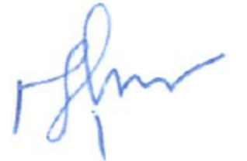  Micah Rachuonyo  For: DIRECTOR STANDARDS DEVELOPMENT DIVISION  MR

The Kenya Bureau of Standards (KEBS) is a member of the International Organization for Standardization (ISO), Codex Alimentarius Commission (CAC), The African Regional Organization for Standardization (ARSO), Associate Member of the International Electrotechnical Commission (IEC), Associate Member of Bureau International des Poids et Mesures (BIPM) and International Organization of Legal Metrology (OIML)

