Ref.: KEBS/STA/16/1/ Date: 24 – 11 – 2020

PUBLIC REVIEW DRAFTS

The attached Draft East Africa Standards have been prepared by the EASC TC 074
SURFACE ACTIVE AGENTS Technical Committee in accordance with the procedures
of the Bureau, and are now being circulated for public comments.

The Committee would appreciate any comments on this Draft Standards, which should be submitted before 01 – 02 – 2021 using the attached template. It will also be appreciated if those who have no specific comments to make but find the draft standards generally acceptable can notify us accordingly. Absence of any reply or comments shall be deemed to be an acceptance of the technical contents of the draft East African standard and shall constitute an approval vote.

Suggestions entailing amendments of the text should include wording preferred and the relevant clause number quoted against any comments made.

These draft standards are subject to change and should not be referred to or
used as East Africa Standards.

All correspondence pertaining to these draft standards should be addressed to the Managing Director, Kenya Bureau of Standards for the attention of JAMES KIOKO.

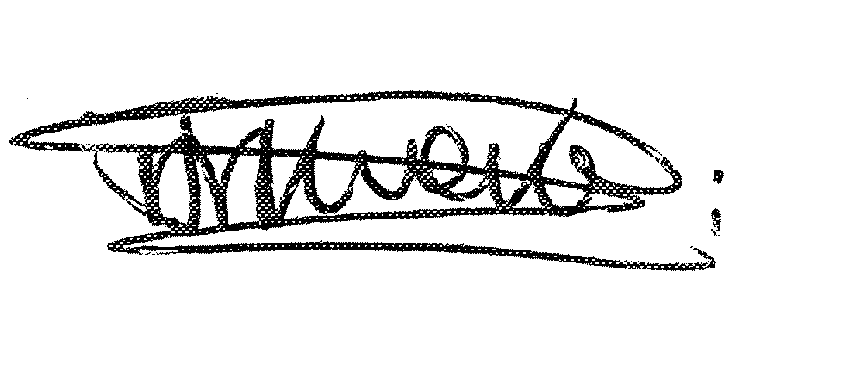
Yours faithfully,
JAMES KIOKO

For: DIRECTOR
STANDARDS DEVELOPMENT AND INTERNATIONAL TRADE
JMK

